Maths Quiz

Joe Down

Royal Grammar School High Wycombe

H446

Contents

2 Analysis of Problem 6

2.1 Problem Identification 6

2.1.1 Problem 6

2.1.2 Why it is solvable by computational methods 6

2.2 Stakeholders 7

2.2.1 Identification 7

2.2.2 Teachers 7

2.2.3 Students 8

2.3 Research 9

2.3.1 Mathmo 9

2.3.2 MathsBot 10

2.3.3 Wolfram Problem Generator 11

2.3.4 Summary 13

2.4 Proposed Solution 13

2.4.1 General proposal 13

2.4.2 Software Limitations 13

2.4.3 Hardware limitations 14

2.4.4 Software requirements 14

2.5 Stakeholder response to analysis 16

2.5.1 Troy Garvin, teacher of Mathematics 16

2.5.2 Tommy Clair, Year 12 student currently studying A Level Maths and Further Maths 16

2.5.3 Analysis 16

2.6 Success Criteria 16

2.6.1 Summary 16

2.6.2 Specific details 16

3 Design of Solution 21

3.1 Decomposition of problem 21

3.2 Solution Structure 24

3.2.1 User Interface 24

3.2.2 Data Structure 32

3.2.3 Class structure 36

3.2.4 Algorithms to develop 37

3.2.5 Algorithms to be used 59

3.3 Usability Features 65

3.4 Approach to Testing 66

3.4.1 During Development 66

3.4.2 Post Development 66

3.5 Stakeholder response to design 70

3.5.1 Troy Garvin, teacher of Mathematics 70

3.5.2 Tommy Clair, Year 12 student currently studying A Level Maths and Further Maths 70

3.5.3 Analysis of responses 70

4 Development of Solution 71

4.1 Database Setup 71

4.1.1 Create classes table using SQLite DB Browser GUI (renamed from class in design as plural is more descriptive of contents) 71

4.1.2 Create users table using SQLite DB Browser GUI (Code generated can later be used to automate creation of database in python if not found) 72

4.1.3 Create class_user table using SQLite DB Browser GUI 72

4.1.4 Create homework table using SQLite DB Browser GUI 73

4.1.5 Create class_homework table using SQLite DB Browser GUI 73

4.1.6 Create question_types table using SQLite DB Browser GUI 74

4.1.7 Create questions table using SQLite DB Browser GUI 74

4.1.8 Create homework_questions table using SQLite DB Browser GUI 75

4.1.9 Create question_results table using SQLite DB Browser GUI 75

4.2 Populating Database (testing.db_populate) 76

4.2.1 Populate users table 76

4.2.2 Populate classes table 77

4.2.3 Populate class_user table 78

4.2.4 Populate homework table 79

4.2.5 Populate class_homework table 80

4.2.6 Populate question_types table 80

4.2.7 Populate questions table 81

4.2.8 Populate homework_questions table 82

4.2.9 Populate question_results table 83

4.3 UI Implementation (window) 84

4.3.1 Base UI 85

4.3.2 Login screen 86

4.3.3 Create account screen 87

4.3.4 Student main menu screen 88

4.3.5 Teacher main menu screen 89

4.3.6 Homework select screen 90

4.3.7 Previous scores screen 90

4.3.8 Set homework screen 91

4.3.9 View classes screen 93

4.3.10 Admin screen 94

4.3.11 Account management screen 99

4.3.12 Template quiz screen 100

4.4 Login Scripts (scripts.db_scripts) 100

4.4.1 Import required Python libraries to perform hashing algorithms and communicate with an SQLite database 100

4.4.2 Connect to database 101

4.4.3 Function to identify if the value passed matches a username stored in the database (True or False should be returned) 101

4.4.4 Function to find the salt for a given username 103

4.4.5 Function to generate a salt 104

4.4.6 Function to hash a password 104

4.4.7 Function to check if a password hash matches the stored hash 106

4.4.8 Function to check if a password is correct for the given username 107

4.4.9 Function to create an account (insert valid data into the users table) 108

4.4.10 Function to get the user id which matches a given username 110

4.4.11 Function to get the account type for a given user id 111

4.4.12 Function to get the username for a given user id 112

4.4.13 Function to get the first name for a given user id 113

4.4.14 Function to get the last name for a given user id 114

4.4.15 Function to format an inputted first/last name according to database rules (all lowercase) 115

4.4.16 Function to update first name in database for a given user id 115

4.4.17 Function to update last name in database for a given user id 117

4.4.18 Function to update password in database for a given user id 118

4.5 UI Scripts (scripts.ui_scripts) 120

4.5.1 Import required Python libraries to communicate with SQLite database and use scripts from login scripts 120

4.5.2 Connect to database 120

4.5.3 Function to get a list of all classes for a given user id 120

4.5.4 Function to get a list of all homework for a given class id 122

4.5.5 Function to get a list of all classes for a given teacher id 124

4.5.6 Function to get a list of all students for a given class id 125

4.5.7 Function to get a list of all questions for a given homework id 126

4.5.8 Function to get the score for a given homework for a given user 128

4.5.9 Function to get the homework name and due date for a given homework id (used in get_homework_score) 133

4.5.10 Function to insert a student into a class 135

4.5.11 Function to check if a given student is in a class 139

4.5.12 Function to remove a student from a class 142

4.5.13 Function to create a new class 144

4.5.14 Function to remove a class 147

4.5.15 Function to get results for a homework for all students in a class 154

4.5.16 Function to get the name of a homework 162

4.5.17 Function to get the all homework scores for a given user in a given class 163

4.5.18 Function to get the question text for a given question 167

4.5.19 Function to get the correct answer for a given question 169

4.5.20 Function to remove a question from a homework 170

4.5.21 Function to insert a question into a homework 172

4.5.22 Function to get the incorrect answers for a given question 177

4.5.23 Function to get the correct status for a given question and user 178

4.5.24 Function to increment user attempts at question 181

4.5.25 Function to mark question as correct 183

4.5.26 Function to insert a new homework into database 186

4.5.27 Function to add a homework to a class 188

4.5.28 Function to remove a homework from database 191

4.5.29 Function to get type of a question 199

4.5.30 Function to get graph equation for a question 202

4.5.31 Function to set graph equation for a question 203

4.6 UI Programming (main) 206

4.6.1 Function to initialise program UI and halt program 206

4.6.2 Function to setup database or, if already present, make sure database structure is correct 208

4.6.3 Window class 215

4.7 Series Scripts (maths_scripts.series) 338

4.7.1 Taylor Series Class 338

4.7.2 Maclaurin Series Class 344

4.7.3 Sine function 344

4.7.4 Cosine function 350

4.8 Calculus Scripts (maths_scripts.calculus) 352

4.8.1 Integral approximation base class 352

4.8.2 Trapezium rule class 355

4.8.3 Simpson’s rule class 357

4.8.4 Comparison of Simpson’s rule to Trapezium rule 359

5 Evaluation 363

5.1 Final Testing 363

5.1.1 Testing 363

5.1.2 Stakeholder response to finished program 399

5.2 Level of Success 402

5.2.1 Success Criteria Summary 402

5.2.2 Evaluation of success criteria 407

5.3 Maintenance and Further Development 407

5.3.1 Current program limitations 407

5.3.2 Summary of further development and maintenance 408

# Analysis of Problem

## Problem Identification

### Problem

Particularly with the introduction of the new A-Level specifications, it can often prove very difficult for both teachers and students to find new and appropriate sample material to assist in practising for the exams. In addition to this, it can be difficult for teachers to keep track of how all students are progressing and in what areas they need to improve due to the large volume of data such as test and homework marks which need to be considered for each student, making it possible for struggling students to be unknowingly left behind.

### Why it is solvable by computational methods

While, in some subjects, questions are very subjective and therefore make more sense to be written by a human, the logical nature of mathematics means that it should be possible to computationally generate unique questions and accurate solutions based around frameworks mimicking the style of actual A-Level questions. Storing and searching large amounts of data is also a far more trivial task for a computer than a human through the implementation of databases, further making this problem amenable to a computational approach as it allows for a vast number of test scores, both on an individual student basis and across a class, to be processed in a variety of different ways in a minimal amount of time and with little to no user input in order to quickly identify areas of weakness, outputting results as needed. A database can also be implemented through a database server, allowing user details and scores to be stored on a single centralised server which could allow client programs to be implemented and submit question responses and pull results from this server over the internet. This would allow a teacher to instantly be able to see how a student is doing in a quiz in real time, something that would not be possible using non-computational methods unless the teacher were with the student while they attempting a test, something not feasible in classes larger than only a handful of students, or in the case of homework where a teacher physically cannot be present in person.

In addition to this, the problem is further amenable to a computational approach as computer systems allow for the inputting, processing and dynamic outputting of data to a user whilst abstracting away the more complex details required to do this in order to simplify all tasks for the end user. For example, scores can be shown without having to show the user how they were calculated, nor require the user to calculate them themselves, a computer is simply reliable enough at tasks such as these that if programmed correctly these can be assumed to be correct. Additionally, for tasks such as a quiz with multiple choice answers, a choice can simply be selected and submitted, with the process of the computer identifying what was selected and validating and storing data related to whether this was correct or incorrect abstracted behind a simple ‘Correct’ or ‘incorrect’ response, giving the student immediate useful feedback without unnecessarily complicating things like by requiring a student to check a mark scheme to confirm all their results manually and tediously themselves.

## Stakeholders

### Identification

The target audience for this program will be both teachers teaching and students studying A-Level Mathematics from 2017 (specifically the program will be based around the Edexcel 9MA0 specification, though the same skills and style of questions should apply to any other exam board). It is possible that this software may also be appropriate for other users in addition to those stated, such as teachers and students in other year groups or on different exam boards, however doing this would exceed the feasibility of this project unless further time was available or additional developers could work on the project. It may also be useful at higher levels than this such as university, or even for self-teaching topics, though again this would exceed the scope of this project.

### Teachers

#### Initial interview with Troy Garvin, teacher of Mathematics

##### Questions

1. Do you feel that there are enough resources available to students with regards to the new style A Level mathematics syllabus?
2. Do you feel that it is useful for students to be given unique questions as homework for which answers are not available to find online? If so, do you find it possible to provide such resources using currently available services?
3. Are there any specific ways you believe a computer program could be used to improve upon existing infrastructure (useful features etc.)?

##### Responses

1. No, definitely not. While many resources are available from the previous specification, a lot of these are only partially applicable to the new exams with significant changes to the way questions are marked and the methods used to find solutions. In addition to this, many topics have been removed so applicable questions need to be removed from all past papers, as well as many topics added not showing up at all. With the amount of work required to adjust available resources I may as well be making them again from scratch. For the new exams themselves we have the 2018 papers and almost nothing else to work with, with very little of the rest of this coming from the exam board, leaving many of myself and my students in the dark about how the exams will really be.
2. It’s very useful for students to have access to a wide range of unique, unseen. With a subject such as mathematics, there isn’t a better means of improving than continuing to practise, and this can’t be done if there aren’t enough questions to do as, even if they were done a long time ago, doing the same questions a second time never has the same beneficial effects. Currently we’re finding the best resources for providing these questions are the Pearson Active Learn online textbooks as these have detailed explanations of how to solve various types of problem under the new specification and many sample questions. Over the course of a year, however, there simply still aren’t enough here and questions also need to be collated from less well-made sources and even then, many questions aren’t representative of the format of questions in the final exam.
3. The main useful feature a computer program could provide is a means of getting immediate feedback to questions as this allows a student to know exactly where they are struggling without my intervention, allowing them to know exactly what it is they need to go back and revise further. To do this normally, a mark scheme would need to be provided and in my experience students are often tempted to simply copy the mark scheme and avoid doing the work, costing them in the long term as they cannot do this in an exam and I am unable to identify where their weaknesses are if they hide them.

#### Summary

For teachers, difficulty comes from the fact that the primary available source of sample questions is from older specification past papers and the few sample papers produced based on the new specification. This is an issue as in the case of the older specification papers, marks are awarded differently to how they will be awarded in upcoming examinations with a newer increased focus on the method used rather than purely the answer provided, making it harder for a teacher to identify how representative a student’s scores in classwork are of the marks they will receive at the end of the course. It is also very easy for students to find mark schemes for these papers as they are released by each exam board ~1 year after the exam takes place, making it difficult for a teacher to identify how genuine a student’s answers and again making it more difficult for a teacher to identify how well a student is progressing. Because of this, a program to generate exam-style sample questions would be very useful as it means a teacher has access to an unlimited supply of sample questions for which answers cannot be found online, allowing enough questions to be set without the possibility of students finding mark schemes. Using relational databases answers and questions can also be stored and re-accessed later, meaning a teacher can also refer to the problems set later without having to print out mark schemes as the questions are generated, nor will they have to create mark schemes themselves, reducing work load and the potential stress of doing everything manually.

### Students

#### Initial interview with Tommy Clair, Year 12 student currently studying A Level Maths and Further Maths

##### Questions

1. Do you feel that there are enough resources available to students with regards to the new style A Level mathematics syllabus?
2. Is helpful to you if feedback is provided immediately as to whether a question has been answered correctly or not something which particularly matters to you?
3. Do you find being able to practise new, previously unseen, questions a useful means of developing your mathematical skills or do you prefer simply learning the theory behind each topic?
4. Are there any specific ways you believe a computer program could be used to improve upon existing infrastructure (useful features etc.)?

##### Responses

1. No way. Our teachers haven’t given us much besides the textbook and I get the impression that’s because that really is all there is. It’s quite annoying because the school really pushes for us to be doing independent learning outside of lessons and we can’t really do that if there isn’t anything for us to learn from or practise with.
2. Yeah. Some of my teachers can be quite slow when it comes to returning work because they teach so many of us, so often by the time I get something back I’ve forgotten about it. That doesn’t really help me learn because I’ve usually either already improved or reinforced my mistakes by repeating them. So yes, it would be helpful to be able to get immediate feedback so I can immediately get to work fixing my mistakes.
3. There’s really no point doing the same questions again and again because I can usually at least roughly remember the answer and it doesn’t introduce you to different ways of solving a problem. It’s definitely very helpful reading the textbook and learning the theory behind doing different types of question, but there’s nothing quite like just doing some.
4. I’m not sure. Well, you were talking about getting immediate responses to questions answered so if that’s a feature you’re planning to implement, that’s something that would be very useful. I think it’s probably just a case of a computer being able to set lots of questions that would help the most because a textbook can only fit so many inside it.

#### Summary

For students, revision can also be difficult, particularly since many resources related to the new maths specifications are not yet accessible unless a subject teacher. For this reason, a means of accessing a large supply of questions is invaluable. Another issue that can be encountered when revising is the fact that a student must see what the correct answer is to know if their answer is correct, preventing them from reliably retrying the question as they already know what they should get as an answer. This could be solved however by using a computer to verify if an answer is correct and allow the student to reattempt the question without being shown the real answer.

## Research

### Mathmo

#### Description

While numerous question banks exist for A-Level mathematics exist, the only A-Level specific question generator appears to be Mathmo ([nrich.maths.org /mathmoApp](https://nrich.maths.org/mathmoApp)), developed by the University of Cambridge.



This tool allows a user to create an exercise and add to it a uniquely generated question from a list of possible topics.

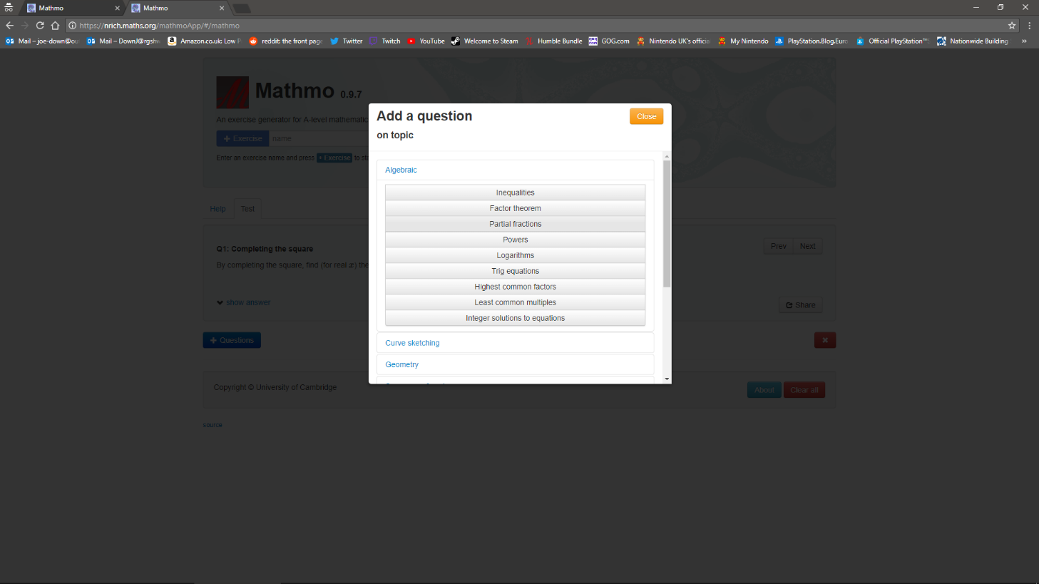

This program does however have several limitations. First it is web based, without a user login system, meaning all exercises are stored locally as cookies, meaning if a different browser is used or cookies are wiped all previously generated questions are lost.

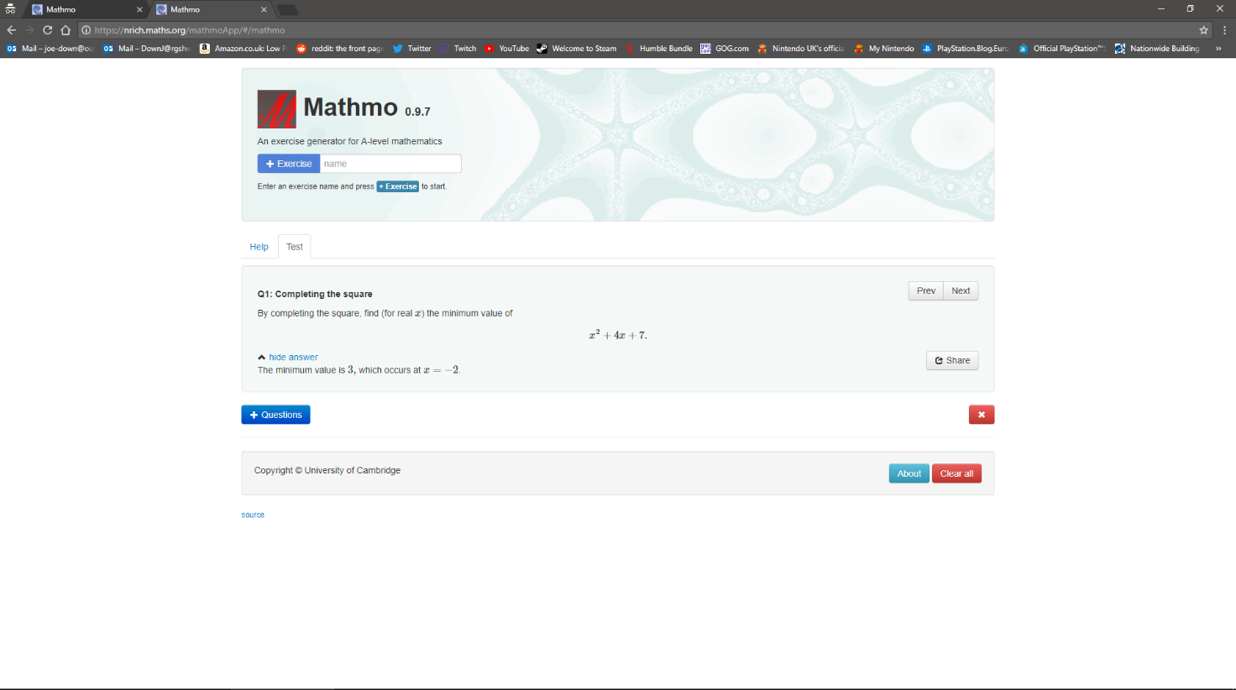

The tool also predates the new style A-Level so is missing some topics and includes some topics which have either been removed from the specification or moved to GCSE.

[qualifications.pearson.com/content/dam/pdf/A%20Level/Mathematics/2017/specification-and-sample-assesment/a-level-l3-mathematics-specification.pdf](https://qualifications.pearson.com/content/dam/pdf/A%20Level/Mathematics/2017/specification-and-sample-assesment/a-level-l3-mathematics-specification.pdf)

#### Advantages

* Web based so accessible from many different devices running many Oses
* Generates unique questions and answers so impossible to cheat and find solutions online
* Large variety of topics
* Allows mixing of topics

#### Disadvantages

* Web bases so inaccessible without an active internet connection
* No login system so data can only be saved locally as cookies (so will be lost if cookies are cleared or using a different device)
* No way of tracking results

### MathsBot

#### Description

An alternative maths question generator is the MathsBot question generator ([mathsbot.com/questionGenerator](https://mathsbot.com/questionGenerator)). This tool, while aimed at a much lower level than A-Level, is more interactive than Mathmo, illustrating how topics can be selected and question output modified using a difficulty selector to tune the tool to different users.

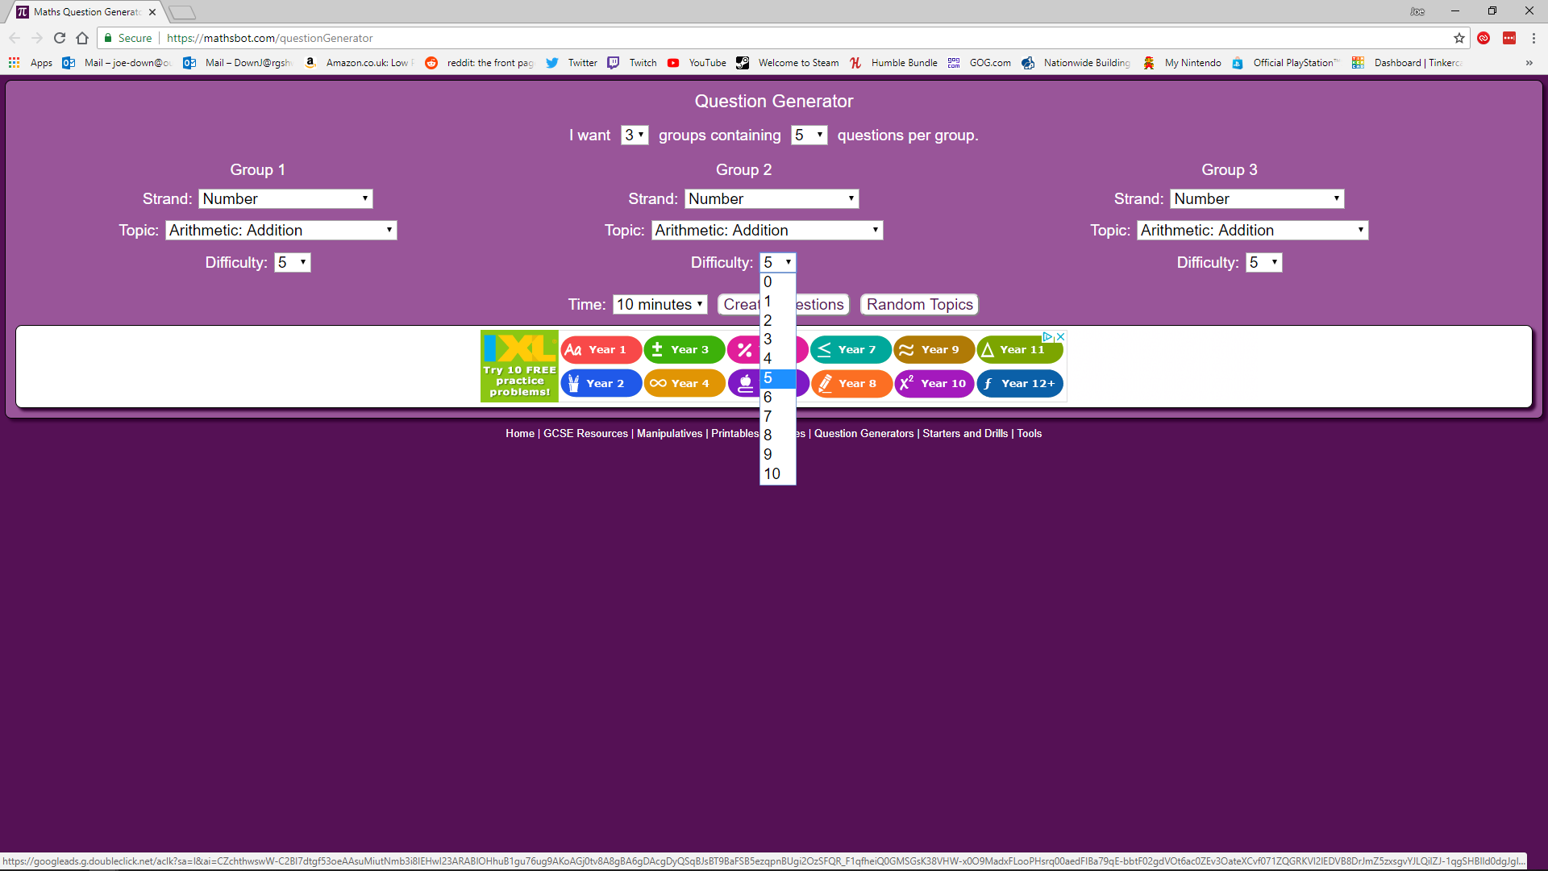

This tool also implements features such as a print function to allow questions to be completed more easily in a classroom if a teacher prefers work to be done by hand, as well as a timer if completing questions online to increase difficulty and ensure students are working at a fast enough pace that they are able to learn from what they are doing and improve later, as well as ensure they put all focus into completing the questions rather than multitasking and lacking concentration.

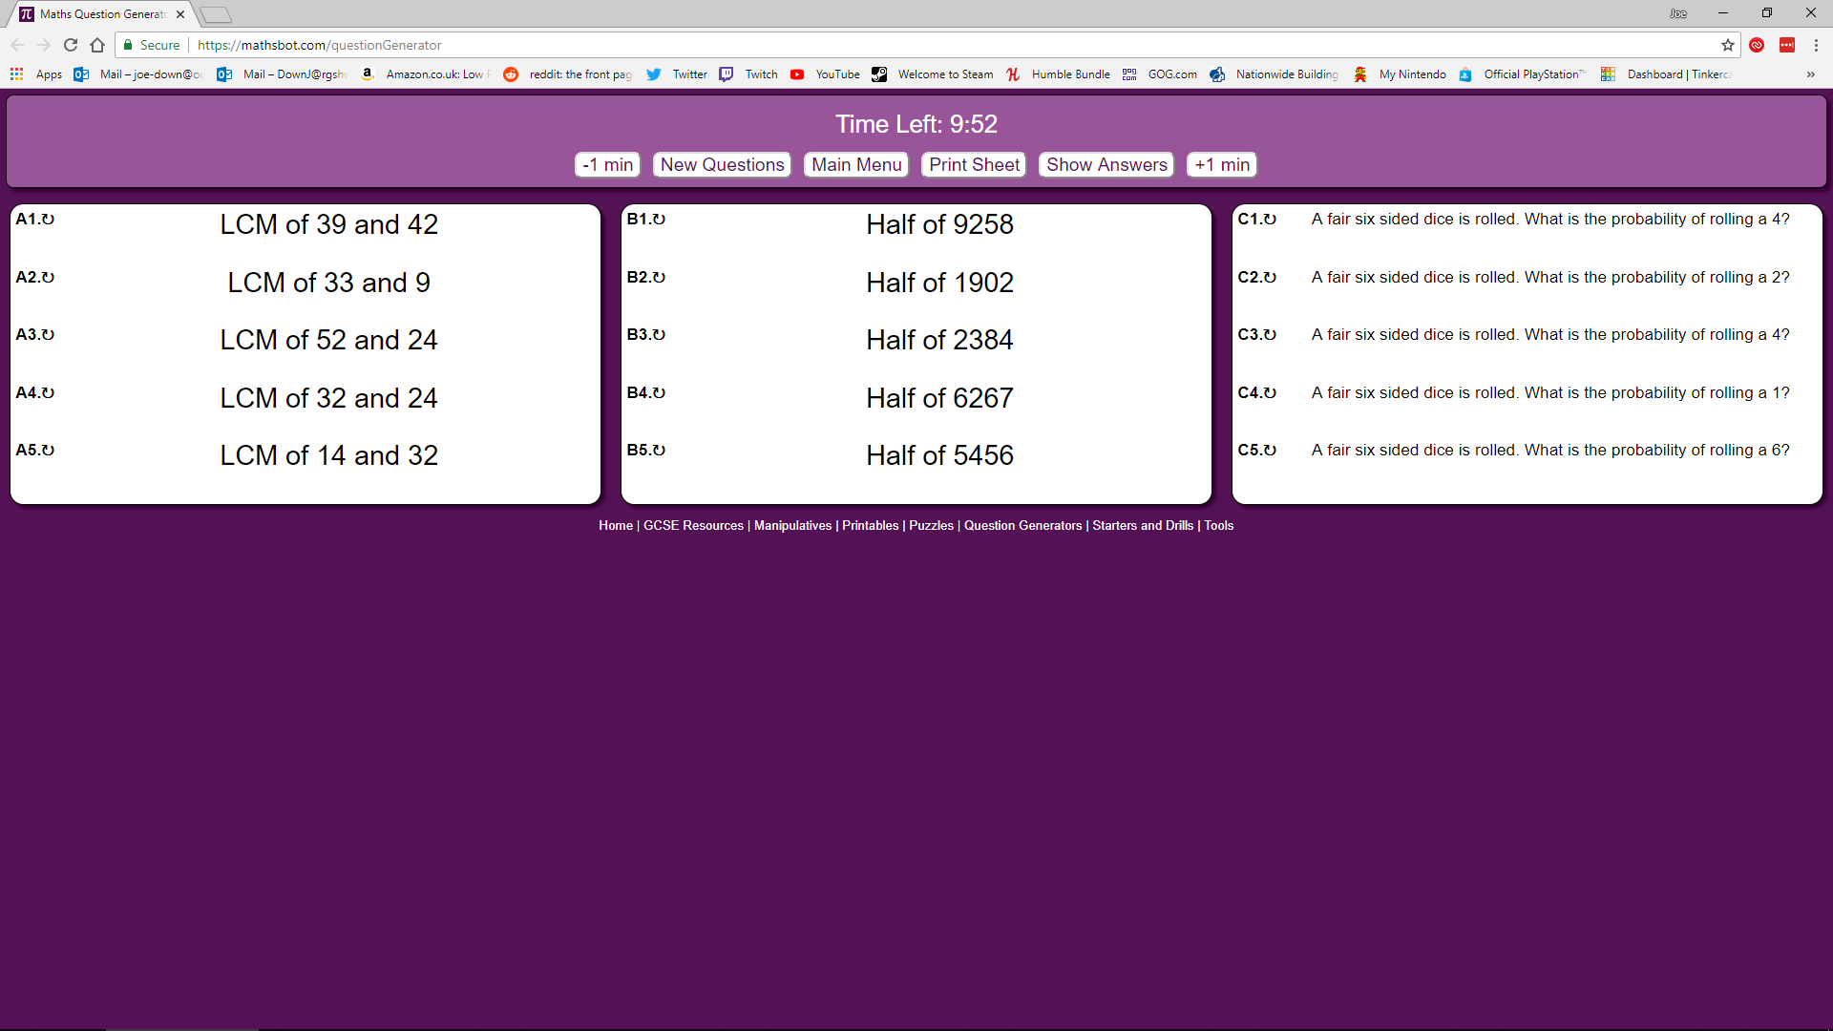

#### Advantages

* Difficulty selector allows questions to be tailored to different users
* Print function allows questions to be generated for use in a classroom without individual computer access
* Timer to encourage tasks be completed in a reasonable amount of time
* Questions uniquely generated
* Allows mixing of topics

#### Disadvantages

* Limited range of topics
* Results are not stored

### Wolfram Problem Generator

A final maths question generator tool is the Wolfram Problem Generator ([wolframalpha.com/problem-generator/](https://www.wolframalpha.com/problem-generator/)). This tool is again not aimed at A-Level specifically; however, it includes the ability to select questions of almost any sort that would be required and more.

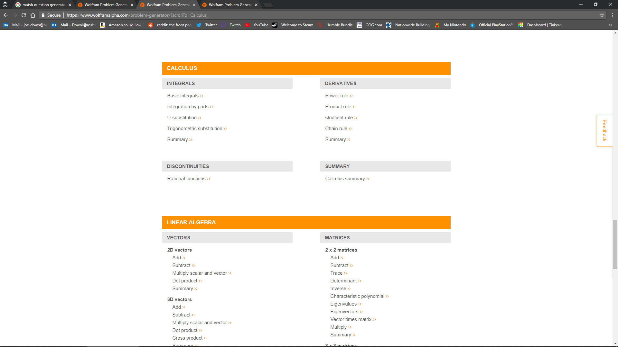

Again, this tool includes a difficulty selector which affects question difficulty by increasing the complexity of the data used (e.g. number of decimal places, number of values to be used etc.), a feature which it is increasingly clear is required to create a competing product.

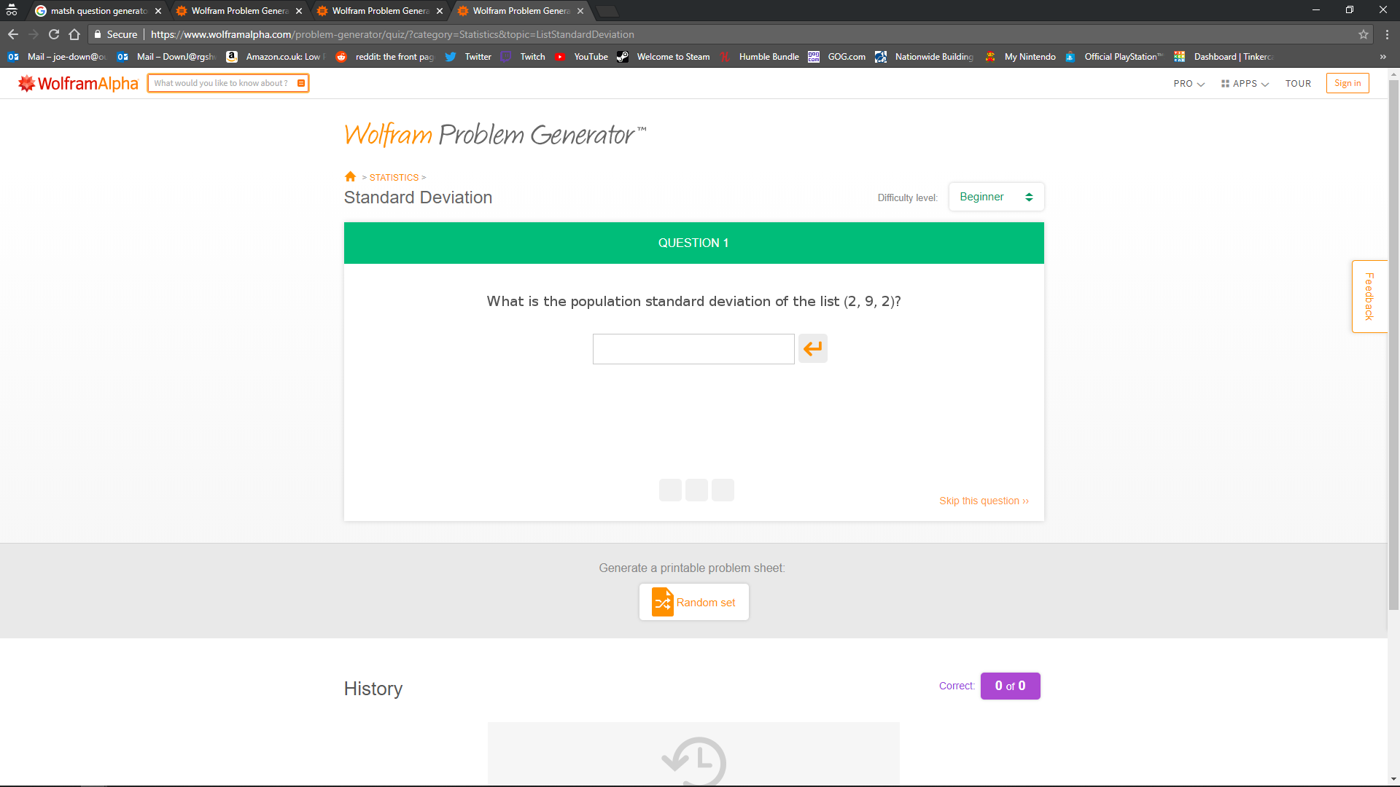

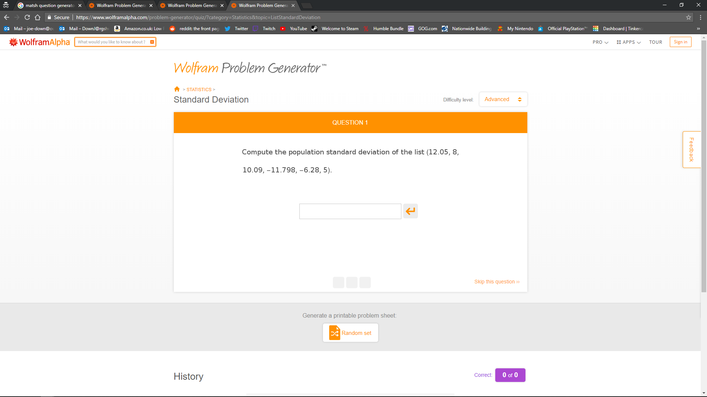

This tool is based around the Wolfram Alpha APIs meaning it can compute a large range of mathematical problems including complex algebra. This is all far beyond the scope of something that can be done for this project, however it is possible that I could also use the same APIs to assist in the development of my solution. This tool is also not very focused on the task of improving exam results specifically, so it also still is not a solution for the problem described, particularly since there is no way to collate questions and solutions from a variety of different topics into quiz form, nor is there any means, in this tool or any of the others, of going back and checking the progress of question scores, nor a sufficient means of saving questions and solutions for later (there is a print function though no digital means of saving and a premium subscription is also required to do this, something many teachers may be unwilling to pay). When solutions are provided by this program it is also only the answer without workings, a key feature for improving exam results to know where mistakes have been made.

#### Advantages

* Uniquely generates questions and marks answers
* Large range of topics of high complexity
* Difficulty level can be set

#### Disadvantages

* Results are not stored

### Summary

#### Key features to include

* Uniquely generated questions
* Auto-mark answers
* Multiple choice
* Difficulty adjustment
* Large range of questions
* Allow mixing of topics
* Login system to save questions and scores

## Proposed Solution

### General proposal

Due to the lack of other tools up to date with the new specification, I propose the development of a program to allow an A-Level maths topic to be selected and a unique practise question, similar in style to a real exam question, to be generated in a style similar to that of the example programs given (particularly similar to Mathmo in terms of complexity of question), though with much more of an emphasis on matching the style of a real exam question. I intend to then perform a different task depending on the user (Student or teacher, a login system should be implemented to allow for this) where a teacher is then given a worked answer and the opportunity to save the question and its answer for future reference, while a student is given an input box into which they must enter the correct answer before they are given solutions in a similar way to the question answering method of Wolfram Problem generator. I intend for the program to be able to save scores depending on how many questions a student can correctly answer and allow teachers and students to browse all relevant scores to identify strengths and weaknesses as this is a feature missing from all the identified similar existing solutions.

### Software Limitations

There are some obvious software limitations to this proposal. The main potential issue is with the volume of questions types which would need to be coded for the program to produce questions covering the entire syllabus. This is infeasible with the time limitations of this project and therefore only as many question generators will be created as can be done within this time as a proof of concept of what could be done if the program were to be developed full time. In addition to this, the nature of a multiple-choice quiz means that a student is marked by the program as either right or wrong. In what way they were wrong or their efficiency in reaching the correct answer cannot be assessed and so the program should only be used as a source of practise and a means of identifying questions which a student frequently gets wrong, rather than actively teaching how to solve each type of problem. Additionally, due to time and cost constraints, the proposed solution is a standalone application, with no web-based component to allow questions and scores to be retrieved from/written to a server which controls a large shared database to which an instance of the program connects as a client. This means homework must be set by teachers and homework attempted by students on the same computer unless they can share the database with each other remotely using their own methods. This also means that, as the database is stored locally, it is possible that a user may be able to tamper with it, for example to change homework scores, from outside the program to cheat which would not be possible if the database was stored remotely as direct access to data would be impossible and validation could be put in place to ensure only valid data edits are committed.

### Hardware limitations

All calculations required for the A-Level maths exam are completable using no more than a regular scientific calculator. All UI elements and database management required for this project should also be relatively lightweight. It would also be inappropriate for hardware requirements to be beyond those of a low-end laptop as students and teachers may be on a limited budget, meaning I will ensure that superfluous features are kept to a minimum. It is also therefore most appropriate to not utilise any proprietary tools within the program which require license fees as it is unlikely that a teacher, or particularly a student, would be willing to pay more than a minimal amount of money, if anything at all.



Above are the advertised specifications of the current best-selling laptop (laptops are far more common in a school environment than a desktop) on Amazon UK ([amazon.co.uk/Computer-Lapbook-x5-Z8350-Windows-Bluetooth/dp/B0764G3FLG](https://amazon.co.uk/Computer-Lapbook-x5-Z8350-Windows-Bluetooth/dp/B0764G3FLG)). From this, test specifications (these can be emulated using a virtual machine) should be at a maximum:

CPU clock: 1.92GHz ([ark.intel.com/products/93361/Intel-Atom-x5-Z8350-Processor-2M-Cache-up-to-1_92-GHz](https://ark.intel.com/products/93361/Intel-Atom-x5-Z8350-Processor-2M-Cache-up-to-1_92-GHz))

Core count: 4

RAM: 4GB

Storage capacity: 64GB

Graphics: Intel HD 200MHz

OS: Windows 10

### Software requirements

I plan to utilise Python 3.6 as a programming language through which to develop this solution with a UI developed using the PyQt5 module. This is because python is a highly adaptable programming language with an emphasis on object orientation, which I plan to use to create dynamic objects for each style of question which can calculate a range of relevant values depending on randomly generated set of relevant variables. PyQt will be used for user interface as it streamlines the process of creating and positioning UI elements compared to other libraries such as Tkinter by including the Qt Designer which provides a visual interface whereby elements can be arranged by the user visually and the relevant code to create the window’s composition is generated automatically. It also provides a variety of widgets such as input boxes and buttons to simplify the system of inputting and outputting data to a user. Python and PyQt are also easily lightweight enough to run on the target specifications defined above. Python does have one potential drawback in that it is interpreted rather than compiled. This means that as high-level code is translated to machine code as it runs rather than before like a compiled program would, it will require additional processing to run and therefore have higher system requirements than a compiled equivalent code. This is mostly counteracted however by the fact that any advanced processing done by the program is contained within only a few features which will only be run as requested, such as when calculating scores or generating a question, and not constantly. This means for most of the program’s usage (navigation, simpler database checks etc.) it is undemanding enough that the performance impact of an interpreted language is negligible and so convenience of language can be prioritised. In addition to this, interpreted code is not platform specific, unlike compiled code which can only be run on a particular type of system, and so the same program can be written and potentially run on various different operating systems with only minimal tweaks to the code being required (i.e. only system calls need to be changed for different platforms), something far more feasible within the scope of this project and it’s time constraints in the event it is decided to create versions of the program for OSes other than Windows.

For handling the database, SQLite will be used. Ideally a database server such as PostgreSQL or MySQL would be used for this project, allowing many clients to remotely connect to the same database and therefore allow teachers and students to set and take homework from any location on any system. Additionally, as a client can only request to make changes or read from the database server and cannot directly access the database itself, the integrity of the database is increased as all validation can be controlled by the server, which can be trusted unless the server itself is compromised as all validation is guaranteed to be implemented as intended by the developer, whereas a local server could potentially be edited by a user if they wish to edit data stored as the database itself is directly accessible. Maintaining a server does however incur costs and opening a server to outside connections introduces potential security issue and so the maintenance which would be required to implement this exceeds what is possible for a project of this scope. SQLite has therefore been selected as it is one of the few SQL dialects which operates serverless and is the most popular dialect of this type for Python, with the most robustly implemented Python libraries and therefore the best documentation and support available in the event of error fixing being required.

Windows will be the target operating as it currently accounts for ~80% ([en.wikipedia.org/wiki/Usage_share_of_operating_systems#Desktop_and_laptop_computers](https://en.wikipedia.org/wiki/Usage_share_of_operating_systems#Desktop_and_laptop_computers)) of the desktop/laptop operating system market and is by far the most accessible to teachers. This does not affect the development of the program in any way as all tools being used are designed for Windows, though changes may have to be made for compatibility if a decision were to be made to get the program running on other operating systems as it is not designed for use with other platforms as, while all major x86 based operating systems support Python and PyQt, testing will need to be done for each platform and code adapted accordingly. For example, most UNIX based OSes use a different standard file system to Windows, and it would be expected of users for the program to conform to these standards.

## Stakeholder response to analysis

Stakeholders were allowed to view the analysis documentation and asked to give any relevant feedback

### Troy Garvin, teacher of Mathematics

You’ve hit the nail on the head with this. The exam board is clearly not able to supply resources quickly enough and in large enough quantities to satisfy our needs as teachers and so an unlimited supply of questions is hard to argue with. I like the idea of being able to create and monitor classes as it means I can keep track of where people are struggling on an individual and class basis as it would help with lesson planning, deciding which topics to focus on and which to spend less time on. Having to do less marking is also always a positive.

### Tommy Clair, Year 12 student currently studying A Level Maths and Further Maths

This sounds very useful as a revision tool. I like that teachers aren’t needed to mark work so I can immediately work out where I’m struggling both while I’m doing a homework and in the grand scheme of things across all topics. Being able to be set such large quantities of work might be a bit daunting but I’m sure my teachers will be able to moderate themselves and set a reasonable amount. I also like the slightly competitive aspect of all our scores being shown to the teacher as a class because it will motivate me to ensure I’m getting the highest scores in the class!

### Analysis

The analysis appears to satisfy the needs of the stakeholders on a basic conceptual level, however further feedback will need to be requested after a more detailed design has been completed

## Success Criteria

### Summary

Ultimately, the success of this program will be measured by how it is received by teachers and students and whether they consider it better than other solutions currently on offer or simply using the limited material supplied by exam boards. To be successful the project must also always produce correct answers to questions and when quizzed never reject an answer that is valid, in whatever form it is entered and should be identified as something enjoyable to use by most students that try it. The program should be navigable by users of any computer literacy level and be intuitive to use. For teachers it must be capable of giving insight into how well both individual students and classes are progressing across different topics and allow them insight into how they can adapt and improve their lessons to accommodate for this, as well as give insight into how hard students are working through the precise knowledge of when students work and for how long.

### Specific details

#### General

|  |  |
| --- | --- |
| Criteria | Evidence of success |
| User can create account | User details (username, password, name etc.) are stored in database:   * Correctly * Permanently |
| User can login with account details | User login details can be:   * Correctly compared to those in database * Matching user access given if login details are matching |
| User can logout | Logout button:   * Can be pressed * Returns to login screen * Revokes access to the rest of the program |
| User can update account details | Non-identifying user details (i.e. All details except for username and id):   * Can be changed and amended * With new values permanently stored * Without introducing data confliction |
| User details are store securely | Password is:   * stored * salted hashed * form |
| Enough usability features are in place | Features are:   * Sufficiently labelled * Features such as buttons or dropdown menus etc. are used as appropriate * Destructive features such as deleting information are made clear to not take lightly (e.g. buttons made red to alert user) |
| Navigation features | Ability to navigate to key pages such as the main menu |
| All features contained within a graphical user interface | All features of the program can:   * Be accessed through a user interface * With user typing kept to a minimum * At no point requiring interaction with a terminal |
| Database integration to permanently store data | * All data is retained when the program is restarted * Structured in such a way that data can be accessed, and new data added as needed |
| Features should be all accessible as required from a main menu | Main menu through which:   * All pages are reachable by navigation * Though a minimal number of other pages |
| Permission system | Access to data should be:   * Restricted to only those it relates to (i.e. teachers can only see their details and student details in their classes and students should be unable to access teacher or other student data).   Program features should be limited to:   * Only the type of user they apply to (only teachers can make and manage classes and only students can be set homework) |

#### Teacher

|  |  |
| --- | --- |
| Criteria | Evidence of success |
| Teacher can create class | Class details (Name, teacher, students, homework etc.) are:   * Correctly * And permanently * Stored in a database |
| Teacher can add student to class | Class student relationship is:   * Correctly * And permanently * Stored in database |
| Teacher can remove student from class | Class student relationship is:   * Correctly * And permanently * Removed from database |
| Teacher can add homework to class | Class homework relationship is:   * Correctly * And permanently stored in database * With relevant homework details (name, questions etc.) |
| Teacher can remove homework from class | Class homework relationship is:   * Correctly * And permanently * Removed from database |
| Teacher can delete class | Class details are:   * Correctly * And permanently * Removed from database |
| Teacher can add custom question to homework | Question homework relationship is:   * Correctly * And permanently stored in database * With relevant question details (name, question text, correct answer, incorrect answers etc.) |
| Teacher can add automatically generated question to homework | Question homework relationship is:   * Correctly * And permanently stored in database * With relevant question details (name, question text, correct answer, incorrect answers etc.) |
| Teacher can select question difficulty and question adjusts as needed | Question difficult is:   * Correctly stored * With question in database * Question generation criteria are satisfied (see below) |
| Teacher can remove question from homework | Question homework relationship is:   * Correctly * And permanently removed from database with relevant question details |
| Teacher can view results for each student for a given homework | For each student, question results for a given homework and student are:   * Retrieved from the database * A score calculated from the number of correct responses |
| Teacher can view results for each homework for a given student | Question results for each homework in the class and a given student are:   * Retrieved from the database * A score is calculated from the number of correct responses |
| Scores correctly calculated | Score calculated as:   * The sum of each correct response * Divided by the number of times that question was attempted * All divided by the number of questions * Multiplied by 100 to give a percentage |
| Database usability | Database should be structured in such a way that it is:   * Fast to insert and find relevant data * Without the need for superfluous extra processing   Database relations should allow for:   * The introduction of new tables * Introduction of new types of relationship between tables * To allow for potential future maintainability and updates without extensive restructuring |
| Validation | All inputs should be validated to be   * Of a valid form * Usable for their intended purposes |

#### Student

|  |  |
| --- | --- |
| Criteria | Evidence of success |
| Student can access homework set for a given class | Program can:   * Output a list of homework from the database for the given class * Launches the quiz if a homework is selected |
| Student can only do homework before due date | Program excludes student from accessing quiz past stored due date |
| Quiz gives question and allows choice and submission of multiple-choice response | Question correct status:   * Is correctly changed to True in database for given user and question * Only if the correct response was selected and submitted |
| Student can see results for each homework in a class by class basis | Question results for each homework in the class and the current student are:   * Retrieved from the database * A score is calculated from the number of correct responses |
| Score correctly calculated | Score calculated as:   * The sum of each correct response * Divided by the number of times that question was attempted * All divided by the number of questions * Multiplied by 100 to give a percentage |

#### Questions

|  |  |
| --- | --- |
| Criteria | Evidence of success |
| Enough topics covered | Topics that can be generated:   * Cover multiple different topics |
| Generated correct answers are correct | When manually calculating answers to generated questions:   * Answer found matches the one generated |
| Generated incorrect answers are unique and incorrect | When manually calculating answers to generated questions:   * Answer found does not match any of the ones generated * Each incorrect answer is different |
| Questions are relevant to the mathematics specification | Topics covered are:   * Within the Edexcel mathematics specification |

# Design of Solution

## Decomposition of problem

1. Login
   1. Username and password input
   2. Username and password verification and program access/denial of access by comparing to data in database
   3. Go to relevant main menu for user type
   4. Option to create an account
2. Logout
   1. Return to login screen
   2. Unselect current user (remove all references to logged in user)
3. User access levels (student/teacher)
4. Data privacy between students (i.e. one student cannot see another’s scores)
5. Navigation
   1. Logout button
   2. Home button
6. Account creation
   1. Request input of
      1. Username
      2. Password
      3. first name
      4. last name
      5. account type (teacher or student)
   2. Require input of password a second time to verify user has entered their new password correctly
   3. Password security
      1. Generate unique salt for each new user (to prevent the usage of lookup tables to find passwords from unsalted password hashes)
      2. Hash password with salt before storing
   4. Store username, first name, last name, account type, password salt and password hash to database
   5. Button to return to login screen
7. Main menu options dependent on user access levels
   1. Both pupil and teacher
      1. Account management
         1. Set new first name
         2. Set new last name
         3. Set new password
         4. Require new password to be entered twice to verify entered correctly
         5. Require old password to make any changes to user data
   2. Pupil
      1. View previous results
         1. View data about previous quizzes
            1. Homework name
            2. Homework score
            3. Homework date
            4. Keep track of number of attempts and factor this in to calculation of final score (i.e. reduce score given for a question as number of attempts increases)
      2. Homework
         1. Select class to do homework from
         2. Select homework task from list of homework
         3. Show due date of each homework
         4. Go to homework task when selected (see quiz requirements)
         5. Do not show homework with due date before current date in list of homework to do
   3. Teacher
      1. View scores
         1. Select class
         2. Select homework
         3. Show homework results list
         4. For each student in class show:
            1. First name
            2. Last name
            3. Raw score
            4. Percentage score
            5. Number of attempts at homework
      2. Manage class
         1. Create class
            1. Enter class name
            2. Insert into database
         2. Manage class
            1. Add user

Enter username

Verify user not already in class

Verify user exists

Create class student relationship in database

* + - * 1. Remove user

Select student from list of students in class

Remove class student relationship from database

* + - * 1. Add homework

Enter homework name

Enter homework description

Enter homework due date

Verify due date is in future

Insert homework into database

Establish class to homework relationship in database

* + - * 1. Remove homework

Select from list of homework in class

Remove class homework relationship from database

Remove class data from database

* + - 1. Delete class
         1. Select from list of classes
         2. Remove from database
    1. Manage homework
       1. Select class
       2. Select homework to add questions to
       3. Add automatic question
          1. Select topic of generated question from list of available topics
          2. Select question difficulty
          3. Generate question for matching type
          4. Create question to homework relationship in database
       4. Add custom question
          1. Enter question name
          2. Enter question text
          3. Enter correct answer
          4. Enter incorrect answers
          5. Create question to homework relationship in database
       5. Remove question
          1. Select question to remove from list of questions in homework
          2. Show question text and correct answer to ensure user knows which homework is being removed
          3. Remove question to homework relationship in database

1. Quiz
   1. Show first question
   2. Provide navigation buttons
      1. Next question
      2. Previous question
   3. Show matching question text
   4. List possible answer
      1. Randomise order of answers to obscure correct answer
      2. Allow only 1 answer to be selected at a time
   5. Allow response to be submitted
      1. Increment number of attempts
      2. Check if correct answer is selected
         1. If selected, update database to show question answered by user correctly
         2. If not selected output that answer is incorrect
2. GUI
   1. GUI design
      1. Design and create login screen, accounting for all features described above (submit buttons, inputs etc.)
         1. Must link to:
            1. Account creation screen
            2. Main menu pages

Goes to matching main menu depending on user type

* + 1. Design and create account creation screen, accounting for all features described above (submit buttons, inputs etc.)
       1. Must link back to login screen
    2. Design and create student main menu screen, accounting for all features described above
       1. Must allow:
          1. Logout
          2. Returning to main menu
          3. Link to homework screen
          4. Link to view results screen
    3. Design and create teacher main menu screen, accounting for all features described above
       1. Must allow
          1. Logout
          2. Returning to main menu
          3. Link to view scores screen
          4. Link to manage class screen
          5. Link to manage homework screen
    4. Design and create view results screen, accounting for all features described above
    5. Design and create view homework menu, accounting for all features described above
    6. Design and create view scores screen, accounting for all features described above
    7. Design and create quiz screen, accounting for all features described above
    8. Design and create manage class screen, accounting for all features described above
    9. Design and create manage homework screen, accounting for all features described above
  1. GUI scripts
     1. Create script to initialise all buttons
     2. Create scripts to navigate between pages
     3. Create scripts to modify page elements
     4. Create scripts to reset page elements

1. Question generation
   1. Generate questions and answers based on a range of mathematical topics
   2. Adjust question generated based on difficulty entered
   3. Generate incorrect answers based off the generated correct answer
      1. Must all be unique
      2. Must not match correct answer
   4. Round all values to a reasonable number of significant figures to be usable
   5. Save question to database
   6. Return information about database entry to allow creation of homework question relationship
      1. Question id

## Solution Structure

### User Interface

#### Login Screen

Must take a username and password and have a button to check against the database and have the program respond accordingly

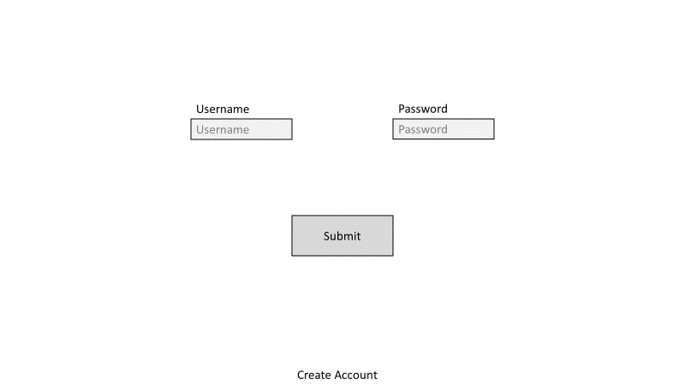

* Input box for username
* Input box for password
* Submit button
* Go to create account page button

#### Create Account

Must take all inputs required for, or used to generate, a record in the user table and have a button to validate this data and have the program respond accordingly

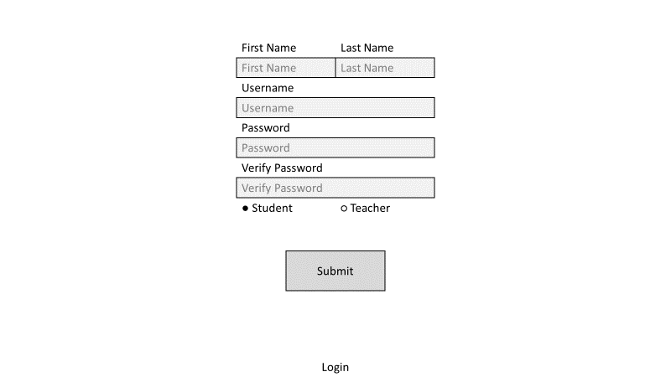

* Input box for first name
* Input box for surname
* Input box for password
* Input box for password verification
* Radio buttons to select account type (student or teacher)
* Submit button
* Go to login page button

#### Student main menu

Must have buttons linking to all student program feature pages

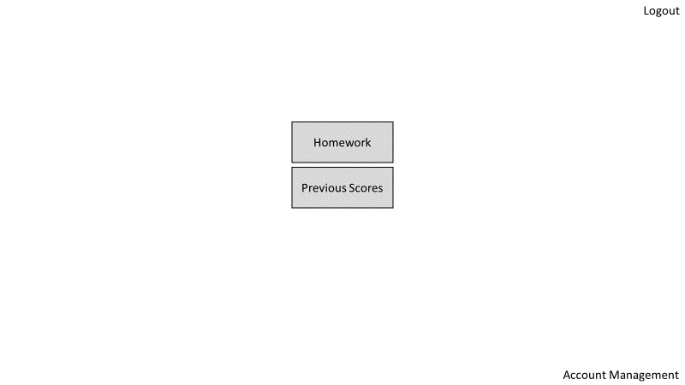

* Logout button
* Go to homework page button
* Go to view previous scores page button
* Go to account management page button

#### Teacher Main Menu

Must have buttons linking to all teacher program feature pages

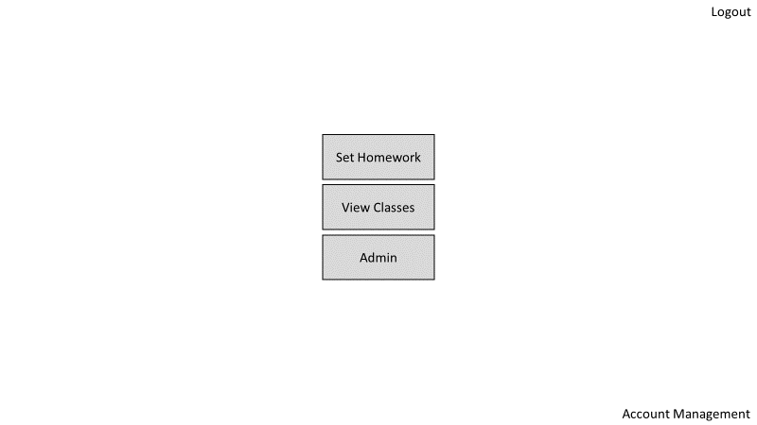

* Logout button
* Go to set homework page button
* Go to view classes page button
* Go to admin page button
* Go to account management page button

#### Homework select page

Must allow a class to be selected by a student and show and link to all homework due

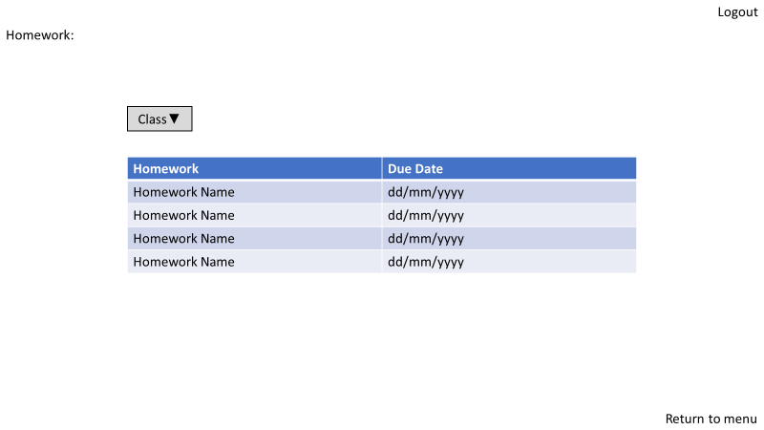

* Logout button
* Select class dropdown
* List of homework, each linking to relevant quiz
* Return to menu button

#### Previous scores page

Must allow a user to view all homework results for each class

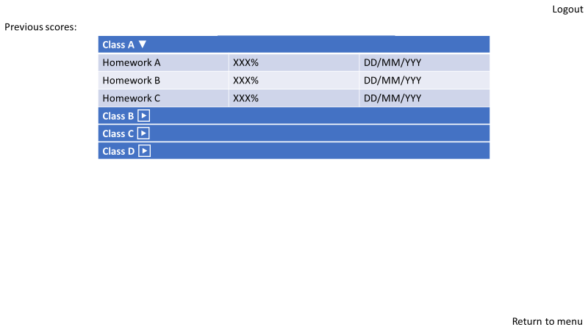

* Logout button
* Dropdown menus for each class student is in
  + List of homework for each class with score and due date
* Return to menu button

#### Set homework page

Must allow teacher to select a class and homework and add or remove questions of various types

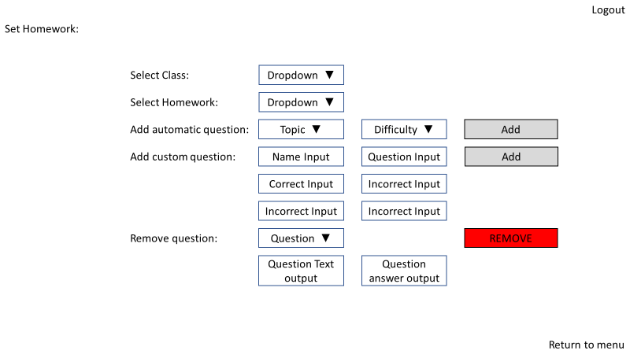

* Logout button
* Dropdown box to select class
* Dropdown box to select homework
* Automatic question
  + Dropdown to select topic
  + Dropdown to select difficulty 1-5
  + Add question button
* Custom question
  + Question name input
  + Question text input
  + Correct answer input
  + Incorrect answer 1 input
  + Incorrect answer 2 input
  + Incorrect answer 3 input
  + Add question button
* Remove question
  + Select question dropdown
  + Selected question text output
  + Selected question answer output
  + Remove question button
* Return to menu button

#### View classes page

Must allow teacher to see student results for each homework in class

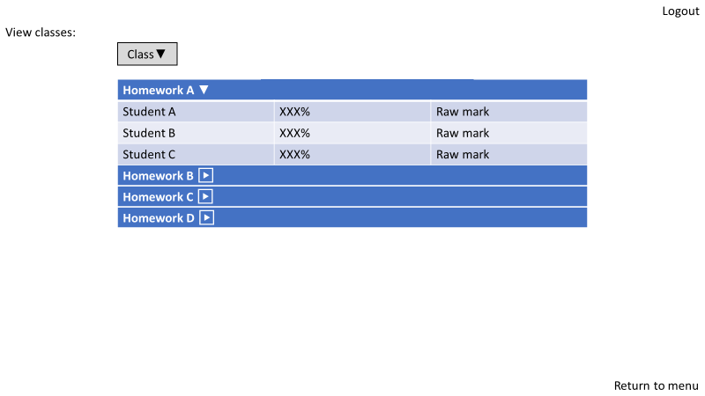

* Logout button
* Class select dropdown menu
* Dropdown menus for each homework in class
  + Under each dropdown show table with student name, percentage and raw mark
* Return to menu button

#### Admin page

Must allow a teacher to manage all aspects of the class (add/remove user, class and homework)

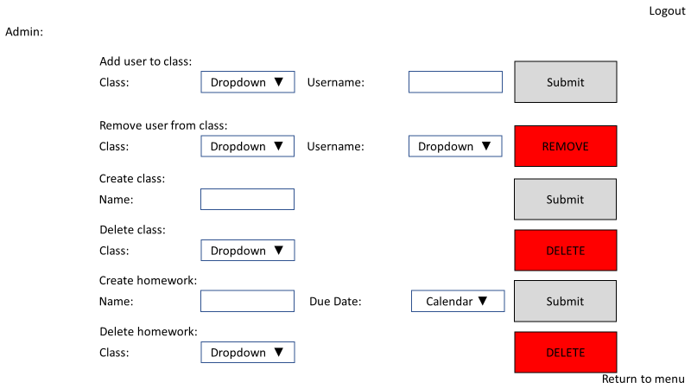

* Logout button
* Add user to class
  + Class select dropdown
  + Input box for username
  + Submit button
* Remove user from class
  + Class select dropdown
  + User select dropdown
  + Submit button
* Create class
  + Input box for class name
  + Submit button
* Delete class
  + Class select dropdown
  + Submit button
* Create homework
  + Input box for homework name
  + Due date select calendar
  + Submit button
* Delete homework
  + Homework select dropdown
  + Submit button
* Return to menu button

#### Account management page

Must allow a user to change non-vital account details

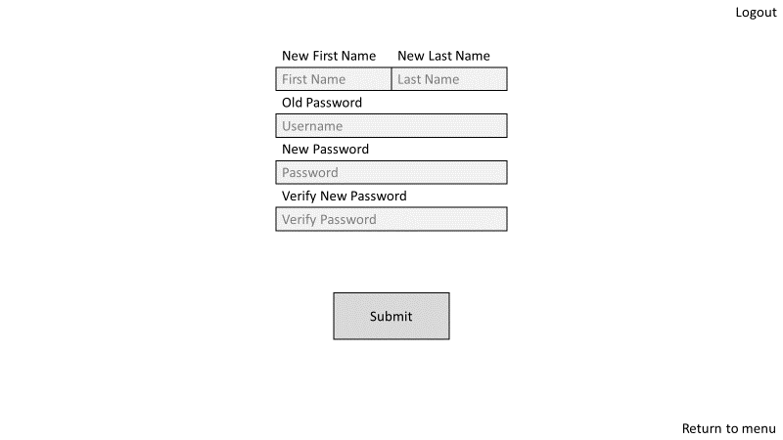

* Logout button
* Input box for new first name
* Input box for new surname
* Input box for password (to verify user making changes is the correct user)
* Input box for new password
* Input box for password verification
* Submit button
* Return to menu button

#### Template quiz page

Must allow a user to navigate between questions, show them a question, allow them to select an answer and submit a response, receiving relevant feedback

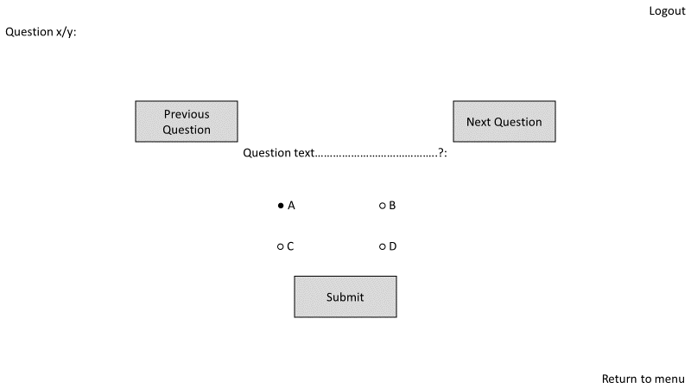

* Logout button
* Previous question button
* Next question button
* Question text area
* Radio buttons to select response (answer a, answer b, answer c, answer d)
* Submit answer button
* Return to menu button

### Data Structure

#### Outline

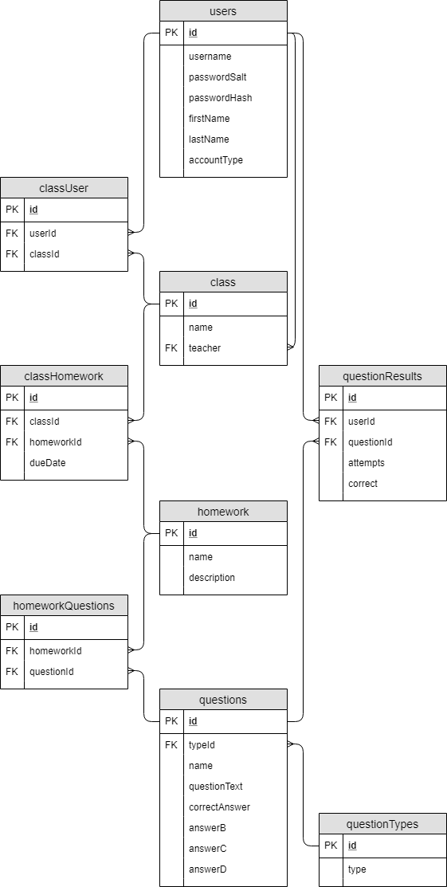

#### Validation

##### users

|  |  |  |  |  |  |  |
| --- | --- | --- | --- | --- | --- | --- |
| Attribute | Key Type | Data Type | Further Properties | Explanation | Test data (student) | Test data (teacher) |
| Id | Primary | Integer | Not null  Unique | Identifier to uniquely identify a single entity in the table | 1 – 100 | 101 – 200 |
| Username |  | Text | Not null  Unique | Unique identifier which is more memorable for a user than the id | student1 – student100 | teacher1 – teacher100 |
| passwordSalt |  | Text | Not null  Unique | Unique string to be appended to the end of any password entered for that user used to increase the uniqueness of the hash (prevent lookup tables being used if database is compromised) |  |  |
| passwordHash |  | Text | Not null | Password stored in an irreversibly encrypted form to keep the password unknown if the database is compromised |  |  |
| firstName |  | Text | Not null | User’s first name | first1 – first100 | first1 – first100 |
| lastName |  | Text | Not null | User’s last name | last1 – last100 | last1 – last100 |
| accountType |  | Text | Not null | Stores the user’s type (student or teacher) | s | t |

Unhashed passwords: password

##### class

|  |  |  |  |  |
| --- | --- | --- | --- | --- |
| Attribute | Key Type | Data Type | Further Properties | Explanation |
| id | Primary | Integer | Not null  Unique | Identifier to uniquely identify a single entity in the table |
| name |  | Text | Not null | Class’s name |
| teacher | Foreign (references user(id)) | Integer | Not null | Links to the user data of the class’s teacher (class admin) |

##### classUser

|  |  |  |  |  |
| --- | --- | --- | --- | --- |
| Attribute | Key Type | Data Type | Further Properties | Explanation |
| id | Primary | Integer | Not null  Unique | Identifier to uniquely identify a single entity in the table |
| classId | Foreign (references class(id)) | Integer | Not null | Links to the class the user is a member of |
| userId | Foreign (references user(id)) | Integer | Not null | Links to the user that is a member of the class |

##### homework

|  |  |  |  |  |  |
| --- | --- | --- | --- | --- | --- |
| Attribute | Key Type | Data Type | Further Properties | Explanation | Test Data |
| Id | Primary | Integer | Not null  Unique | Identifier to uniquely identify a single entity in the table | 1 |
| Name |  | Text | Not null | Name of homework task | name1 |
| Description |  | Text |  | Description of homework task | description1 |

##### classHomework

|  |  |  |  |  |
| --- | --- | --- | --- | --- |
| Attribute | Key Type | Data Type | Further Properties | Explanation |
| Id | Primary | Integer | Not null  Unique | Identifier to uniquely identify a single entity in the table |
| classId | Foreign (references class(id)) | Integer | Not null | Links to the class to which the homework relates |
| homeworkId | Foreign (references homework(id)) | Integer | Not null | Links to the homework task |
| dueDate |  | String | Not null | Expiry date for homework, beyond which it will be inaccessible |

##### questionTypes

|  |  |  |  |  |  |
| --- | --- | --- | --- | --- | --- |
| Attribute | Key Type | Data Type | Further Properties | Explanation | Test Data |
| id | Primary | Integer | Not null  Unique | Identifier to uniquely identify a single entity in the table | 1 |
| Type |  | Text | Not null  Unique | Human understandable question type identifier | type1 |

##### questions

|  |  |  |  |  |
| --- | --- | --- | --- | --- |
| Attribute | Key Type | Data Type | Further Properties | Explanation |
| Id | Primary | Integer | Not null  Unique | Identifier to uniquely identify a single entity in the table |
| Name |  | Text | Not null | Name of question |
| typeId | Foreign (references questionTypes(id)) | Integer | Not null | Links to question type of question |
| questionText |  | Text | Not null | Text to be displayed as a question |
| correctAnswer |  | Text | Not null | Correct answer to question |
| answer |  | Text | Not null | A unique incorrect answer to the question |
| answer |  | Text | Not null | A unique incorrect answer to the question |
| answerD |  | Text | Not null | A unique incorrect answer to the question |

##### homeworkQuestions

|  |  |  |  |  |
| --- | --- | --- | --- | --- |
| Attribute | Key Type | Data Type | Further Properties | Explanation |
| Id | Primary | Integer | Not null  Unique | Identifier to uniquely identify a single entity in the table |
| homeworkId | Foreign (references homework(id)) | Integer | Not null | Links to the homework to which the homework entry relates |
| questionId | Foreign (references questions(id)) | Integer | Not null | Links to the question to which the homework entry relates |

##### questionResults

|  |  |  |  |  |
| --- | --- | --- | --- | --- |
| Attribute | Key Type | Data Type | Further Properties | Explanation |
| id | Primary | Integer | Not null  Unique | Identifier to uniquely identify a single entity in the table |
| userId | Foreign (references users(id)) | Integer | Not null | Links to the user to which the question score relates |
| questionId | Foreign (references questions(id)) | Integer | Not null | Links to the question to which the question score relates |
| attempts |  | Integer | Not null | Total number of times the question has been attempted by a user |
| correct |  | Boolean | Not null | Stores True or False depending on whether a correct answer has been submitted |

#### Normalisation

All tables have been verified to be in Third Normal Form. This means that each non-prime attribute in a table is dependent only on the primary key, wholly by the key and all fields contain atomic values (i.e. store only a single value, no lists). In most cases this was most easily achieved by including an id attribute in each table with the ‘not null’ and ‘unique’ properties, meaning each record in the table will always have at least one attribute with which it can be uniquely identified and can therefore act as a primary key. Using an id column also simplifies development as only integer values need to be considered when referencing items in the database and so functions can be shared between various functions relating to using various different files compared to if more complex compound string based primary keys were used. Keeping fields atomic has been achieved by including tables to link instances in one table to instances in another, with each entry in the table simply including two foreign keys referencing one item in one table and one in another. This means additional data can be linked together by inserting a new entry into the connecting table rather than requiring lists of data to be stored as in a single table solution. Examples of this are the classUser classHomework and homeworkQuestions tables which allow respectively a user to be linked to many classes, a homework to be linked to many classes and a question to be linked to many homework without listing each user id in the class table, each homework id in the class table and each question id in the homework table.

### Class structure

#### Summary

The main program is to be contained within a window class based off PyQt’s built in QMainWindow class. This means a large proportion of the workings of the UI, though not specifically how it is laid out and what each element in the UI does, is already prewritten (i.e. do not need to define how a button works, simply what it does) through the use of inheritance from this parent class. Methods can then be developed to define what each interaction with the UI itself is to do (see UML diagrams below). By containing these within a window class, it also means certain variables can be easily stored as class attributes and used by methods without needing to e manually passed through each proceeding function such as the current page id or currently logged in username and user id (for specifics see UML).

Additionally, questions are to be generated using a base question class which stores all the data required to be stored in the database as class attributes and methods to intelligently generate data as needed depending on how much data was initially supplied to the class (e.g. generate incorrect answers if only a single correct numerical answer was provided). This simplifies the production of functions to generate questions of various more specific types as all that needs to be done is to generate question text and a single correct answer, with the rest able to be handles by then passing all this data to the question class.

#### UML

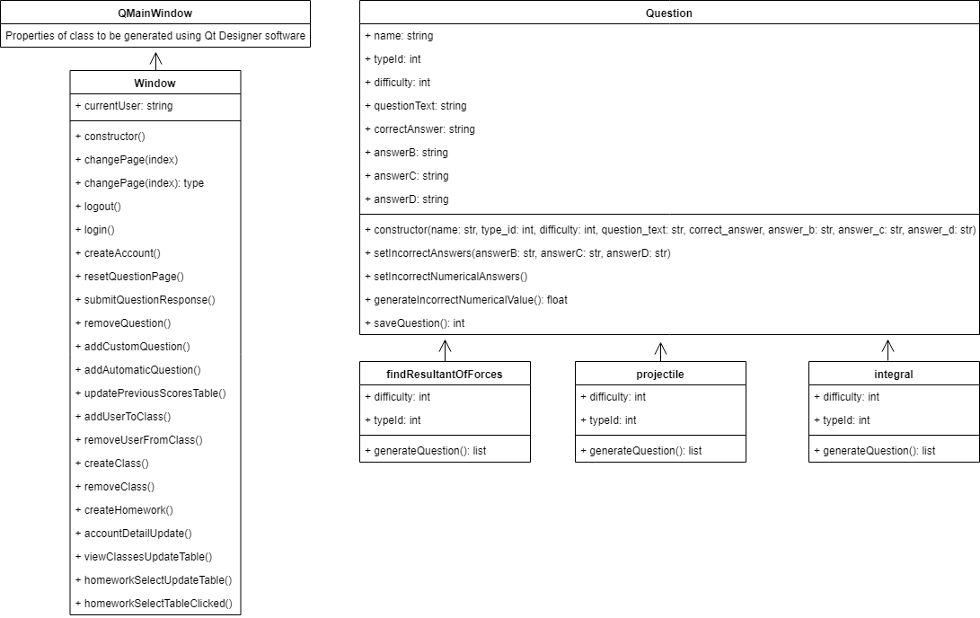

### Algorithms to develop

#### Database interaction

##### Check if a user exists [checkUserExists(name)]

###### Pseudocode

function checkUserExists(name):

if (count from users where username = name) > 0:

return True

else:

return False

end if

end function

###### Explanation

Takes in a username and queries the database to find the number of occurrences of it in the database. If the query returns 0, False is returned as the username does not exist in the database whereas if the query returns 1 the username is in the database and True is returned.

###### Test Data

|  |  |  |  |  |
| --- | --- | --- | --- | --- |
| Test Number | Test | Parameter values | Data types | Expected Outcome |
| 1 | Valid data | test | String (irrelevant) | Returns True |
| 2 | Invalid data | qwerty | String (irrelevant) | Return False |

##### Find a salt for a given username [findSalt(userId)]

###### Pseudocode

function findSalt(userId):

return (passwordSalt from users where id = userId)

end function

###### Explanation

Takes in a user id (assumes this has already been validated) and queries the database to find the password salt for the matching user then returns this value.

###### Test data

|  |  |  |  |  |
| --- | --- | --- | --- | --- |
| Test Number | Test | Parameter values | Data types | Expected Outcome |
| 1 | Valid data | Test | String (irrelevant) | Returns 6a29c0b26e104282a42aab2f9c55d2b8 |
| 2 | Invalid data | N/A (validation done before using function) | N/A | N/A |

##### Generate salt [generateSalt]

###### Pseudocode

function generateSalt:

return randomString(length = 32)

end function

###### Explanation

Returns a randomly generated 32-character string to be used as a salt. Python contains inbuilt libraries to do this

###### Test data

|  |  |  |  |  |
| --- | --- | --- | --- | --- |
| Test Number | Test | Parameter values | Data types | Expected Outcome |
| 1 | Returns a unique valid salt | N/A | N/A | Returns a unique salt each of three times it is run |

##### Generate hash [generateHash(password, salt)]

###### Pseudocode

function generateHash(password, salt):

return sha256(password + salt)

end function

###### Explanation

Takes in a password and a salt as strings, appends the salt to the end of the string and generates the sha256 hash for this string (python has inbuilt libraries to do this). The hashed value is then returned.

###### Test data

|  |  |  |  |  |
| --- | --- | --- | --- | --- |
| Test Number | Test | Parameter values | Data types | Expected Outcome |
| 1 | Password 1 | test, generateSalt() | String, string | Returns string which is the sha256 hash of test and generateSalt() concatenated |
| 2 | Password 2 | abc123, generateSalt() | String, string | Returns string which is the sha256 hash of abc123 and generateSalt() concatenated |
| 3 | Password 3 | password, generateSalt() | String, string | Returns string which is the sha256 hash of password and generateSalt() concatenated |

##### Check password against hashed password [checkPassword(userId, password)]

###### Pseudocode

function checkPassword(userId, password):

return checkHash(userId, password, findSalt(userId))

end function

###### Explanation

Takes in a user ID and a password to check. The salt is then found for the given user and the user id, password and the salt are passed to the checkHash function. The result of the checkHash function (True or False depending on if password matches) is then returned.

###### Test data

|  |  |  |  |  |
| --- | --- | --- | --- | --- |
| Test Number | Test | Parameter values | Data types | Expected Outcome |
| 1 | Valid data | test, test12345 | String, string | Returns True |
| 2 | Invalid username | qwerty, test12345 | String (irrelevant), string | Returns False |
| 3 | Invalid password | test, qwerty | String, string (irrelevant) | Returns False |
| 4 | Invalid username and password | qwerty, qwerty | String (irrelevant), string (irrelevant) | Returns False |

##### Check hashed password matches stored hashed password [checkHash(userId, password, salt)]

###### Pseudocode

function checkHash(userId, password, salt):

generatedHash = generateHash(password, salt)

if (count from users where id = userId and passwordHash = generatedHash) > 0:

return True

else:

return False

end if

end function

###### Explanation

Takes in a user id, an inputted password and a salt provided. These are validated though previous functions. A hash is generated using the pre-written function from the password and salt. The database is then queried and if both the user id and hashed password match an entry in the users table an item is found and 1 is returned so True is returned to indicate the password is valid. If 0 is returned the hash does not match and the password is invalid so False is returned.

###### Test data

|  |  |  |  |  |
| --- | --- | --- | --- | --- |
| Test Number | Test | Parameter values | Data types | Expected Outcome |
| 1 | Valid data | test, test12345, findSalt(test) | String, string, string | Returns True |
| 2 | Invalid username | qwerty, test12345, findSalt(test) | String (irrelevant), string | Returns False |
| 3 | Invalid password | test, qwerty, findSalt(qwerty) | String, string (irrelevant), string | Returns False |
| 4 | Invalid username and password | qwerty, qwerty, findSalt(qwerty) | String (irrelevant), string (irrelevant), string | Returns False |

##### Get user id [getUserId(username)]

###### Pseudocode

function getUserId(username):

return(id from users where username = username)

end function

###### Explanation

Takes in a username and queries the users table of the database to find the entry with a matching name value. The value in the id column (the primary key for the user) is then returned. Assumes username pre-validated with the checkUserExists function.

###### Test data

|  |  |  |  |  |
| --- | --- | --- | --- | --- |
| Test Number | Test | Parameter values | Data types | Expected Outcome |
| 1 | Valid data | test | String | Returns 1 |
| 2 | Invalid data | N/A (validation done before using function) | N/A | N/A |

##### Get account type [getAccountType(userId)]

###### Pseudocode

function getAccountType(userId):

return(type from users where id = userId)

end function

###### Explanation

Takes in a user id and queries the users table of the database to find the entry with a matching id value. The value in the type column is then returned. Assumes pre-validated id passed

###### Test data

|  |  |  |  |  |
| --- | --- | --- | --- | --- |
| Test Number | Test | Parameter values | Data types | Expected Outcome |
| 1 | Valid data | 1 | Integer | Returns “s” |
| 2 | Invalid data | N/A (validation done before using function) | N/A | N/A |

##### Get username [getUserName(userId)]

###### Pseudocode

function getUserName(userId):

return(username from users where id = userId)

end function

###### Explanation

Takes in a user id and queries the users table of the database to find the entry with a matching id value. The value in the username column is then returned. Assumes pre-validated id passed

###### Test data

|  |  |  |  |  |
| --- | --- | --- | --- | --- |
| Test Number | Test | Parameter values | Data types | Expected Outcome |
| 1 | Valid data | 1 | Integer | Returns “test” |
| 2 | Invalid data | N/A (validation done before using function) | N/A | N/A |

##### Get first name [getFirstName(userId)]

###### Pseudocode

function getFirstName(userId):

return(firstName from users where id = userId)

end function

###### Explanation

Takes in a user id and queries the users table of the database to find the entry with a matching id value. The value in the firstname column is then returned. Assumes pre-validated id passed

###### Test data

|  |  |  |  |  |
| --- | --- | --- | --- | --- |
| Test Number | Test | Parameter values | Data types | Expected Outcome |
| 1 | Valid data | 1 | Integer | Returns “te” |
| 2 | Invalid data | N/A (validation done before using function) | N/A | N/A |

##### Get last name [getLastName(userId)]

###### Pseudocode

function getLastName(userId):

return(lastName from users where id = userId)

end function

###### Explanation

Takes in a user id and queries the users table of the database to find the entry with a matching id value. The value in the lastname column is then returned. Assumes pre-validated id passed

###### Test data

|  |  |  |  |  |
| --- | --- | --- | --- | --- |
| Test Number | Test | Parameter values | Data types | Expected Outcome |
| 1 | Valid data | 1 | Integer | Returns “st” |
| 2 | Invalid data | N/A (validation done before using function) | N/A | N/A |

##### Create account

Pseudocode

procedure create_account(username, password, firstName, lastName, accountType):

salt = generateSalt()

insert into users(username=username, passwordSalt=salt, passwordHash= generateHash(password, salt), firstName=firstName, lastName=lastName, type=accountType)

end procedure

Explanation

Takes in a username, password, firstname, lastname and account type. A unique salt is then generated to be used to hash the password before storing it. All values are then inserted into the users table as needed with a hashed password design generated in place of storing the password as string by passing the password with the salt into the generateHash function.

###### Test data

|  |  |  |  |  |
| --- | --- | --- | --- | --- |
| Test Number | Test | Parameter values | Data types | Expected Outcome |
| 1 | Valid data | a, b, c, d, s | String, string, string, string, string | Data correctly inserted into database |
| 2 | Invalid data | N/A (validation done before using function) | N/A | N/A |

##### Update first name in database [updateFirstName(userId, newFirstName)]

###### Pseudocode

procedure updateFirstName(userId, newFirstName):

set first_name = newFirstName in users where id = userID

end procedure

###### Explanation

Takes in a user ID and a new first name. Finds the entry in the users table within the database for the given user id and sets the first name value to the new first name entered

###### Test data

|  |  |  |  |  |
| --- | --- | --- | --- | --- |
| Test Number | Test | Parameter values | Data types | Expected Outcome |
| 1 | Valid user id and new first name | 67, test | int, string | Updates first name in database for given user to given name |
| 2 | Invalid user id |  |  | N/A, should be verified in advance |
| 3 | Invalid new first name |  |  | N/A, should be verified in advance |

##### Update last name in database [updateLastName(userId, newLastName)]

###### Pseudocode

procedure updateLastName(userId, newLastName):

set last_name = newLastName in users where id = userID

end procedure

###### Explanation

Takes in a user ID and a new last name. Finds the entry in the users table within the database for the given user id and sets the last name value to the new last name entered

###### Test data

|  |  |  |  |  |
| --- | --- | --- | --- | --- |
| Test Number | Test | Parameter values | Data types | Expected Outcome |
| 1 | Valid user id and new last name | 134, test | int, string | Updates last name in database for given user (134) to given name (test) |
| 2 | Invalid user id |  |  | N/A, should be verified in advance |
| 3 | Invalid new last name |  |  | N/A, should be verified in advance |

##### Update password in database [updatePassword(userId, newPassword)]

###### Pseudocode

procedure updatePassword(userId, newPassword):

set password_hash = generateHash(newPassword, findSalt(userID)) in users where id = userID

end procedure

###### Explanation

Takes a new password as a string and a user ID. Finds the entry in the users table within the database for the given user id and sets the hashed password value to a hash of the given password using the relevant user’s salt.

###### Test data

|  |  |  |  |  |
| --- | --- | --- | --- | --- |
| Test Number | Test | Parameter values | Data types | Expected Outcome |
| 1 | Valid user id and new password | 45, test | int, string | Updates password in database for given user (45) to given password (test) |
| 2 | Invalid user id |  |  | N/A, should be verified in advance |
| 3 | Invalid new password |  |  | N/A, should be verified in advance |

##### Get list of classes for given user [getClassesOfStudent(userId)]

###### Pseudocode

function getClassesOfStudent(userId):

return id and name in classes where id from users = userID)

end function

###### Explanation

Takes in a user ID and returns a list of all class ids and names related to that user

###### Test data

|  |  |  |  |  |
| --- | --- | --- | --- | --- |
| Test Number | Test | Parameter values | Data types | Expected Outcome |
| 1 | Valid user id | 5 | int | Returns list of all classes user is in (will be checked manually before running test) |
| 2 | Invalid user id |  |  | N/A, should be verified in advance |

##### Get list of homework for given class [getHomeworkOfClass(userId)]

###### Pseudocode

function getHomeworkOfClass(classId):

join homework with class_homework on id = homework_id

return id and name in homework where class_id from class_homework = classId)

end function

###### Explanation

Takes in a class ID and returns a list of all homework ids and names related to that class

###### Test data

|  |  |  |  |  |
| --- | --- | --- | --- | --- |
| Test Number | Test | Parameter values | Data types | Expected Outcome |
| 1 | Valid class id | 123 | int | Returns list of all homework class contains (will be checked manually before running test) |

##### Get score of homework [getHomeworkScore(userId, homeworkId, classId)]

###### Pseudocode

function getHomeworkScore(userId, homeworkId, classId):

scoreList = (attempts and correct) from question_results in (homework join homework_questions on homework.id = homework_questions.homework_id join questions on homework_questions.question_id = questions.id join question_results on questions.id = question_results.question_id) where (user_id from question_results = userID and id from homework = homeworkId)

questionCount = 0

score = 0

for i = 0 to length(scoreList):

questionCount = questionCount + 1

if eachScore[1] is True:

score = score + (1/eachScore[0])

result = round(score / questionCount *100)

nameAndDueDate = getHomeworkNameAndDueDate(homeworkId, classId)

return nameAndDueDate[0], result, nameAndDueDate[1]

end function

###### Explanation

Takes in a user id, homework id and class id and retrieves for the relevant class, user and homework the correct status and attempt count for each question in the homework. Iterates through all question results gathered and adds 1 to the question count for each question and (1/number of attempts) to the score count for each question with a correct status of 1 (only awards marks for correct questions, and marks awarded decreases from 1 for correct first time with each incorrect attempt recorded). The result for the homework is then calculated as a percentage as the score/number of questions multiplied by 100 (i.e. proportion of questions correct with a bias against questions which required multiple attempts). The name of the homework and its due date are then retrieved and returned along with the score

###### Test Data

|  |  |  |  |  |
| --- | --- | --- | --- | --- |
| Test Number | Test | Parameter values | Data types | Expected Outcome |
| 1 | Valid data | 87, 50, 778 | Int, int, int | Returns (‘name50’, 28, ‘2017-9-4’) |
| 2 | Invalid data (e.g. homework does not exist in class) | 87. 49, 778 | Int, int, int | Returns (‘name49’, ‘N/A’, ‘2018-5-21’) |

#### UI Programming

Defined below are all methods which will be required alongside UI code within the Window class

##### Constructor method [new()]

###### Pseudocode

public procedure new():

super.new()

setupUi()

loginPage = 0

createAccountPage = 1

studentMainMenuPage = 2

teacherMainMenuPage = 3

questionPage = 4

homeworkSelectPage = 5

previousScoresPage = 6

setHomeworkPage = 7

adminPage = 8

accountManagementPage = 9

viewClassesPage = 10

changePage(loginPage)

buttonSetup()

currentUser = 1

end procedure

###### Explanation

Inherits all properties of the predefined window class provided with PyQt. SetupUi function is then called from PyQt to initialise the window. Constants are then declared to more easily identify what page number in Qt contains what screen to make understanding cod elater on easier. The changePage function is then called with loginPage as a parameter to load the landing page on program start-up (this should occur by default as it is page 0 though this is still done in case of unexpected behaviour). buttonSetup is then called to ensure all buttons in the program will run the associated scripts when clicked. Current user is set to a placeholder value which will be replaced with the user id of the user once logged in.

##### Change page method [changePage()]

###### Pseudocode

Public procedure changePage(index):

resetPage(Index)

window.setIndex(index)

end procedure

###### Explanation

Sets the page index to the desired index to change the viewed page and resets page layout to default.

Test Data

|  |  |  |  |  |
| --- | --- | --- | --- | --- |
| Test Number | Test | Parameter values | Data types | Expected Outcome |
| 1 | Load login page | 0 | int | Resets and shows page |
| 2 | Load create account page | 1 | int | Resets and shows page |
| 3 | Load student menu page | 2 | int | Resets and shows page |
| 4 | Load teacher menu page | 3 | int | Resets and shows page |
| 5 | Load quiz page | 4 | int | Resets and shows page |
| 6 | Load homework select page | 5 | int | Resets and shows page |
| 7 | Load student results page | 6 | int | Resets and shows page |
| 8 | Load homework management page | 7 | int | Resets and shows page |
| 9 | Load class management page | 8 | int | Resets and shows page |
| 10 | Load edit account page | 9 | int | Resets and shows page |
| 11 | Load view class results page | 10 | int | Resets and shows page |

##### Logout method [logout()]

###### Pseudocode

private procedure logout():

currentUser = 1

changePage(loginPage)

hideLogoutButton()

end procedure

###### Explanation

Resets the value of current user back to a placeholder value. The login page is then loaded.

###### Test Data

|  |  |  |  |  |
| --- | --- | --- | --- | --- |
| Test Number | Test | Parameter values | Data types | Expected Outcome |
| 1 | Press logout button | N/A | N/A | Returns to login page and sets user status to loggedout |

##### Login Page

###### Login to account [login()]

Pseudocode

private procedure login():

if loginScripts.checkUserExists(loginUsernameInput.text):

userId = loginScripts.getUserId(loginUsernameInput.text)

if loginScripts.checkPassword(userId, loginPasswordInput.text):

loginSuccessOutput.setText(“Success”)

currentUser = userId

if loginScripts.getAccountType(currentUser) = ‘t’:

changePage(teacherMainMenuPage)

else if loginScripts.getAccountType(currentUser) = ‘s’:

changePage(studentMainMenuPage)

end if

else:

loginSuccessOutput.setText(“Invalid password”)

loginPasswordInput.setText(“”)

end if

else:

loginSuccessOutput.setText(“Invalid username”)

end if

end procedure

Explanation

Runs script from login scripts to check if the username entered is an existing user.

If true

* Gets the user id for that user and stores it in the temporary variable userId. Next the checkPassword script from the login scripts is run with the user id and the inputted password and checked if valid.
* If password valid
  + Outputs “Success” in output box. currentUser is set to the id of the now logged in user. The account type is then checked using the getAccountType function.
  + If a teacher
    - Loads the teacher main menu page
  + If a student
    - Loads the student main menu page
* If password invalid
  + Outputs “Invalid password” in the output box and clears the password input box.

If false

* Outputs “Invalid username” in output box

Test Data

|  |  |  |  |  |
| --- | --- | --- | --- | --- |
| Test Number | Test | Parameter values | Data types | Expected Outcome |
| 1 | Login to student account | Student1, password | Str, str | Loads student main menu page and displays correct first name (First1) |
| 2 | Login to teacher account | Teacher1, password | Str, str | Loads teacher main menu page and displays correct first name (First1) |
| 3 | Invalid username | qwertyuiop, password | Str, str | Displays incorrect username message |
| 4 | Invalid password | Student1, qwertyuiop | Str, str | Displays incorrect password message |
| 5 | No username | BLANK, password | Str, str | Displays incorrect username message |
| 6 | No password | BLANK, password | Str, str | Displays incorrect password message |

##### Create Account Page

###### Function to create an account

Pseudocode

private procedure createAccount():

if usernameInput == ‘’:

successOuput = “Invalid Username”

else if checkUserExists(usernameInput):

successOutput = “Username taken”

else if length(firstNameInput) > 100 or length(firstNameInput) < 1:

successOutput = “Invalid First Name”

else if length(lastNameInput) > 100 or length(lastNameInput) < 1:

successOutput = “Invalid Last Name”

else if length(passwordInput) < 8:

successOutput = “Password must be at least 8 characters”

else if passwordInput != passwordVerifyInput:

successOutput = “Passwords must match”

else if not(accountTypeSelected = ‘s’ or accountTypeSelected = ‘t’):

successOutput = “Account type not selected”

else:

createAccount(usernameInput, firstNameInput, lastNameInput, getAccountType(currentUser))

successOutput = “Account Created”

end procedure

Explanation

Takes the inputs for username, first name, last name, password and password verification (see UI design). If all validation is passed (see test data for conditions), calls function to create account by inserting data into database and outputs a success message. If validation fails, outputs cause of failure and does not create account.

Test data

|  |  |  |  |  |
| --- | --- | --- | --- | --- |
| Test Number | Test | Parameter values | Data types | Expected Outcome |
| 1 | Valid student account creation | Student12345, password, stu, dent, student | Str, str, str, str, bool | Creates a student account by verifying all inputs are valid and outputs relevant success message. User is added to database |
| 2 | Valid teacher account creation | Teacher12345, password, password, tea, cher, teacher | Str, str, str, str, bool | Creates a teacher account by verifying all inputs are valid and outputs relevant success message. User is added to database |
| 3 | No username given | BLANK, password, password, stu, dent, student | Str, str, str, str, bool | Does not create account and outputs no username error message |
| 4 | Existing username given | Student1, password, password, password, stu, dent, student | Str, str, str, str, bool | Does not create account and outputs username taken error message |
| 5 | No first name | Student1, password, password, BLANK, dent, student | Str, str, str, str, bool | Does not create account and outputs no first name error message |
| 6 | First name greater than 100 characters | Student1, password, password, q x110, dent, student | Str, str, str, str, bool | Does not create account and outputs invalid first name error message |
| 7 | No last name | Student1, password, password, stu, BLANK, student | Str, str, str, str, bool | Does not create account and outputs no last name error message |
| 8 | Last name greater than 100 characters | Student1, password, password, stu, q x110, student | Str, str, str, str, bool | Does not create account and outputs invalid last name error message |
| 9 | Password less than 8 characters | Student1, qwertyu, qwertyu, stu, dent, student | Str, str, str, str, bool | Does not create account and outputs invalid password error message |
| 10 | Non-Matching password verification | Student1, password, qwerty, stu, dent, student | Str, str, str, str, bool | Does not create account and outputs non-matching password error message |

##### Question Page

###### Function to set up page

Pseudocode

private procedure resetQuestionPage(questionId):

radioA.checked = True

radioB.checked = False

radioC.checked = False

radioD.checked = False

textOutput = getQuestionTextOfQuestion(questionId)

correctAnswer = getCorrectAnswerOfQuestion(questionId)

incorrectAnswers = getIncorrectAnswersOfQuestion

correctAnswerLocation = randomInteger(1 to 4)

if correctAnswerLocation = 1:

radioA.text = correctAnswer

radioB.text = incorrectAnswers[0]

radioC.text = incorrectAnswers[1]

radioD.text = incorrectAnswers[2]

else if correctAnswerLocation = 2:

radioA.text = incorrectAnswers[0]

radioB.text = correctAnswer

radioC.text = incorrectAnswers[1]

radioD.text = incorrectAnswers[2]

else if correctAnswerLocation = 3:

radioA.text = incorrectAnswers[0]

radioB.text = incorrectAnswers[1]

radioC.text = correctAnswer

radioD.text = incorrectAnswers[2]

else if correctAnswerLocation = 4:

radioA.text = incorrectAnswers[0]

radioB.text = incorrectAnswers[1]

radioC.text = incorrectAnswers[2]

radioD.text = correctAnswer

end if

end procedure

Explanation

Selected answer is reset to default (first answer). Fetches for the current question id the question text, the correct answer and each stored incorrect answer from the database. The correct answer is then randomly placed in one of the four answer slots with its position stored for use when verifying a response. The remaining three slots are filled with the remaining incorrect answers in a randomised order.

Test data

|  |  |  |  |  |
| --- | --- | --- | --- | --- |
| Test Number | Test | Parameter values | Data types | Expected Outcome |
| 1 | Load a question | N/A | N/A | Loading a question page correctly outputs question text and answers in a randomised order |

###### Function to submit question response

Pseudocode

private procedure submitQuestionResponse():

uiScripts.incrementUserAttemptAtQuestion(currentUser, questionId)

if (correctAnswerLocation = 1 and radioA = True) or (correctAnswerLocation = 2 and radioB = True) or (correctAnswerLocation = 3 and radioC = True) or (correctAnswerLocation = 4 and radioD = True):

uiScripts.markQuestionAsCorrect(currentUser, questionId)

submitButton.enabled = False

questionFeedbackOutput = “Correct”

else:

submitButton.enabled = True

questionFeedbackOutput = “Incorrect”

end procedure

Explanation

Increments attempt count for current user and question as an attempt has been made. If the selected answer radio at time of submission matches position of correct answer, submit button is disabled and user is informed they were correct. The question is also marked as correctly answered by the current user in the database. If the condition is not met, the user is instead told they were incorrect.

Test data

|  |  |  |  |  |
| --- | --- | --- | --- | --- |
| Test Number | Test | Parameter values | Data types | Expected Outcome |
| 1 | Incorrect response | Select incorrect response for loaded question | N/A | Outputs that response was incorrect when submitted |
| 2 | Correct response | Select correct response for loaded question | N/A | Outputs that response was correct when submitted and correct status in database is update |

##### Set Homework Page

###### Function to remove question

Pseudocode

private procedure removeQuestion():

questionId =questions[questionComboBox.index()]

homeworkId = homework[homeowrkComboBox.index()]

uiScripts.removeQuestionFromHomework(questionId, homeworkId)

homeworkRemovedOutput = (“Question removed”)

end procedure

Explanation

Gets the question id and homework id from of the selected question and homework in the UI. Runs script to remove question-homework relationship from database using these values. Outputs that homework removal was a success.

Test data

|  |  |  |  |  |
| --- | --- | --- | --- | --- |
| Test Number | Test | Parameter values | Data types | Expected Outcome |
| 1 | Removing from homework which contains questions | Remove button click | Boolean | Question-homework relationship is successfully removed, and success message outputted |
| 2 | Removing from homework which contains no questions | Remove button click | Boolean | No question to remove message outputted |

###### Function to add custom question

Explanation

See UI design for page layout. Uses script to add question written in DB scripts to insert question into database using relevant input fields in UI. Errors should be raised if any inputs are left blank and database entries not applied. Two out of three incorrect answer fields can be left blank as they are not required though preferred (multiple choice question can be out of two possible answers)

Test data

|  |  |  |  |  |
| --- | --- | --- | --- | --- |
| Test Number | Test | Parameter values | Data types | Expected Outcome |
| 1 | One incorrect answer given | Qwerty, asdf, a, b, NONE, NONE | String, String, String, String, NONE, NONE | Informs user adding question was a success and inserts it into database |
| 2 | Three incorrect answers given | Qwerty, asdf, a, b, c, d | String, String, String, String, String, String | Informs user adding question was a success and inserts it into database |
| 3 | No name given | None, asdf, a, b, c, d | NONE, String, String, String, String, String | Informs user that a question name is required |
| 4 | No question text given | Qwerty, NONE, a, b, c, d | String, NONE, String, String, String, String | Informs user that question text is required |
| 5 | No correct answer given | Qwerty, asdf, NONE, b, c, d | String, String, NONE, String, String, String | Informs user that a correct answer is required |
| 6 | No incorrect answers given | Qwerty, asdf, a, NONE, NONE, NONE | String, String, String, NONE, NONE, NONE | Informs user that an incorrect answer is required |
| 7 | Matching answers given | Qwerty, asdf, a, a, NONE, NONE | String, String, String, String, NONE, NONE | Informs user that all potential answers should be unique |

###### Function to add automatic question

Explanation

Calls relevant function to generate a question of the selected type (see UI design) and writes to database as in database scripts

Test data

|  |  |  |  |  |
| --- | --- | --- | --- | --- |
| Test Number | Test | Parameter values | Data types | Expected Outcome |
| 1 | Add question | Submit button | Boolean | Generates and inserts question of selected topic into homework and informs user adding question was successful |

##### Previous Scores Page

###### Function to fill scores table

Pseudocode

private procedure updateTable():

table.clear()

for eachHomework in uiScripts.getHomeworkOfClass(currentClasses[classComboBox.Index()]):

data = uiScripts.getHomeworkScore(currentUser, eachHomework[0], self. currentClasses[classComboBox.Index()]]

table.insertRow(data[0], data[1], data[2])

end for

end procedure

Explanation

For the selected class, each homework in the class is fetched from the database using the getHomeworkOfClass function. For each homework, homework data for the current user in the current class is fetched using the getHomeworkScore function and a row is inserted into the table containing homework name, user score and homework date.

Test data

|  |  |  |  |  |
| --- | --- | --- | --- | --- |
| Test Number | Test | Parameter values | Data types | Expected Outcome |
| 1 | Load page | N/A | N/A | Loading page lists all homework for the given class along with the date and the correctly calculated score (for detail on score calculation see database scripts section) |

##### Admin Page

###### Function to add user to class

Explanation

Calls function written earlier in database scripts to add user to class according to selected items on page (see UI design)

Test data

|  |  |  |  |  |
| --- | --- | --- | --- | --- |
| Test Number | Test | Parameter values | Data types | Expected Outcome |
| 1 | Add user not in class | student1 | String | Adds given student to class and informs user of success |
| 2 | Add non-existent user | NONE | NONE | Informs user that no such student exists |
| 3 | Add user already in class | student1 | String | Informs user that student is already in class |

###### Function to remove user from class

Explanation

Calls function written earlier in database scripts to remove user according to selected items on page (see UI design)

Test data

|  |  |  |  |  |
| --- | --- | --- | --- | --- |
| Test Number | Test | Parameter values | Data types | Expected Outcome |
| 1 | Remove user in class | User from dropdown | String | User selected is removed from class |

###### Function to create class

Explanation

Calls function written earlier in database scripts to create class according to input box on page (see UI design)

Test data

|  |  |  |  |  |
| --- | --- | --- | --- | --- |
| Test Number | Test | Parameter values | Data types | Expected Outcome |
| 1 | Create valid class | Testclass | String | Creates new class with given name under current teacher |
| 2 | No class name given | NONE | NONE | Informs user that class to be added must be named |

###### Function to remove class

Explanation

Calls function written earlier in database scripts to remove class according to selected items on page (see UI design)

Test data

|  |  |  |  |  |
| --- | --- | --- | --- | --- |
| Test Number | Test | Parameter values | Data types | Expected Outcome |
| 1 | Remove class | Class from dropdown selected | String | Removes selected class from database |

###### Function to create homework

Explanation

Calls function written earlier in database scripts to remove create homework according to selected items on page (see UI design)

Test data

|  |  |  |  |  |
| --- | --- | --- | --- | --- |
| Test Number | Test | Parameter values | Data types | Expected Outcome |
| 1 | Add valid homework | Qwerty, asdf, 1/1/2020 | String, string, date | Inserts new homework into class with given name, description and due date |
| 2 | No homework name given | NONE, asdf, 1/1/2020 | NONE, string, date | Informs user that a name is required |
| 3 | No description given | Qwerty, NONE, 1/1/2020 | String, NONE, date | Informs user that a description is required |
| 4 | Past due date | Qwerty, asdf, DAY BEFORE CURRENT DATE AT TIME OF TESTING | String, string, date | Informs user date must be in the future |

###### Function to remove homework

Explanation

Calls function written earlier in database scripts to remove homework according to selected items on page (see UI design)

Test data

|  |  |  |  |  |
| --- | --- | --- | --- | --- |
| Test Number | Test | Parameter values | Data types | Expected Outcome |
| 1 | Remove valid homework | Homework selected from dropdown | String | Removes selected homework from class |

##### Account Management Page

###### Function to update account details

Explanation

See UI design for page layout. Uses pre-written scripts (see DB scripts) to verify existing password matches that in database. For any input box with data, scripts in DB scripts are used to change the database entry and leaves it alone if the input is blank. For password to be changed, the value in verify password must match the new password

Test data

|  |  |  |  |  |
| --- | --- | --- | --- | --- |
| Test Number | Test | Parameter values | Data types | Expected Outcome |
| 1 | No new first name given | NONE, b, password, c, c | NONE, string, string, string, string | Leaves first name unchanged |
| 2 | No new last name given | a, NONE, password, c, c | string, NONE, string, string, string | Leaves last name unchanged |
| 3 | No new password given | a, b, password, NONE, NONE | string, string, string, NONE, NONE | Leaves password unchanged |
| 4 | New first name | Abc, Def, password, qwertyuiop, qwertyuiop | string, string, string, string, string | Updates first name to Abc |
| 5 | New last name | Abc, Def, password, qwertyuiop, qwertyuiop | string, string, string, string, string | Updates last name to Def |
| 6 | New password | Abc, Def, password, qwertyuiop, qwertyuiop | string, string, string, string, string | Updates password to qwertyuiop |
| 7 | Incorrect current password | Abc, Def, abcdef, qwertyuiop, qwertyuiop | string, string, string, string, string | Refuses to apply any changes and informs user password is incorrect |
| 8 | Mismatching password verification | Abc, Def, password, qwertyuiop, abc | string, string, string, string, string | Informs user new passwords do not match and does not update password |
| 9 | Invalid new password (less than 8 characters) | Abc, Def, password, qwertyu, qwertyu | string, string, string, string, string | Informs user password is invalid |

##### View Classes Page

###### Function to update results table

Pseudocode

private procedure viewClassesUpdateTable():

table.clear()

scores = getResultsOfHomework(currentClass, currentHomework)

if length(scores) != 0:

rowCounter = -1

for eachScore in scores

scoreTable.setRow(eachScore)

end procedure

Explanation

Clears any existing data from the table, gets score data using the function previously defined to get the all student results for the currently selected class and homework. Unless there are no scores, the list is then iterated through with each score being placed in the table as a new row.

Test data

|  |  |  |  |  |
| --- | --- | --- | --- | --- |
| Test Number | Test | Parameter values | Data types | Expected Outcome |
| 1 | Class view selected | Class view selected from dropdown | String | Calculates and outputs all required score data for selected class and homework |
| 2 | Student view selected | Student view selected from dropdown | String | Calculates and outputs all required score data for selected class and student |

##### Homework Select Page

###### Function to update homework list

Explanation

Calls function written earlier in database scripts to remove retrieve homework data according to selected items on page (see UI design)

Test data

|  |  |  |  |  |
| --- | --- | --- | --- | --- |
| Test Number | Test | Parameter values | Data types | Expected Outcome |
| 1 | Load page | N/A | N/A | Loads all homework for selected class with future due date |

### Algorithms to be used

#### Libraries

* PyQt5 library
  + QmainWindow
    - Pre-set class which interacts with a QT .ui file to setup a class containing all relevant procedures and constants needed to initialise and interact with a QT GUI
  + QtChart
    - Allows for the creation and output of graphs
* Math library
  + sin function
    - Takes in a value and returns the sine of that value
  + cos function
    - Takes in a value and returns the cosine of that value
  + tan function
    - Takes in a value and returns the tangent of that value
  + asin function
    - Takes in a value and returns the arc sine of that value
  + acos function
    - Takes in a value and returns the arc cosine of that value
  + atan function
    - Takes in a value and returns the arc tangent of that value
  + degrees function
    - Takes in a value in radians and returns the same value in degrees
    - Returns (value * 180 / π)
  + radians function
    - Takes in a value in degrees and returns the same value in radians
    - Returns (value * π / 180)
* SymPy
  + Allow for the expression of mathematical functions in terms of a variable and easy use of this equation (e.g. evaluate for a given value, solve, or integrate/differentiate)

#### Mathematics

##### Taylor expansion

An algorithm to perform a Taylor expansion of a given expression as it allows for the relatively simple approximation of the value of complex mathematical function which cannot easily be evaluated such as sine and cosine waves (or any other function which can be differentiated infinitely, referred to in mathematics as an “infinitely differentiable” function). Additionally, it is included within the Further Maths specification and so could have questions generated about it for quizzes.

A Taylor expansion works by taking an expression in terms of a variable (to be referred to from now on as x) and expressing it as an infinite series of less complex terms in terms powers of x multiplied by fractions. The more terms that are found in the infinite series, the more accurate the approximation of the function for a given value of x as more turning points are introduced to the curve defined by the function, allowing it to be brought closer to the infinite number of curves on the true function. The nature of a Taylor expansion means that it is more accurate when the parameter passed is closer to the centre of expansion as terms are generated getting further and further away from this point as eventually the generated finite series runs out of turning points to keep it approximating the complex original curve, with more and more terms needing to be generated before an accurate approximation can be found for values of larger magnitude (in theory an infinite number of terms would be needed to accurately find a value infinitely far away from the centre of expansion). Below is shown images of a graphical representation of the Taylor expansion of cos(x) with the blue line showing the approximation, showing how as more terms are added the approximation approaches the true line of the true value of the function (red) further and further from the centre of expansion:

1 term in expansion

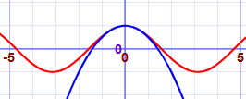

2 terms in expansion

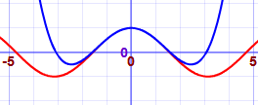

5 terms in expansion

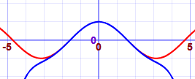

4 terms in expansion

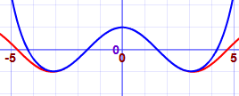

Performing an expansion is done using the following process:

1. Take the initial function and substitute the centre of expansion (from here this will be expressed as a) into this to get an integer value for the first term
2. To get each successive term (term number will be expressed as n from here), differentiate the function use in the previous term, substitute in the previous term and multiply by ((x-a)^n)/n!
3. Each successive term can be added to the sum of all the previous terms to get an equation in x for which an approximate value of the original function will be given when a value of x is substituted in

This can be represented with the following pseudocode which takes in a function in terms of x and the number of terms in the expansion to be generated (SymPy library will be used to evaluate functions and perform differentiation):

function TaylorExpansion(function, centre, terms):

finalEquation = 0

previousFunction = function

for n = (0 to terms):

f = evaluate(previousFunction at x = centre)

finalEquation = finalEquation + ( f*(((x-centre)^terms)/terms!))

previousFunction = derivative(previousFunction)

end for

return finalEquation

end function

There is a case where a Taylor expansion is invalid, that being when the value of each derivative at x=a is 0 (e.g. the derivative of e^(x^2) is 2xe^(x^2) which equals 0 when x=a=0 and will continue to equal 0 as each further derivative will involve multiplication by 0 when evaluated) and so the series will terminate prematurely. This can be addressed by picking a value for the centre of expansion where the value of each derivative is not 0 and so the expansion will not terminate. Relevant error checking will be needed to avoid this problem.

##### Maclaurin expansion

A Maclaurin series is just a special case of the Taylor series for which the centre of expansion is 0. This means the series is simpler to compute as each calculated addition to the series is only in terms of a single power of x and so further processing to expand (x-a)^n and to simplify the expression is not needed as each terms will simply be in terms of x^n.

This can be represented by the following pseudocode:

function MaclaurinExpansion(function, terms):

finalEquation = 0

previousFunction = function

for n = (0 to terms):

f = evaluate(previousFunction at x = 0)

finalEquation = finalEquation + ( f*((x^terms)/terms!))

previousFunction = derivative(previousFunction)

end for

return finalEquation

end function

When programming this, as the code is so like a Taylor expansion, object-oriented programming could be used to create a Maclaurin class as a child of a Taylor class and through polymorphism the centre of expansion can be automatically set to 0 when a Maclaurin instance is initialised.

The same caveat applies to a Maclaurin expansion as to a Taylor expansion. This means that, as the centre of expansion cannot be moved certain functions simply cannot be expanded and so error checking will need to be included to ensure that functions entered for a Maclaurin expansion are valid before an attempt is made (an example of one such function is given in the explanation of the limitations of Taylor expansion)

###### Sine and cosine functions

One example of a place where a Maclaurin expansion is valid is with sine and cosine functions as each are the derivative of the other (derivative of sin(x) is cos(x) and derivate of cos(x) is -sin(x)) and, while sin(0) = 0, cos(0) = 1 and so terms in the Maclaurin series can be generated for every other derivative as the values of sine and cosine are known from the definition of them. The above definition of a Maclaurin expansion can therefore be used to approximate the values of each function for any value of x for which the values of sin(x) and cos(x) are not known. In addition to this, as sine and cosine waves are repeating functions every 2*pi values of x, precision can be ensured as multiples of 2*pi can be taken off any value of x given to get it within the range 0 to 2*pi, an area within which the Maclaurin expansion can be much more accurately approximated than further away from the centre.

If this is implemented, the math library is no longer needed to find values of sin(x) and cos(x) as my own code will be usable.

##### Trapezium rule

The trapezium rule is a method of approximating an integral by approximating a curve as a series of straight lines of fixed width and calculating the area underneath these straight lines, essentially by working out the areas of trapezia:

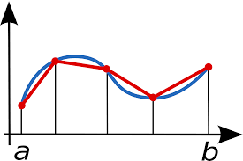

The area of a single trapezium is equal to the mean vertical side length multiplied by the width (0.5*(y1+ y2) * change in x). The area under a curve with given limits a and b is therefore approximately equal to the sum of all trapezia under it between x=a and x-b. This can be simplified into a single easier equation as follows which simplifies the area of all trapezia into a single equation (assuming width is kept constant):

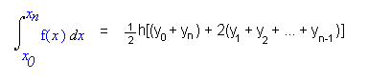

In the above equation, h is strip width and can be calculated by taking the lower limit from the upper limit and dividing by the desired number of strips. Each y value is then calculated by, starting with the lower limit, evaluating the equation of the curve at a x values increasing each time by the strip width up until the upper limit is reached. The first and last terms are used once in the equation as they each only appear as the first and last side length of the first and last trapezia respectively, whereas each other y value is both the last side length of one trapezium and the first of the other and so is added twice.

This equation can be expressed as the following pseudocode:

function TrapeziumRule(function, lowerLimit, upperLimit, stripCount):

h = (upperLimit – lowerLimit) / stripCount

ySum = evaluate(function at x = lowerLimit) + evaluate(function at x = upperLimit)

for n = 1 to stripCount – 1:

ySum = ySum + 2 * evaluate(function at x = lowerLimit + n * h)

end for

return ySum * 0.5 * h

end function

##### Simpson’s rule

Simpson’s rule is somewhat like the trapezium rule in that it splits a curve into multiple regions of even width and finds the area under these simpler regions. The difference however is that a straight line is not approximated between each y value, but a parabola through a set of three y values (this means that an even number of strips are required for the function to work however). This means that between y values, the approximated area of the curve is closer to the true value as the curved line can better fit to the line of the curve of the true function.

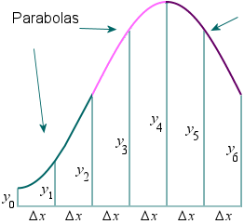

The area under each parabola is calculated by taking the x and y co-ordinates of three points on the line horizontally equidistant (with the separation between each x value being defined in the same way as in the Trapezium rule as (upper limit – lower limit)/number of strips), and using them to solve the equation y=ax^2+bx+c for a b and c by substituting in each pair of x and y values to construct three equations which can e solved simultaneously. Putting these values of a, b and c back into the equation y=ax^2+bx+c gives the equation of the parabola passing through all these points (see pink line above). The area under this parabola within the range of the three x values substituted as the integral of the parabola equation with upper limit of the highest of the x values (middle x value + h, where h is strip width) used and lower limit of the lowest limit (middle x value + h). This integral can easily be calculated to be of the general form (ax^3)/3 + (bx)/2 + cx + d, where a,b and c are the same as in the original equation. When the definite integral with the given limits is calculated, this gives ((a(x+h)^3)/3 + (b(x+h))/2 + c(x+h)) – ((a(x-h)^3)/3 + (b(x-h))/2 + c(x-h)) where x is the middle x value. This simplifies to h/3(2ah^2+6c). This process can be repeated for each set of three x values to get the total approximate area under the integral. All of this can be simplified to give a single equation to find the total area under the entire region in one go:

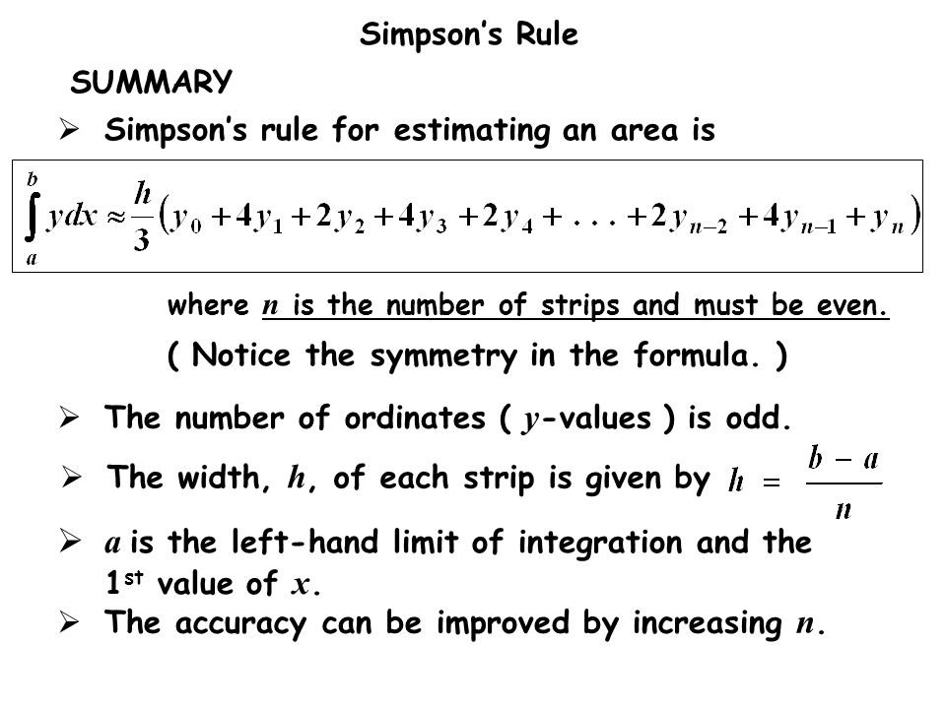

Where h is strip width.

This can be expressed as the following pseudocode:

function SimpsonsRule(function, lowerLimit, upperLimit, stripCount):

h = (upperLimit – lowerLimit) / stripCount

ySum = evaluate(function at x = lowerLimit) + evaluate(function at x = upperLimit)

for n = 1 to stripCount – 1:

if n MOD 2 = 0:

ySum = ySum + 2 * evaluate(function at x = lowerLimit + n * h)

else:

ySum = ySum + 4 * evaluate(function at x = lowerLimit + n * h)

end if

end for

return ySum * (h/3)

end function

#### Proposed class structures

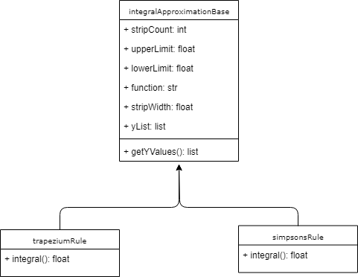

## Usability Features

* Sufficiently large text
  + Easy to read, even from beyond a typical screen distance and by those who may have a slight visual impairment (more advanced disability features such s text to speech are however beyond the scope of this program), though not so large as to be obstructive of other elements
* Large buttons
  + Easy to select with a typical cursor or even a finger if used on a device with a touchscreen. Large buttons also ensure that not too much precision is needed to select elements, for example for those with more limited fine motor skills (e.g. those with a movement impairing disability)
* High contrast between elements
  + All text is kept dark and backgrounds light, with text and background also of different colour, to maximise readability even for those with visual impairments such as colour blindness
* Clear indication of destructive features
  + Features to indicate if a button press will delete data to cause hesitation before pressing by colouring the button red and using capital letters
* Radio buttons
  + Allows for the easy selection of an answer from a set of possible answers
  + Superior to a checkbox for required implementation of a multiple choice quiz with only one correct answer as only a single radio can be selected at a time whereas more than one checkbox can be selected, avoiding the need for extra validation to ensure only a single checkbox is selected by making an invalid selection impossible
* Password reset
  + Allows a user to reset their password using a teacher of one of their classes in order to reduce the chance of complete loss of access to an account in the event of a password being forgotten
* Tables to present results
  + Data from the database can be pulled as needed and represented in a table format where user scores are to be viewed within the program to clearly and space-efficiently present many results on screen at once without compromising the ease with which the output can be understood. This is ensured by keeping all related data, and only related data, within the same row in the table, and all columns titled appropriately and with only data matching that field included within the column.

## Approach to Testing

### During Development

After the development of each function it will be tested individually to ensure it always behaves as expected. This will be done by passing through all possibilities of valid data and ensuring the correct result is produced. Following this, the function will then be fed invalid data of various types to ensure it handles the errors correctly. If the function fails at any of these stages, it will be tweaked and then re-tested again at all stages. This will repeat until all errors are eliminated. Testing criteria will be based on the test data defined below.

By this process when larger functions are developed utilising other pre-tested functions, it can be almost certainly ensured that any errors which occur in the testing of the newer function are in fact an error in the way it has been developed and not the result of a function it is dependent on, making it much less likely for hard to track problems surfacing from functions many layers deep.

All testing will be logged, as well as every occurrence of errors and how they were fixed.

How each function will be tested has been included alongside relevant pseudocode. Test data is either as stated in the data structure or, where not stated, will be generated in compliance with the data structure at the start of development when populating the database.

### Post Development

#### Overview

All objectives will be checked and verified to still be functional after testing during development. More general objectives about the usability of the program will then be assessed and tweaks made to the program where necessary.

Stakeholders, a teacher and student, will also be consulted to assess that the program meets their requirements and any suggestions for improvements will be noted for evaluation.

Post development, all testing will be limited to what can be directly tested from within the program itself, and not individual functions by themselves in a contained environment as these will be assumed to be still working since testing during development. The focus of testing here is for usability and direct functionality.

#### Tests

##### Robustness

|  |  |  |  |
| --- | --- | --- | --- |
| Test Number | Test | Test method | Expected outcome |
| 1 | Pages change within a reasonable amount of time | All page transition buttons will be rapidly clicked when used and ensured to still complete in a reasonable amount of time to the stakeholder each time | Pages change near instantly any time transitions should occur |
| 2 | Deleting database while in use | Delete file using file explorer whilst a student is attempting a quiz | File cannot be removed |

##### Usability

|  |  |  |  |  |
| --- | --- | --- | --- | --- |
| Test Number | Test | Expected outcome | Stakeholder to perform test | Decomposition of problem area covered |
|  | Go to create account screen | Loads create account screen | Either | 1d |
|  | Create teacher account | Teacher account permanently created | Teacher | 6ai, 6aii, 6aiii, 6aiv, 6av |
|  | Create student account | Student account permanently created | Student |  |
|  | Return from account creation to login screen | Loads login screen | Either | 6e |
|  | Teacher login | Loads teacher main menu as relevant teacher | Teacher | 1a, 1b, 1c, 6d |
|  | Student login | Loads student main menu as relevant student | Student | 3 |
|  | Logout button | Returns to login screen and unselects current user | Either | 2a, 2b, 5a |
|  | Go to account management | Loads account management page | Either | 7ai |
|  | Set new first name, last name and password | Sets new first name and last name and only new password works when attempting to login with the edited account | Either | 7ai1, 7ai2, 7ai3, 7ai4, 7ai5 |
|  | Home button | When clicked returns to main menu | Either | 5b |
|  | Create class | Enter a class name and new class is created | Teacher | 7cii1a, 7cii1b |
|  | Add user to class | Enter username and adds given username to class | Teacher | 7cii2ai, 7cii2aiv |
|  | Remove user from class | Select student from list and removes user from class | Teacher | 7cii2bi, 7cii2bii |
|  | Add homework to class | Enter homework name, description and due date and inserts homework into class | Teacher | 7cii2ci, 7cii2cii, 7cii2ciii, 7cii2civ, 7cii2cv |
|  | Remove homework from class | Select from list of homework in class and remove homework from database and class | Teacher | 7cii2di, 7cii2dii, 7cii2diii |
|  | Delete class | Select from list of classes and remove from database | Teacher | 7cii3a, 7cii3b |
|  | Add automatic question to homework | Select class and homework to add question to and question topic and difficulty to add an automatically generated question to the class | Teacher | 7ciii1, 7ciii2, 7ciii3a, 7ciii3b, 7ciii3c, 7ciii3d |
|  | Add custom question to homework | Select class and homework to add question to and enter question name, text, answer and incorrect answers and add to homework | Teacher | 7ciii4a, 7ciii4b, 7ciii4c, 7ciii4d, 7ciii4e |
|  | Remove question from homework | Select question to remove from list, show question details and when remove selected remove from database | Teacher | 7ciii5a, 7ciii5b, 7ciii5c |
|  | Select homework | Select class to do homework from and select homework to do from a list of homework, showing the due date. Go to quiz when selected and show first question | Student | 7bii1, 7bii2, 7bii3, 7bii4, 8a |
|  | Navigate quiz | Next question loads next question and previous loads previous | Student | 8bi, 8bii |
|  | Question output | Must show question text and four potential answers, allowing only 1 to be selected, submitted and a response given | Student | 8c, 8di, 8dii, 8eii1, 8eii2 |
|  | View previous homework results | Show list of homework with name, score and date | Student | 7bi1a, 7bi1b, 7bi1c |
|  | View class scores | Select class view, select class, select homework and output a list of results showing for each student: first name, last name, raw score, weighted percentage and number of attempts | Teacher | 7ci1, 7ci2, 7ci3, 7ci4a, 7ci4b, 7ci4c, 7ci4d, 7ci4e |

## Stakeholder response to design

Stakeholders were allowed to view the design documentation and asked to give any relevant feedback

### Troy Garvin, teacher of Mathematics

The UI mock-ups given seem reasonably intuitive, though perhaps a few are a little cluttered and could be tidied up visually. It also seems as if a little more feedback could be given when performing actions in the program as to whether it has been successful or not. Functionality wise, everything seems great as I can view a lot of data about how my students are performing, and I will never have to worry about having to reuse the same questions

### Tommy Clair, Year 12 student currently studying A Level Maths and Further Maths

The quiz seems well laid out and simple to use and navigate. I like that it is multiple choice as many programs we’ve used in the past have been inconsistent with the formatting of your inputs, losing marks for correct answers, so it’s good that I won’t be penalised for that. Selecting a quiz also seems as straightforward as it could be, and I really like that I’ll be able to look at a list of every homework I’ve ever done and be able to see where I can improve. This should all be very helpful.

### Analysis of responses

Overall it seems like the program’s design has been created in a way that is suitable for the intended end users. Some criticism has been given to the cluttered nature of some pages in the program, however this should be simple to fix by separating functionalities into separate labelled tabs, so they are not all shown at once and It is clearer how to use them (this is mostly relevant on the teacher side of the program). Extra text outputs will also be included in the program to help clear up any areas where it may be unclear whether an action has been completed successfully or not

# Development of Solution

## Database Setup

### Create classes table using SQLite DB Browser GUI (renamed from class in design as plural is more descriptive of contents)

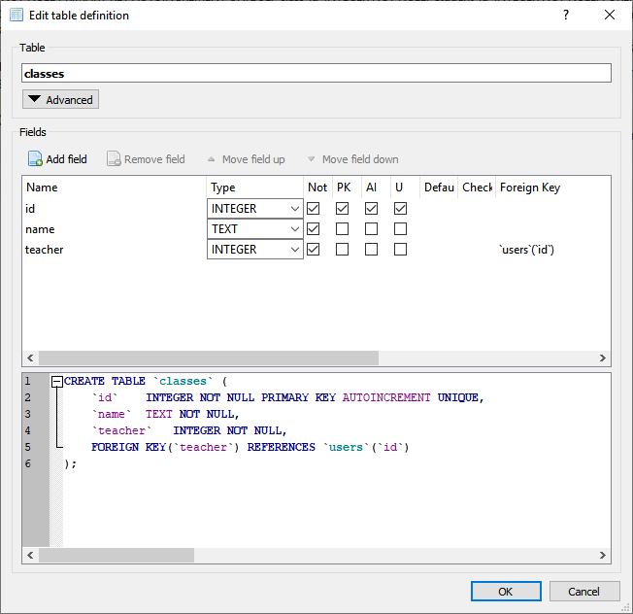

### Create users table using SQLite DB Browser GUI (Code generated can later be used to automate creation of database in python if not found)

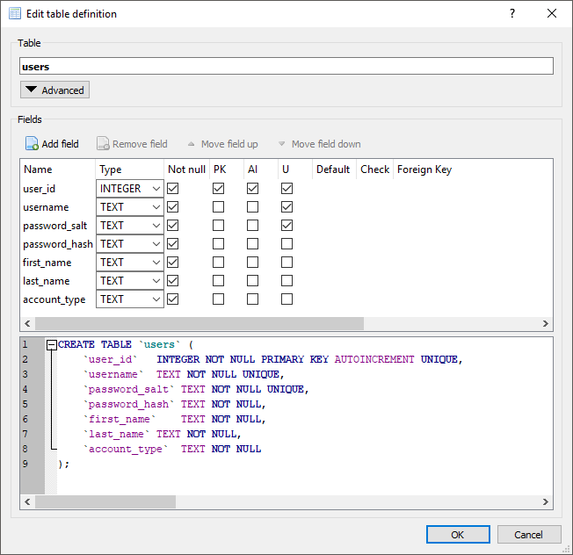

### Create class_user table using SQLite DB Browser GUI

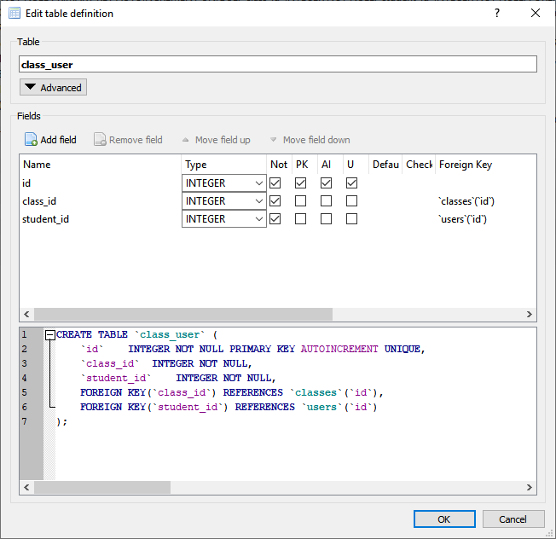

### Create homework table using SQLite DB Browser GUI

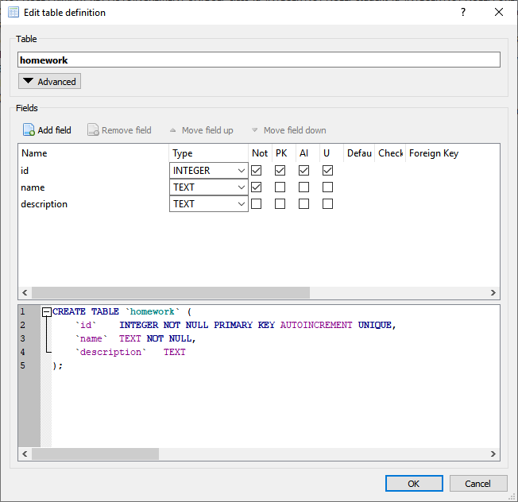

### Create class_homework table using SQLite DB Browser GUI

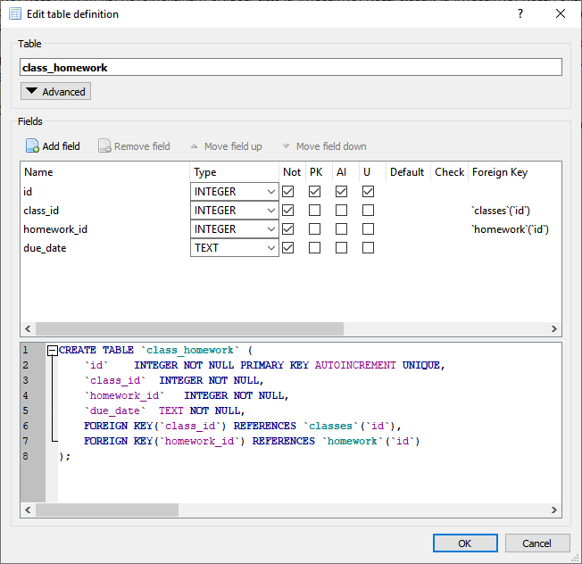

### Create question_types table using SQLite DB Browser GUI

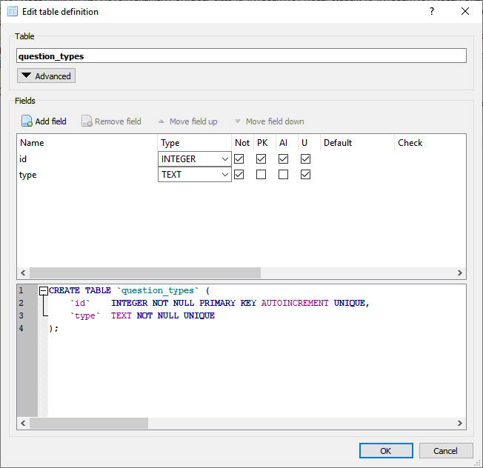

### Create questions table using SQLite DB Browser GUI

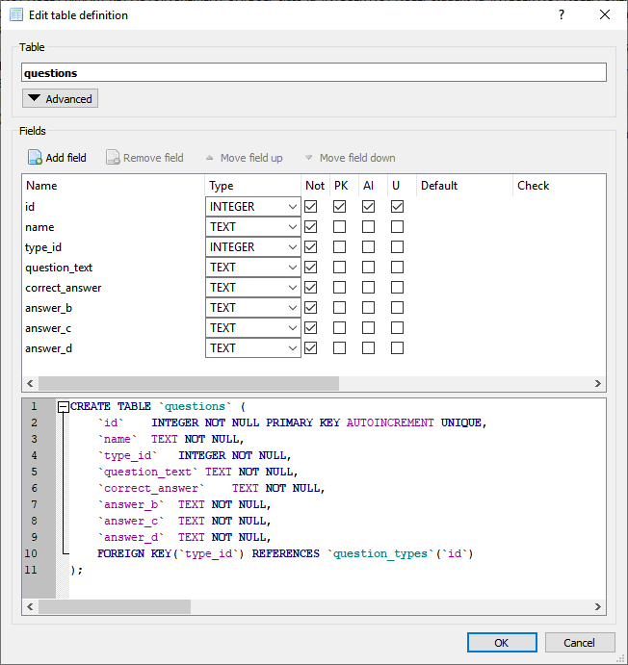

### Create homework_questions table using SQLite DB Browser GUI

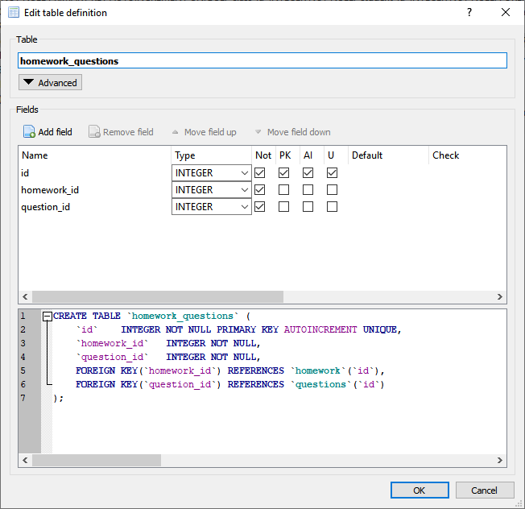

### Create question_results table using SQLite DB Browser GUI

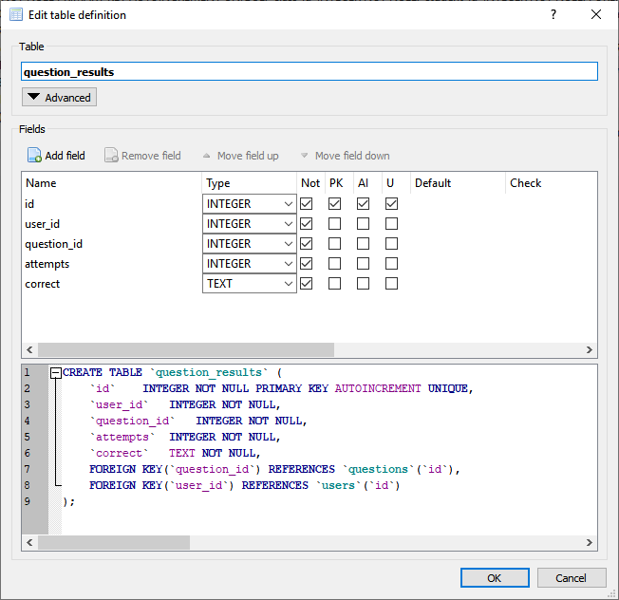

## Populating Database (testing.db_populate)

All code written below is designed to format each field in the way described in the data structure and all relationships are designed in accordance with the rules of the database (if rules are contradicted SQLite will prevent database changes made from being committed)

### Populate users table

#### Code



#### Result

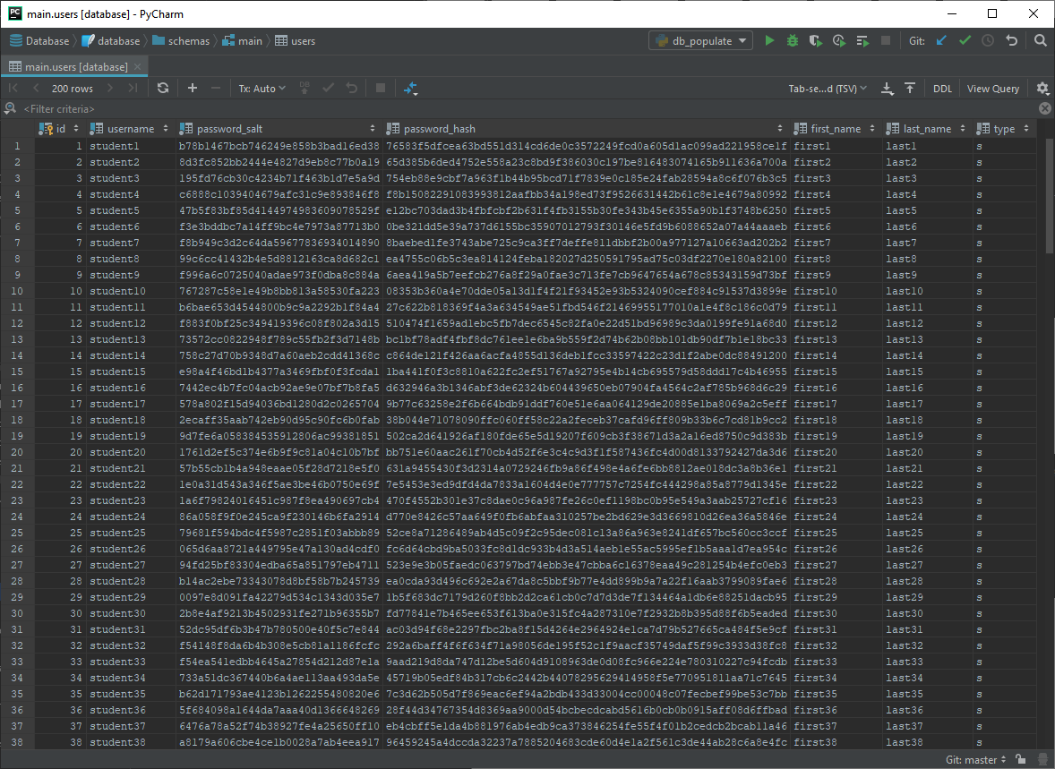

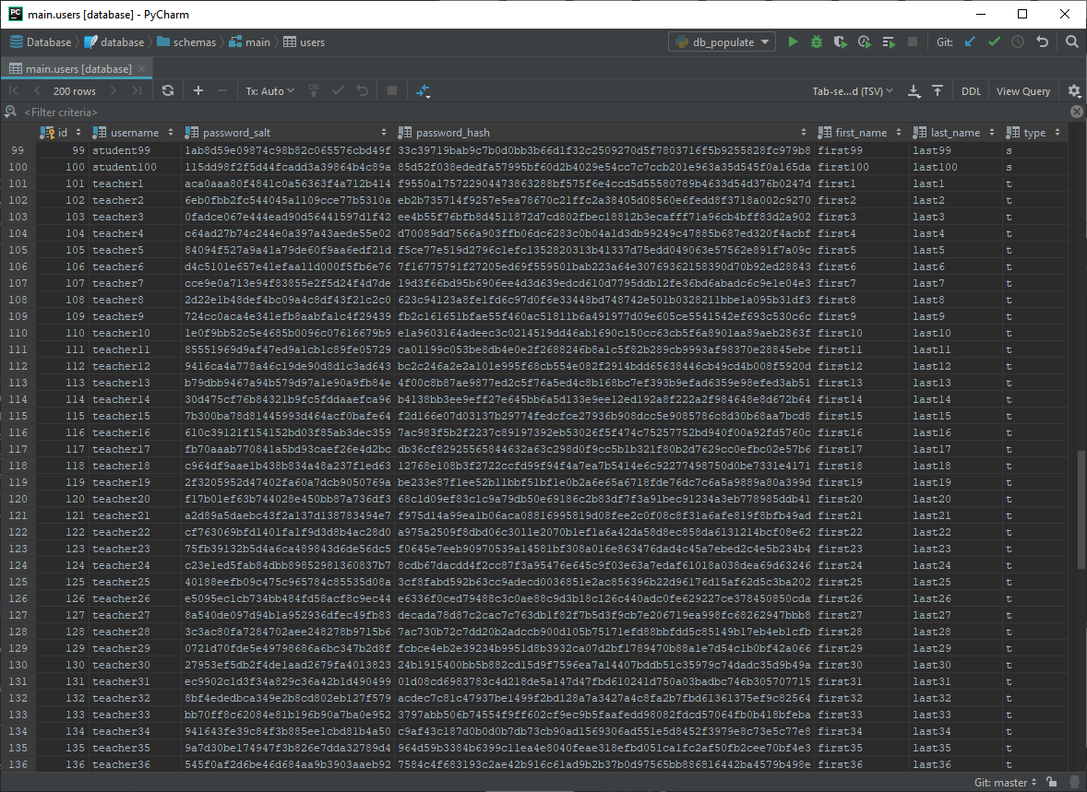

#### Evaluation

Table successfully filled with data of valid form and in accordance to data structure and design

### Populate classes table

#### Code



#### Result

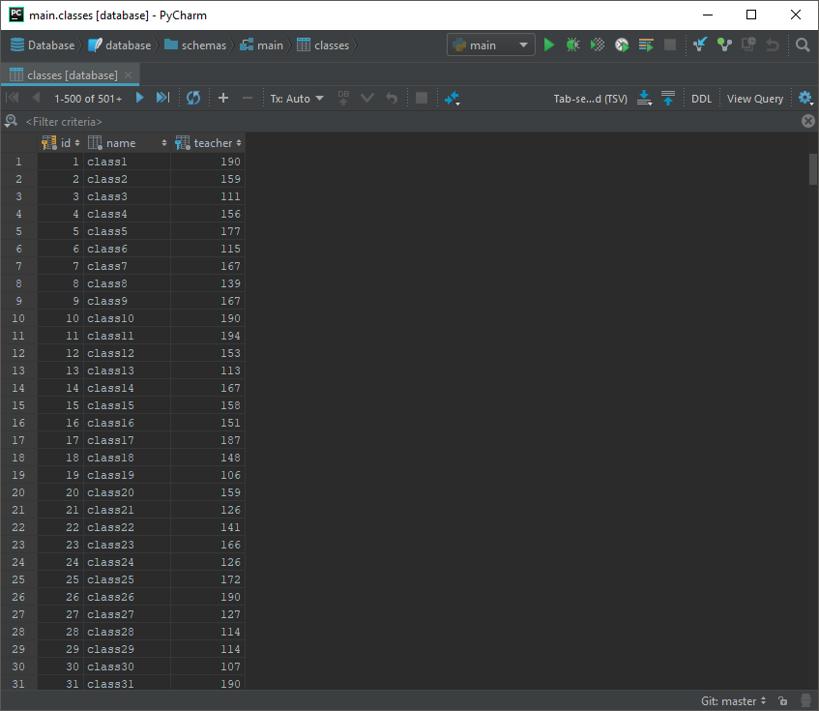

#### Evaluation

Table successfully filled with data of valid form and in accordance to data structure and design

### Populate class_user table

#### Code



#### Result

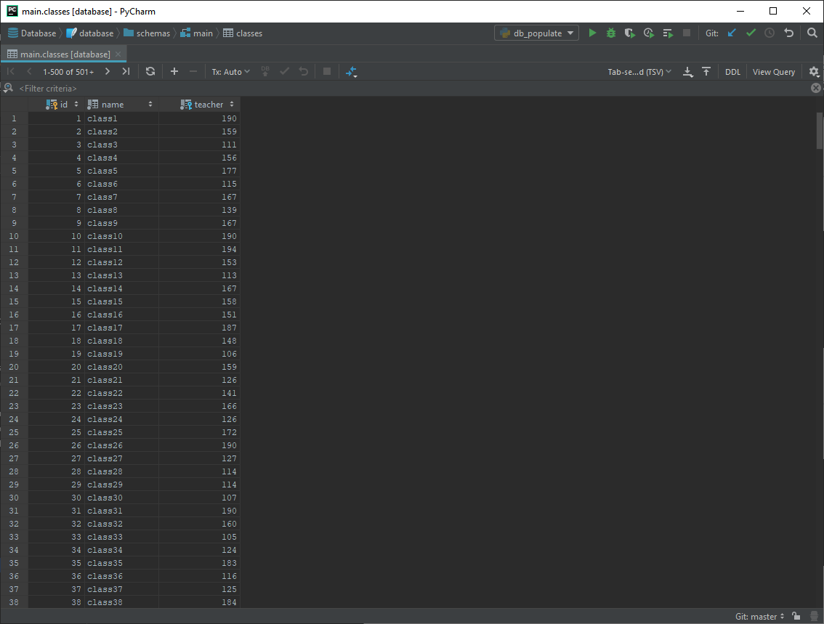

#### Evaluation

Table successfully filled with data of valid form and in accordance to data structure and design

### Populate homework table

#### Code



#### Result

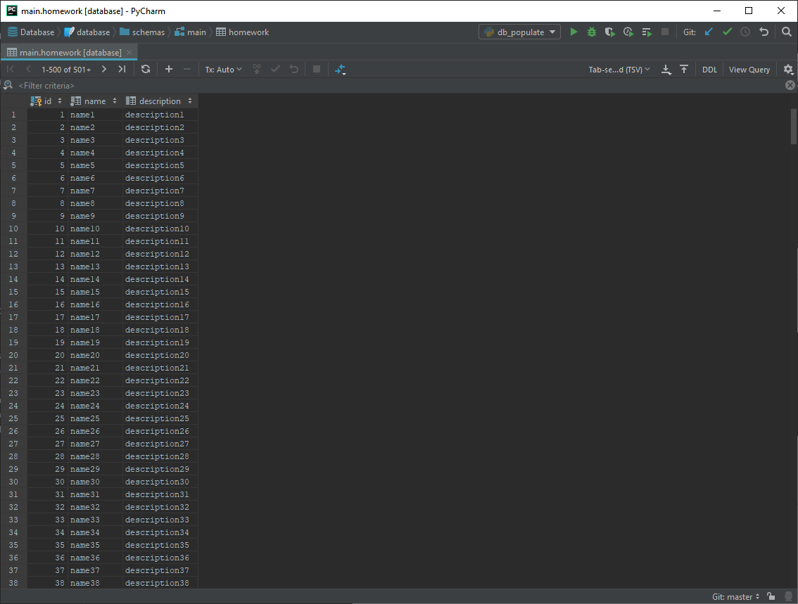

#### Evaluation

Table successfully filled with data of valid form and in accordance to data structure and design

### Populate class_homework table

#### Code



#### Result

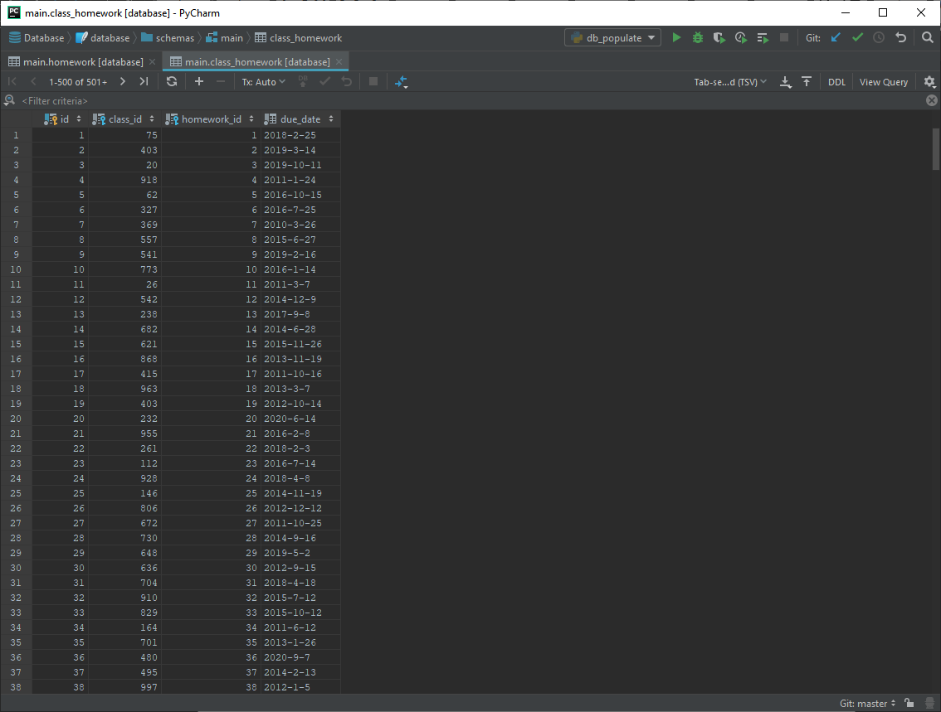

#### Evaluation

Table successfully filled with data of valid form and in accordance to data structure and design

### Populate question_types table

#### Code



#### Result

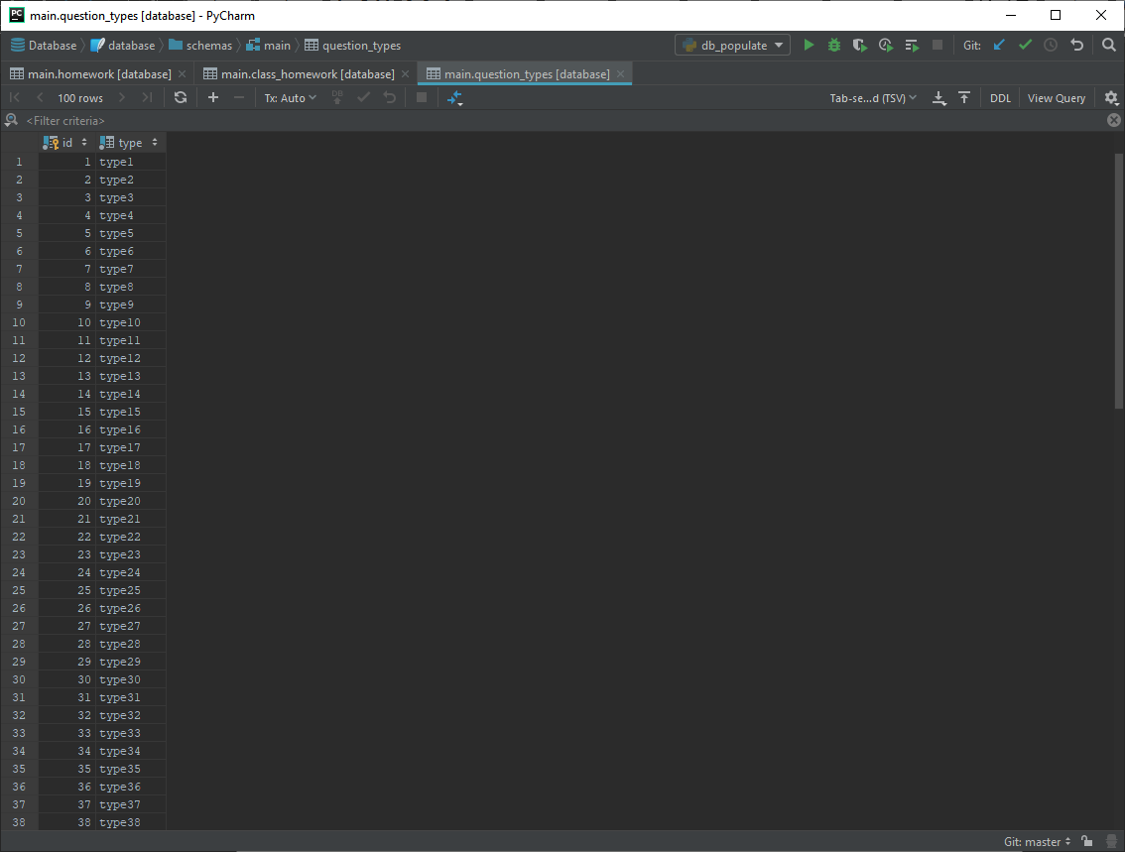

#### Evaluation

Table successfully filled with data of valid form and in accordance to data structure and design

### Populate questions table

#### Code



#### Result

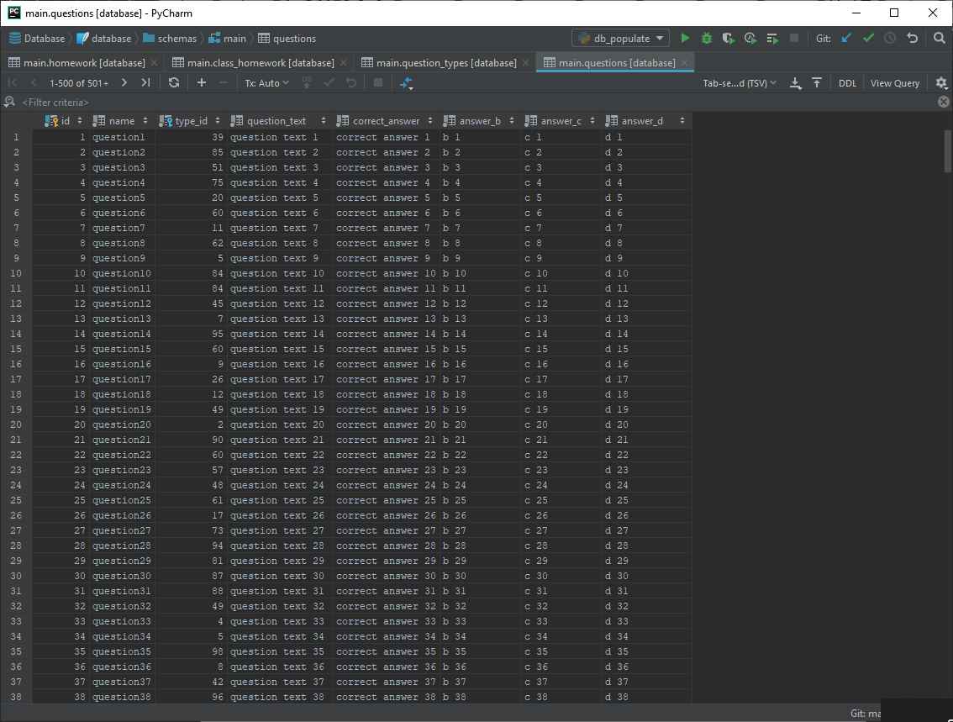

#### Evaluation

Table successfully filled with data of valid form and in accordance to data structure and design

### Populate homework_questions table

#### Code



#### Result

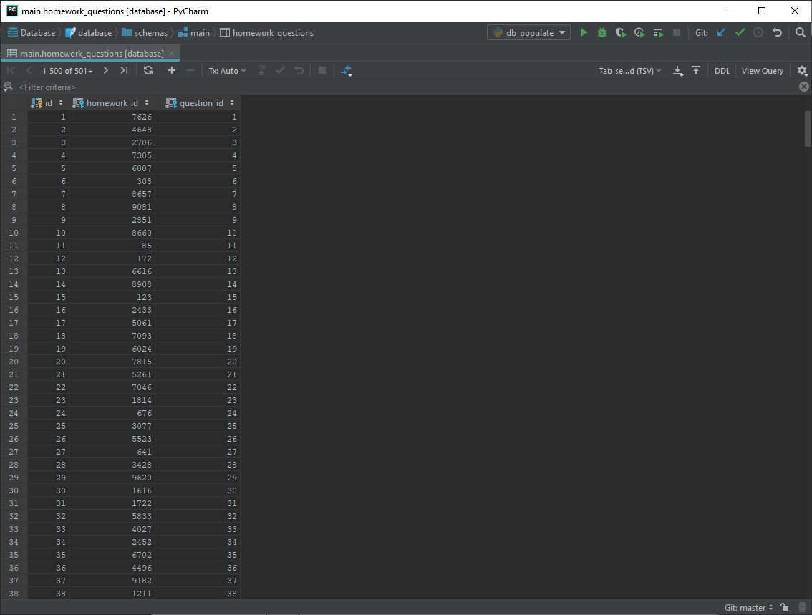

#### Evaluation

Table successfully filled with data of valid form and in accordance to data structure and design

### Populate question_results table

#### Code



#### Result

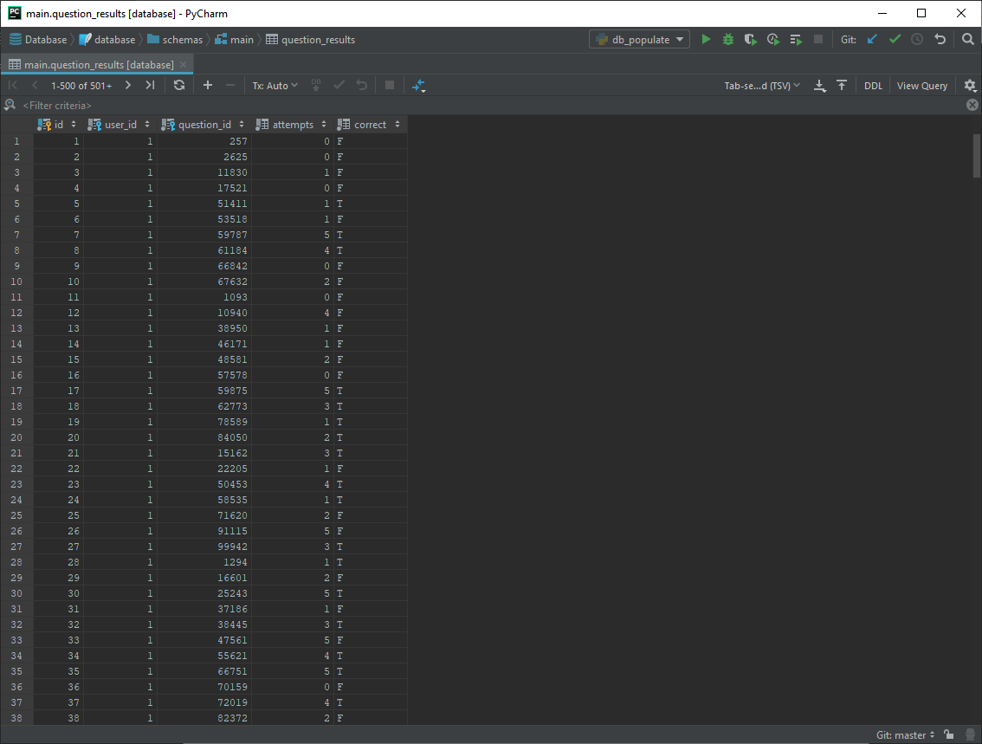

#### Evaluation

Table successfully filled with data of valid form and in accordance to data structure and design

## UI Implementation (window)

The following UI designs were created using QtDesigner as a .ui file and .qrc resource file, which were then converted to PyQt compatible .py files using the code below to allow them to be used as a library in the rest of the code



### Base UI

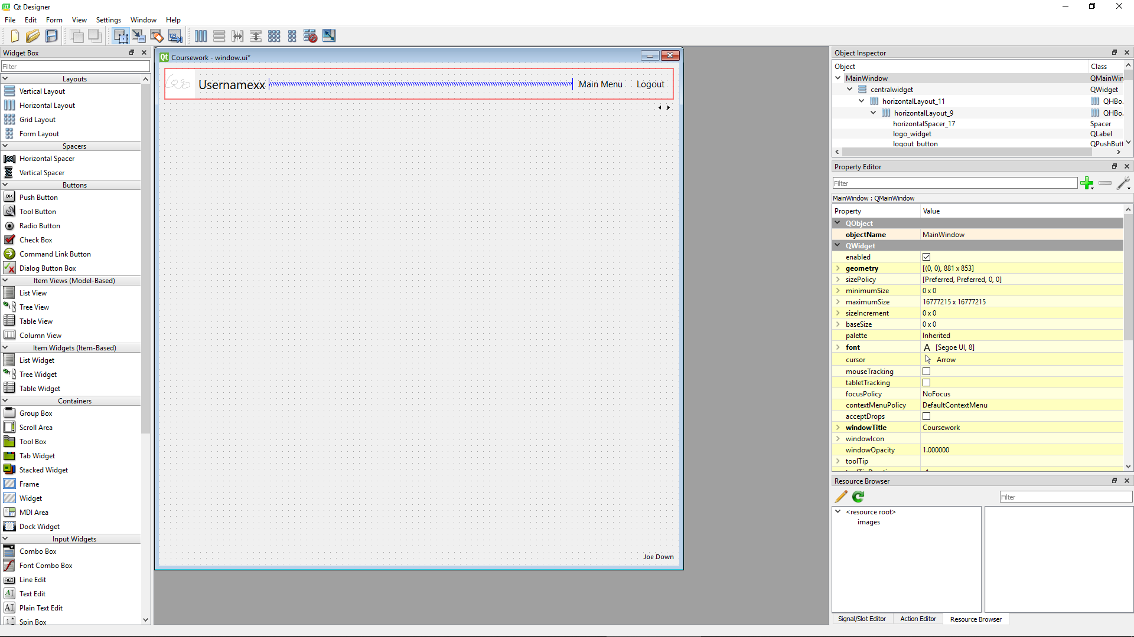

Successfully provides navigation buttons to go to main menu or logout (these can be hidden or shown as needed during running of program)

All points in design specification regarding logout buttons and main menu buttons can be disregarded as they have instead been implemented program wide

### Login screen

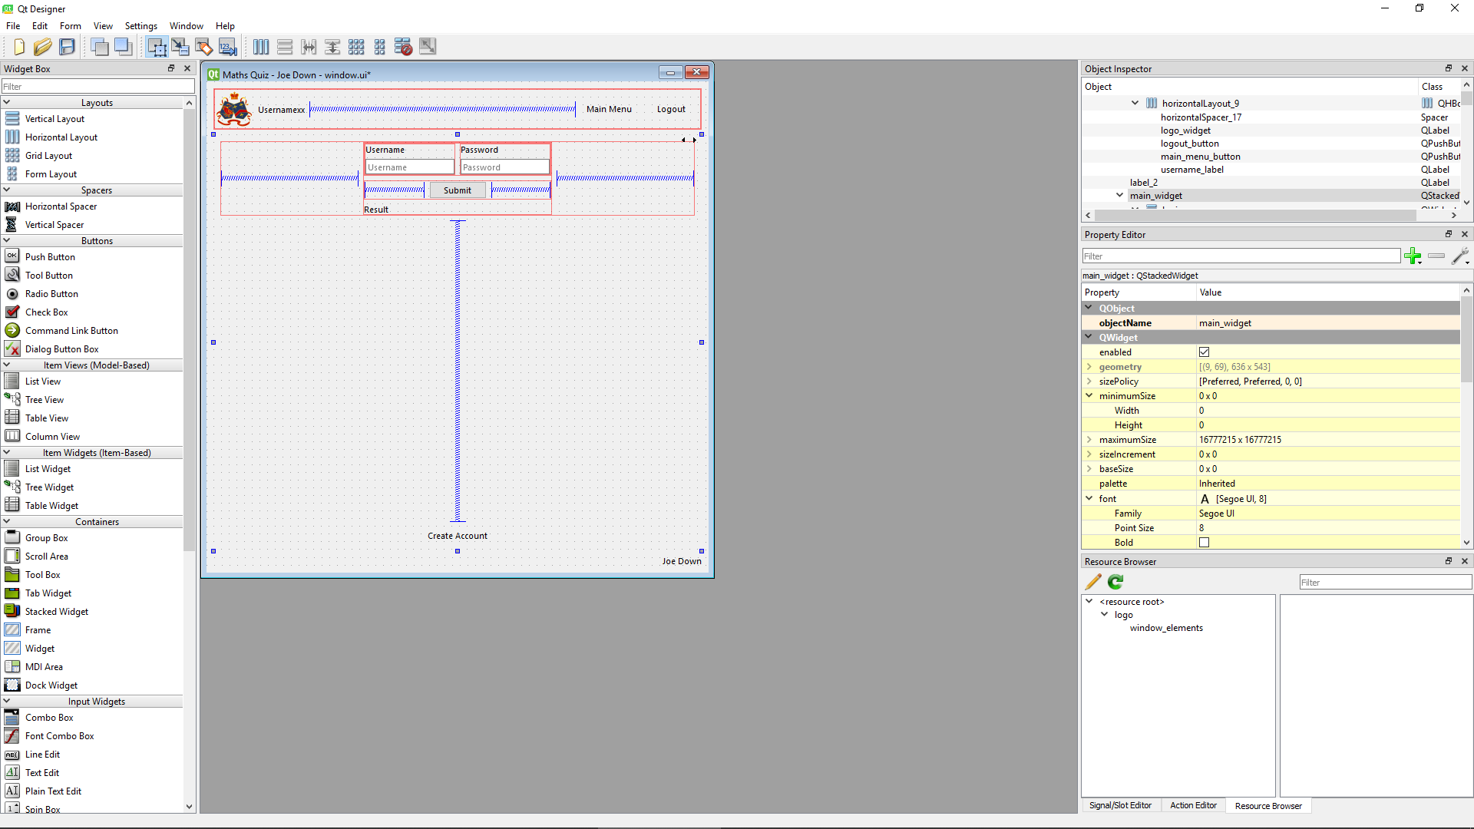

* Input box for username successfully provided (login_username_input)
* Input box for password successfully provided (login_password_input)
* Submit button successfully provided (login_submit_button)

### Create account screen

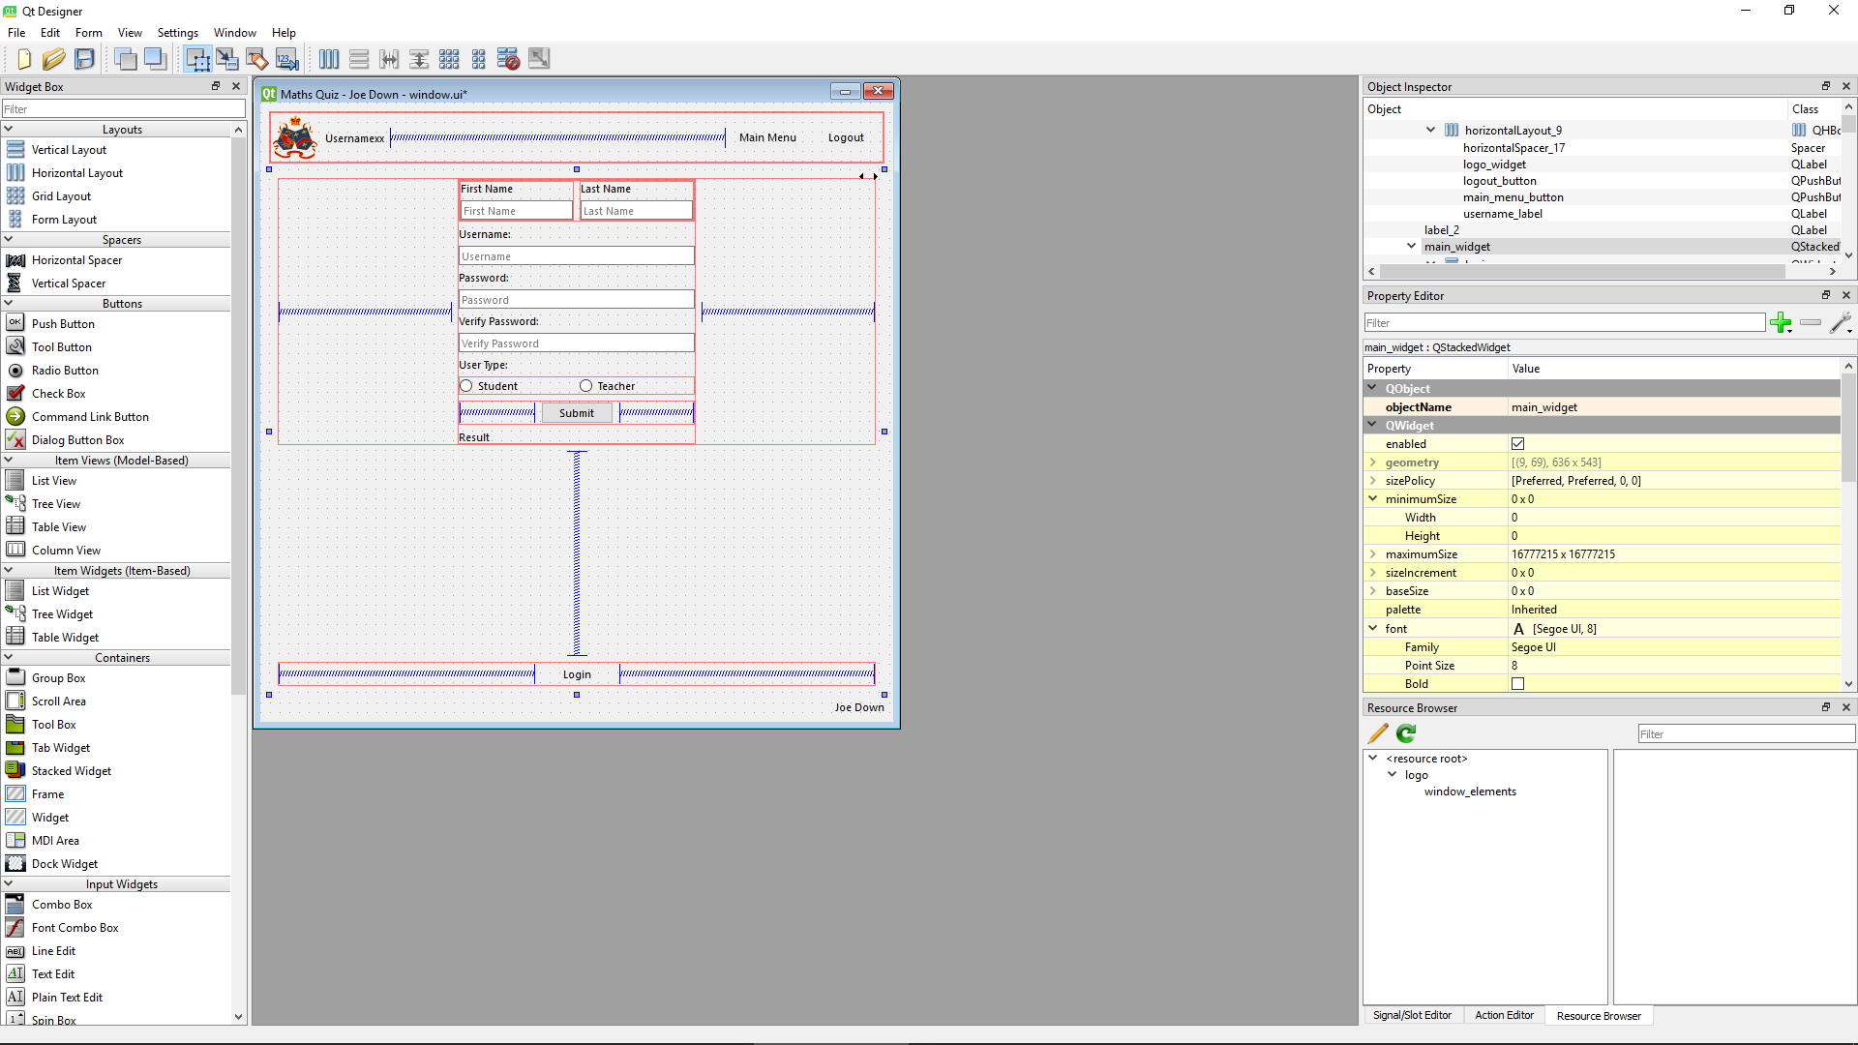

* Input box for first name successfully provided (create_account_first_name_input)
* Input box for surname successfully provided (create_account_last_name_input)
* Input box for username successfully provided (create_account_username_input)
* Input box for password successfully provided (create_account_password_input)
* Input box for password verification successfully provided (create_account_password_verify_input)
* Radio buttons to select account type (student or teacher) successfully provided (create_account_radio_student, create_account_radio_teacher)
* Submit button successfully provided (create_account_submit_button)
* Go to login page button successfully provided (create_account_login_button)
* Result output box added from design to improve user interaction (create_account_success_output)

### Student main menu screen

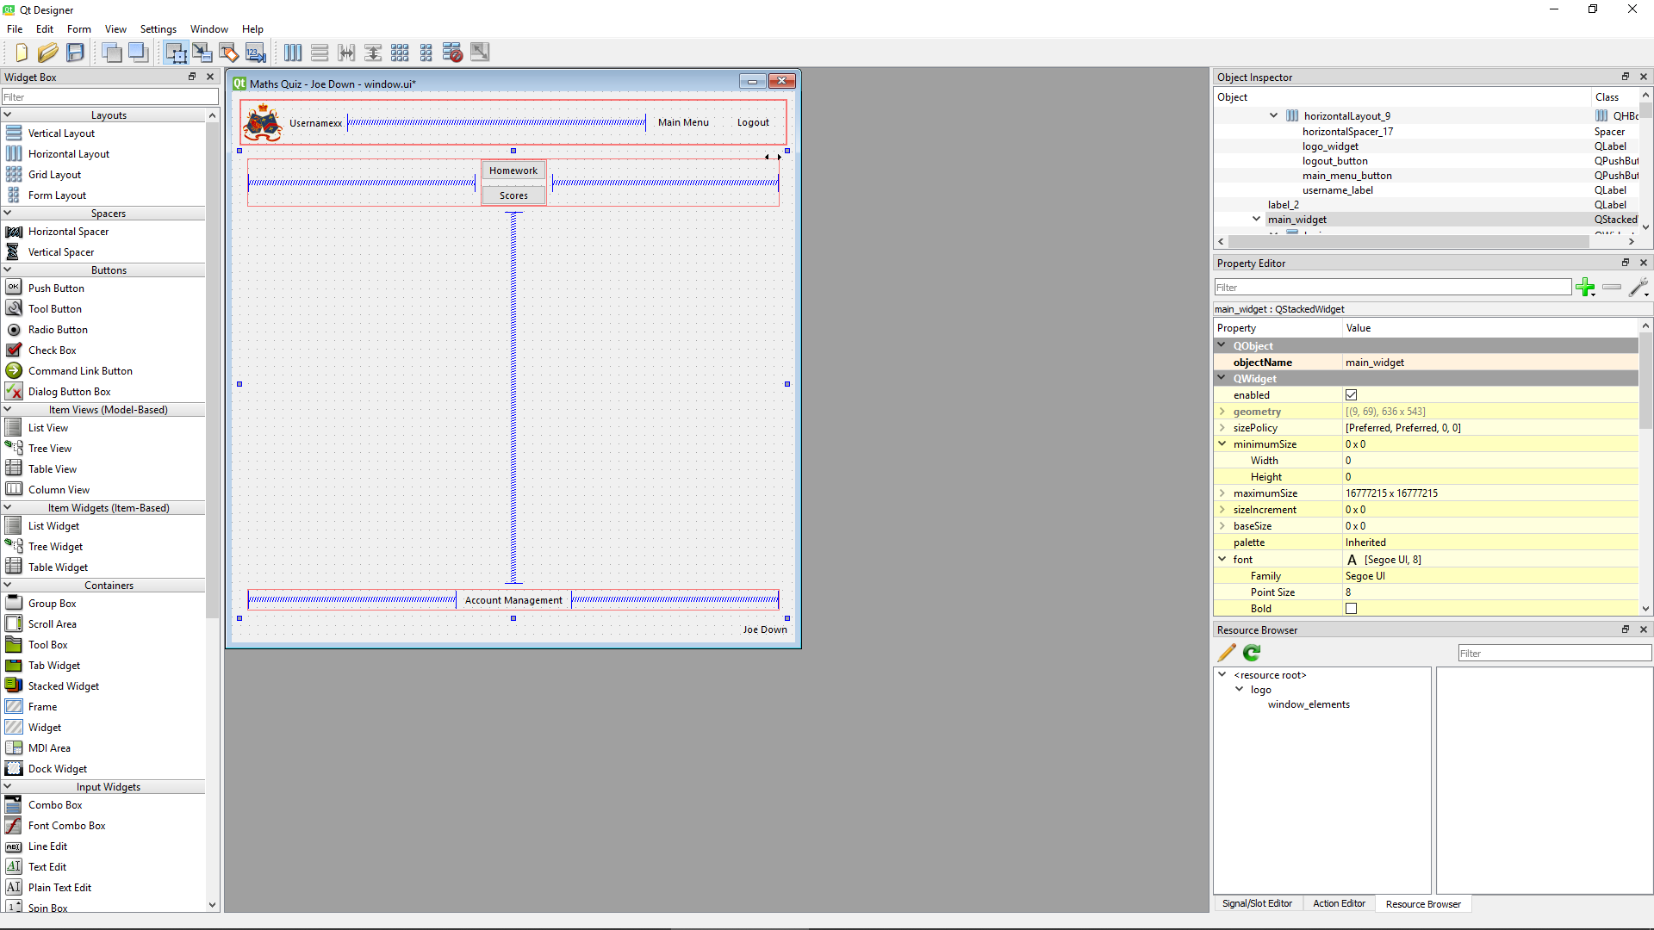

* Go to homework page button successfully provided (student_main_menu_homework_button)
* Go to view previous scores page button successfully provided (student_main_menu_previous_scores_button)
* Go to account management page button successfully provided (student_main_menu_account_management_button)

### Teacher main menu screen

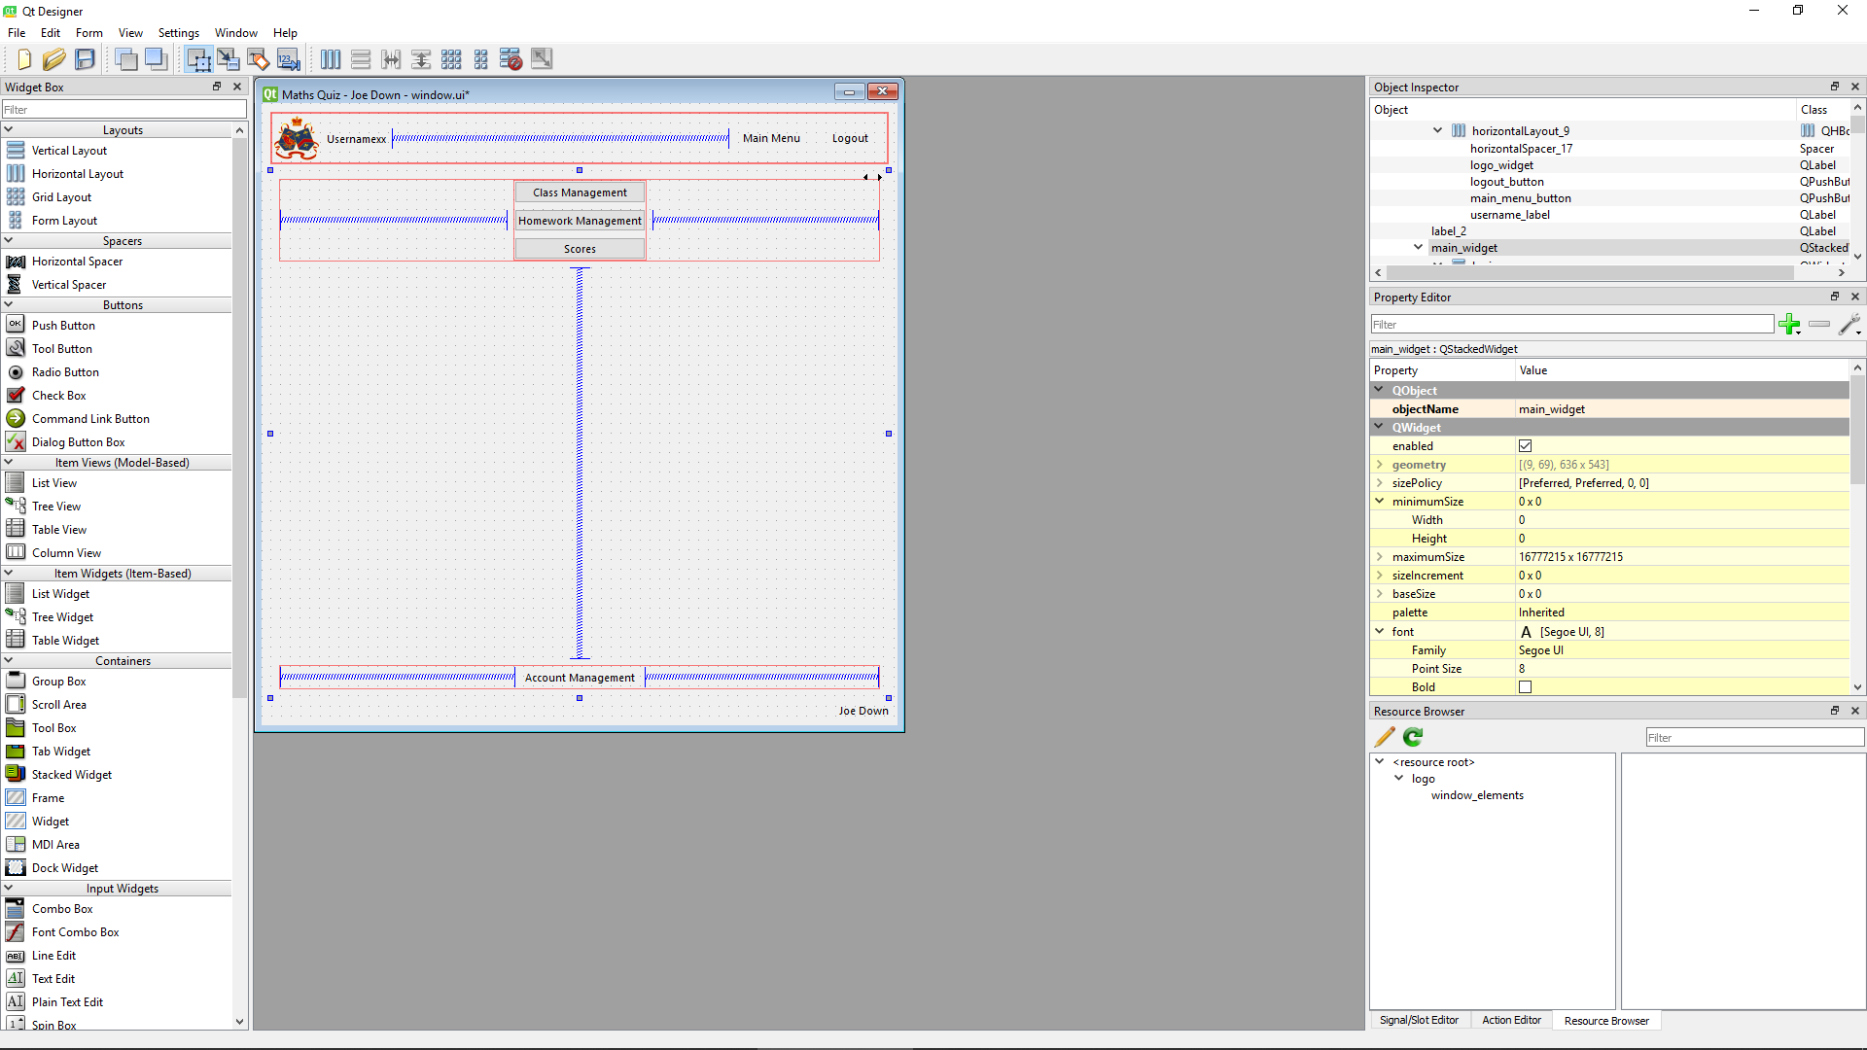

* Go to class admin page button successfully provided (teacher_main_menu_admin_button)
* Go to set homework page button successfully provided (teacher_main_menu_set_homework_button)
* Go to view classes page button successfully provided (teacher_main_menu_view_classes_button)
* Go to account management page button successfully provided (teacher_main_menu_account_management_button)

### Homework select screen

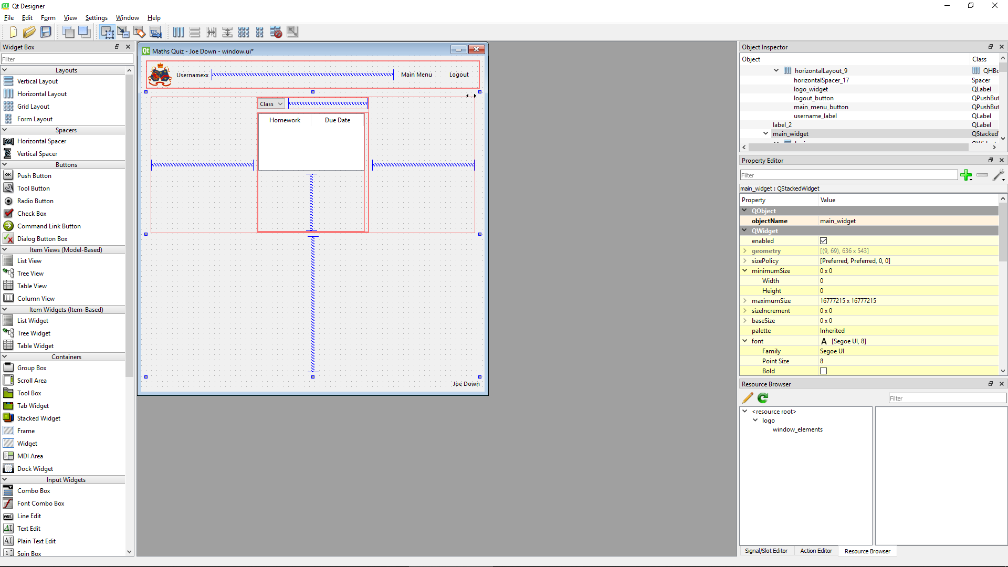

* Select class dropdown button successfully provided (homework_select_class_combo_box)
* List of homework, each linking to relevant quiz provided as a table that can be filled during the running of the program as required (homework_select_table)

### Previous scores screen

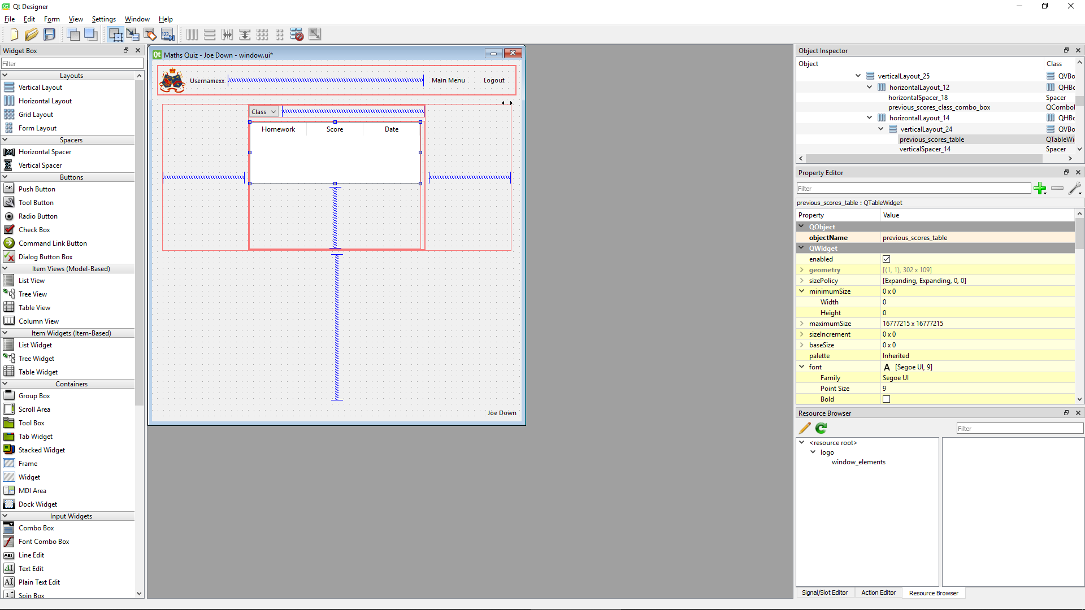

* Dropdown menus for each class student is in replaced with dropdown menu to select a class (previous_scores_class_combo_box)
  + List of homework for each class with score and due date provided as a table (previous_scores_table)

### Set homework screen

Design of page has been altered to separate each of the main functions of the page into their own separate selectable tab. Otherwise functionality remains unchanged from design.

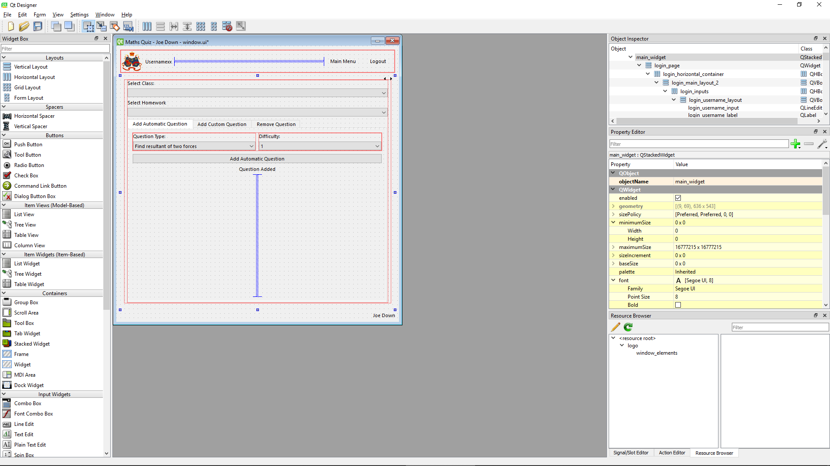

* Dropdown box to select class successfully provided (set_homework_class_combo_box)
* Dropdown box to select homework successfully provided (set_homework_homework_combo_box)
* Automatic question
  + Dropdown to select topic successfully provided (set_homework_type_combo_box)
  + Dropdown to select difficulty 1-5 successfully provided (set_homework_difficulty_combo_box)
  + Add question button successfully provided (set_homework_add_automatic_question_button)
  + Add question status output added from design to increase usability (set_homework_auto_question_added_output)

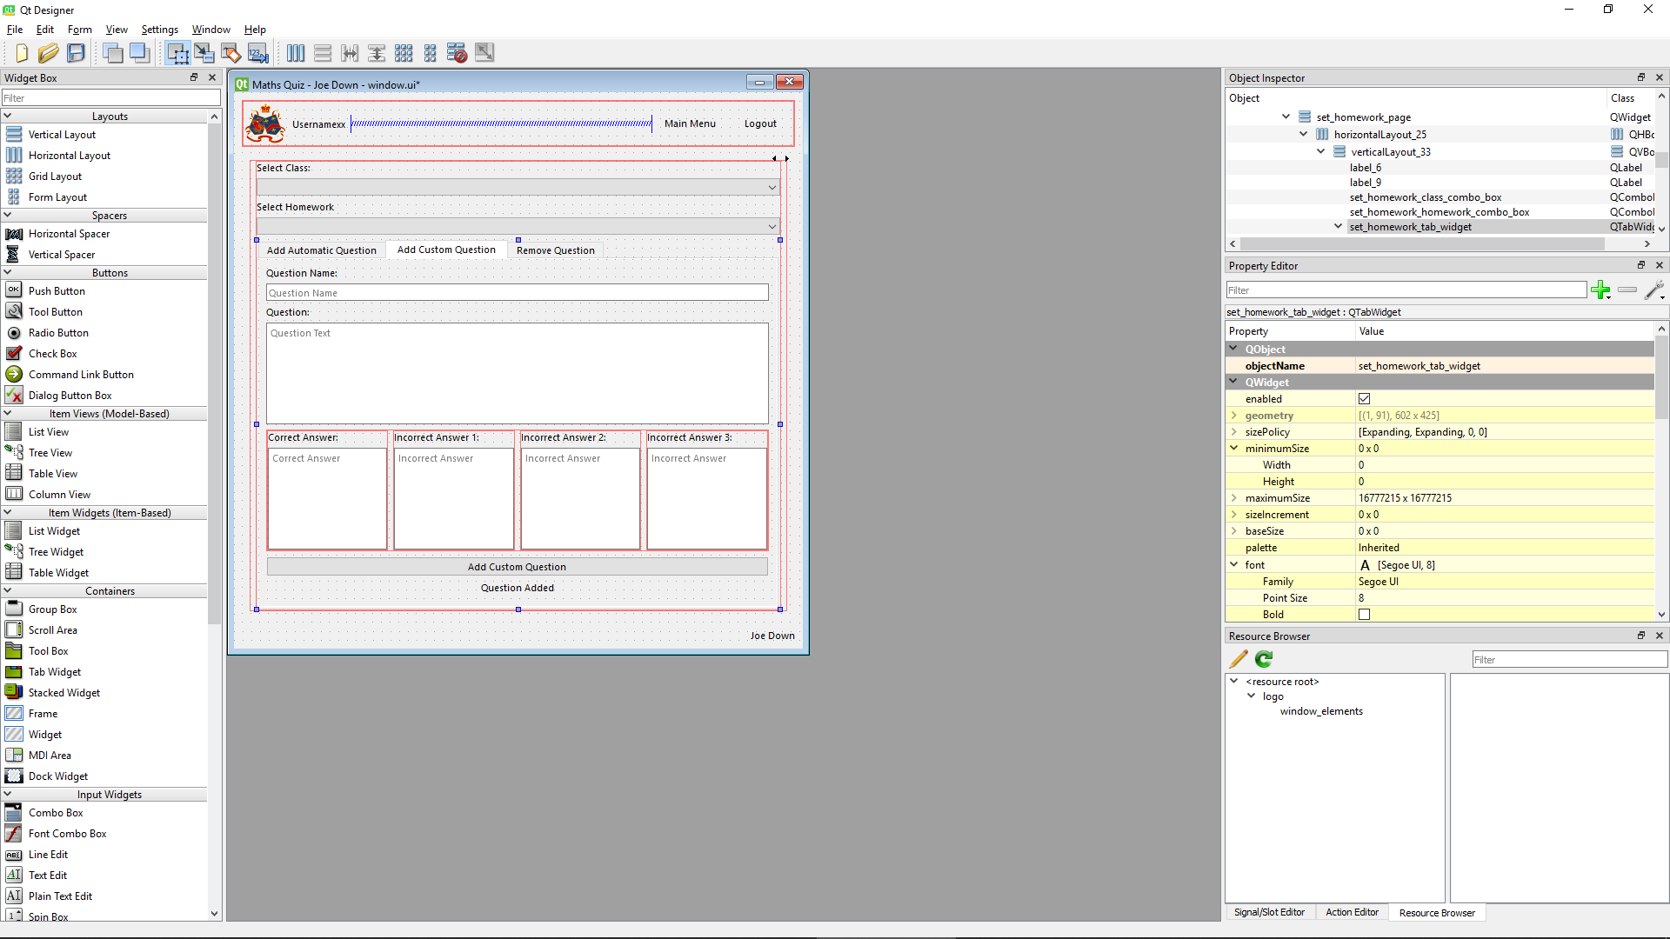

* Custom question
  + Question name input successfully provided (set_homework_question_name_input)
  + Question text input successfully provided (set_homework_question_input)
  + Correct answer input successfully provided (set_homework_correct_answer_input)
  + Incorrect answer 1 input successfully provided (set_homework_answer_b_input)
  + Incorrect answer 2 input successfully provided (set_homework_answer_c_input)
  + Incorrect answer 3 input successfully provided (set_homework_answer_d_input)
  + Add question button successfully provided (set_homework_add_custom_question_button)
  + Add question status output added from design to increase usability (set_homework_custom_question_added_output)

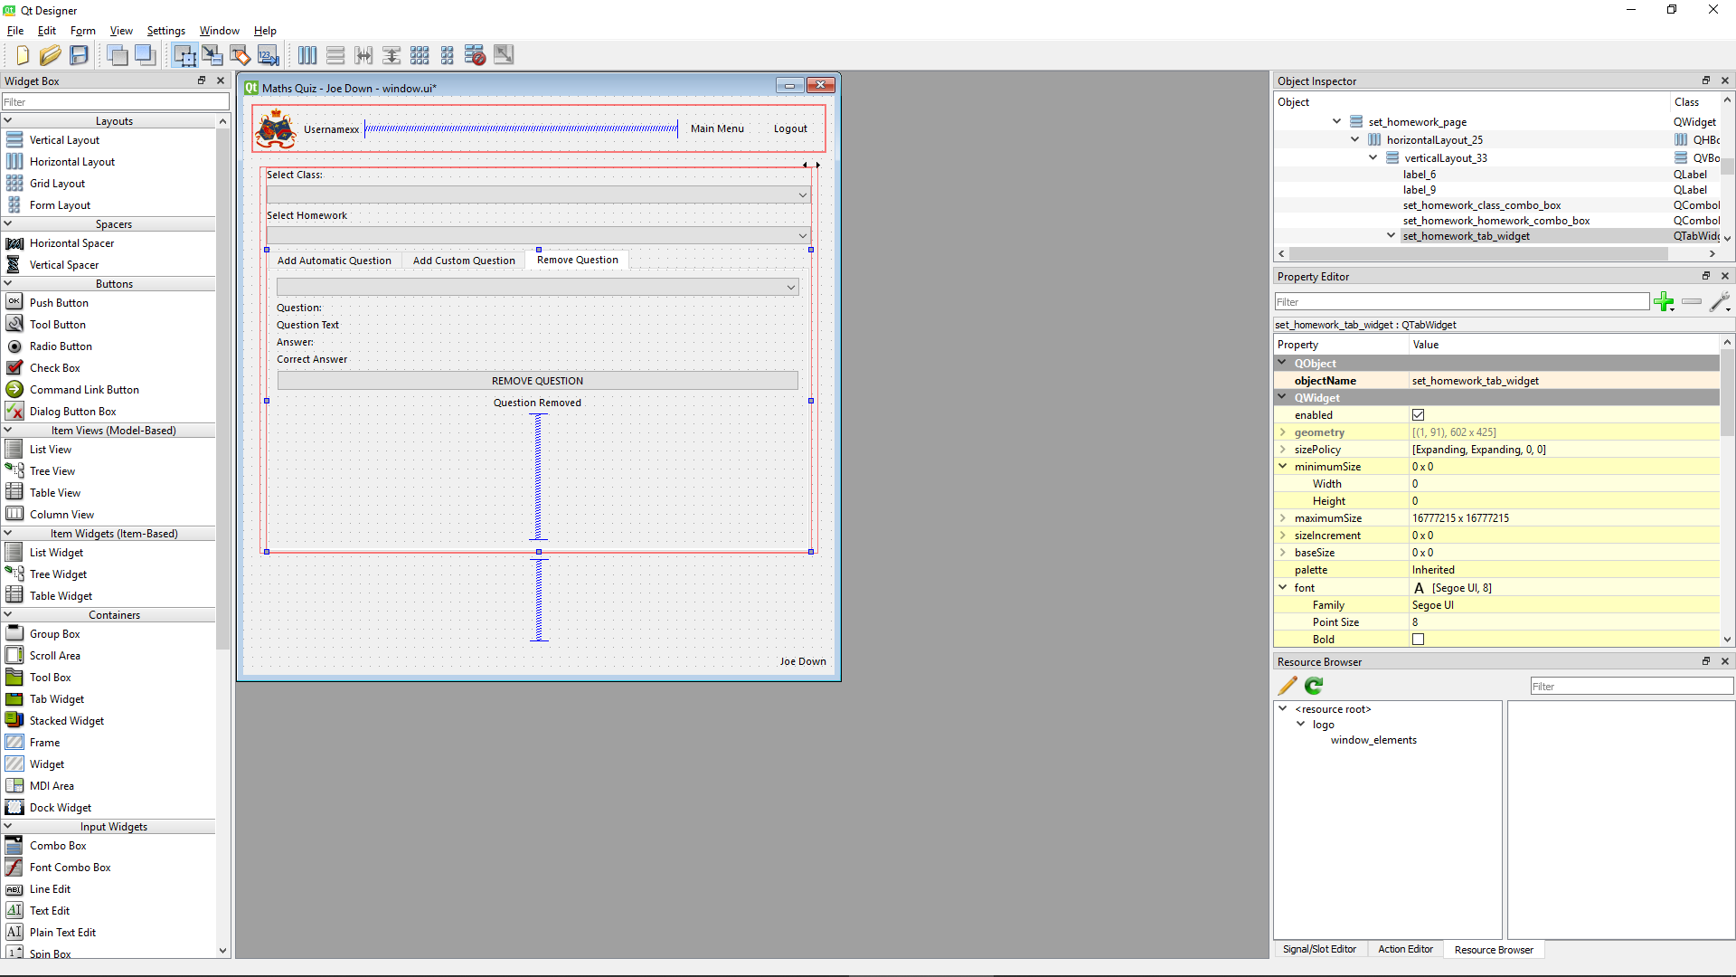

* Remove question
  + Select question dropdown successfully provided (set_homework_question_combo_box)
  + Selected question text output successfully provided (set_homework_question_label)
  + Selected question answer output successfully provided (set_homework_answer_label)
  + Remove question button successfully provided (set_homework_remove_question_button)
  + Remove question status output added from design to increase usability (set_homework_removed_output)

### View classes screen

Functionality of page has been updated from design to also allow a teacher to instead view a table for all homework done by a student in their class to allow for more detailed tracking of student progress

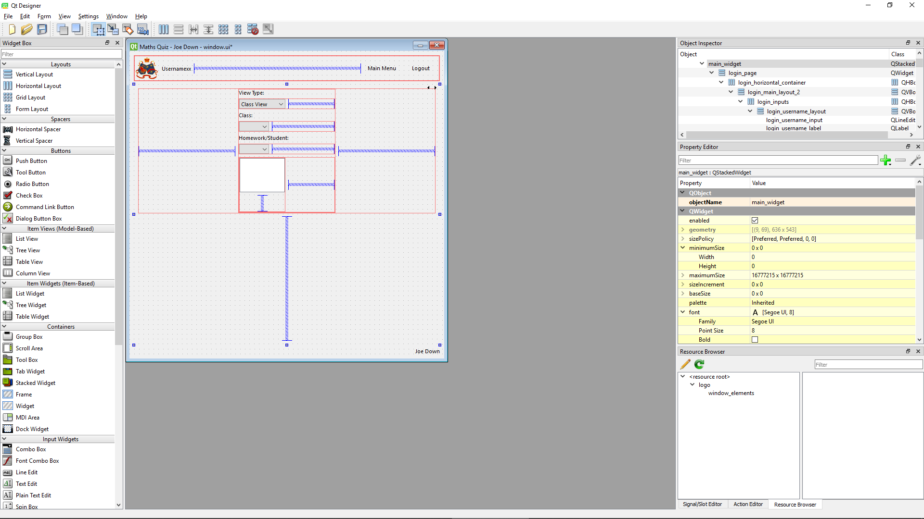

* View type dropdown added since design to allow a teacher to select to view all homework of a student as well as all students of a homework (view_classes_view_type_combo_box)
* Class select dropdown menu successfully provided (view_classes_class_combo_box)
* Dropdown menus for each homework in class replaced with a single dropdown to either allow the selection of a student in the class or homework class depending on status of view type (view_classes_homework_or_student_combo_box)
  + Table to view data will be dynamically added depending on functionality selected in future code (view_classes_score_table)

### Admin screen

Design of page has been altered to separate each of the main functions of the page into their own separate selectable tab. Otherwise functionality remains unchanged from design except for a single class select button being used across all functions rather than being duplicated as in design.

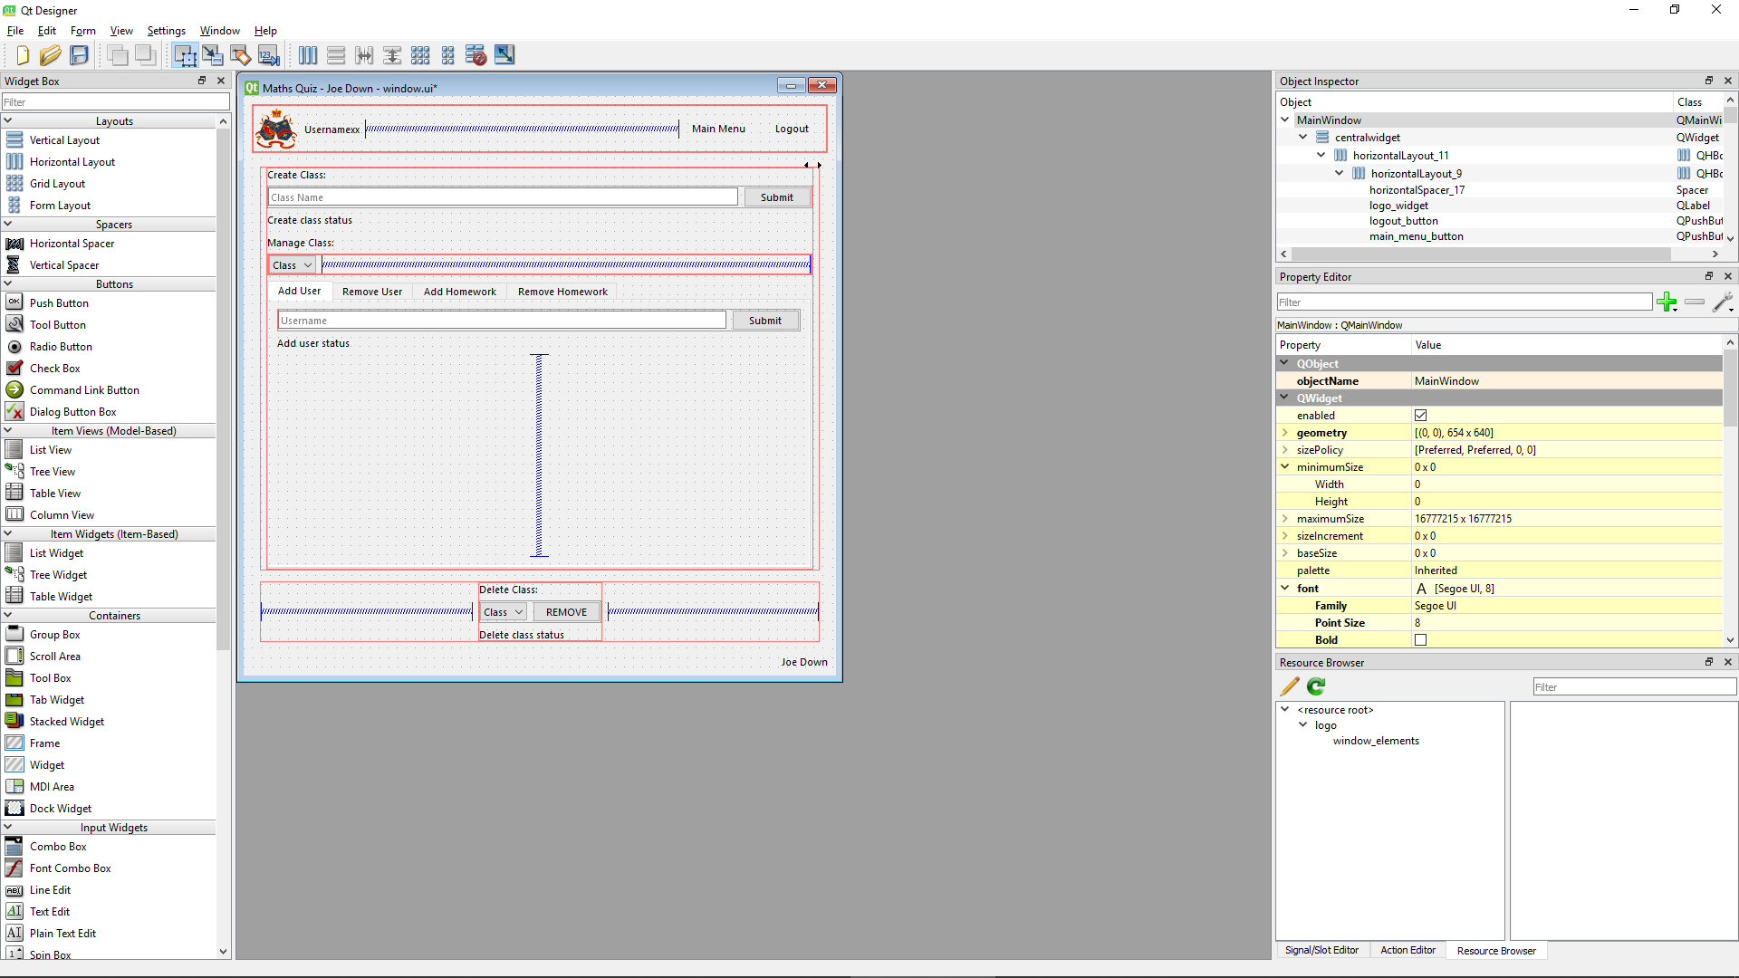

* Create class
  + Input box for class name successfully provided (admin_class_input)
  + Submit button successfully provided (admin_create_class_submit_button)
  + Create class status output added since design to increase usability (admin_create_class_status_label)
* Class select dropdown successfully provided (admin_class_user_combo_box)
* Add user to class
  + Input box for username successfully provided (admin_username_input)
  + Submit button successfully provided (admin_username_submit_button)
  + Add user status output added since design to increase usability (admin_add_user_status_label)
* Delete class
  + Class select dropdown successfully provided (admin_delete_class_combo_box)
  + Submit button successfully provided (admin_remove_class_button)
  + Delete class status output added since design to increase usability (admin_delete_class_status_label)

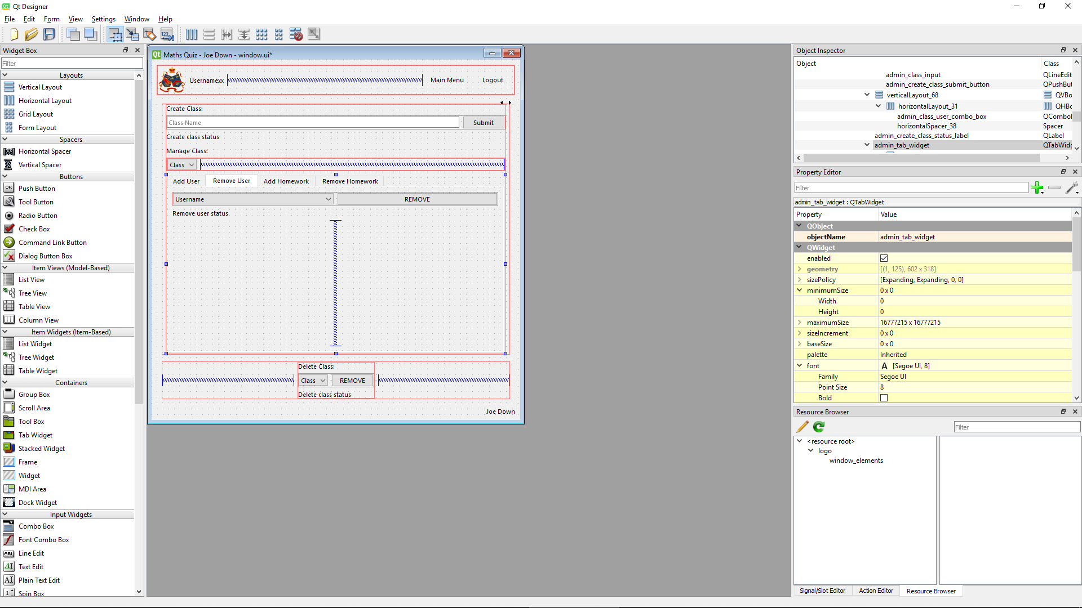

* Remove user from class
  + User select dropdown successfully provided (admin_username_combo_box)
  + Submit button successfully provided (admin_remove_user_button)
  + Remove user status output added since design to increase usability (admin_remove_user_status_label)

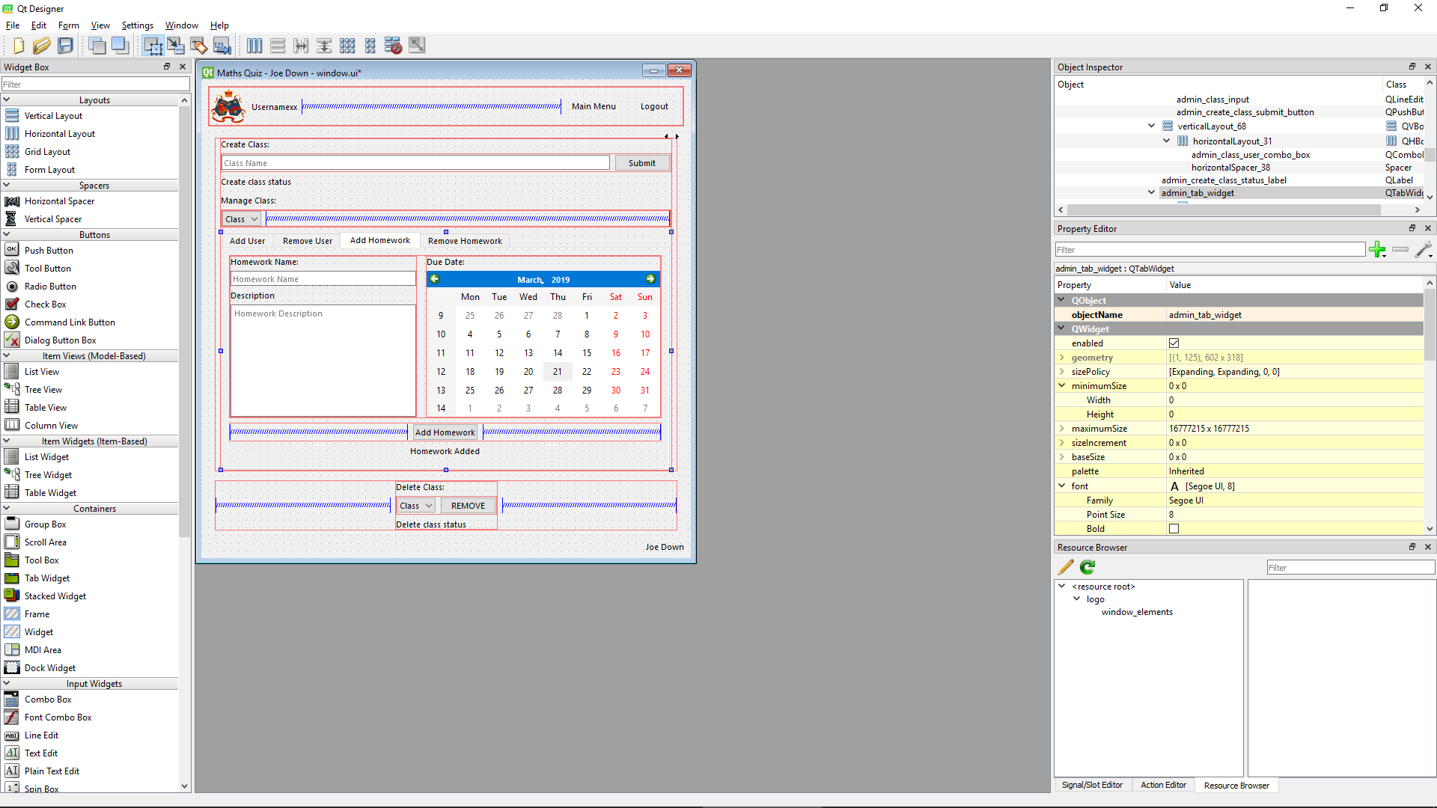

* Create homework
  + Input box for homework name successfully provided (admin_homework_name_input)
  + Input box for homework description added since design as it was missing and is required to satisfy the data structure of the question table (admin_homework_description_input)
  + Due date select calendar successfully provided (admin_due_date_calendar)
  + Submit button successfully provided (admin_add_homework_button)
  + Add homework status output added since design to increase usability (admin_add_homework_status_output)

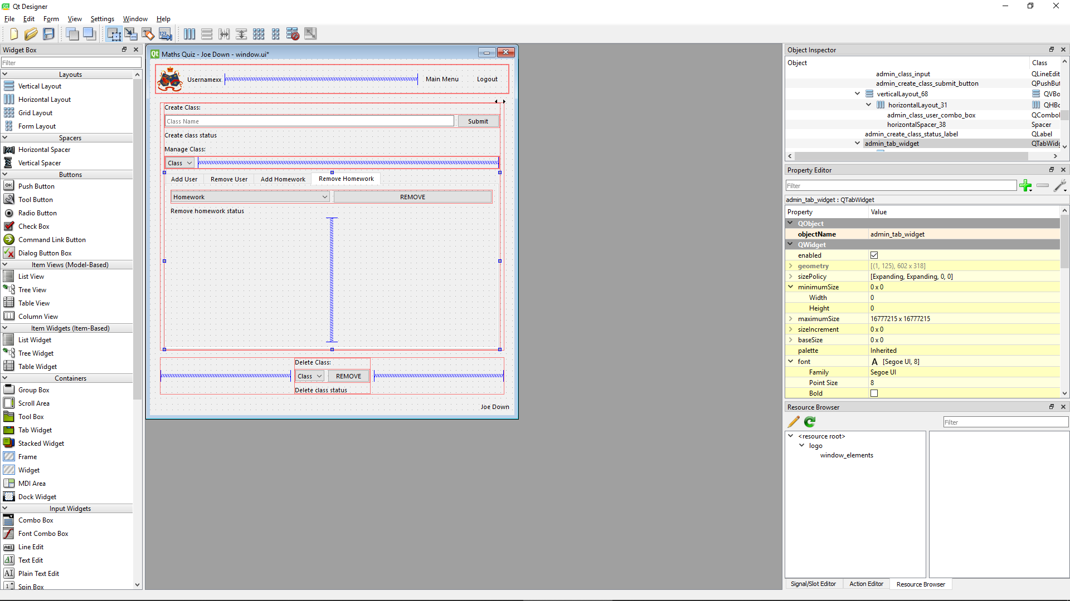

* Delete homework
  + Homework select dropdown successfully provided (admin_remove_homework_combo_box)
  + Submit button successfully provided (admin_remove_homework_button)
  + Remove homework status output added since design to increase usability (admin_remove_homework_status_label)

### Account management screen

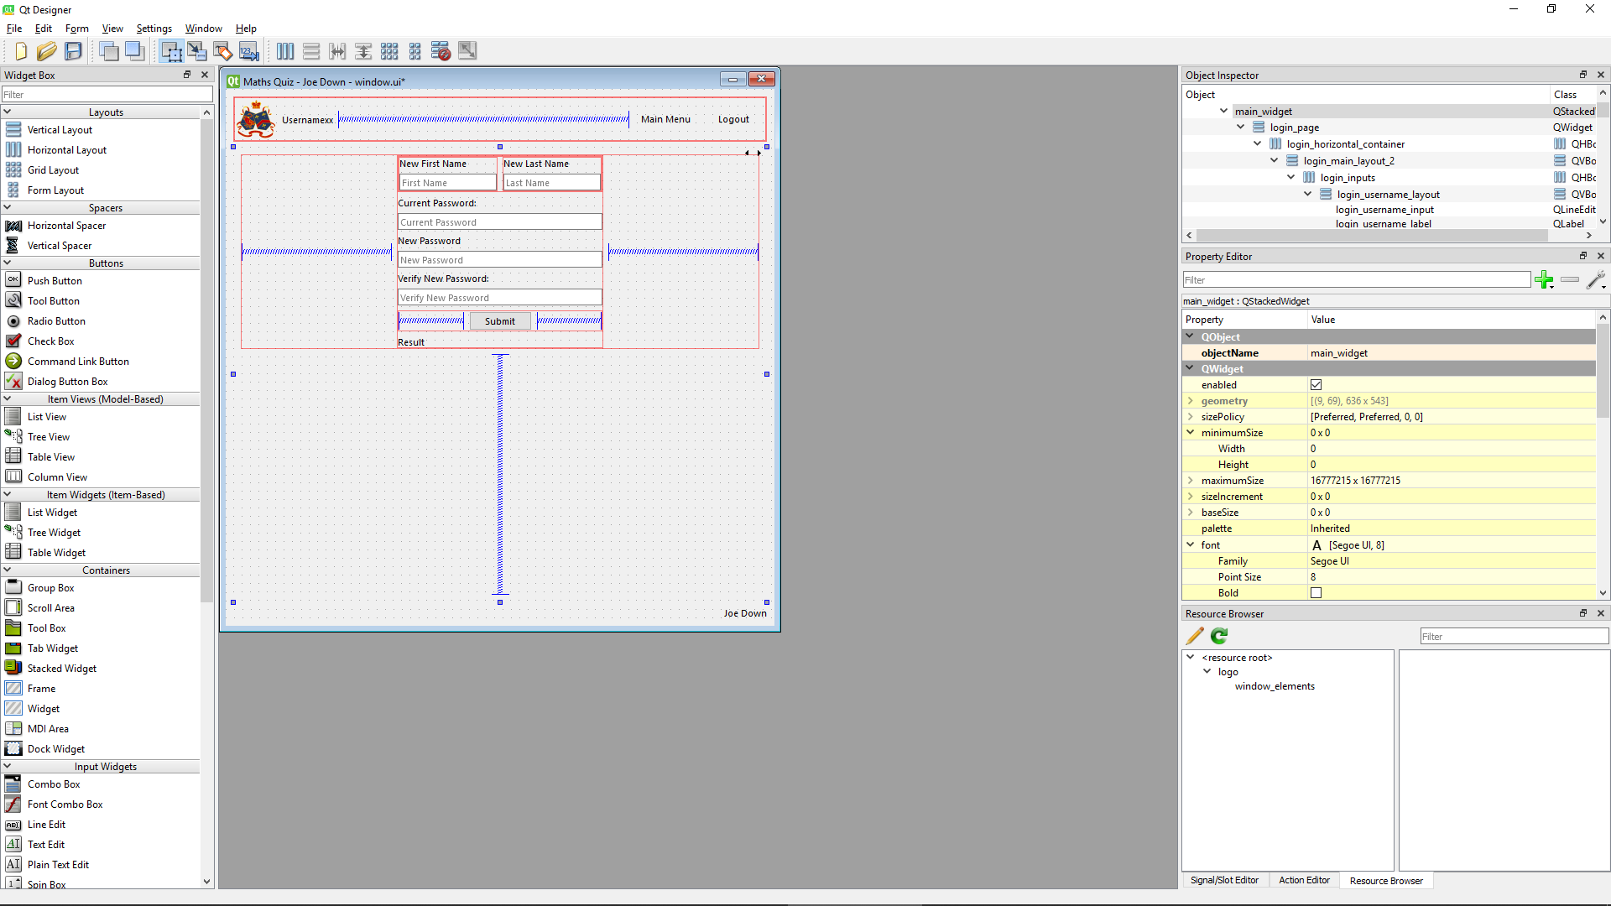

* Input box for new first name successfully provided (account_management_first_name_input)
* Input box for new surname successfully provided (account_management_last_name_input)
* Input box for password (to verify user making changes is the correct user) successfully provided (account_management_old_password_input)
* Input box for new password successfully provided (account_management_new_password_input)
* Input box for password verification successfully provided (account_management_new_password_verify_input)
* Submit button successfully provided (account_management_submit_button)
* Edit user status output added since design to increase usability (account_management_success_output)

### Template quiz screen

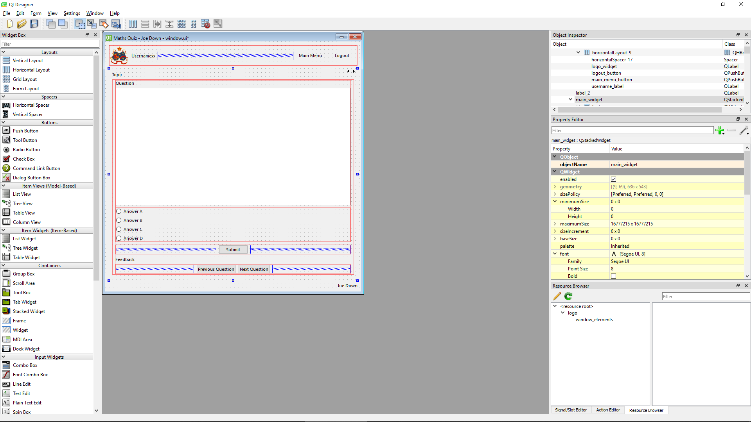

* Previous question button successfully provided (question_previous_question_button)
* Next question button successfully provided (question_next_question_button)
* Question text area successfully provided (question_question_output)
* Graph widget added since design to allow for questions to be graphed if appropriate (widget can be hidden when graph is not provided) (question_chart)
* Radio buttons to select response (answer a, answer b, answer c, answer d) successfully provided (question_radio_a, question_radio_b, question_radio_c, question_radio_d)
* Submit answer button successfully provided (question_submit_button)
* Question feedback output added since design to increase usability (question_feedback_output)

## Login Scripts (scripts.db_scripts)

### Import required Python libraries to perform hashing algorithms and communicate with an SQLite database

#### Final Code



When generating salts later in development the following import was added:



### Connect to database

#### Final Code



Generic code used

### Function to identify if the value passed matches a username stored in the database (True or False should be returned)

#### Issues during development

Initially the below code was written:



This produce the following error:



This turned out to be due to the fact that an SQL query will always return an array, even if there is only a single value, of the form [(data,)], meaning to reference the single piece of data it must be referred to using c.fetchall[0][0]

#### Final Code



#### Testing

##### SQL

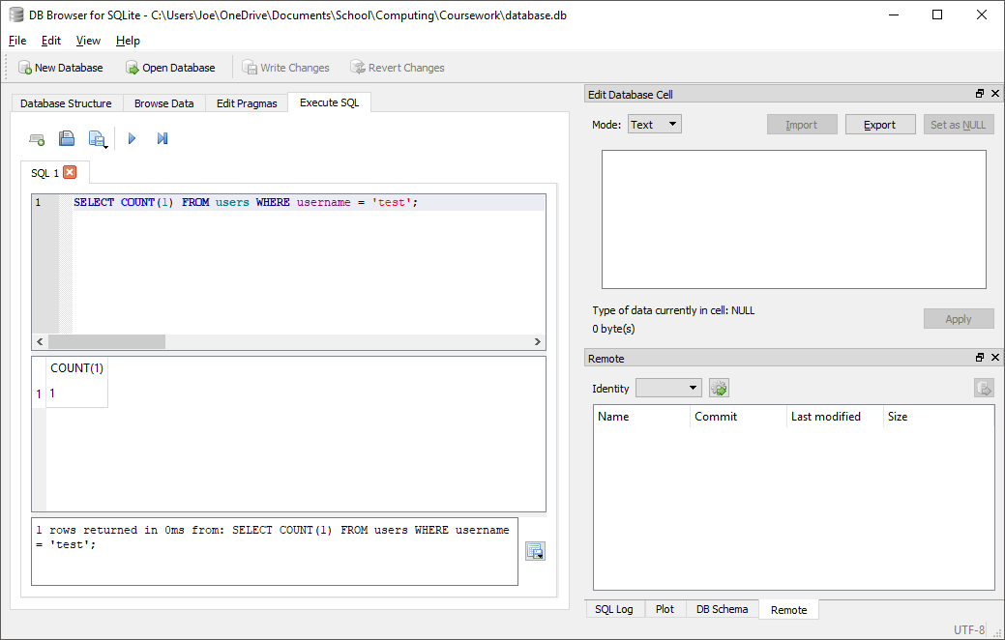

##### Test code



##### With valid data:



##### With Invalid data:



##### Evaluation

Function returns correctly either True or False depending on whether a username is present in the database

### Function to find the salt for a given username

#### Final Code



#### Testing

##### SQL

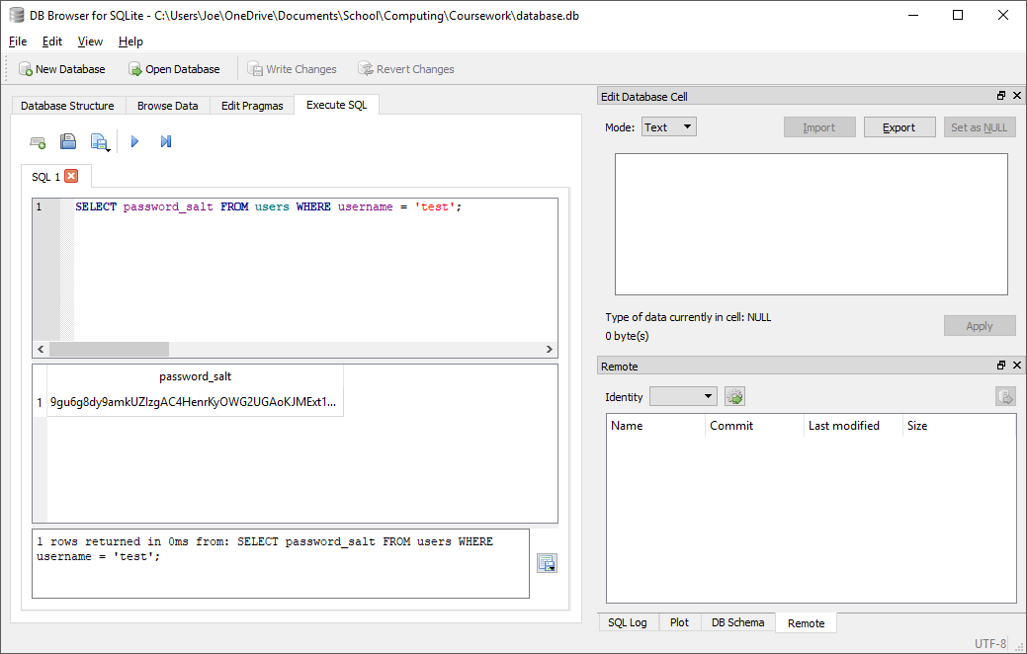

##### Test code



##### With valid data



##### With invalid data

N/A, any errors should be addressed before calling function by verifying username in advance

##### Evaluation

Function correctly returns the salt for the given username

### Function to generate a salt

#### Final Code



Salt generation code based on example given at [stackoverflow.com](https://stackoverflow.com/questions/9594125/salt-and-hash-a-password-in-python)

#### Testing

##### Test code



##### Outputs







##### Evaluation

Successfully and securely produces a unique valid salt every time function is run

### Function to hash a password

#### Final Code



Hashing code based on examples given at [docs.python.org](https://docs.python.org/2/library/hashlib.html)

#### Testing

##### Test code



##### Outputs







##### Evaluation

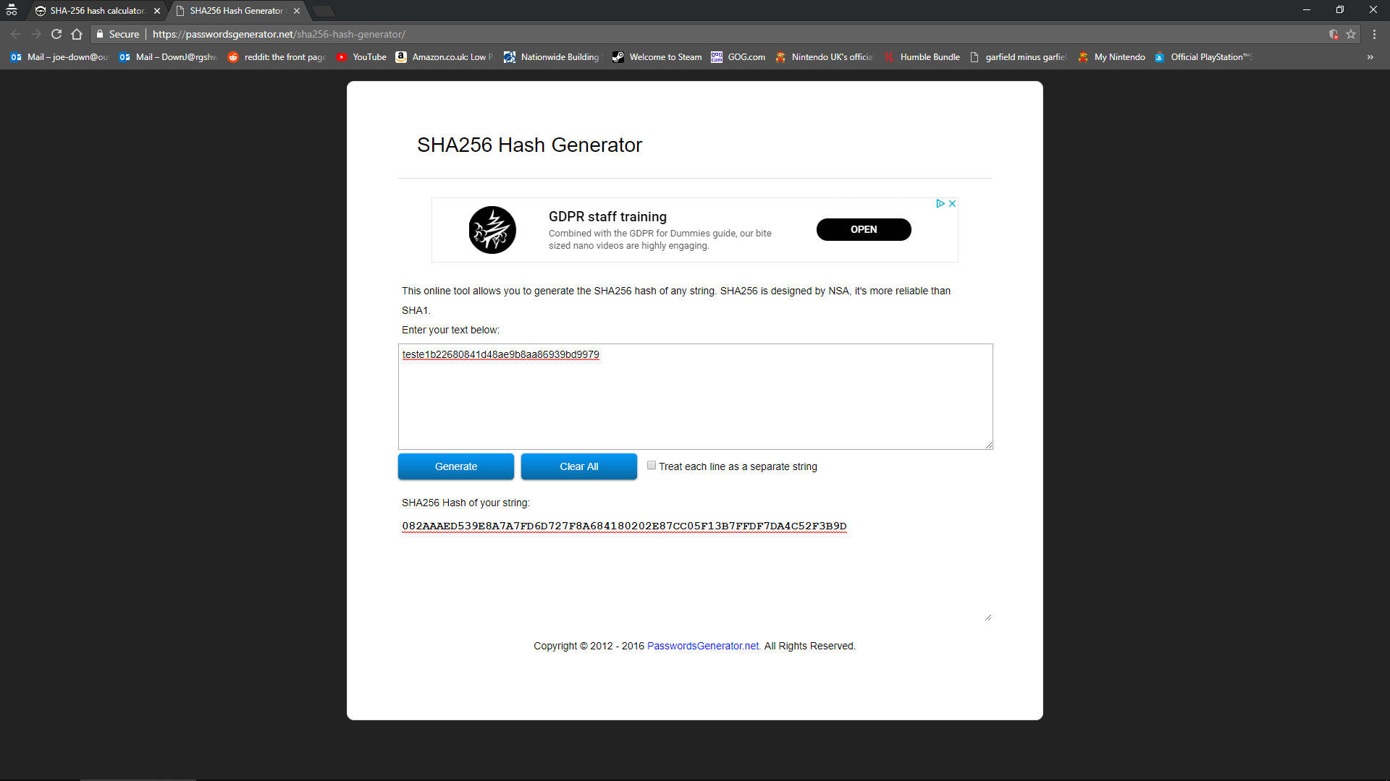

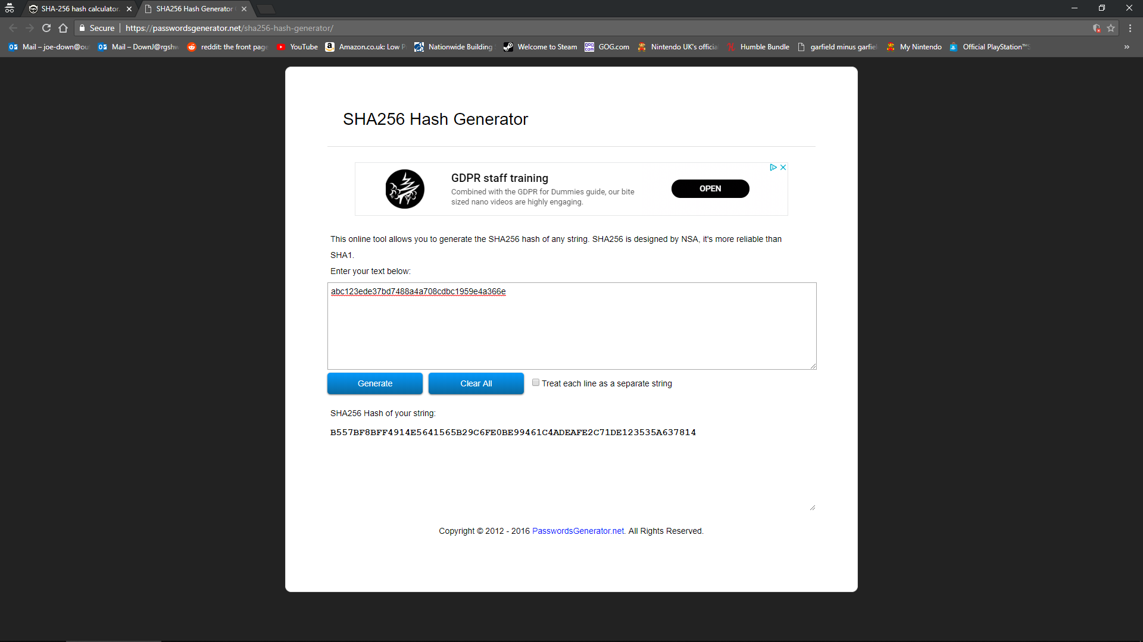

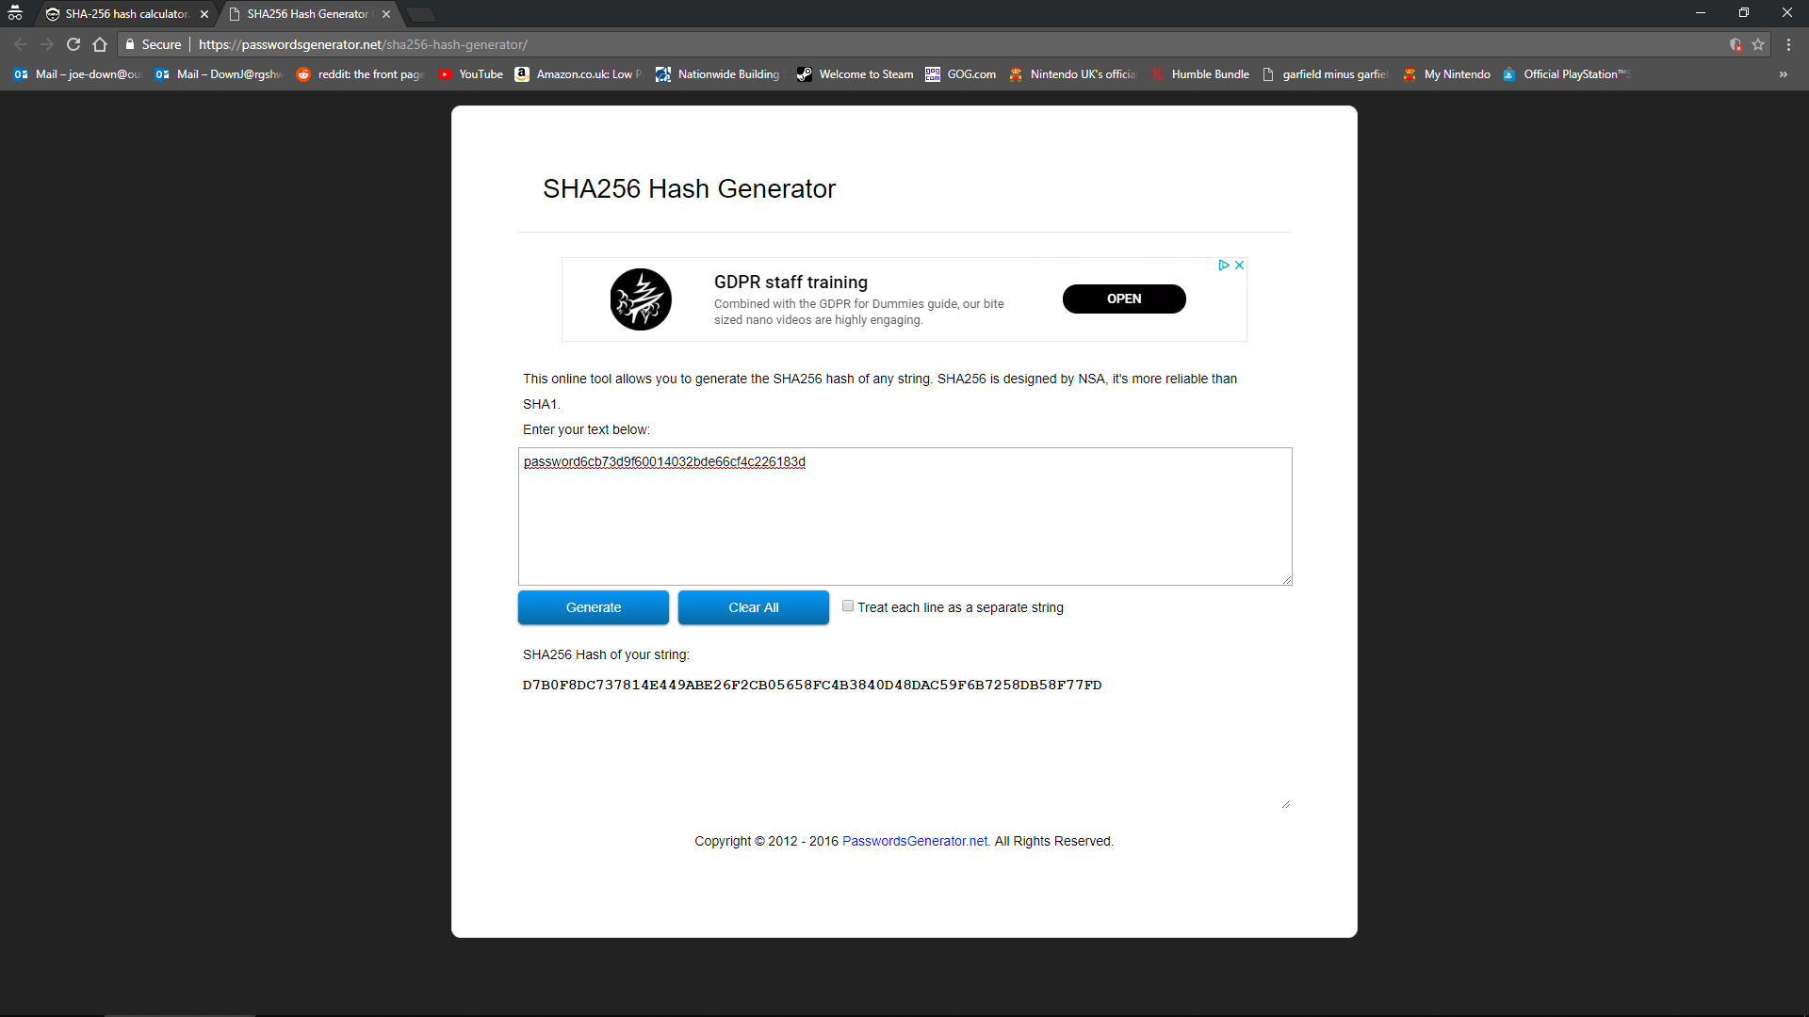

Function works as intended as all hashes generated at [passwordsgenerator.net](https://passwordsgenerator.net/sha256-hash-generator/) match hashes generated by program

### Function to check if a password hash matches the stored hash

#### Final Code



#### Testing

##### Test code



##### With valid data



##### With invalid data

###### Invalid username



###### Invalid password



###### Invalid username and password



##### Evaluation

Function correctly returns that login data is valid only if both the username and salted password are correct

### Function to check if a password is correct for the given username

#### Final Code



#### Testing

##### Test code



##### With valid data



##### With invalid data

###### Invalid username



###### Invalid password



###### Invalid username and password



##### Evaluation

Function correctly returns that login data is valid only if both the username and password are correct

### Function to create an account (insert valid data into the users table)

#### Issues during development

Initially, the following code was used:



This would result in no changes being made to the database. This was because simply executing an insert statement does permanently make changes to the database on secondary storage, the line ‘conn.commit()’ must be used to permanently apply the changes made and insert the data

#### Final Code



#### Testing

##### SQL

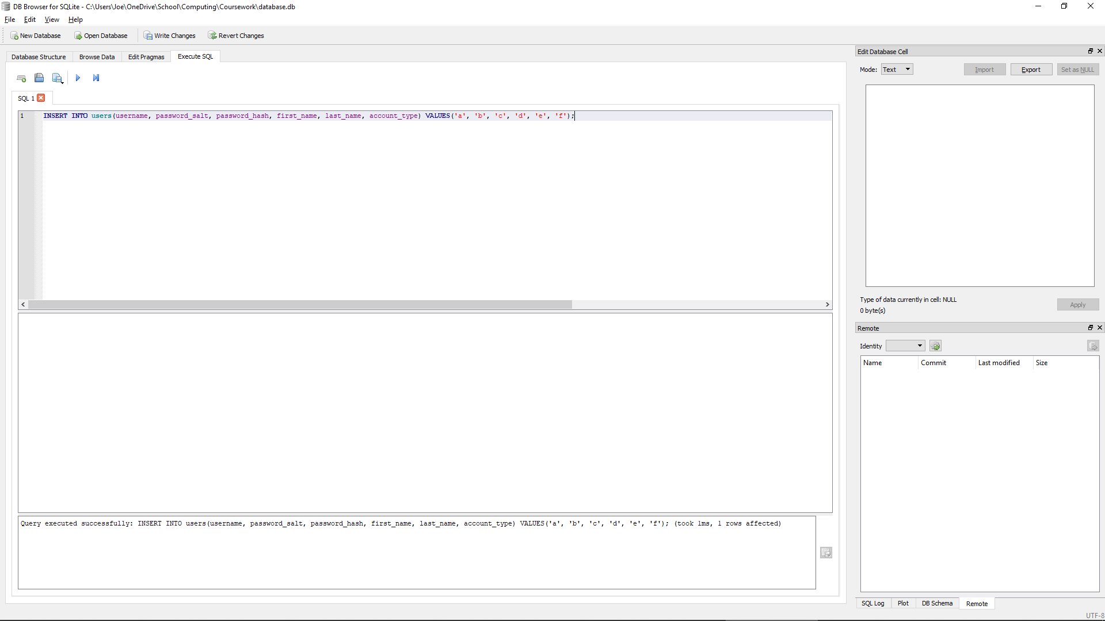



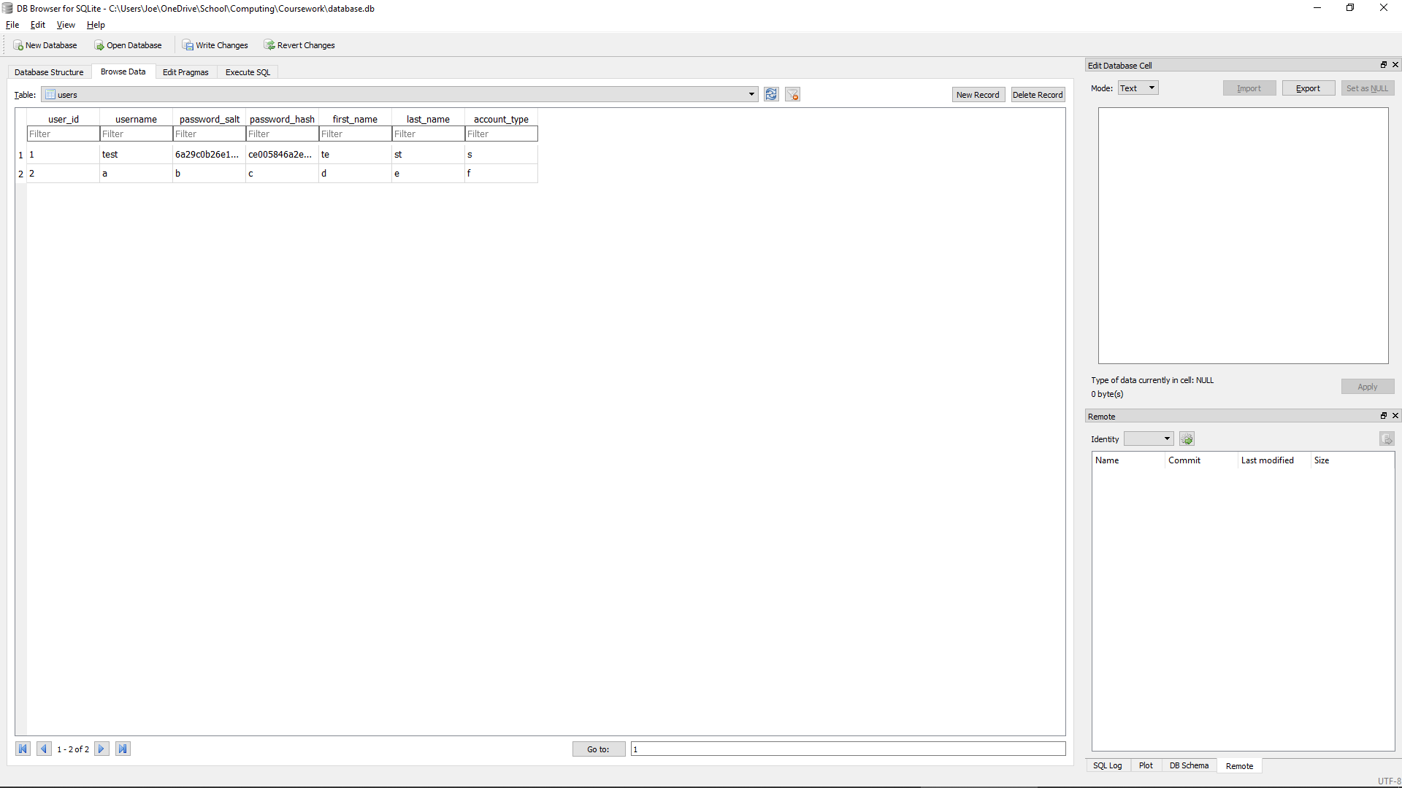

##### Test code



##### With valid data:



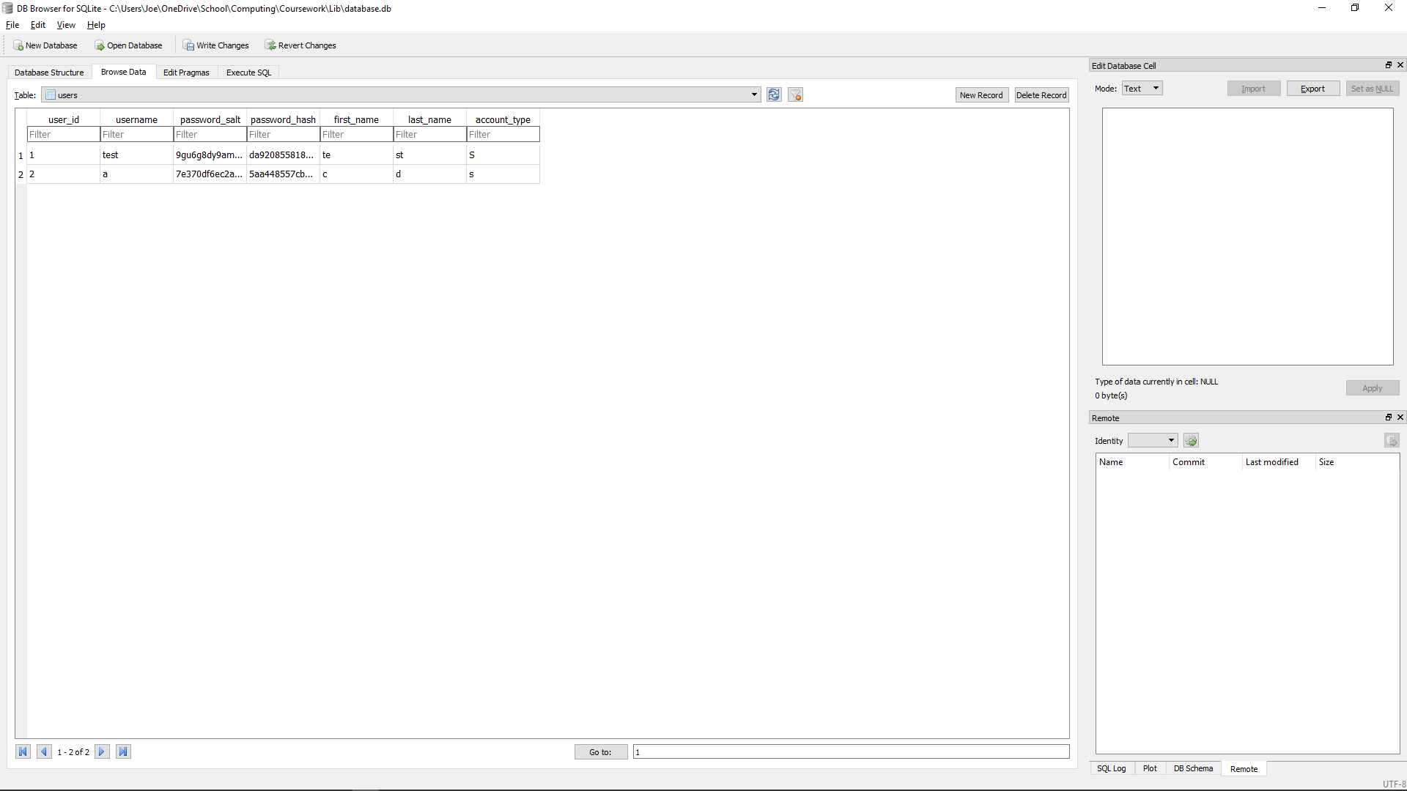

##### With Invalid data:

N/A, all data should be validated before being passed into the function

##### Evaluation

Correctly inserts new data into the database as expected with the originally entered password now in hashed and salted form

### Function to get the user id which matches a given username

#### Final Code



#### Testing

##### SQL

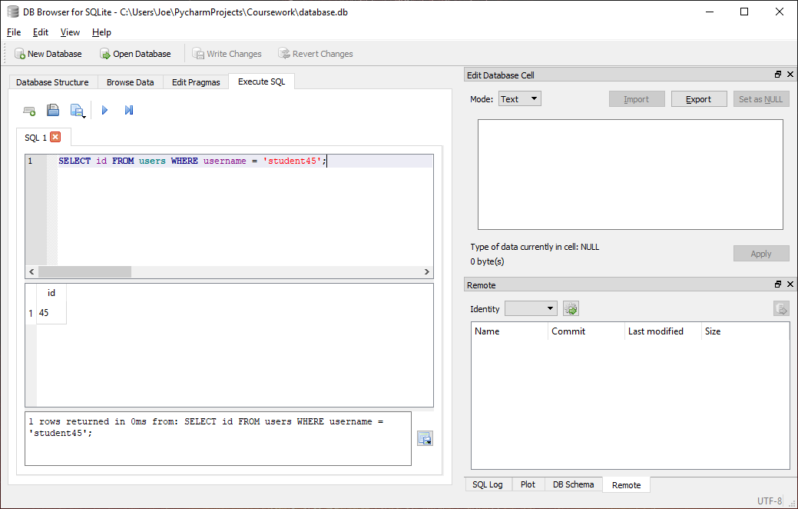

##### Test code



##### With valid data:



##### With Invalid data:

N/A, any errors should be addressed before calling function by verifying username in advance

##### Evaluation

Function returns correctly matching user id for given username if present in database

### Function to get the account type for a given user id

#### Final Code



#### Testing

##### SQL

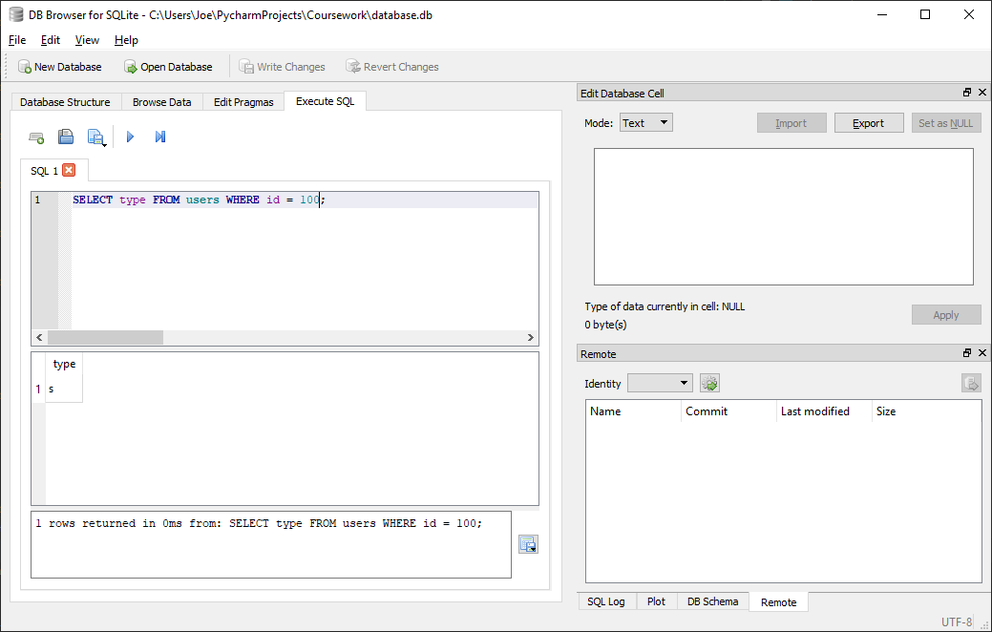

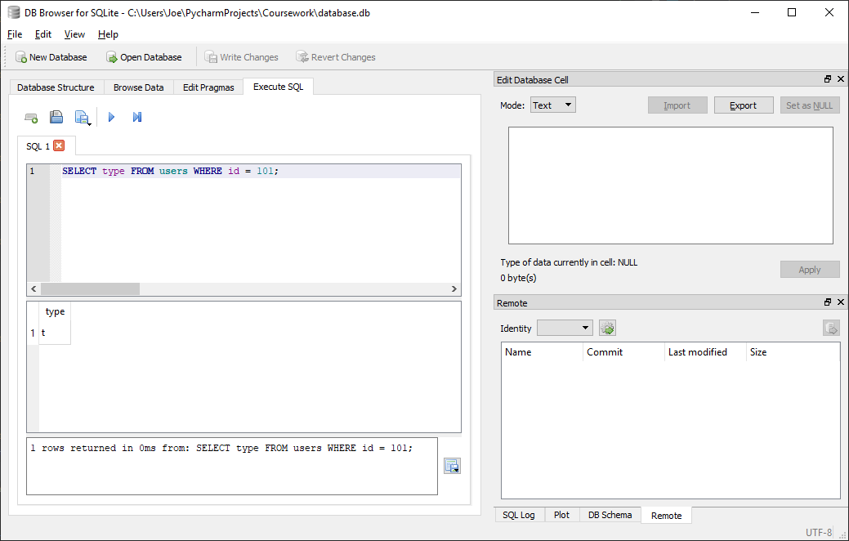

##### Test code



##### With valid data:





##### With Invalid data:

N/A, any errors should be addressed before calling function by verifying user id in advance

##### Evaluation

Function returns correctly matching user type for given user id if present in database

### Function to get the username for a given user id

#### Final Code



#### Testing

##### SQL

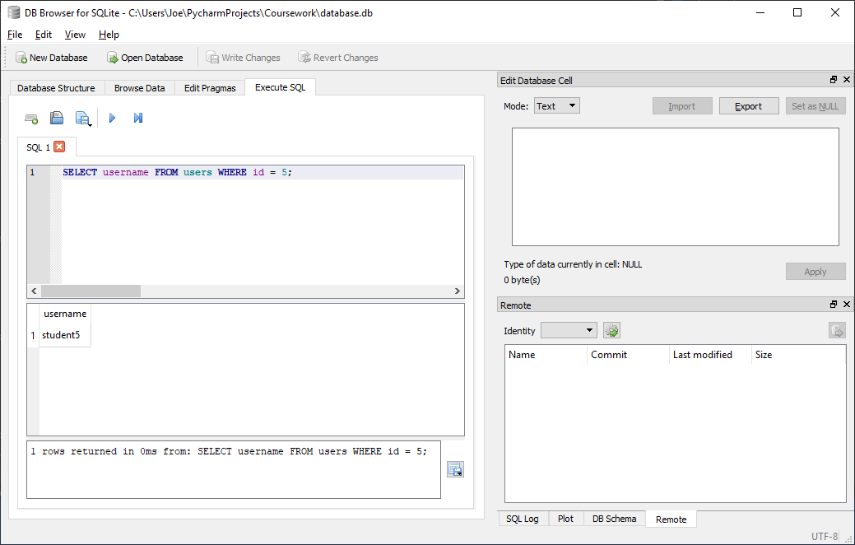

##### Test code



##### With valid data:



##### With Invalid data:

N/A, any errors should be addressed before calling function by verifying user id in advance

##### Evaluation

Function returns correctly matching username for given user id if present in database

### Function to get the first name for a given user id

#### Final Code



#### Testing

##### SQL

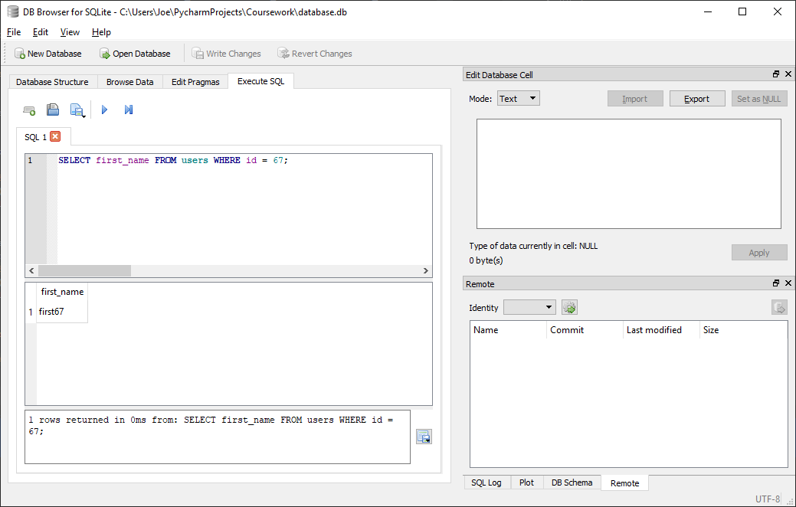

##### Test code



##### With valid data:



##### With Invalid data:

N/A, any errors should be addressed before calling function by verifying user id in advance

##### Evaluation

Function returns correctly matching first name for given user id if present in database

### Function to get the last name for a given user id

#### Final Code



#### Testing

##### SQL

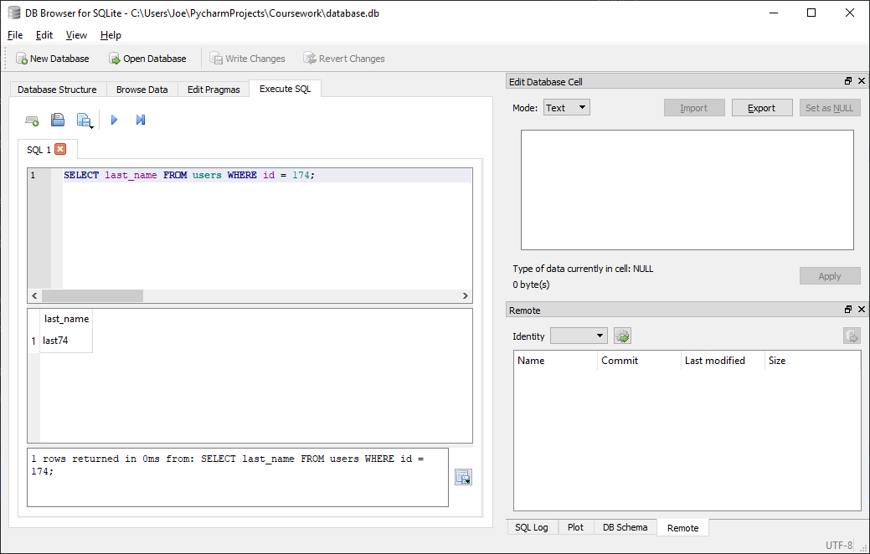

##### Test code



##### With valid data:



##### With Invalid data:

N/A, any errors should be addressed before calling function by verifying user id in advance

##### Evaluation

Function returns correctly matching last name for given user id if present in database

### Function to format an inputted first/last name according to database rules (all lowercase)

#### Final Code



#### Testing

##### Test code



##### With valid data:



##### With Invalid data:

N/A, any errors should be addressed before calling function by ensuring type passed is string

##### Evaluation

Function returns correctly converts all characters to lowercase

### Function to update first name in database for a given user id

#### Final Code



#### Testing

##### SQL

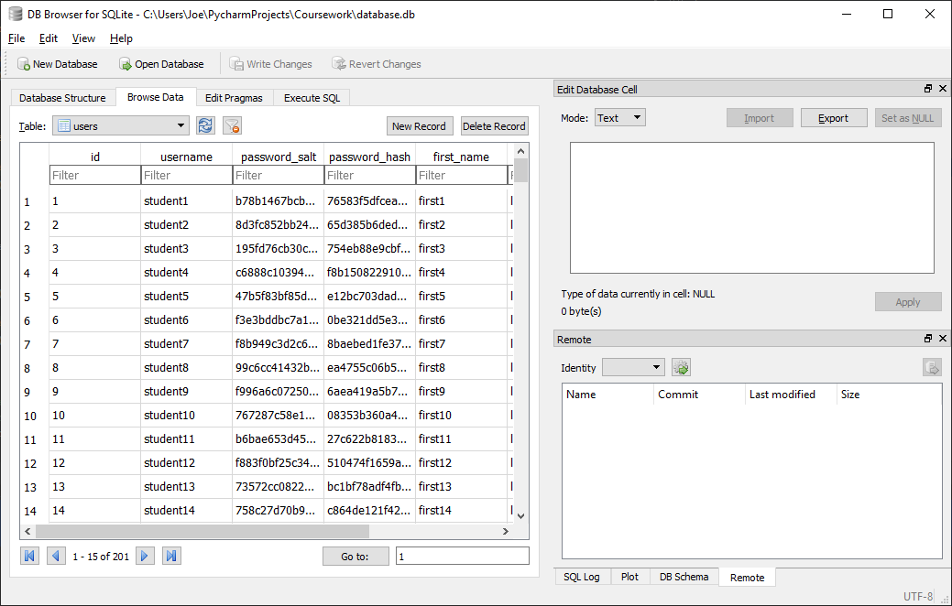

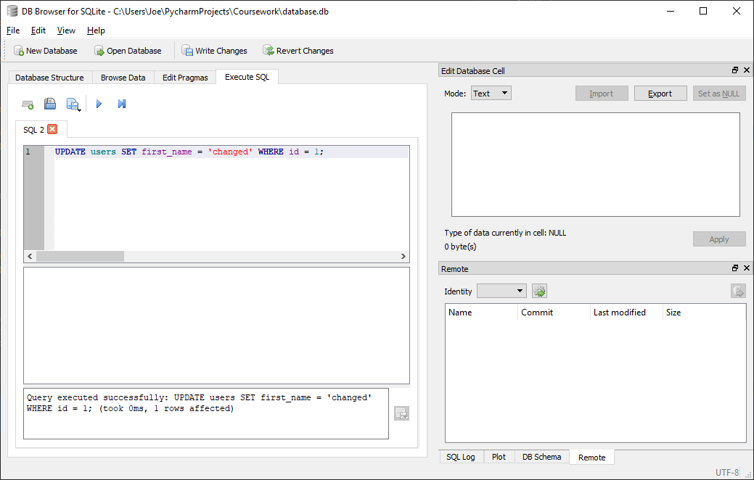

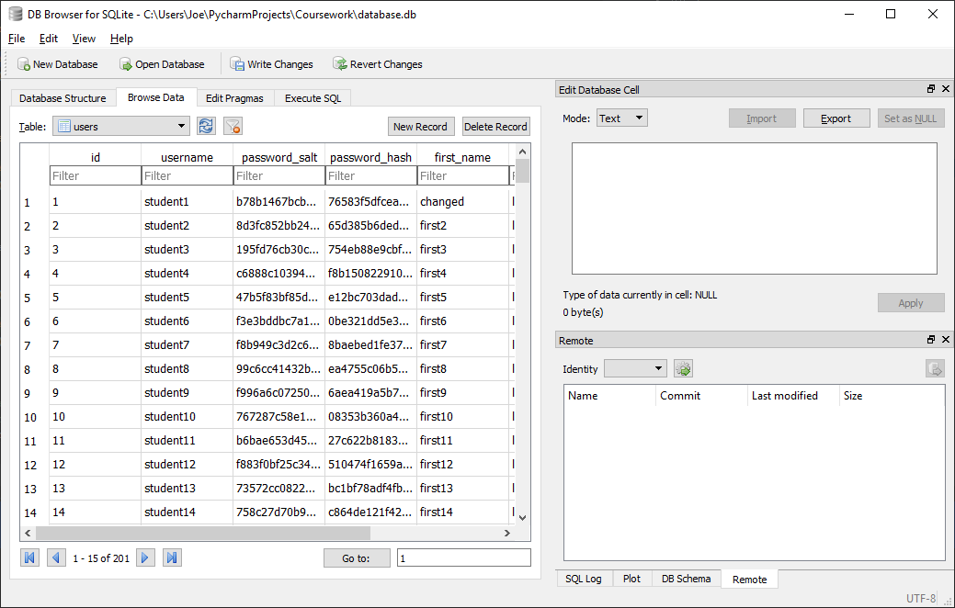

##### Test code



##### With valid data:



##### With Invalid data:

N/A, any errors should be addressed before calling function by verifying user id in advance

##### Evaluation

Function returns correctly changes database value for first name for given user id

### Function to update last name in database for a given user id

#### Final Code



#### Testing

##### SQL

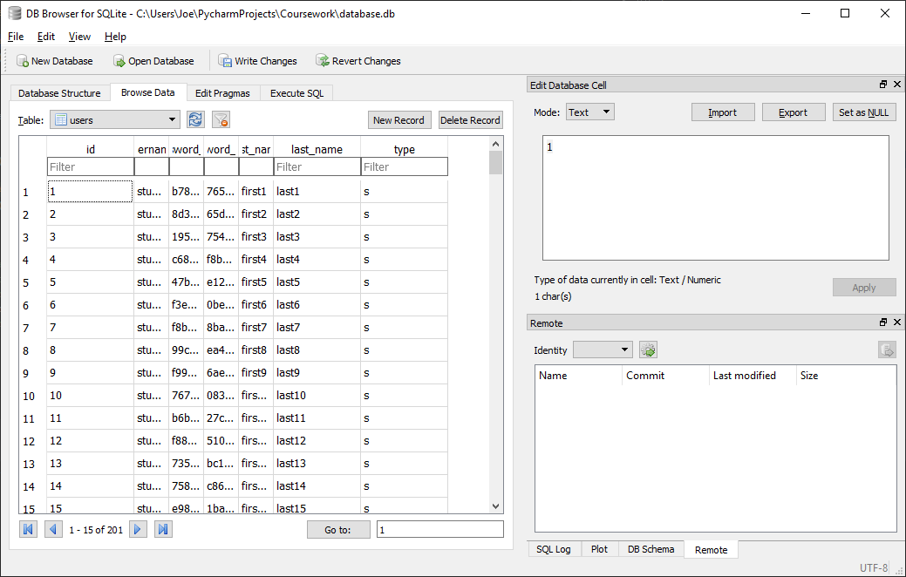

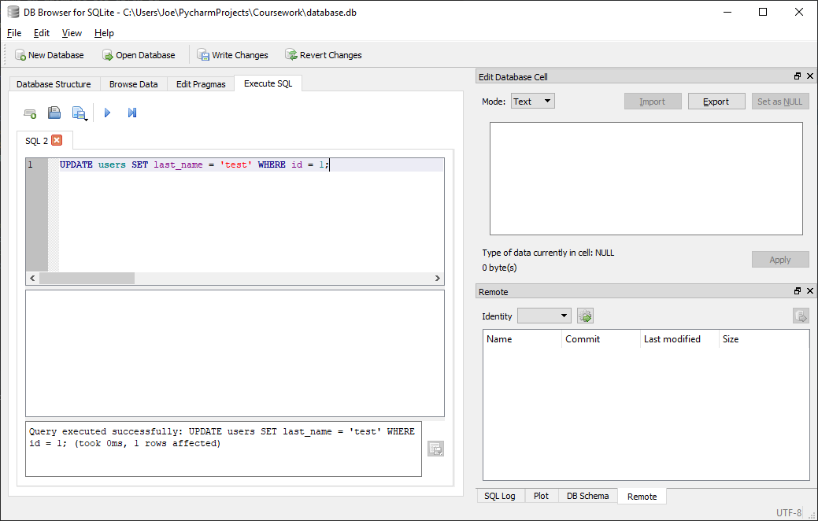

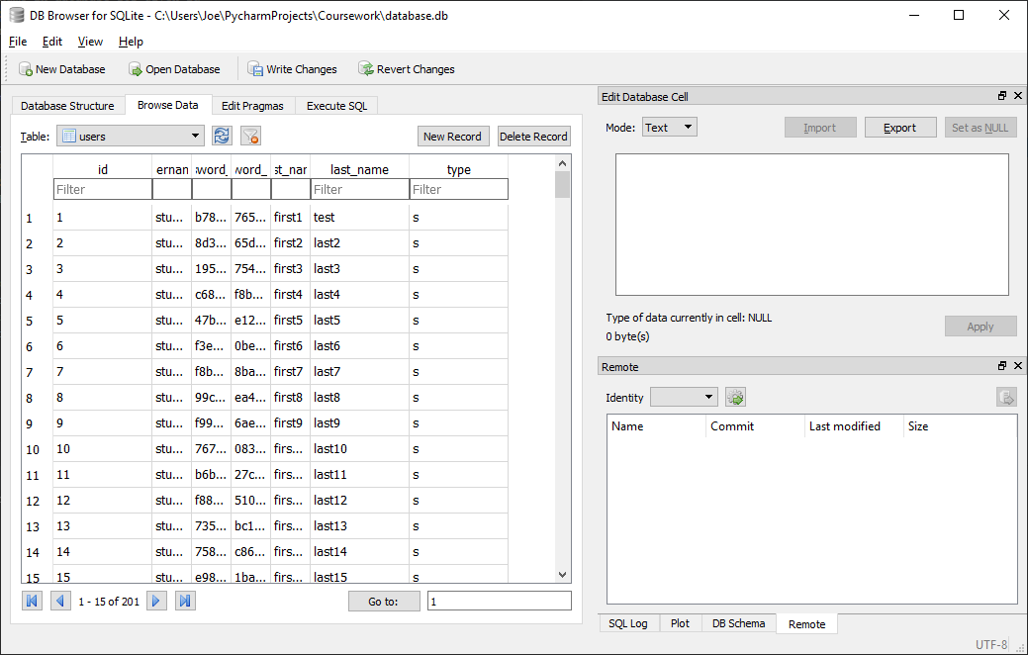

##### Test code



##### With valid data:



##### With Invalid data:

N/A, any errors should be addressed before calling function by verifying user id in advance

##### Evaluation

Function returns correctly changes database value for last name for given user id

### Function to update password in database for a given user id

#### Final Code



#### Testing

##### SQL

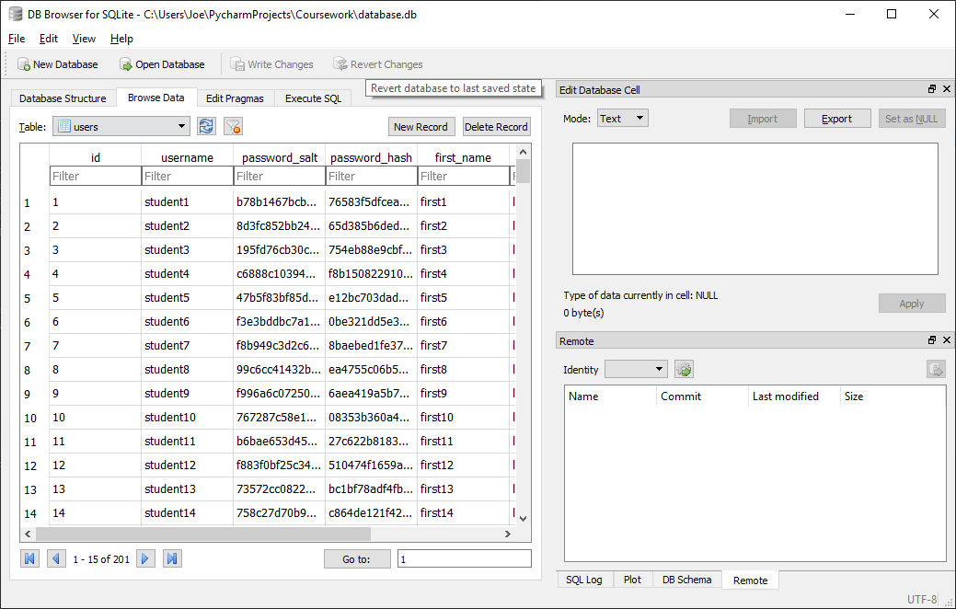

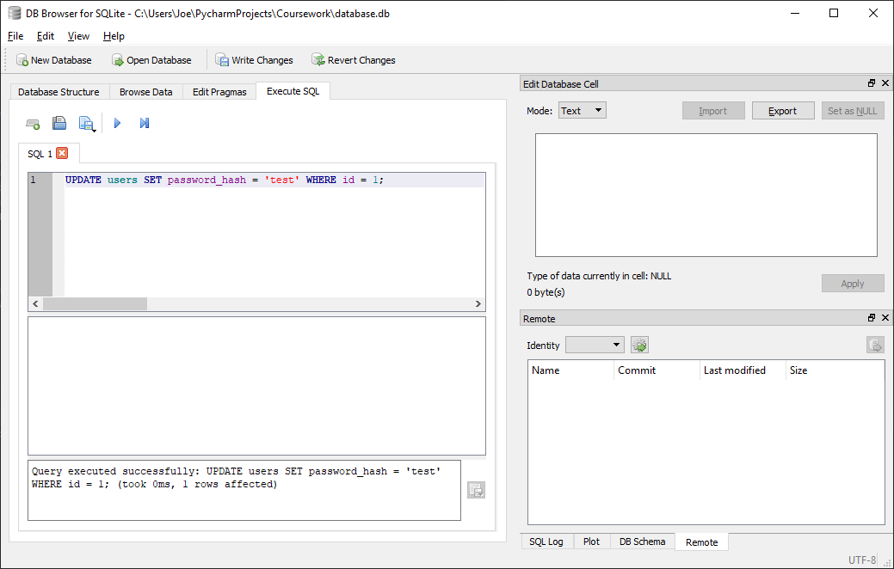

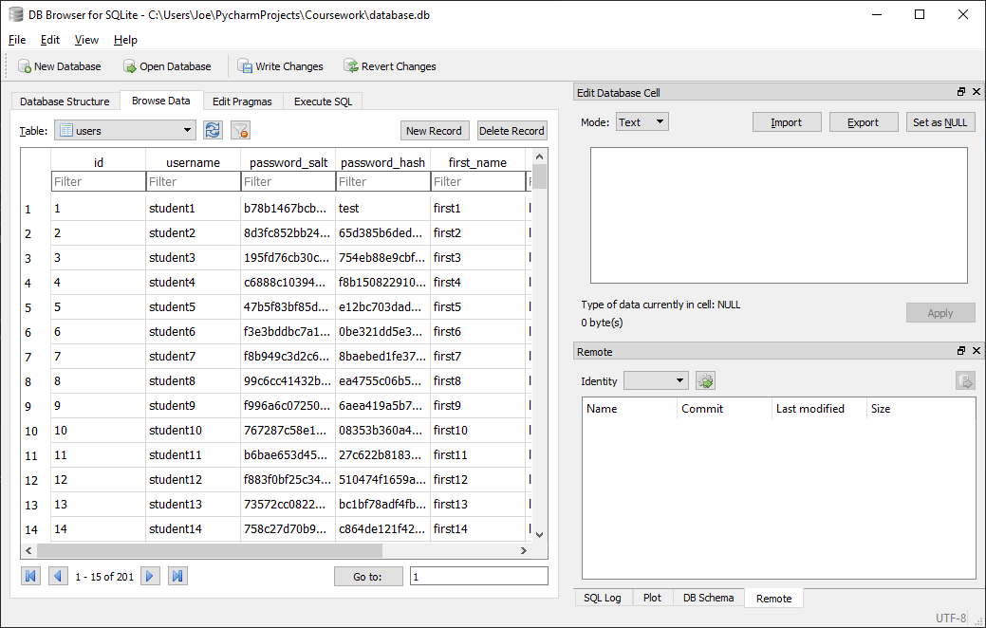

##### Test code



##### With valid data:



##### With Invalid data:

N/A, any errors should be addressed before calling function by verifying user id in advance

##### Evaluation

Function returns correctly changes database value for password hash for given user id

## UI Scripts (scripts.ui_scripts)

### Import required Python libraries to communicate with SQLite database and use scripts from login scripts

#### Final Code



### Connect to database

#### Final Code



Generic code used

### Function to get a list of all classes for a given user id

#### Final Code



#### Testing

##### SQL

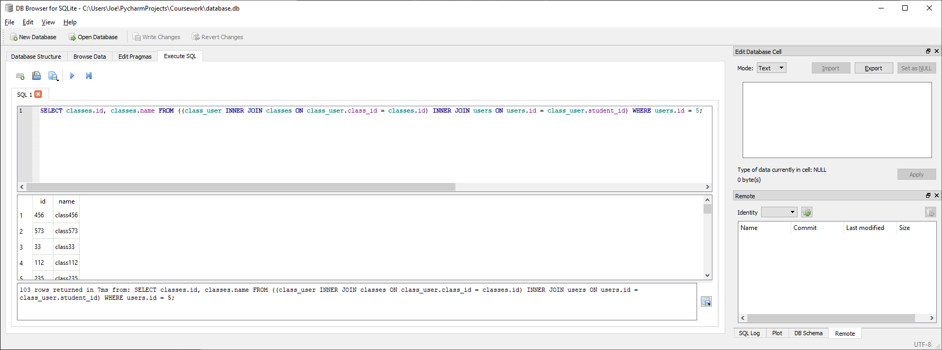

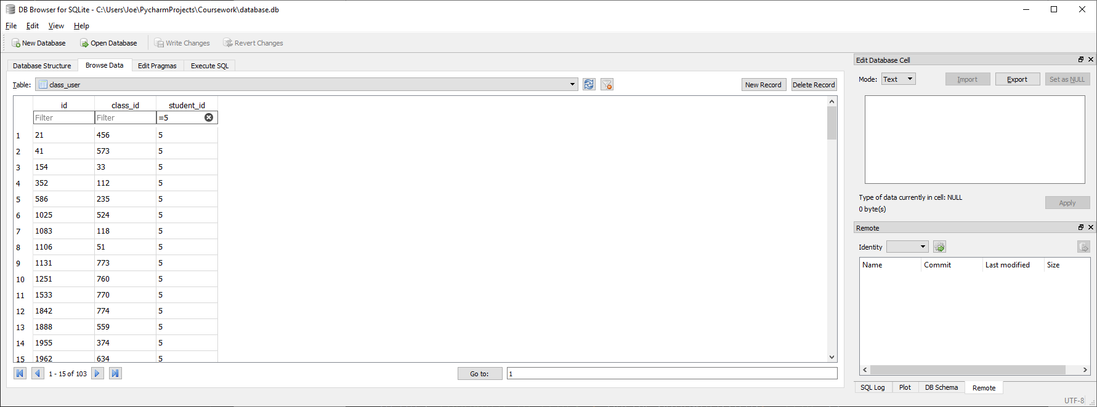

Correctly finds all 103 classes user 5 is in and outputs the required data (class id and class name)

##### Test code



##### With valid data:



##### With Invalid data:

N/A, any errors should be addressed before calling function by verifying user id in advance

##### Evaluation

Function correctly returns complete list of classes which contain user with given user id as an array of tuples of the format (class id, class name)

### Function to get a list of all homework for a given class id

#### Final Code



#### Testing

##### SQL

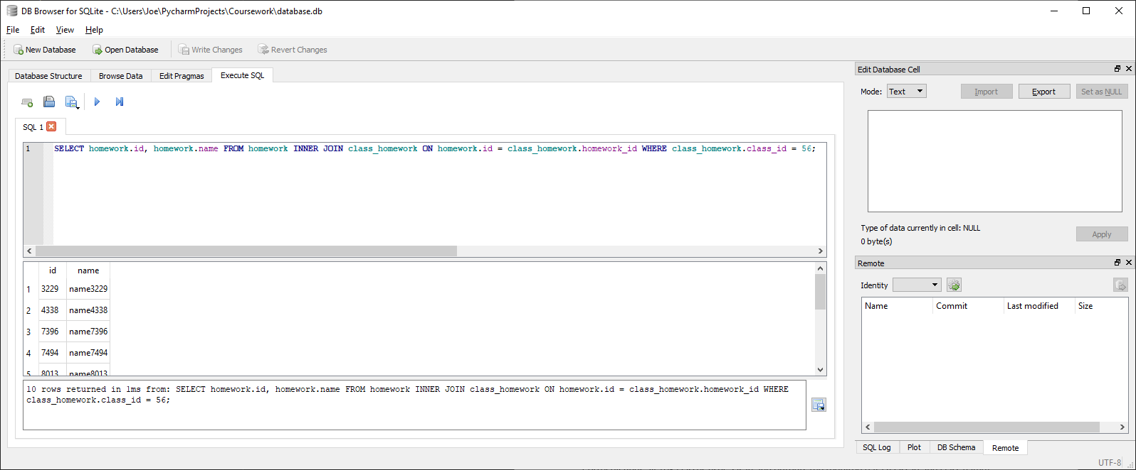

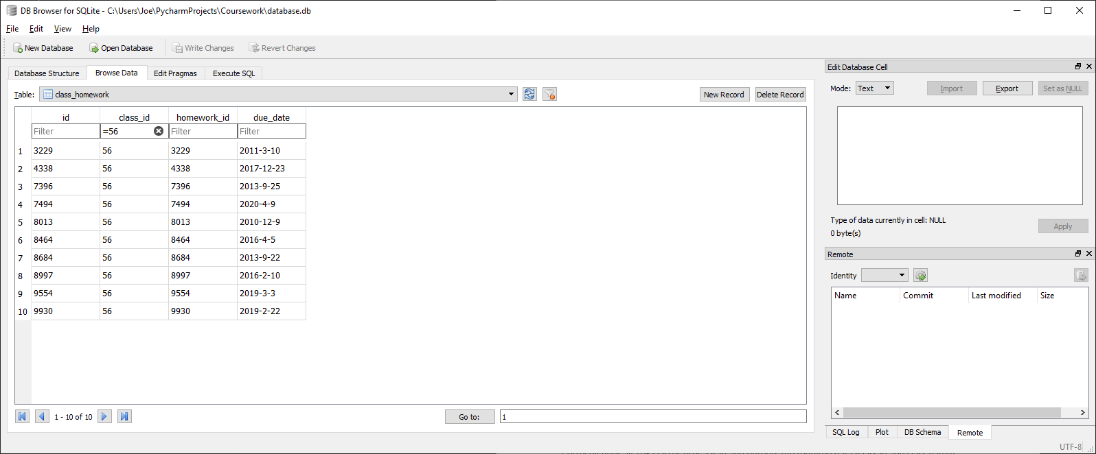

Correctly finds all 10 homework set for class 56 and outputs the required data (homework id and homework name)

##### Test code



##### With valid data:



##### With Invalid data:

N/A, any errors should be addressed before calling function by verifying class id in advance

##### Evaluation

Function correctly returns complete list of homework set by class with given class id as an array of tuples of the format (homework id, homework name)

### Function to get a list of all classes for a given teacher id

#### Final Code



#### Testing

##### SQL

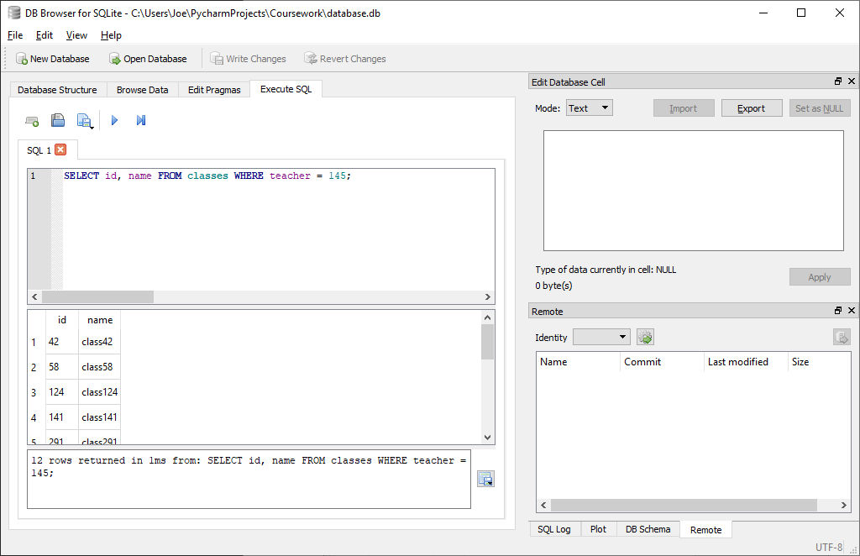

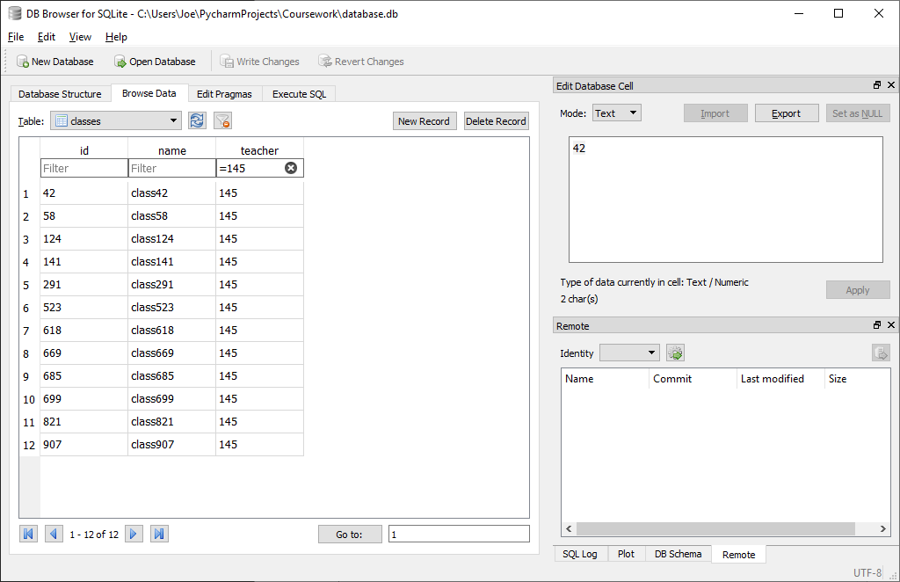

Correctly finds all 12 classes under teacher id 145 and outputs the required data (class id and class name)

##### Test code



##### With valid data:



##### With Invalid data:

N/A, any errors should be addressed before calling function by verifying teacher id in advance

##### Evaluation

Function correctly returns complete list of classes for teacher with given teacher id as an array of tuples of the format (class id, class name)

### Function to get a list of all students for a given class id

#### Final Code



#### Testing

##### SQL

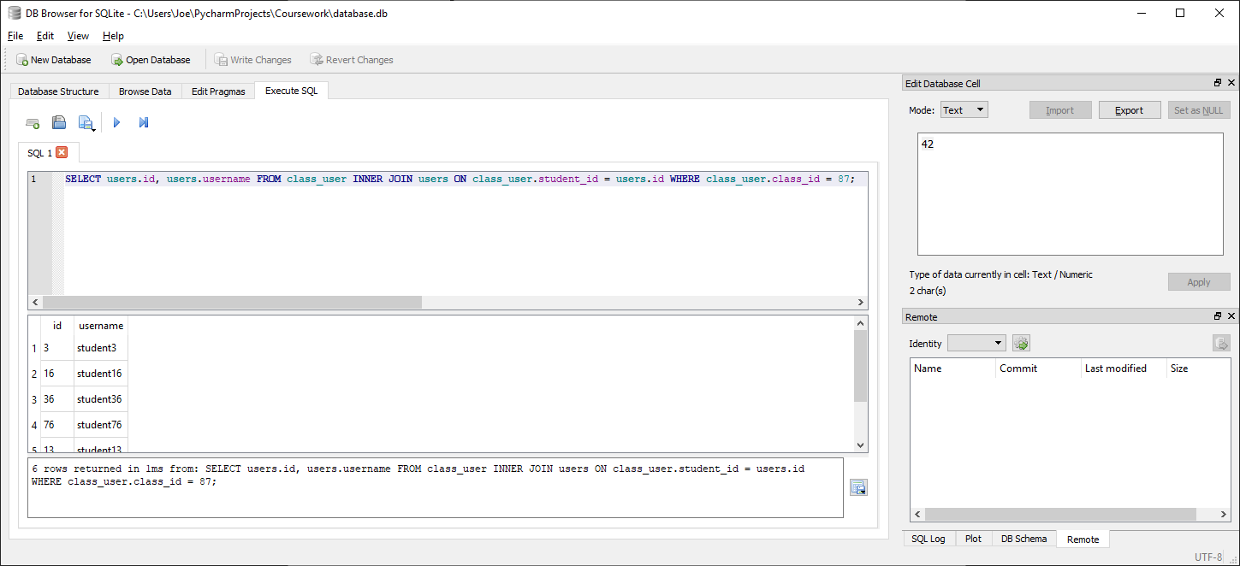

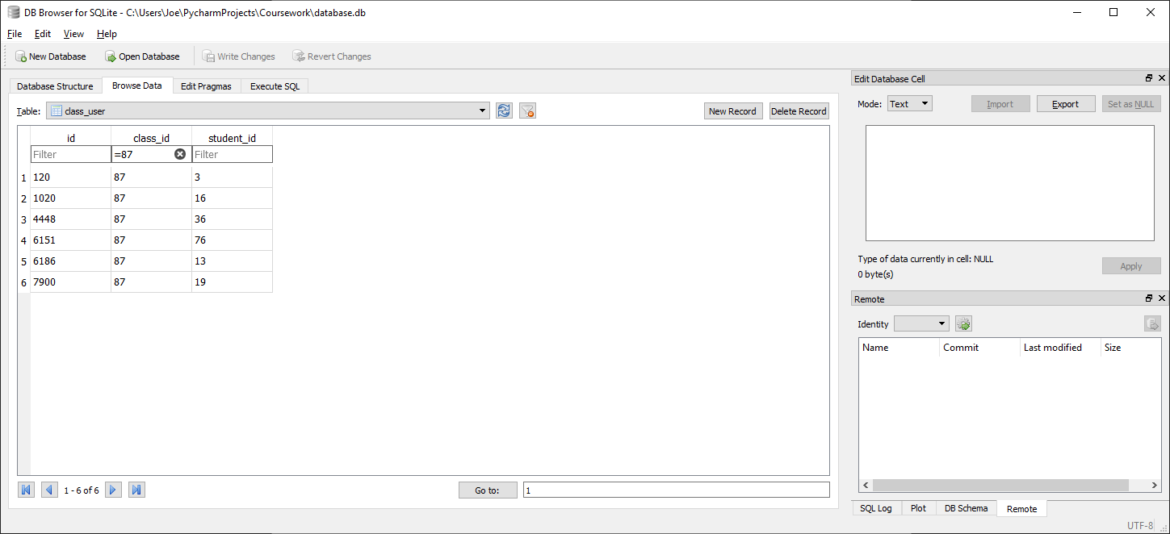

Correctly finds all 6 students under class id 87 and outputs the required data (user id and username)

##### Test code



##### With valid data:



##### With Invalid data:

N/A, any errors should be addressed before calling function by verifying class id in advance

##### Evaluation

Function correctly returns complete list of students for class with given class id as an array of tuples of the format (user id, username)

### Function to get a list of all questions for a given homework id

#### Final Code



#### Testing

##### SQL

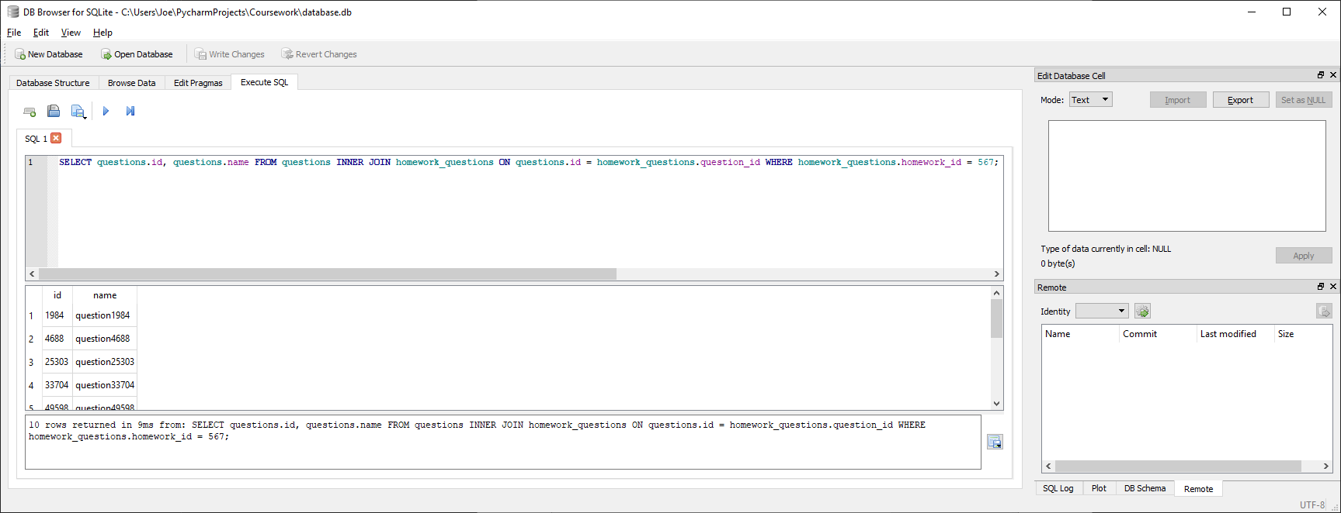

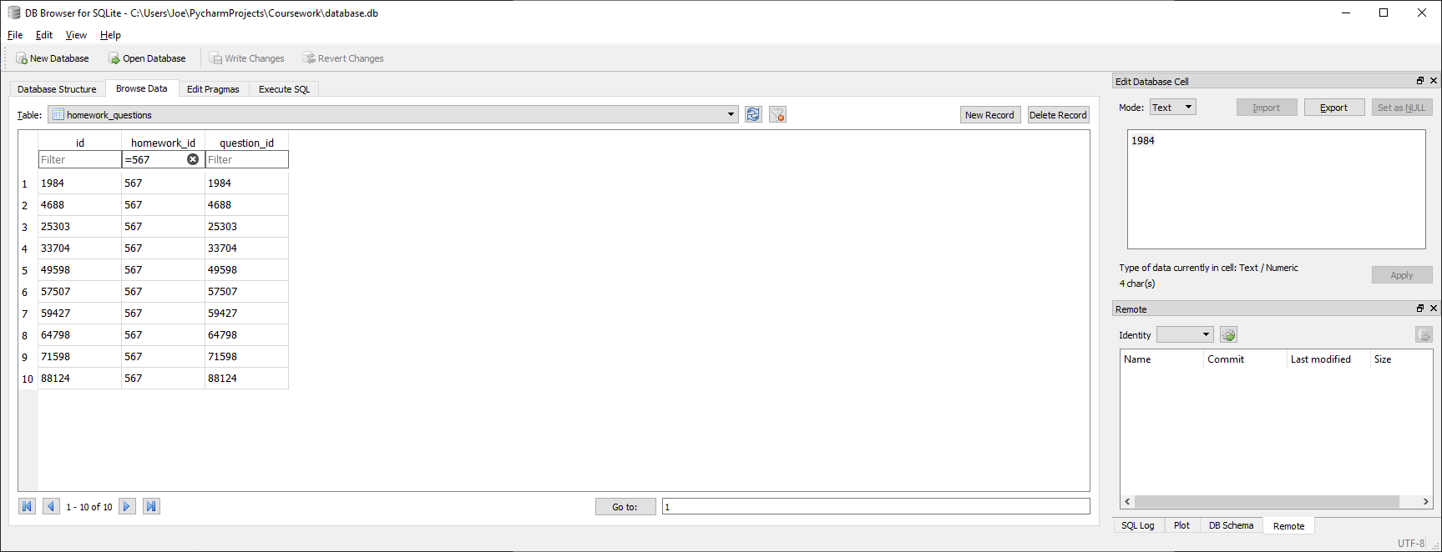

Correctly finds all 10 questions under homework id 567 and outputs the required data (question id and question name)

##### Test code



##### With valid data:



##### With Invalid data:

N/A, any errors should be addressed before calling function by verifying homework id in advance

##### Evaluation

Function correctly returns complete list of questions for homework with given homework id as an array of tuples of the format (question id, question name)

### Function to get the score for a given homework for a given user

#### Issues during development

Initially the below code was implemented:



This would result in an error occurring if for any reason the question count took a value of 0 (if a given homework has no questions or the given homework was never set for the given user and no results have therefore been stored).



This was fixed by placing the calculation of the percentage within a try statement and defining that if a division by zero error occurs then the score to be returned is “N/A” (i.e. the score being requested is invalid)



#### Final Code



#### Testing

##### SQL

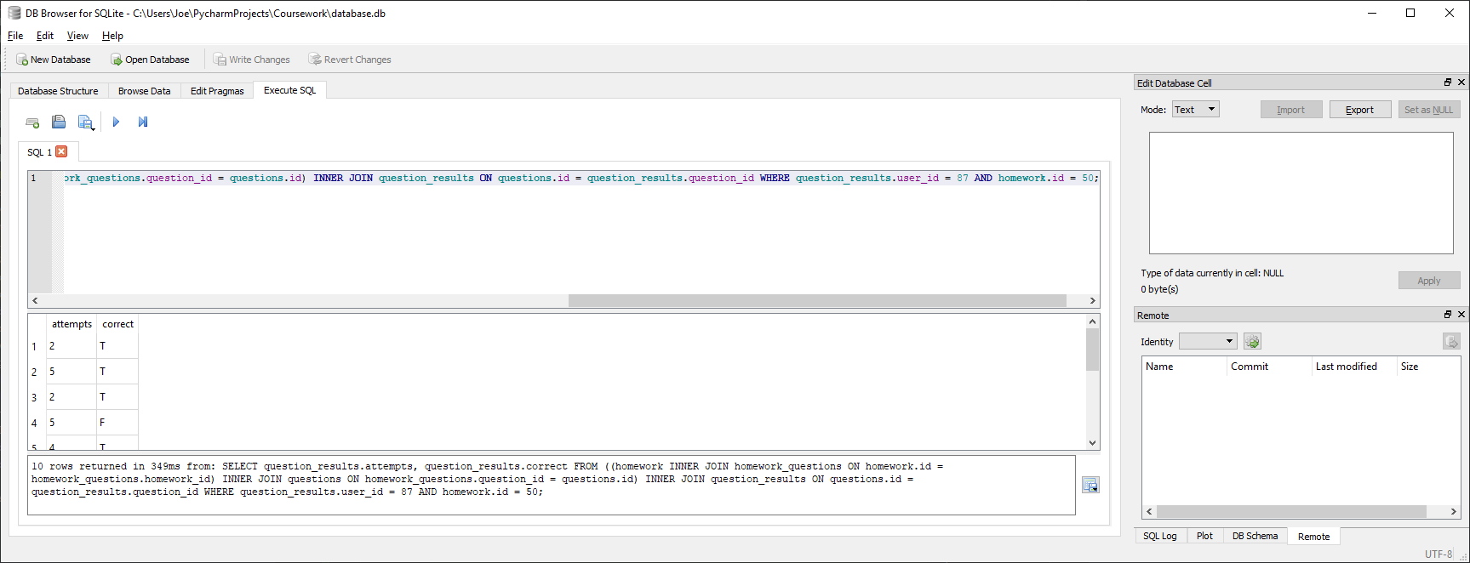

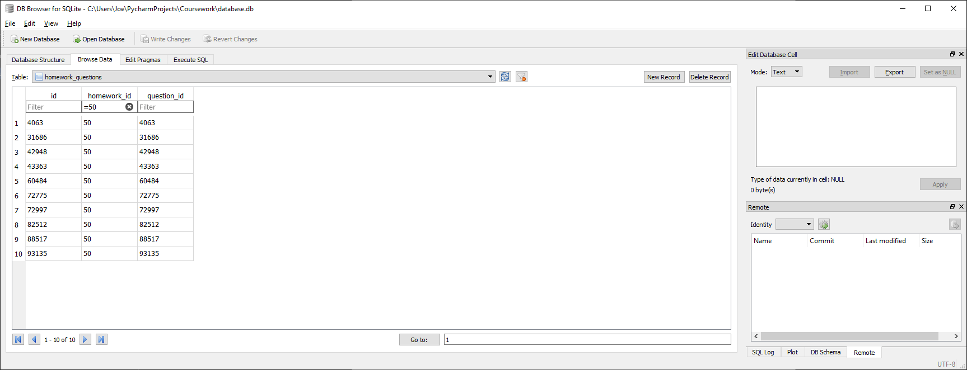

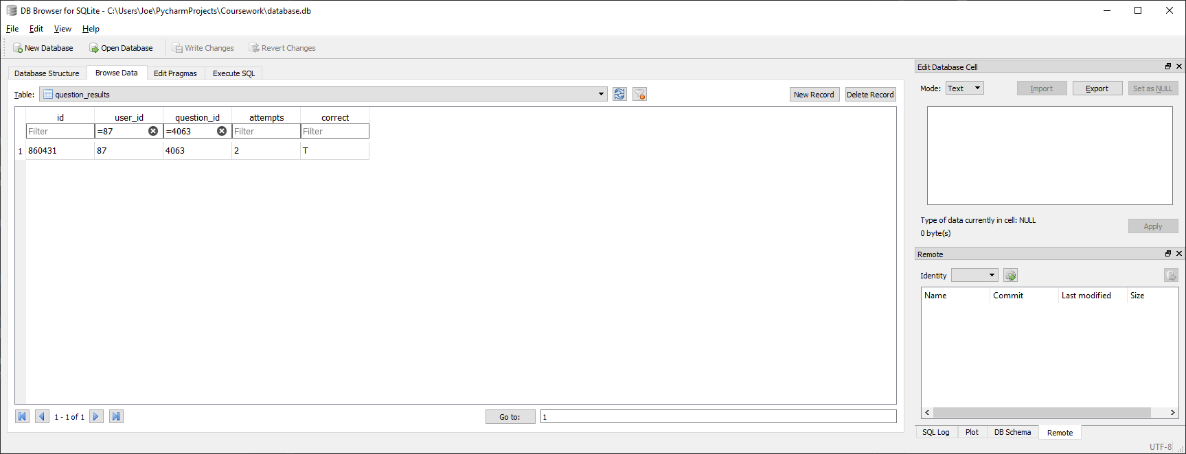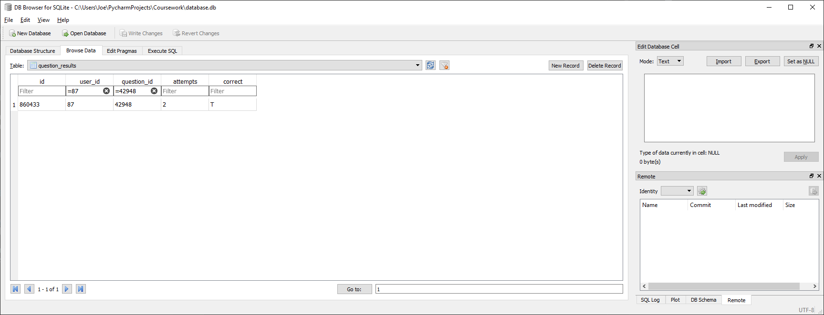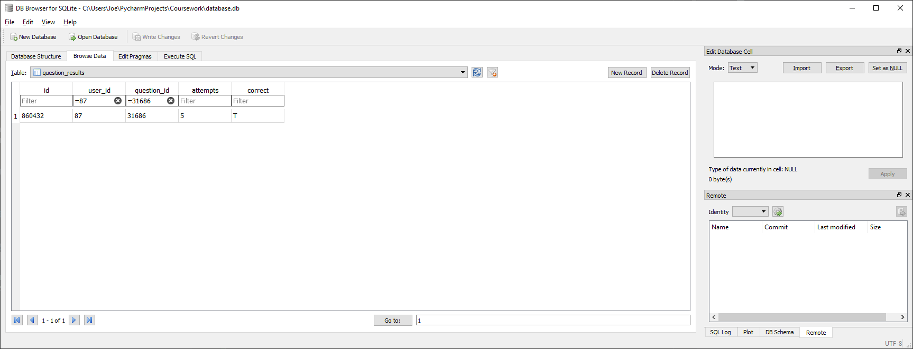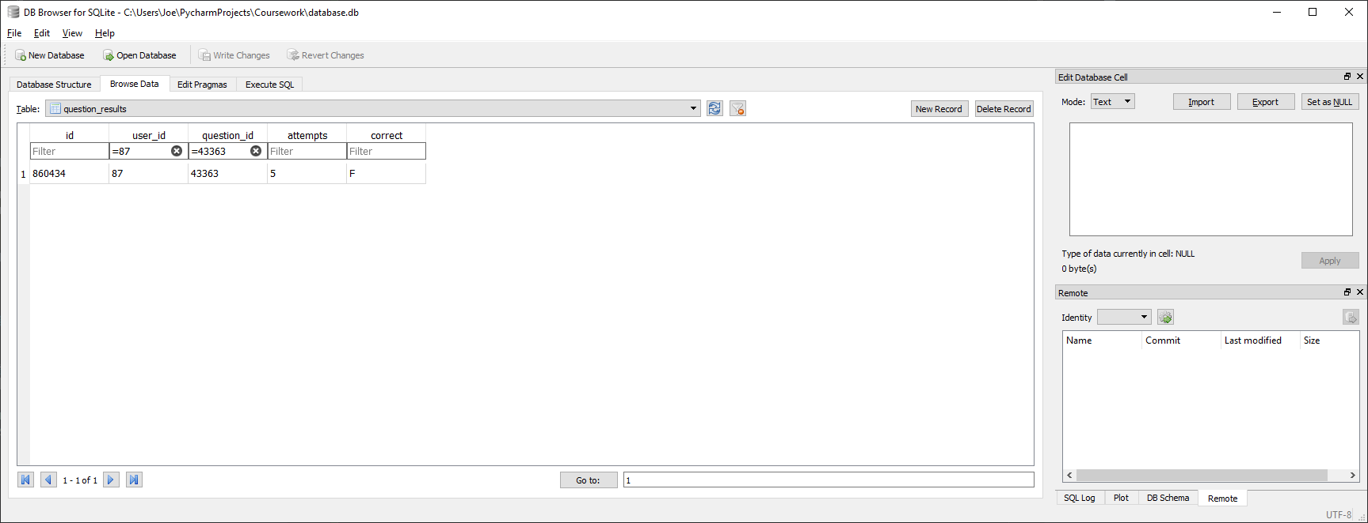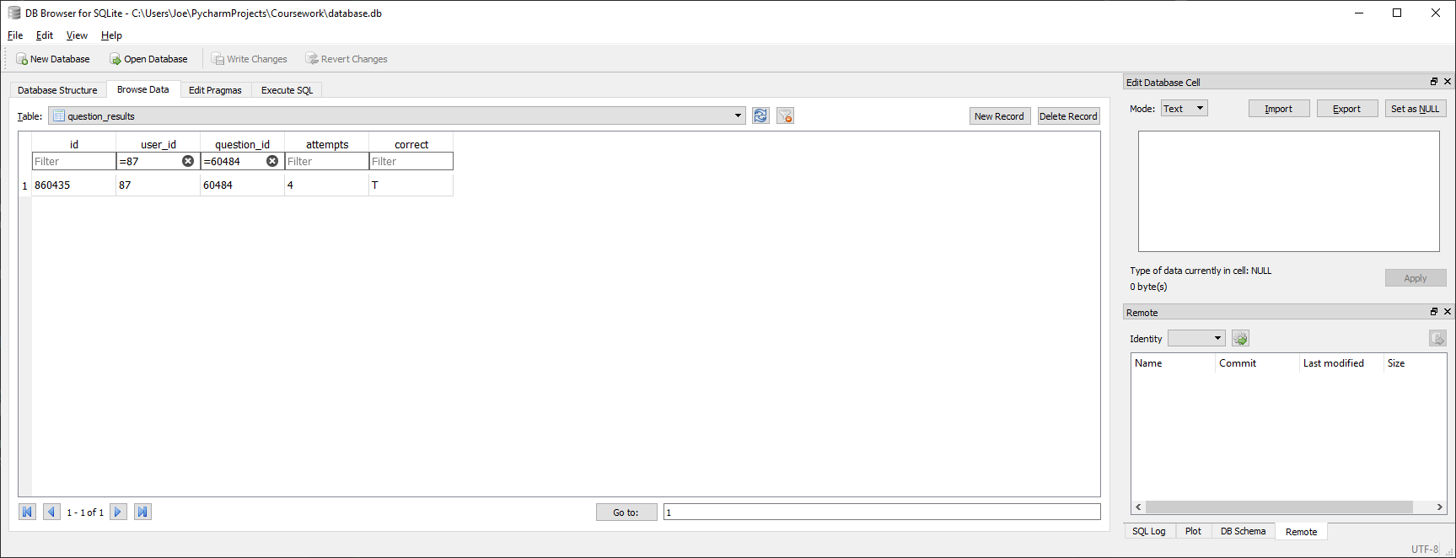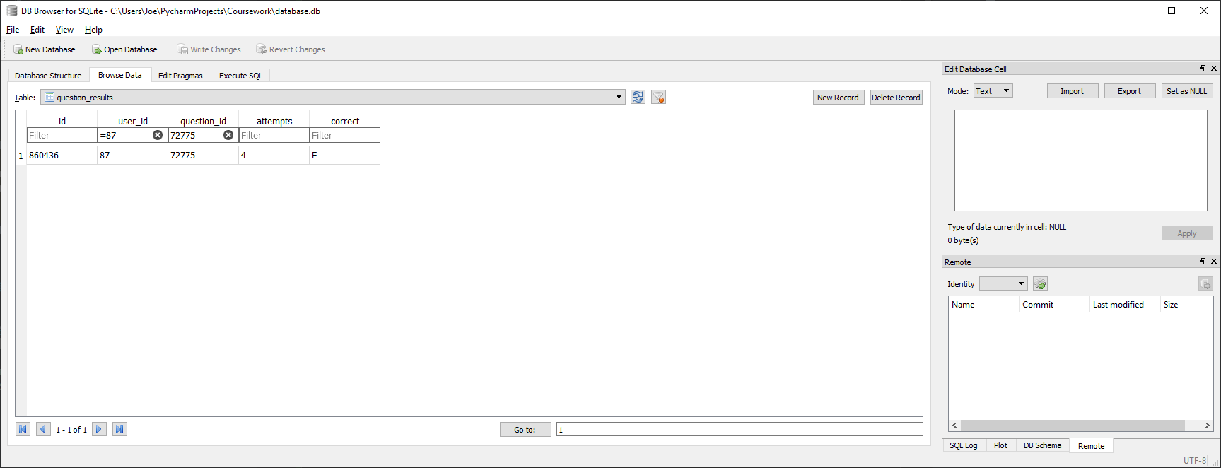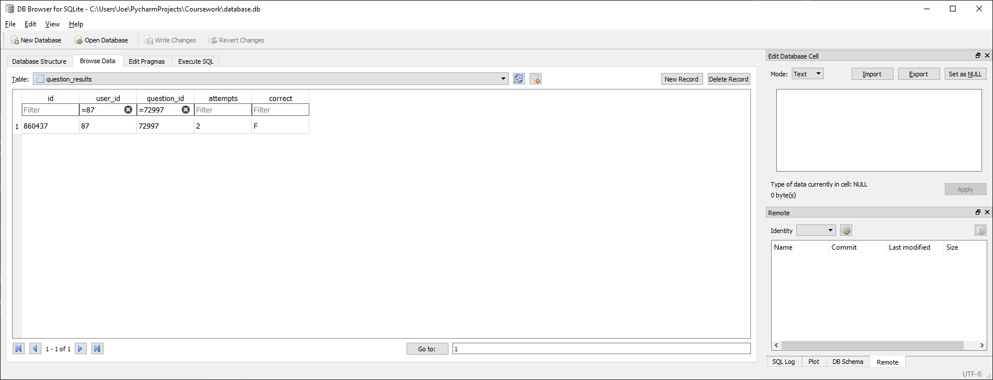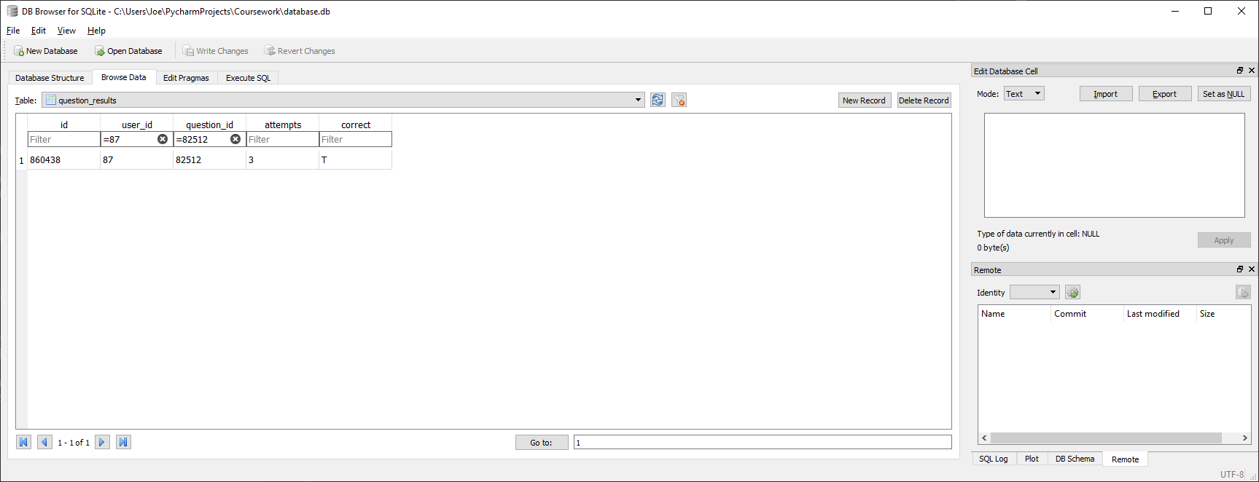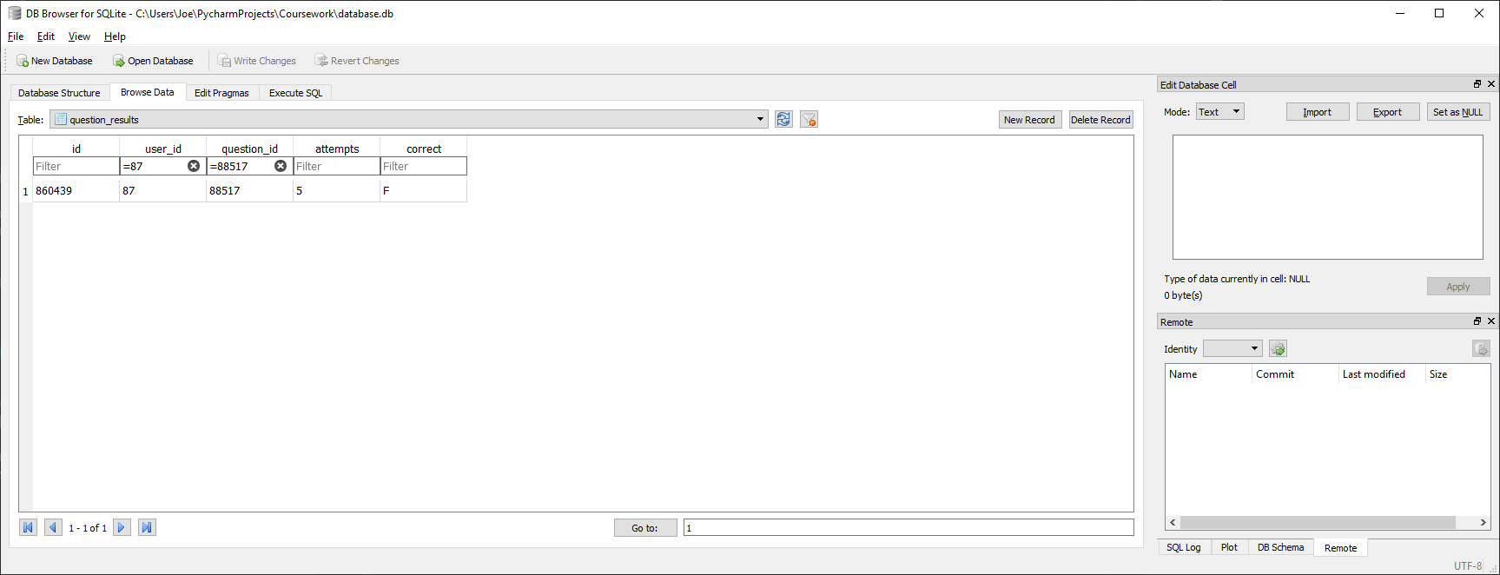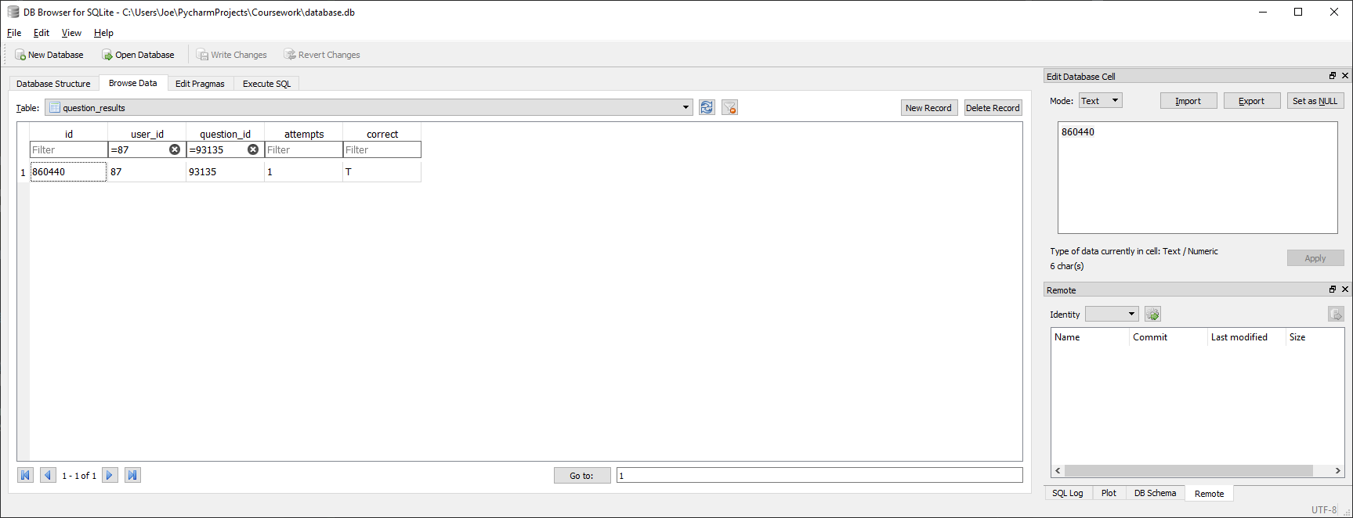

Correctly finds results for the given user (87) for all questions within the homework with the given id (50) and for each question outputs the number of attempts and whether the correct answer has been achieved

##### Test code



##### With valid data:



For this user and homework id the correct answer should be

(((1/2) + (1/2) + (1/5) + (1/4) + (1/3) + (1/1)) / 10) * 100 = 27.8333333333

This rounds to 28% to the nearest whole %

##### With Invalid data:

No question results for given user for given homework (e.g. if a given homework has no questions or the given homework was never set for the given user and no results have therefore been stored)



Errors relating to whether the given homework is within the given class should be addressed before calling the function

##### Evaluation

Function correctly returns the score for a given user in a given homework as a tuple of the format (homework name, score, due date) where the score is a either a percentage or, if the requested score is for any reason invalid, “N/A”

### Function to get the homework name and due date for a given homework id (used in get_homework_score)

#### Final Code



#### Testing

##### SQL

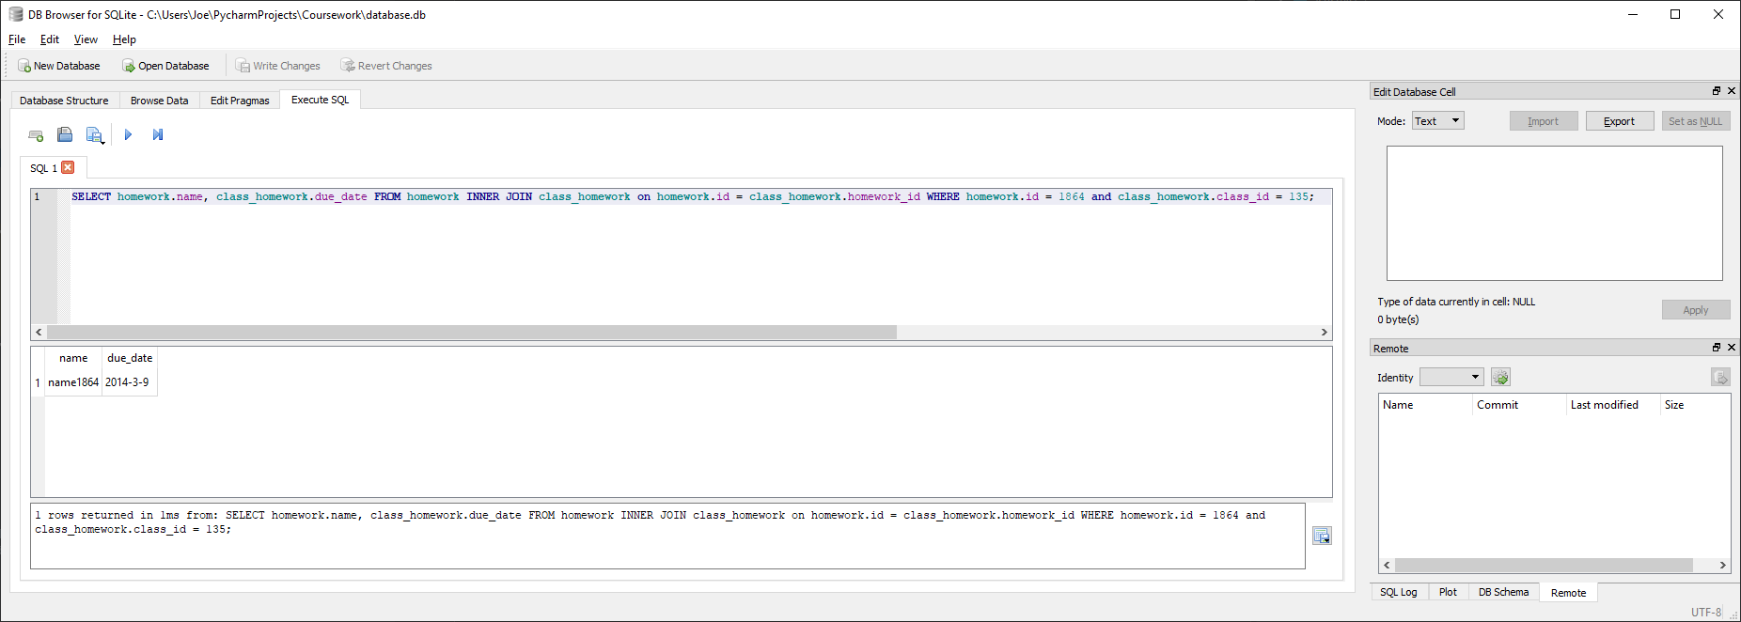

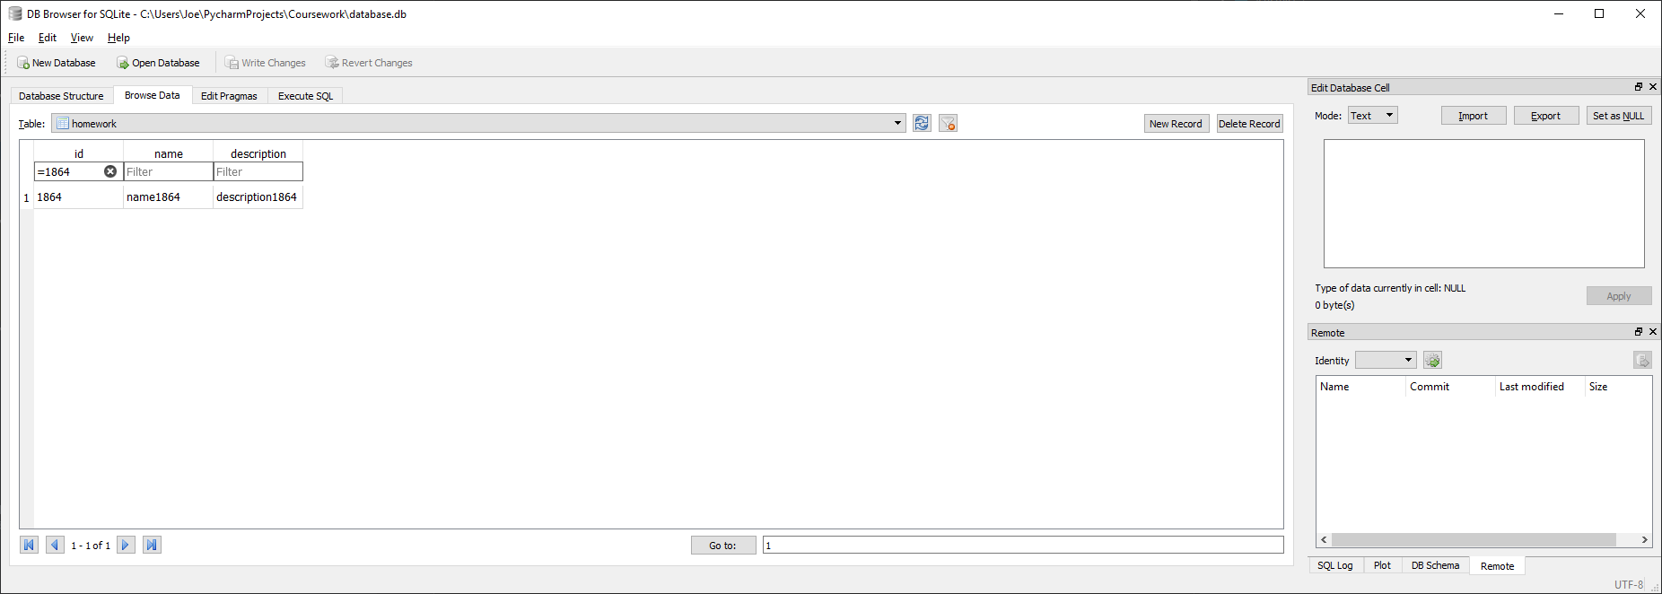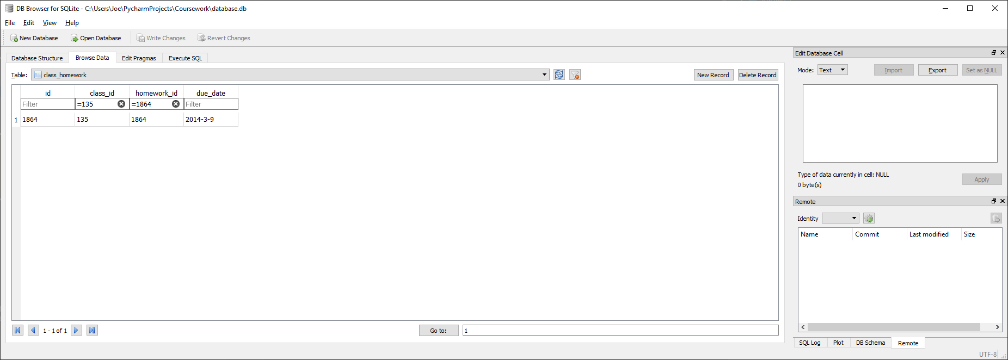

Correctly finds and returns the name and due date stored in the database for homework id 1864 within class 135

##### Test code



##### With valid data:



##### With Invalid data:

N/A, any errors should be addressed before calling function by verifying given homework is assigned to given class

##### Evaluation

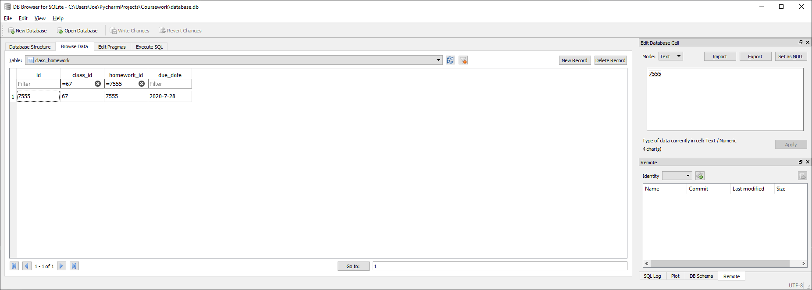

Function correctly returns list of the format (homework name, homework due date) for the given homework and class ids

### Function to insert a student into a class

#### Final Code



#### Testing

##### SQL

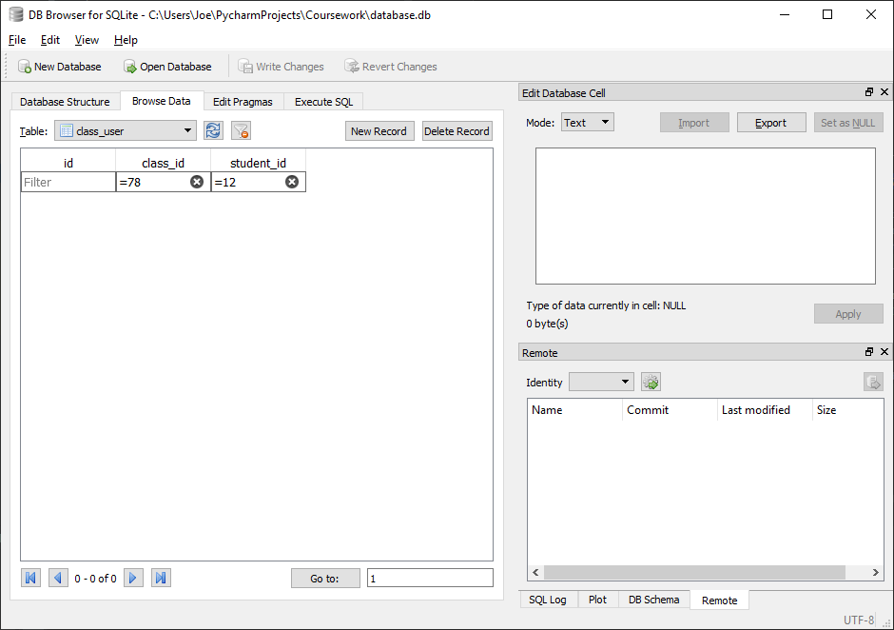

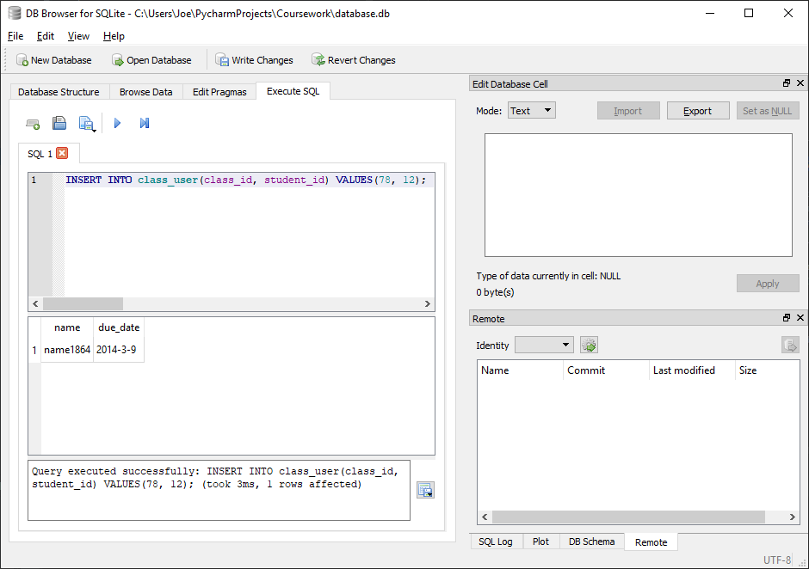

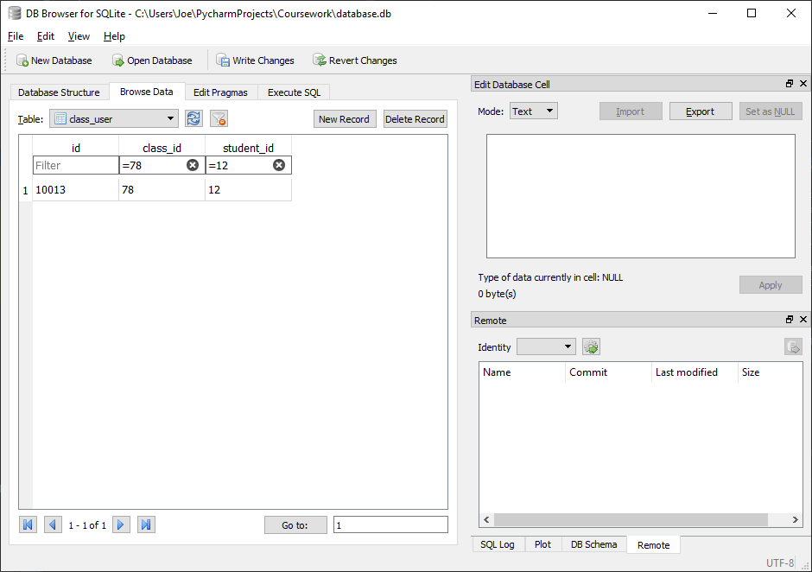

Correctly inserts an entry into class_user linking class 78 to student 12

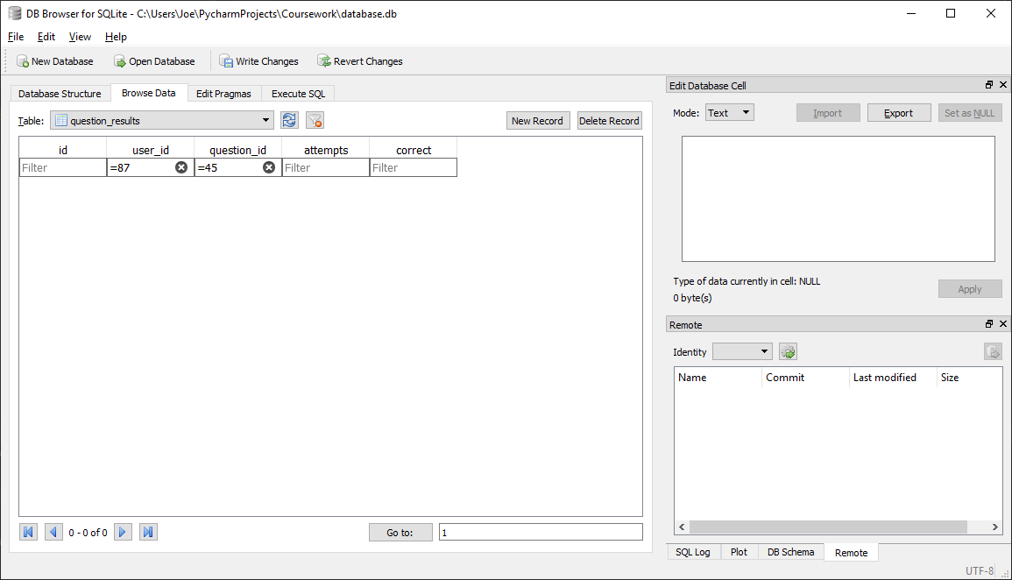

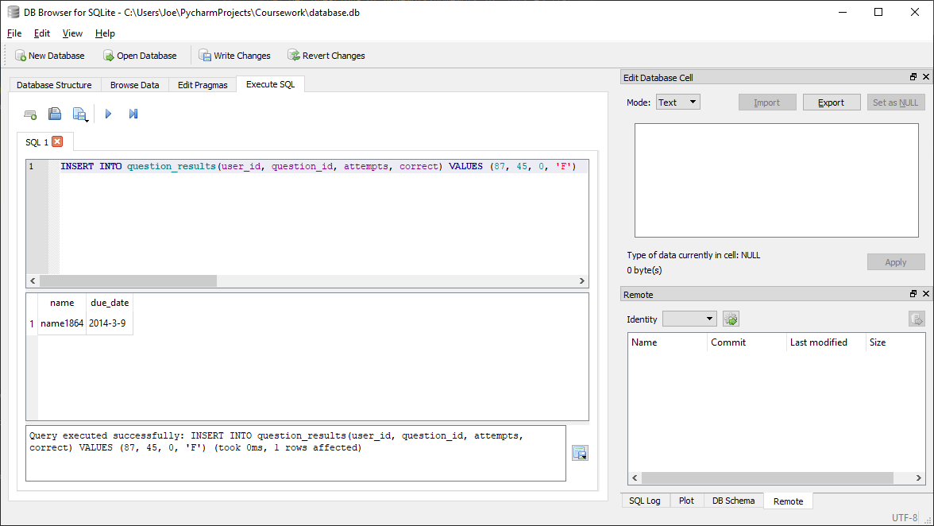

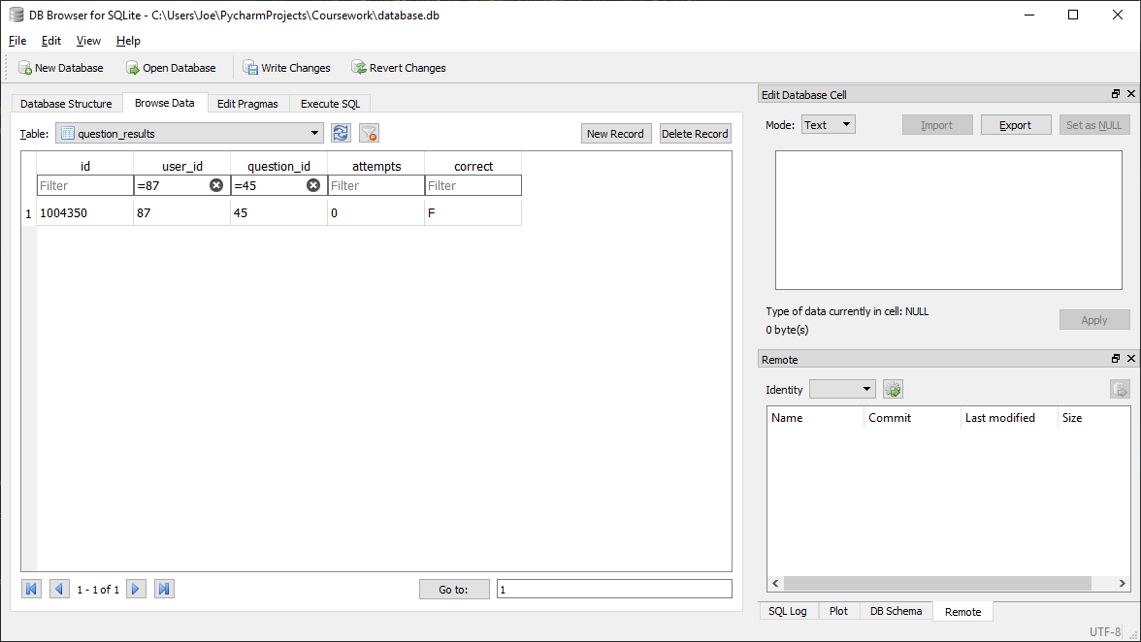

Correctly inserts an entry into question_results linking student 87 to question 45 with attempts and correct set to desired values

##### Test code



##### With valid data:

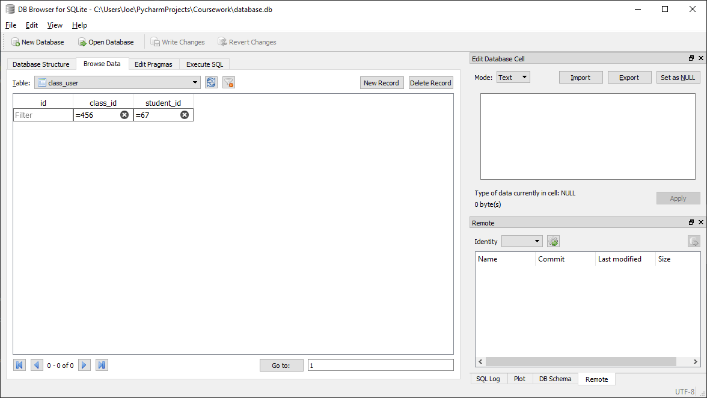



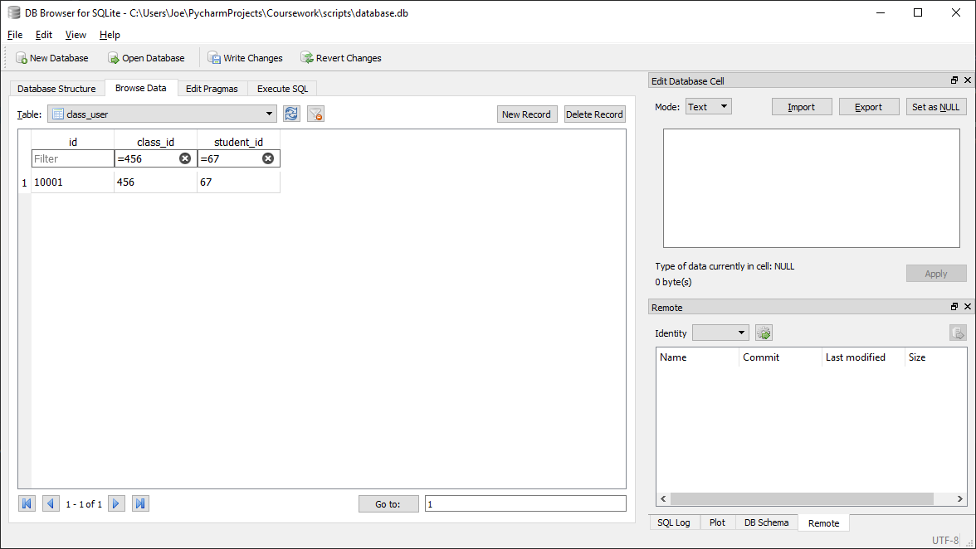

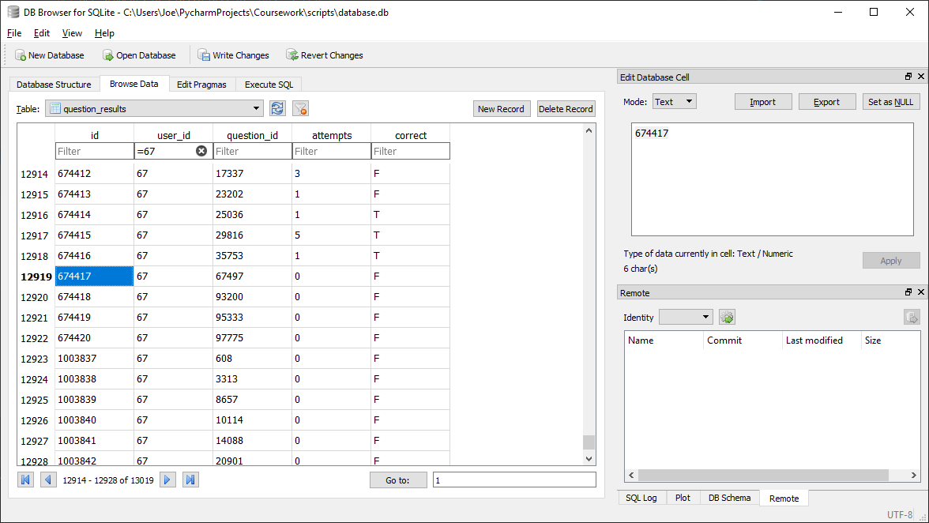

##### With Invalid data:

N/A, any errors should be addressed before calling function by verifying student is not already in class before calling function

##### Evaluation

Function correctly inserts user-class relationship into class_user table and inserts all required results into question_results table

### Function to check if a given student is in a class

#### Final Code



#### Testing

##### SQL

###### User in class

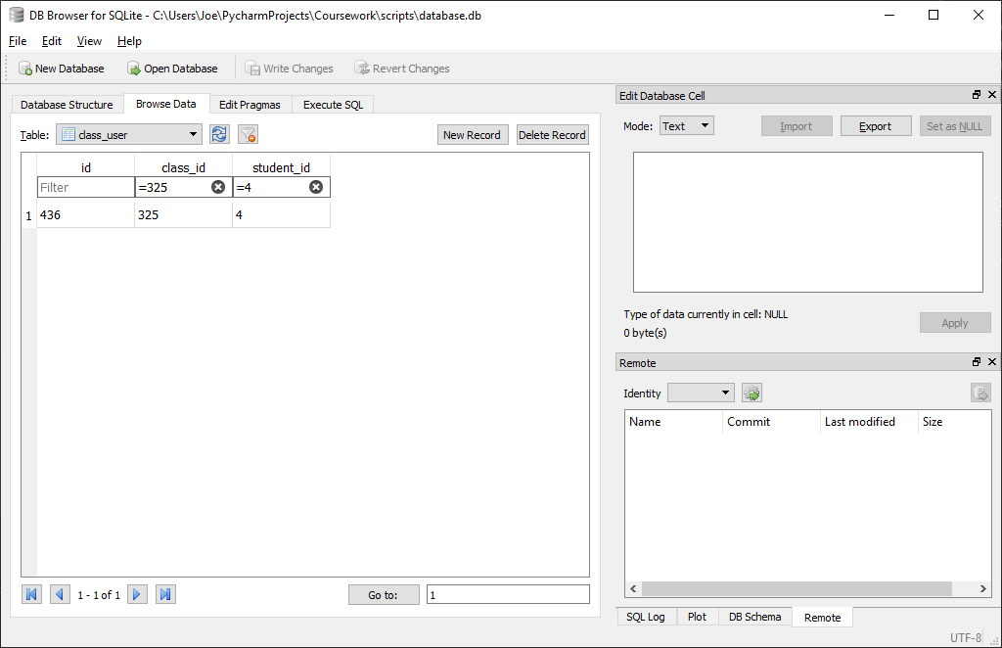

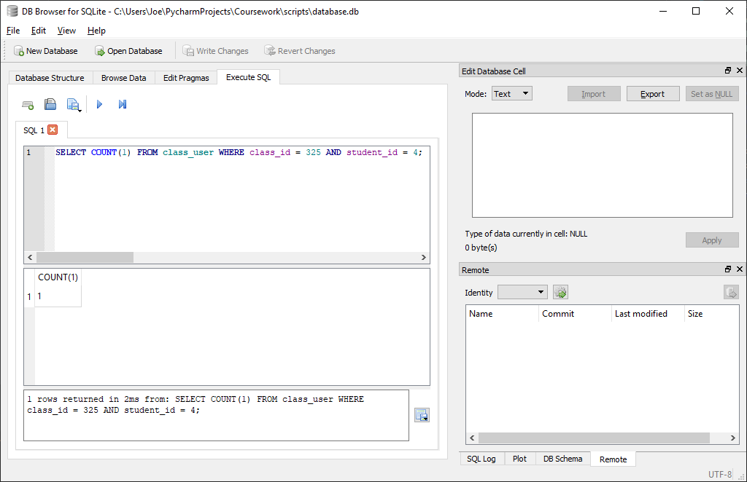

Correctly identifies that user 4 is in class 325

###### User not in class

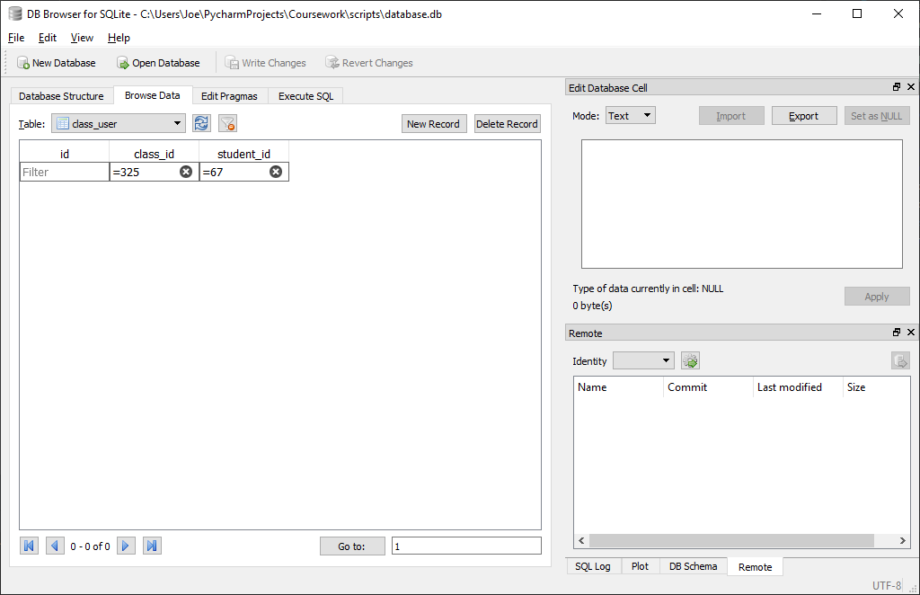

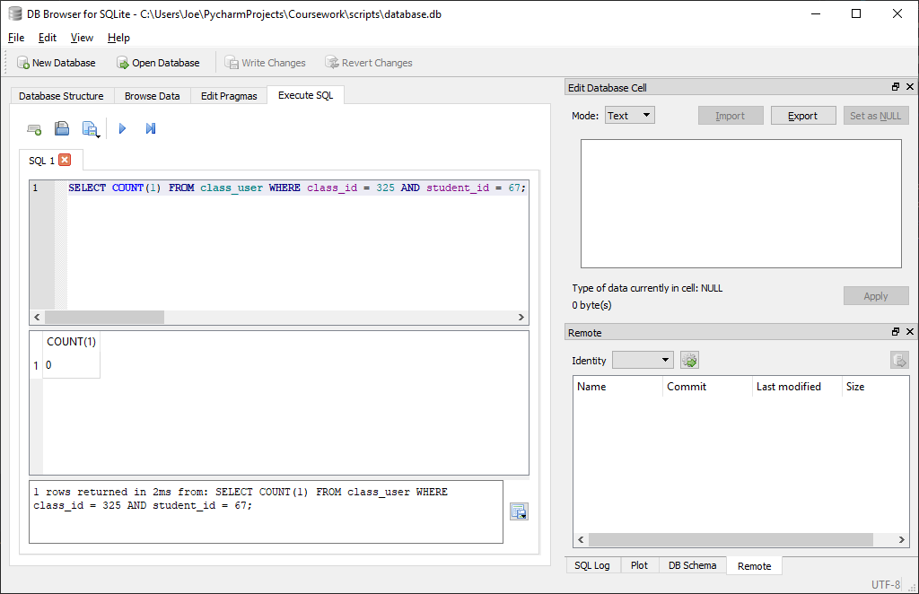

Correctly identifies that user 67 is not in class 325

##### Test code



##### With valid data:

###### User in class

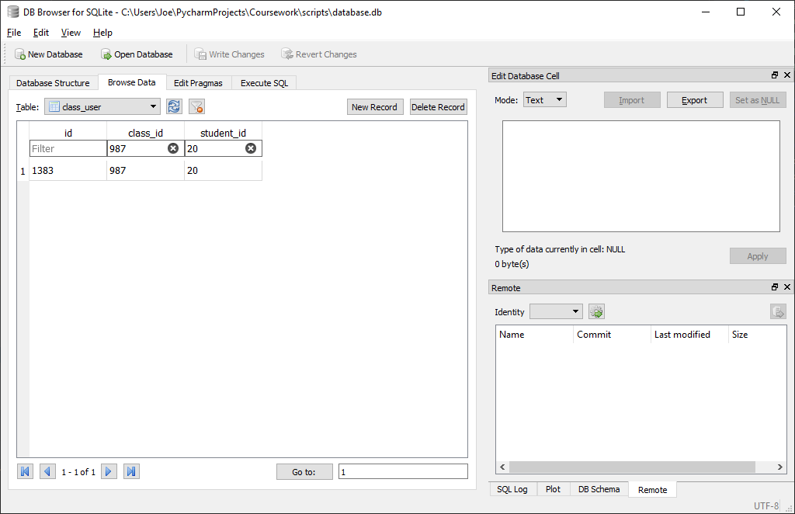



###### User not in class

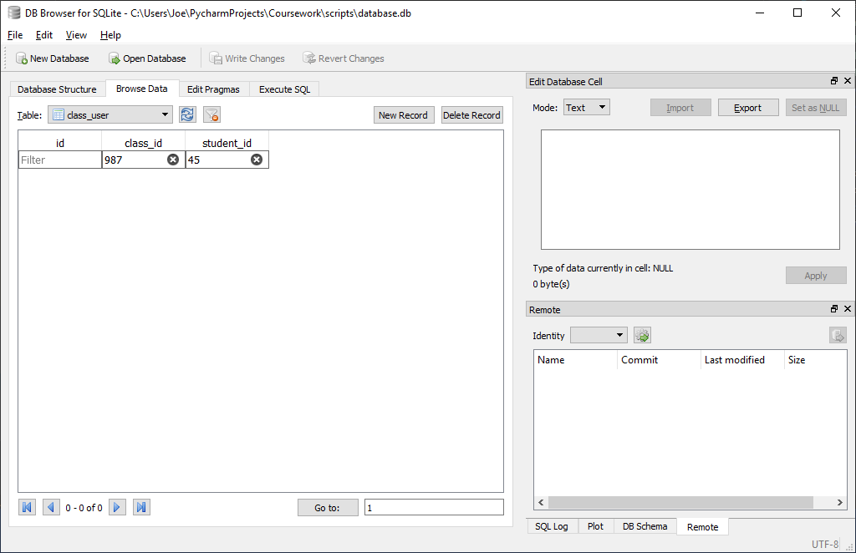



##### With Invalid data:

N/A, class_id should be verified to exist and student_id verified to be an integer before calling function

##### Evaluation

Function correctly returns True if the given user is in the given class and False otherwise

### Function to remove a student from a class

#### Final Code



#### Testing

##### SQL

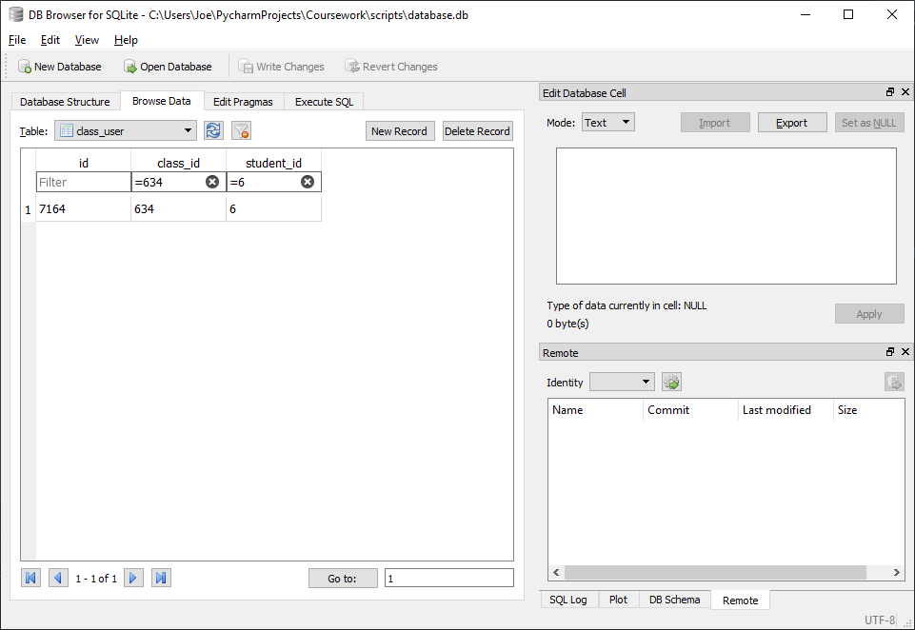

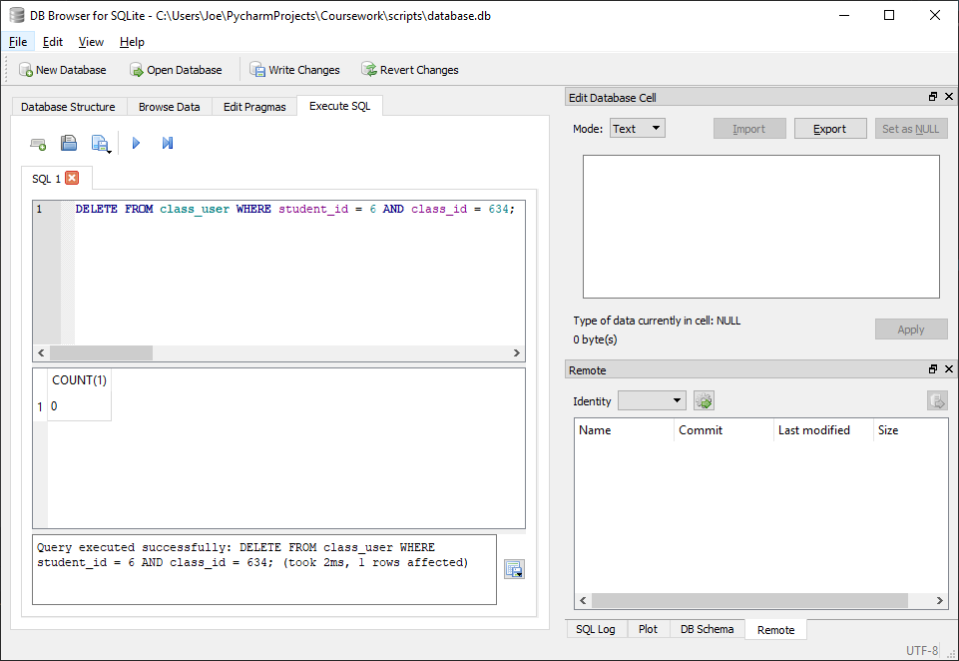

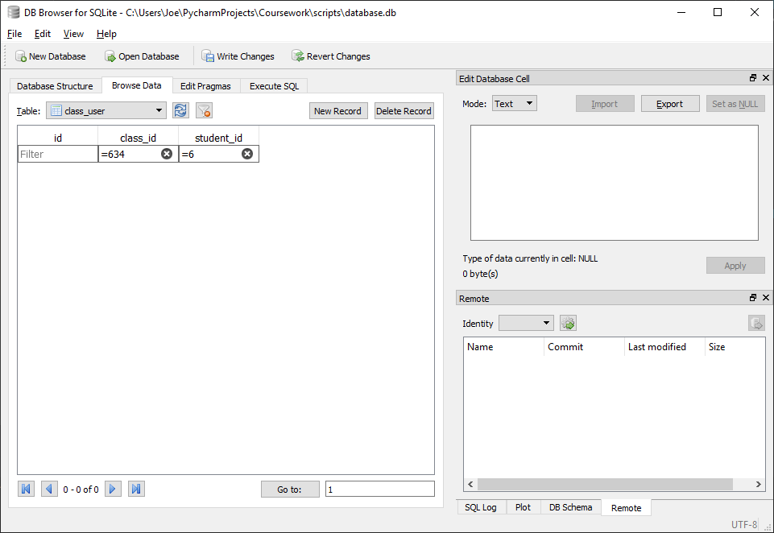

Correctly removes student 6 from class 643

##### Test code



##### With valid data:

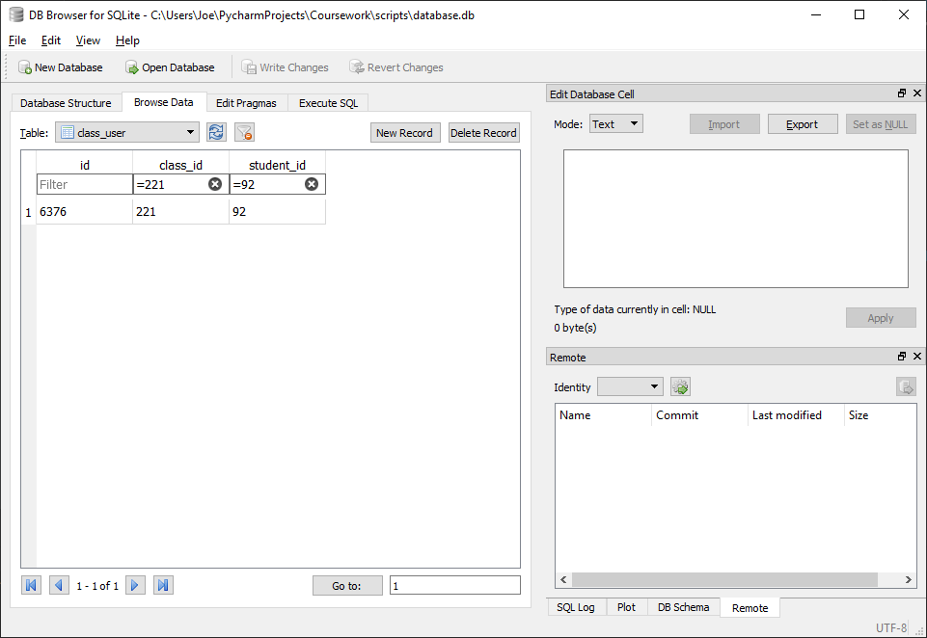



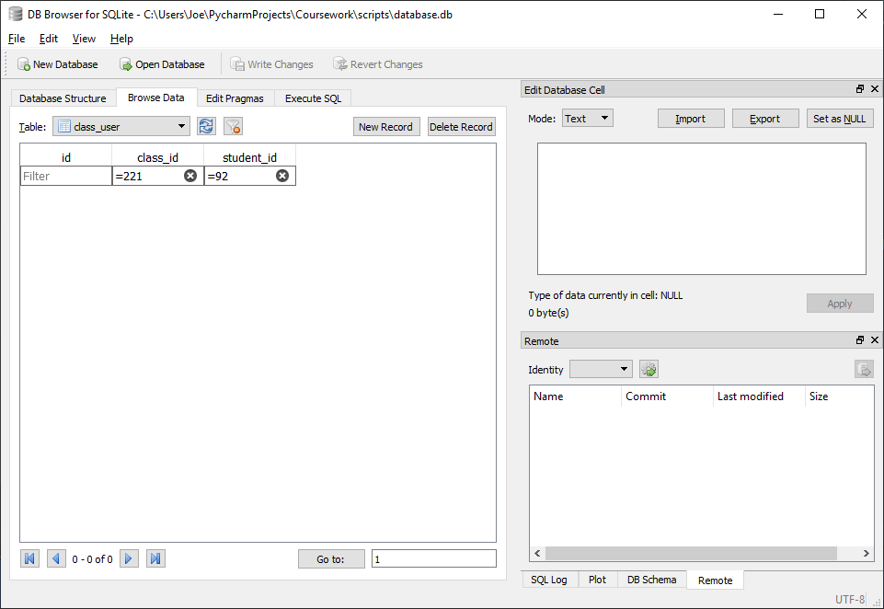

##### With Invalid data:

N/A, class_id should be verified to exist and student_id verified to be in class before calling function

##### Evaluation

Function correctly removes entry in class_user linking given student to given class

### Function to create a new class

#### Final Code



#### Testing

##### SQL

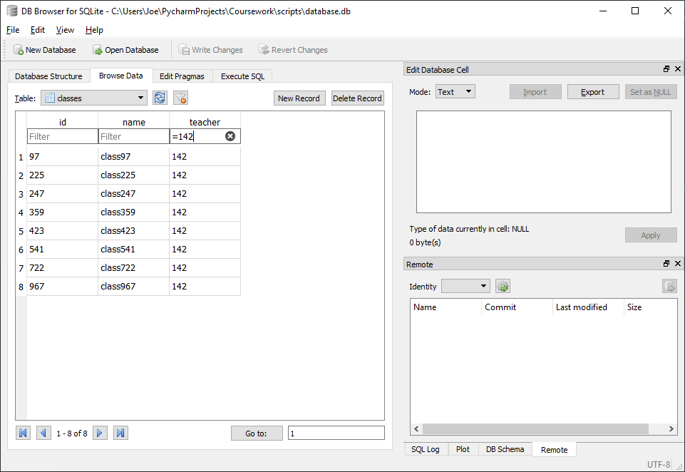

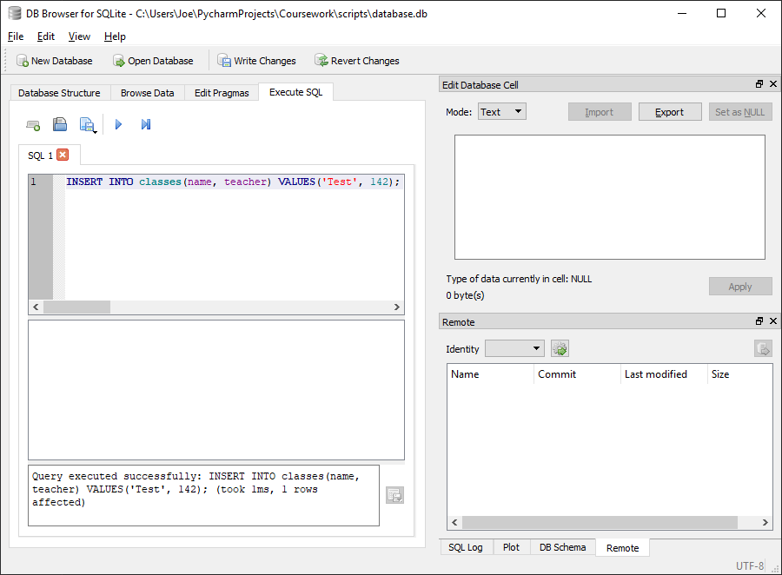

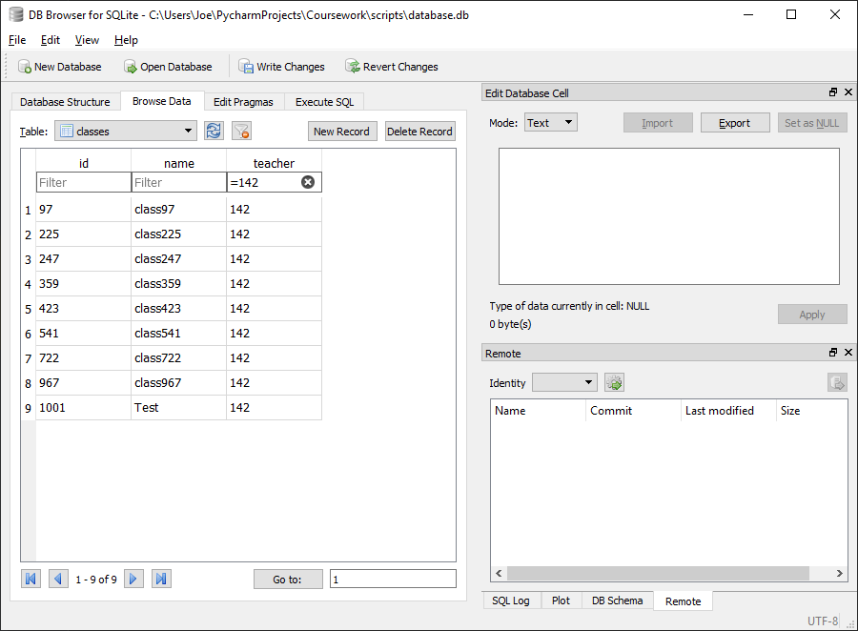

Entry in classes for new class with appropriate name (Test) and teacher id (142) successfully added

##### Test code



##### With valid data:

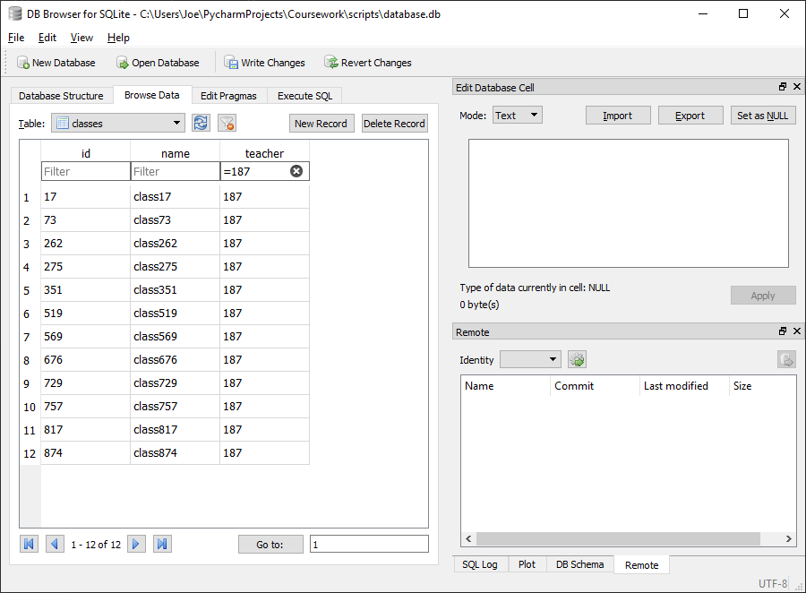



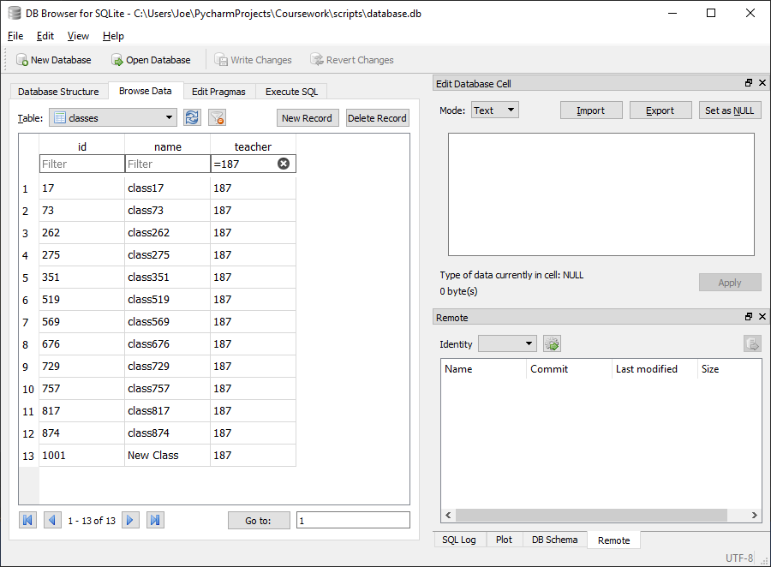

##### With Invalid data:

N/A, teacher_id should be verified to exist before calling function

##### Evaluation

Function correctly inserts new class into database with the appropriate class name and teacher id

### Function to remove a class

#### Final Code



#### Testing

##### SQL

###### Remove class from class_user

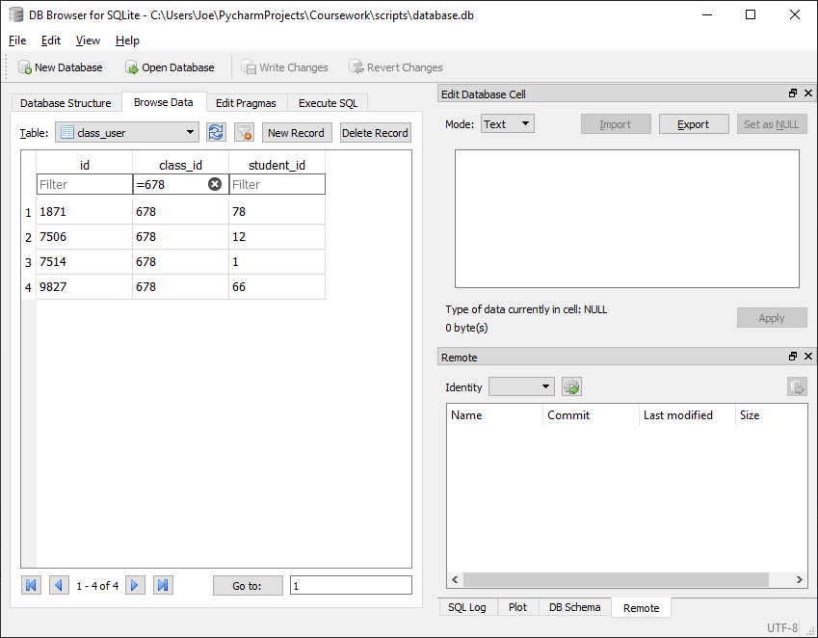

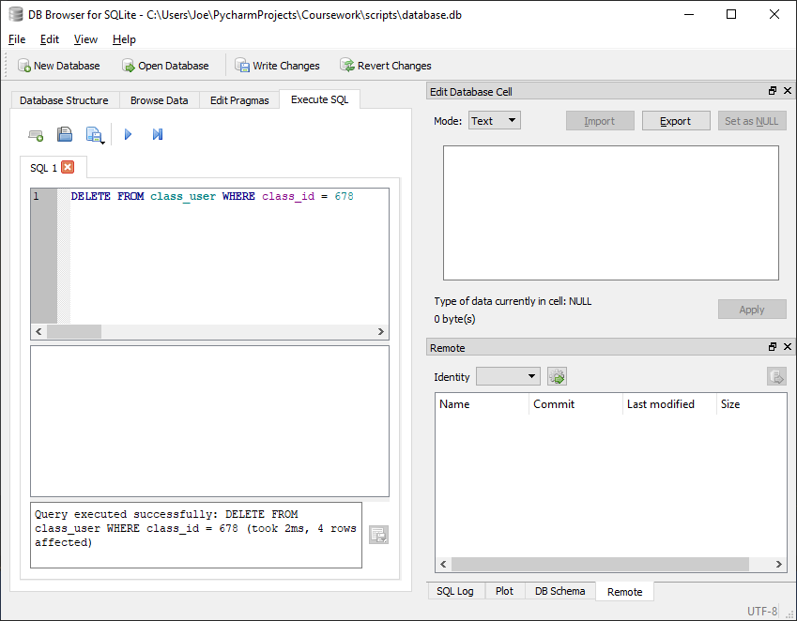

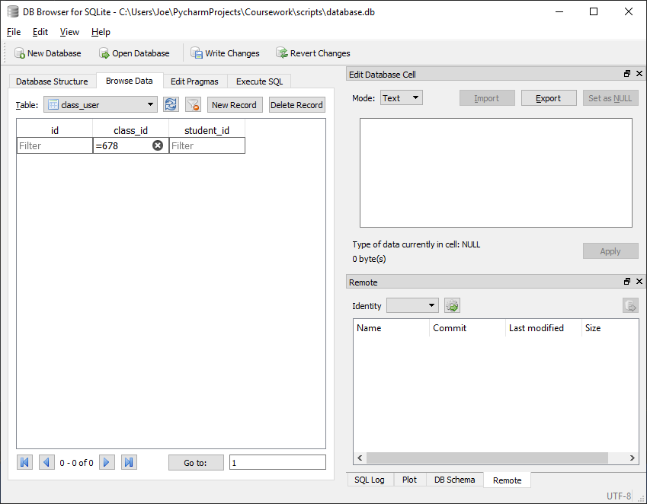

Successfully removes all references to given class (678) from class_user table

###### Remove class from class_homework

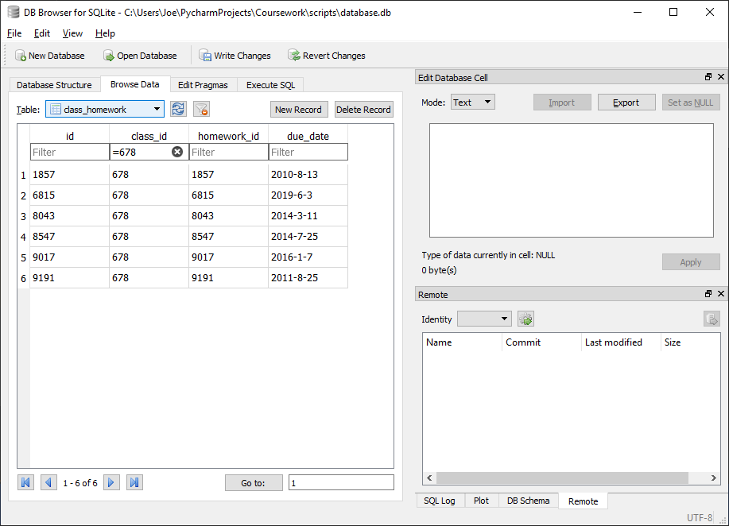

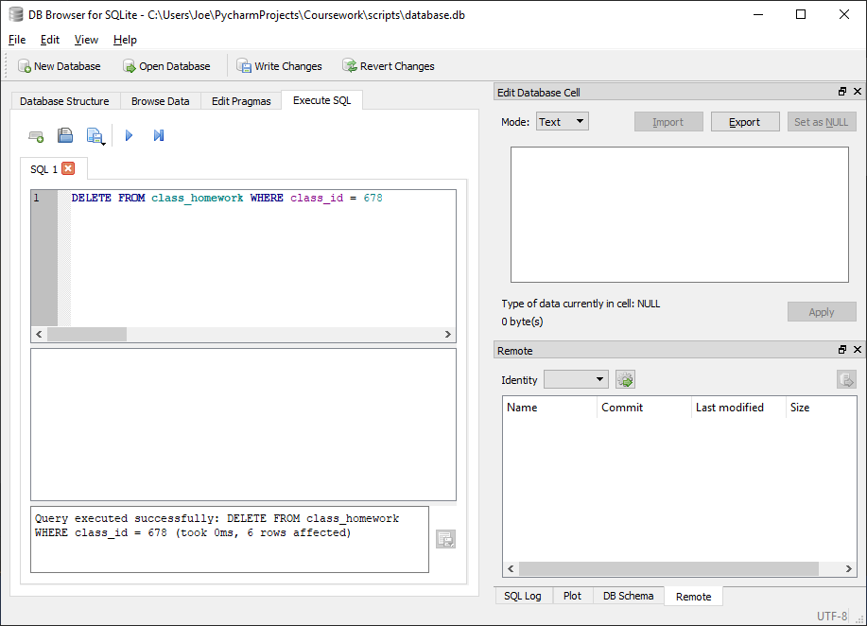

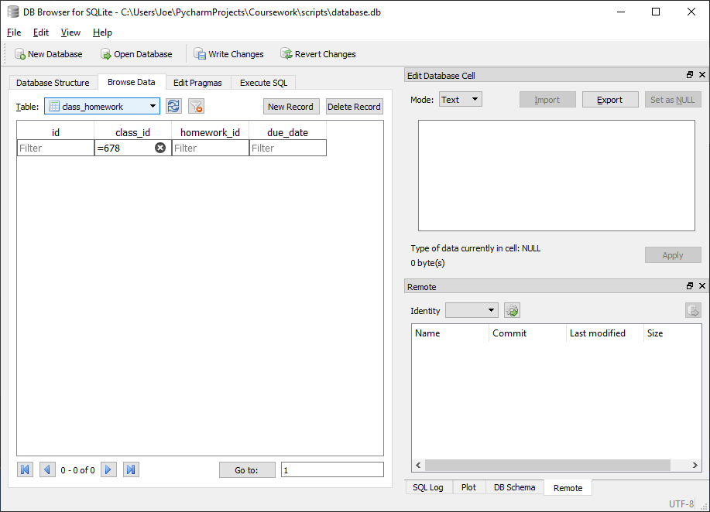

Successfully removes all references to given class (678) from class_homework table

###### Remove class from classes

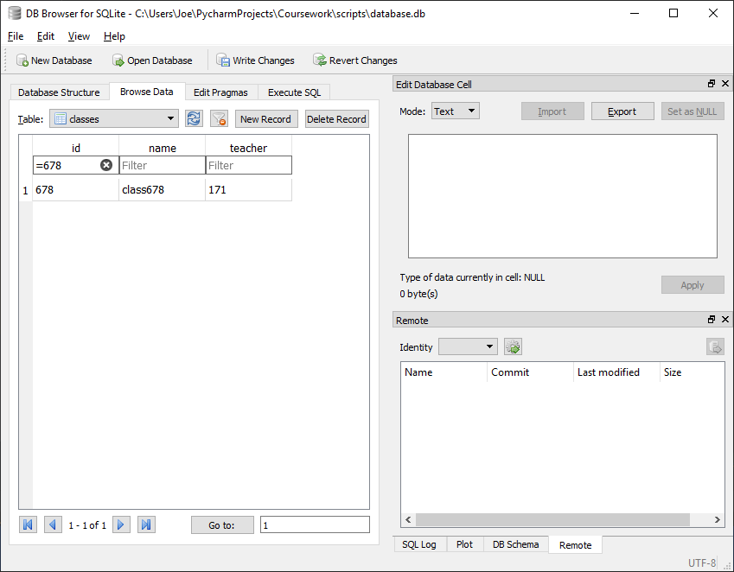

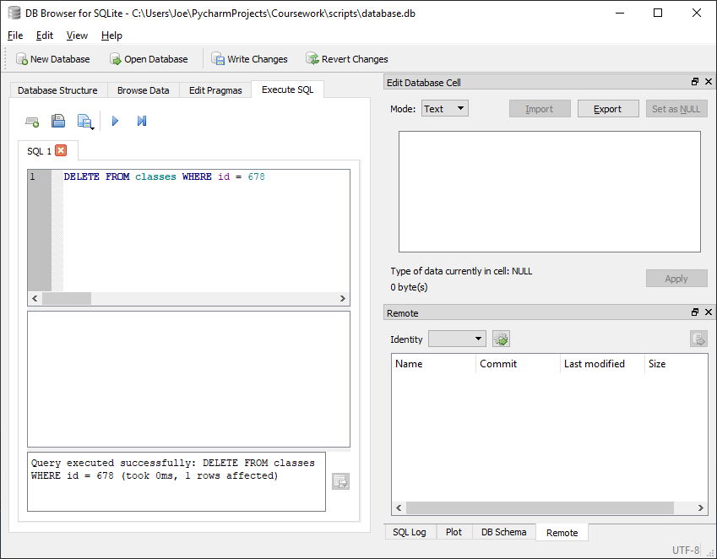 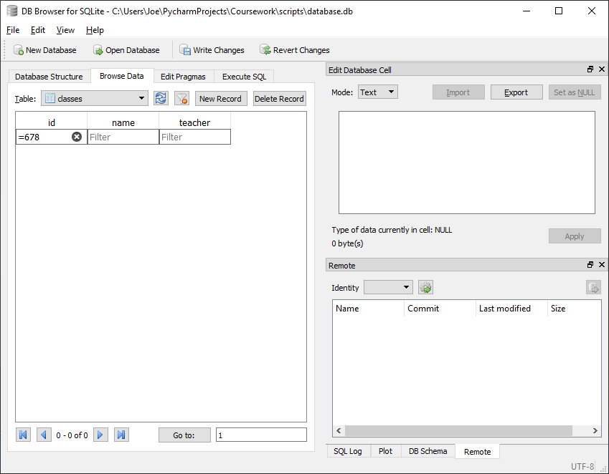

Successfully removes all references to given class (678) from classes table

##### Test code



##### With valid data:

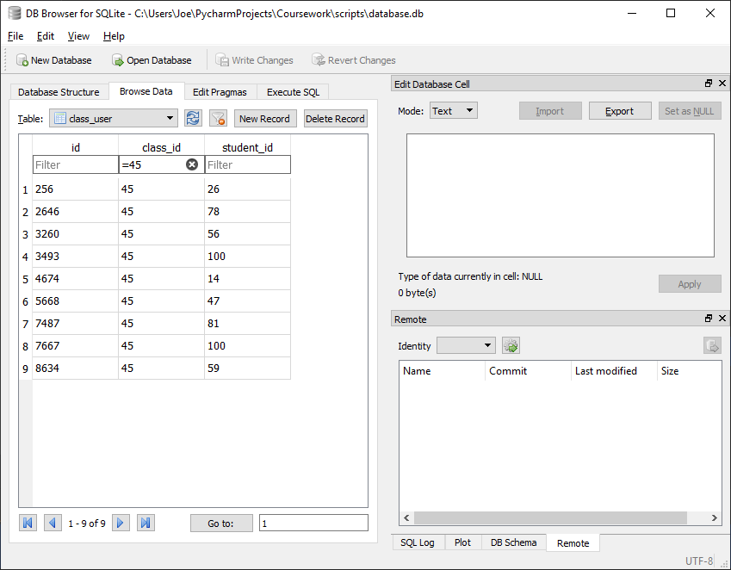

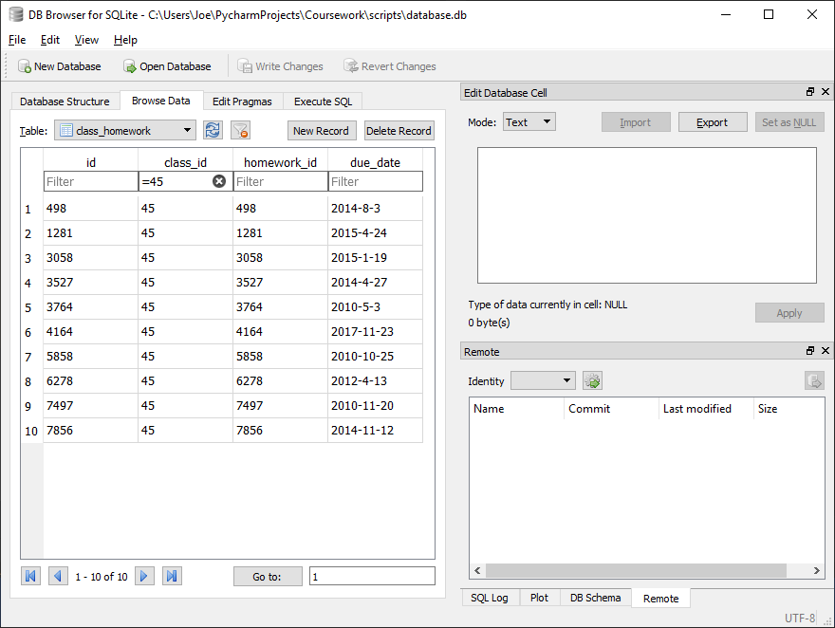

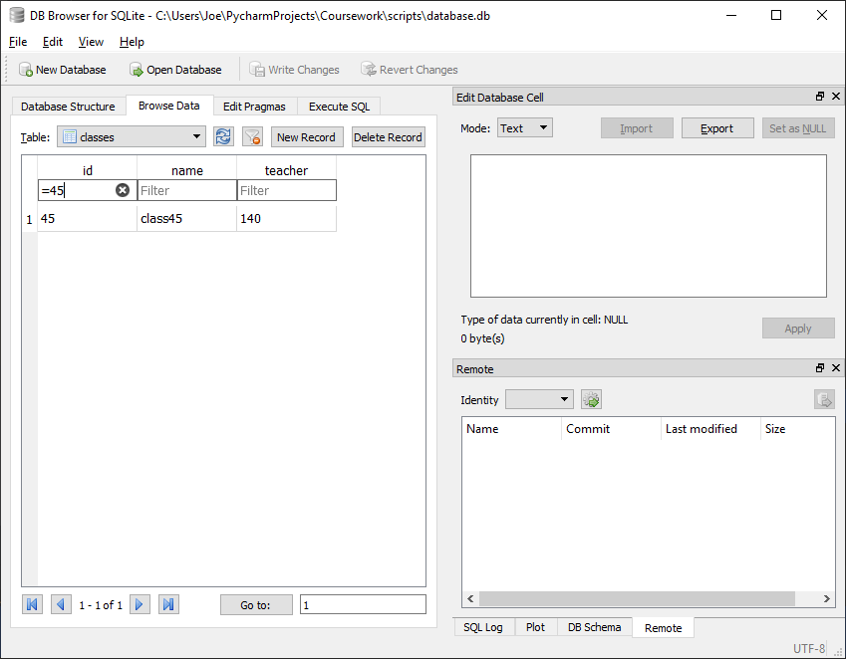



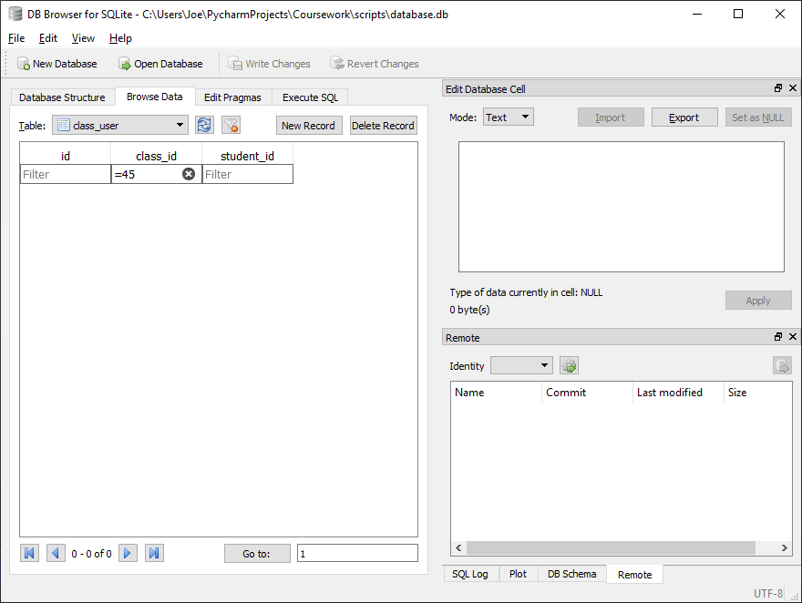

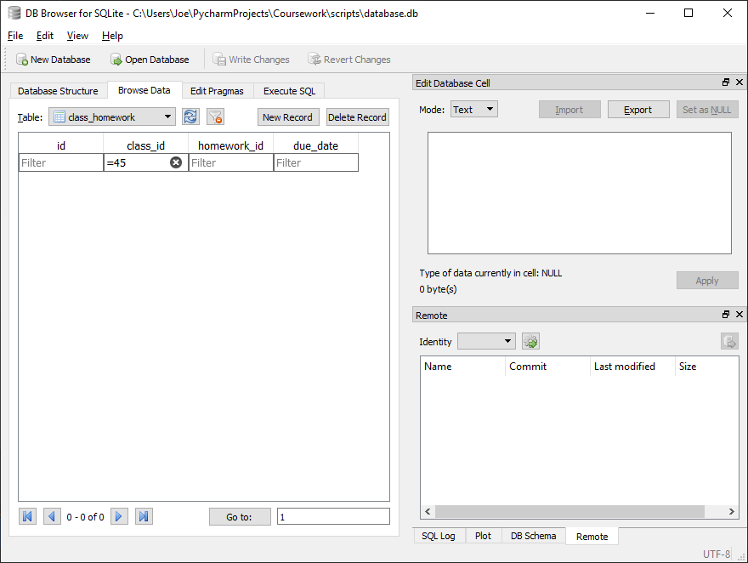

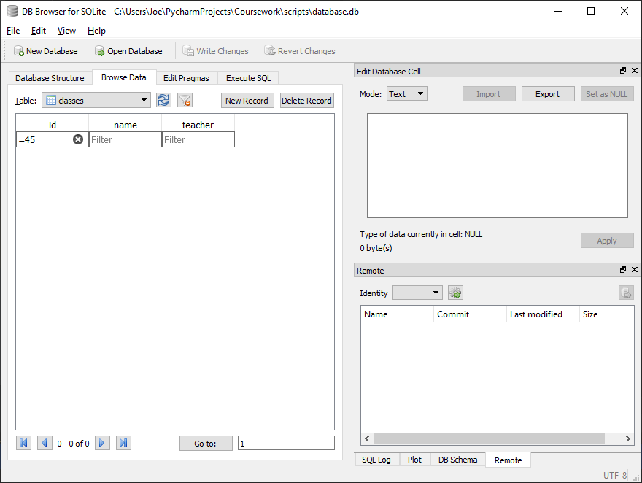

##### With Invalid data:

N/A, class_id should be verified to exist before calling function

##### Evaluation

Function correctly removes all references to the given class in all tables where it may occur (class_user, class_homework, classes)

### Function to get results for a homework for all students in a class

#### Issues during development

Initially the below code was implemented:



This would result in an error occurring if for any reason the question count took a value of 0 (if a given homework has no questions or the given homework was never set for the given user and no results have therefore been stored).



This was fixed by placing the calculation of the percentage within a try statement and defining that if a division by zero error occurs then the score to be returned is “N/A” (i.e. the score being requested is invalid).



#### Final Code



#### Testing

##### SQL

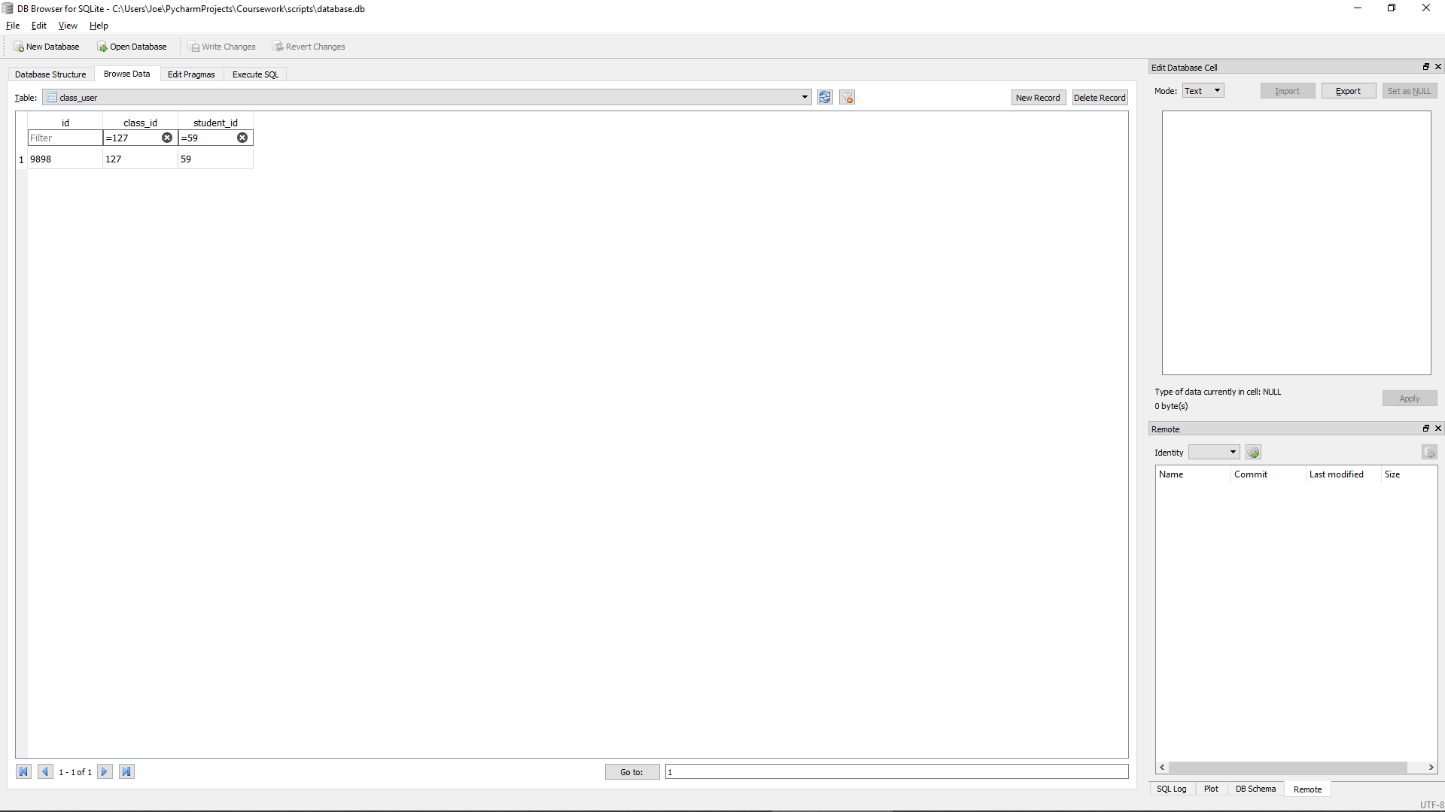

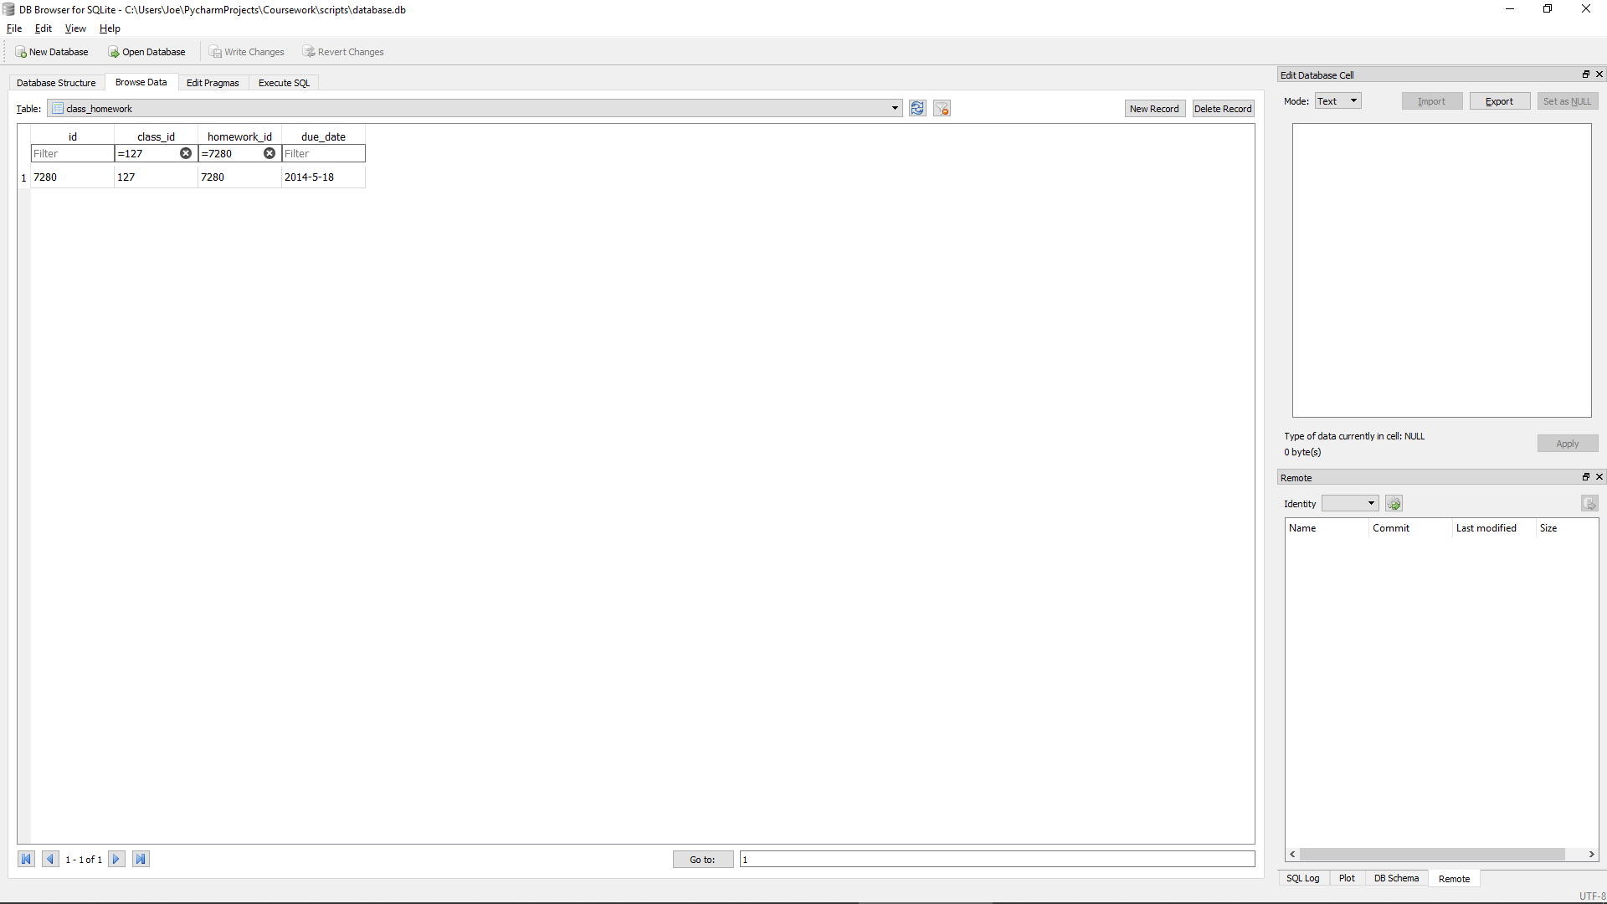

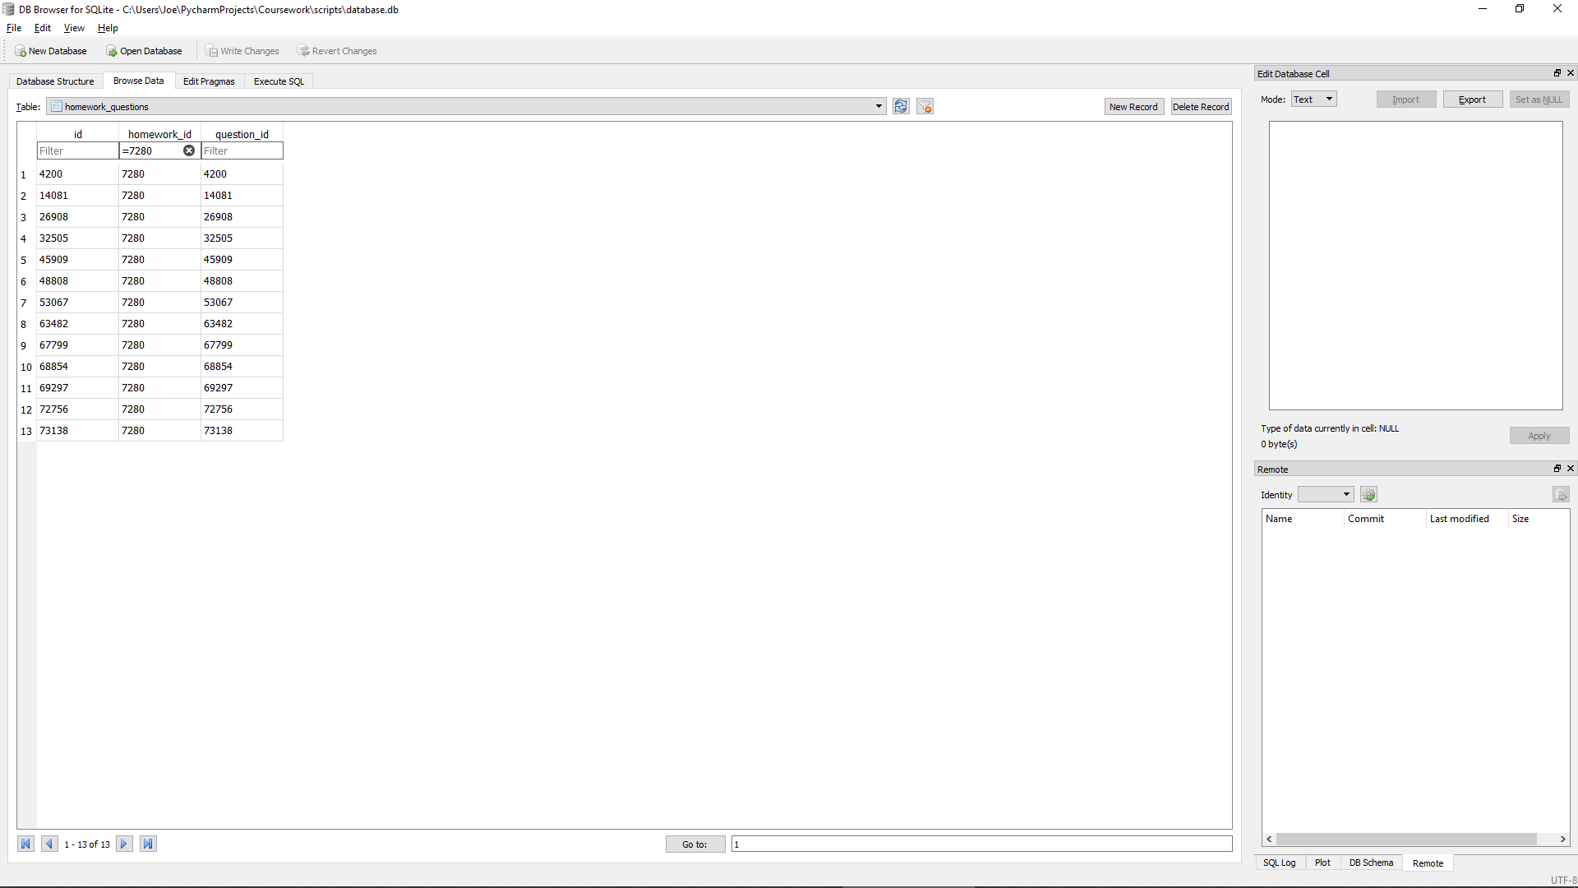

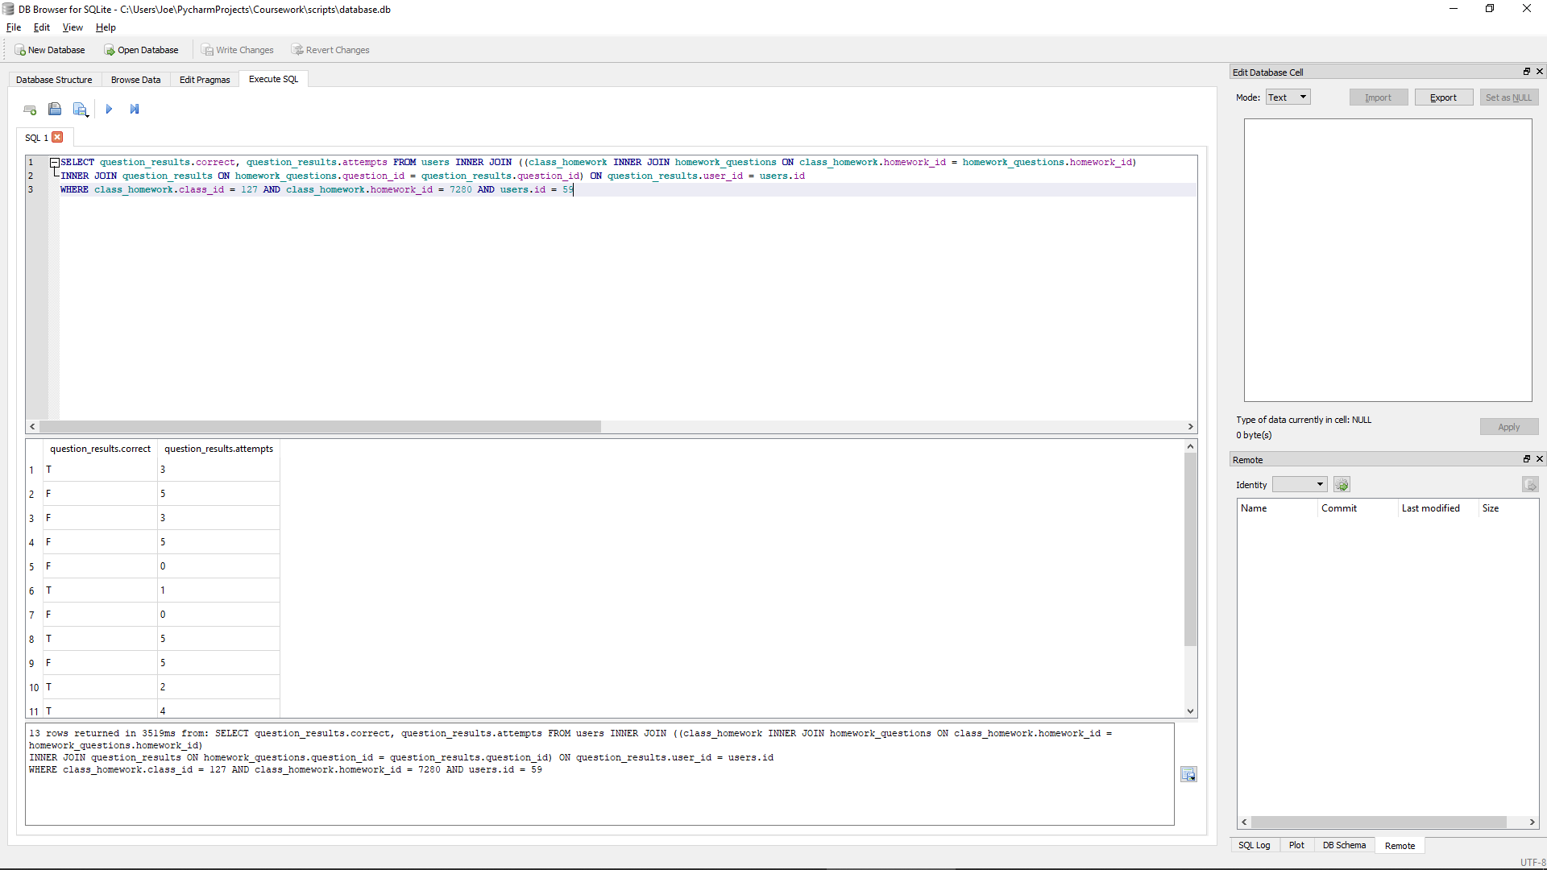

Correctly finds the correct status and number of attempts for each question in the given homework (7280) in the given class (127) for the given user (59)

##### Test code



##### With valid data:

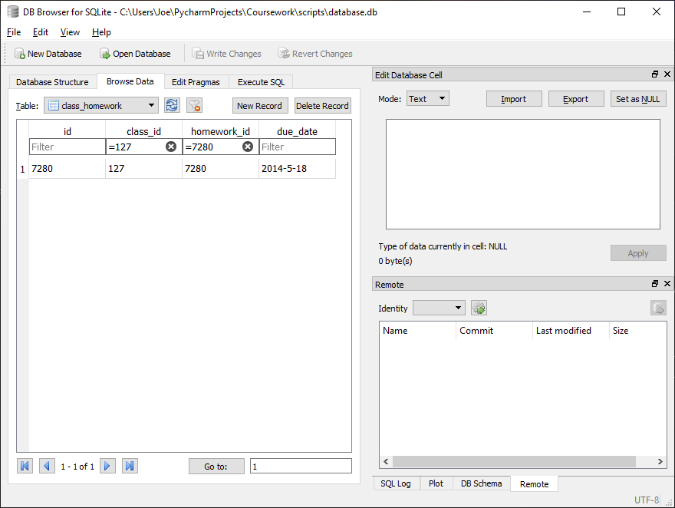

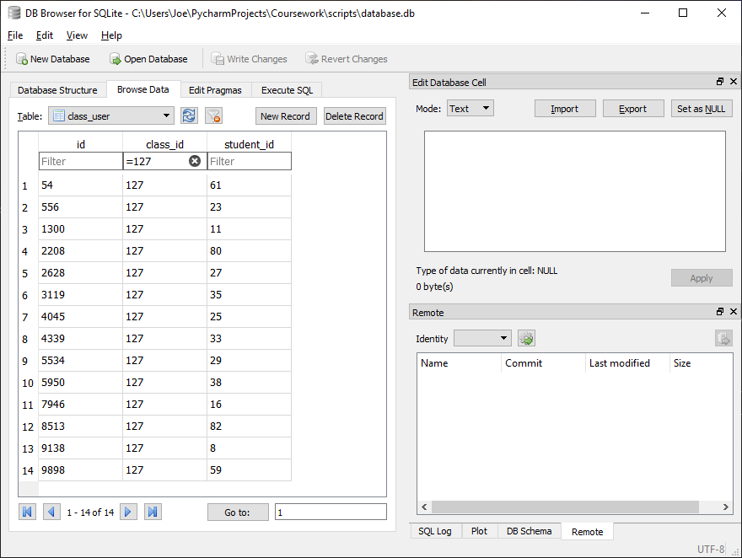

Correctly outputs correct results for the given class and homework as an array of tuples of the format [first name, last name, score for the given homework, percentage for the given homework, number of attempts for the given homework and number of attempts at the given homework]

##### With Invalid data:

Homework with no results stored:

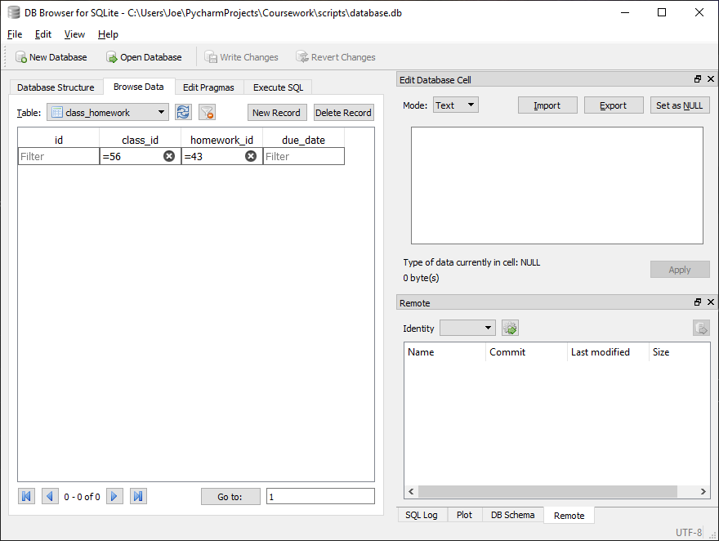

Class was not set given homework so no question results should be stored



Percentages for each student are correctly set to ‘N/A’

Any errors relating to the use of invalid class_id and/or homework_id should be addressed before calling function

##### Evaluation

Function correctly finds all students in the given class, for each student finds their [first name, last name, score for the given homework, percentage for the given homework, number of attempts for the given homework and number of attempts at the given homework]. This data is then correctly outputted as an array of tuples containing the data for each student as just defined.

In the event of a no questions being present for any reason which would result in a division by zero error usually, the program correctly sets percentage to ‘N/A’.

### Function to get the name of a homework

#### Final Code



#### Testing

##### SQL

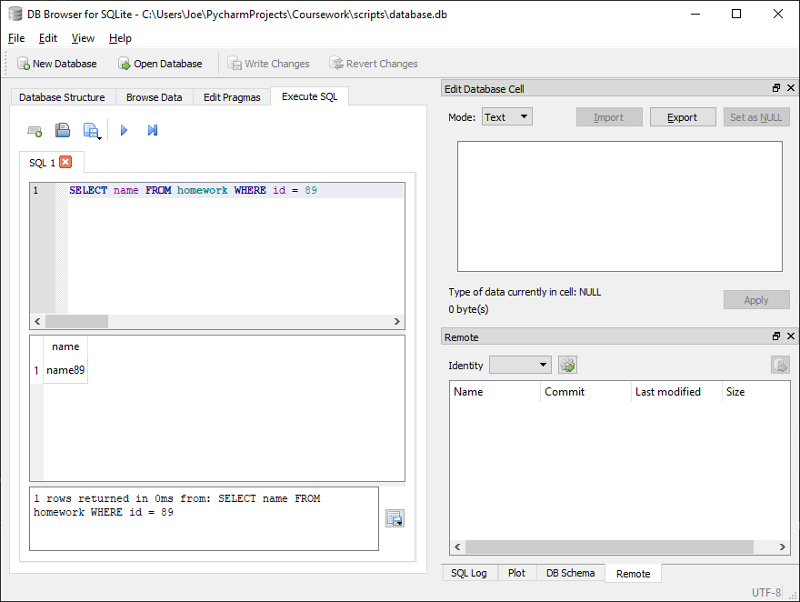

Correctly finds matching homework name (name89) for given homework id (89)

##### Test code



##### With valid data:



Correctly finds matching homework name for given homework id

##### With Invalid data:

N/A, any errors should be addressed before calling function by verifying homework id in advance

##### Evaluation

Function correctly finds matching homework name for given homework id

### Function to get the all homework scores for a given user in a given class

#### Final Code



#### Testing

##### SQL

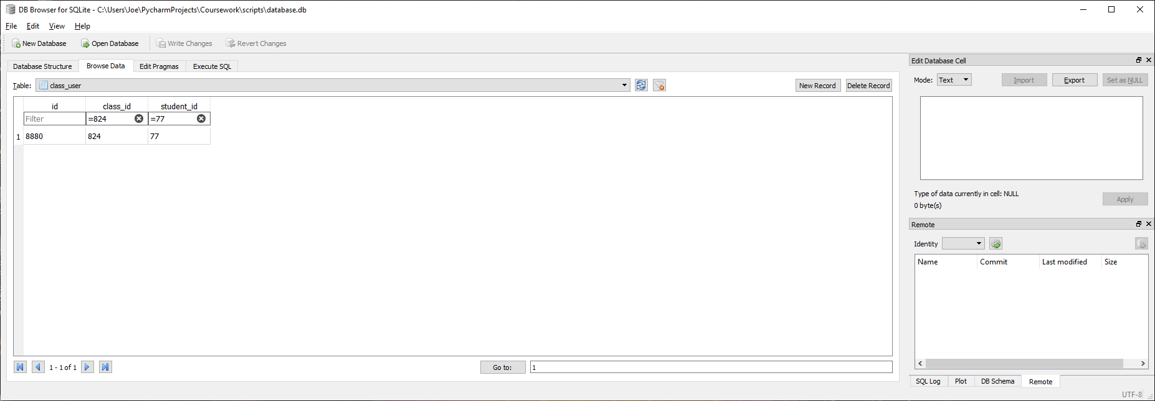

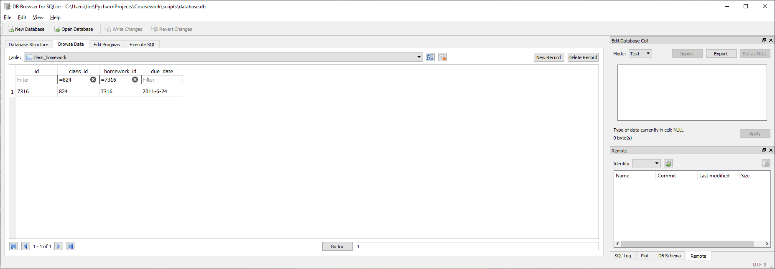

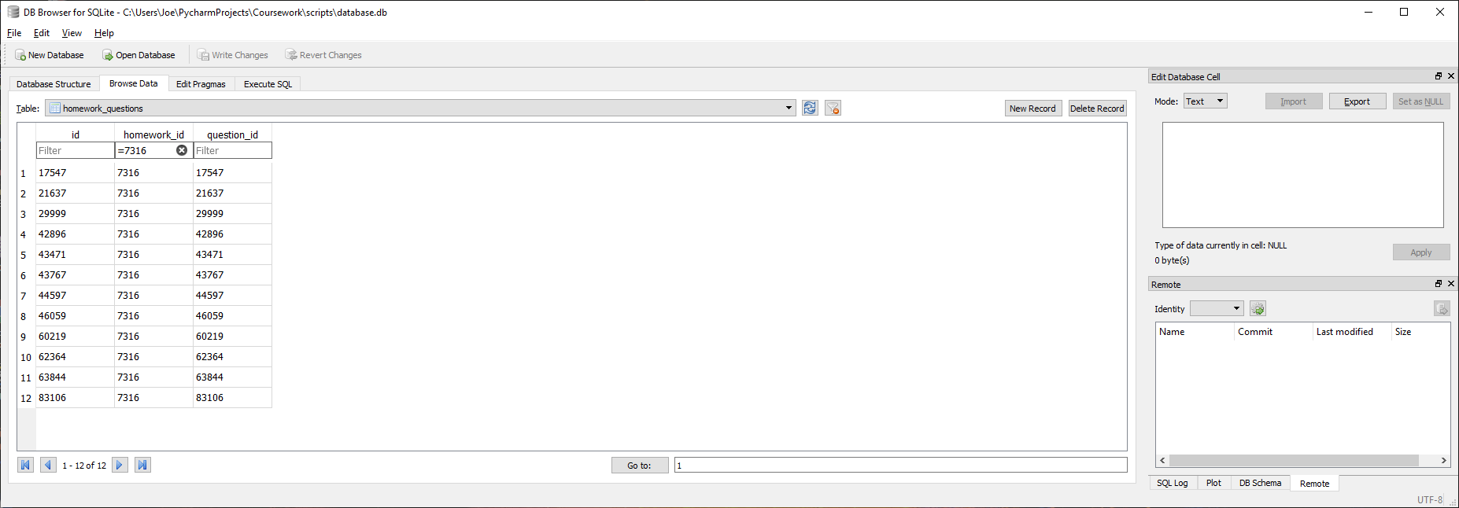

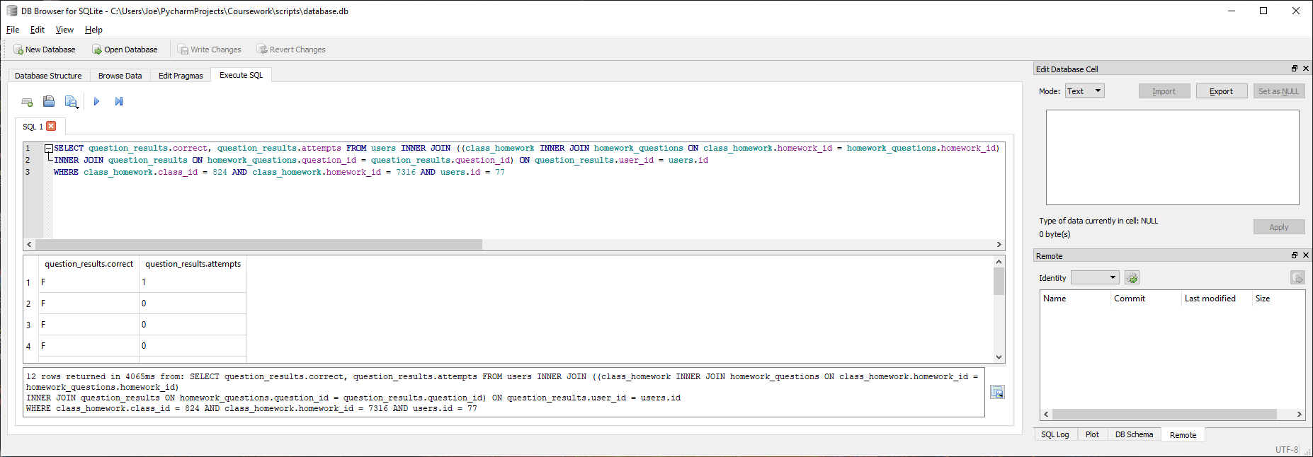

Correctly finds question correct status and attempt count for the given user id (77) for each of the 12 questions in the given homework (7316) within the given class (824)

##### Test code



##### With valid data:

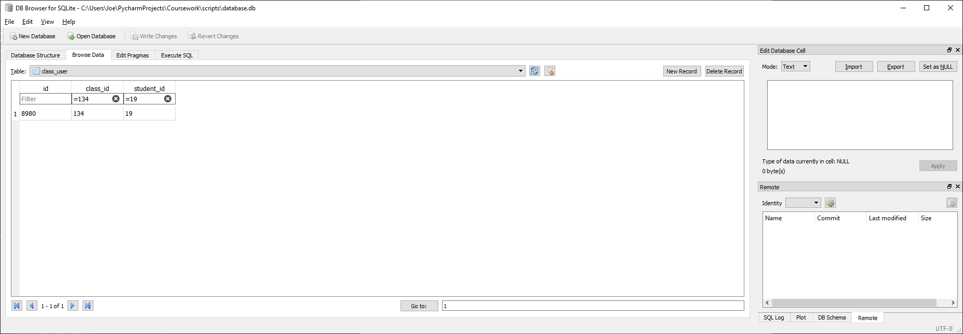

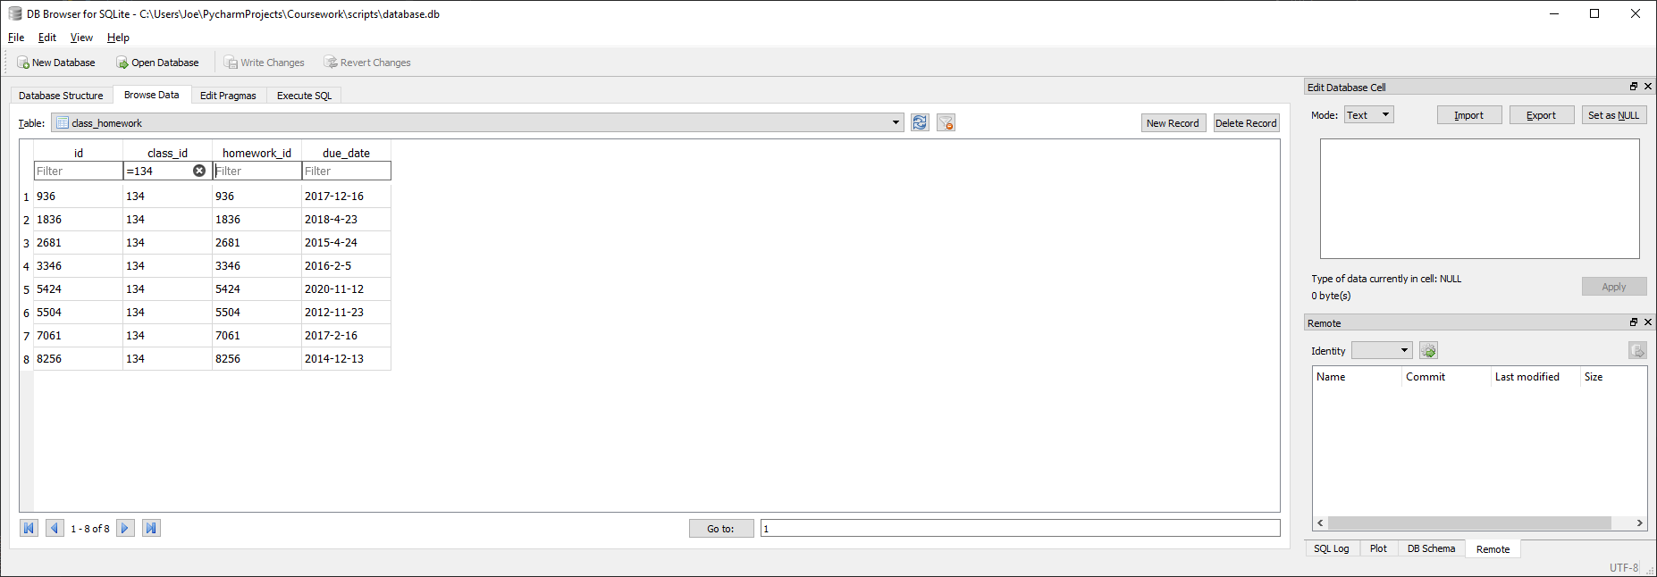



Correctly finds all 8 matching homework for the given class (134) and student (19) and successfully outputs all results as an array of tuples containing, for each homework, [homework name, score, percentage, number of attempts]

##### With Invalid data:

Homework with no results stored:

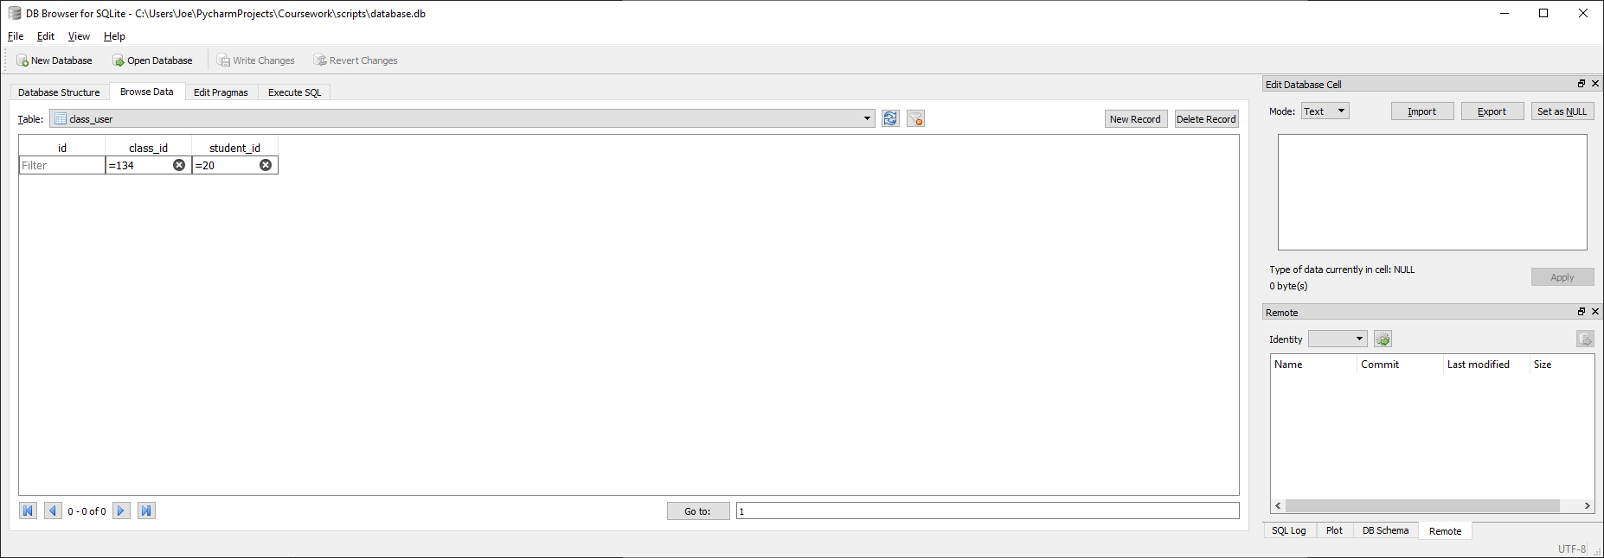

Student is not in the class so should have no results for any of the homework within the class



Percentages for each homework are correctly set to ‘N/A’

Any errors relating to the use of invalid class_id and/or student_id should be addressed before calling function

##### Evaluation

Function correctly finds all homework in the given class and, for each homework, for the given student, finds the [homework name, score, percentage, number of attempts]. This data is then correctly outputted as an array of tuples containing the data for each homework as just defined.

In the event of no questions being present within a homework for any reason which would result in a division by zero error usually, the program correctly sets percentage to ‘N/A’.

### Function to get the question text for a given question

#### Final Code



#### Testing

##### SQL

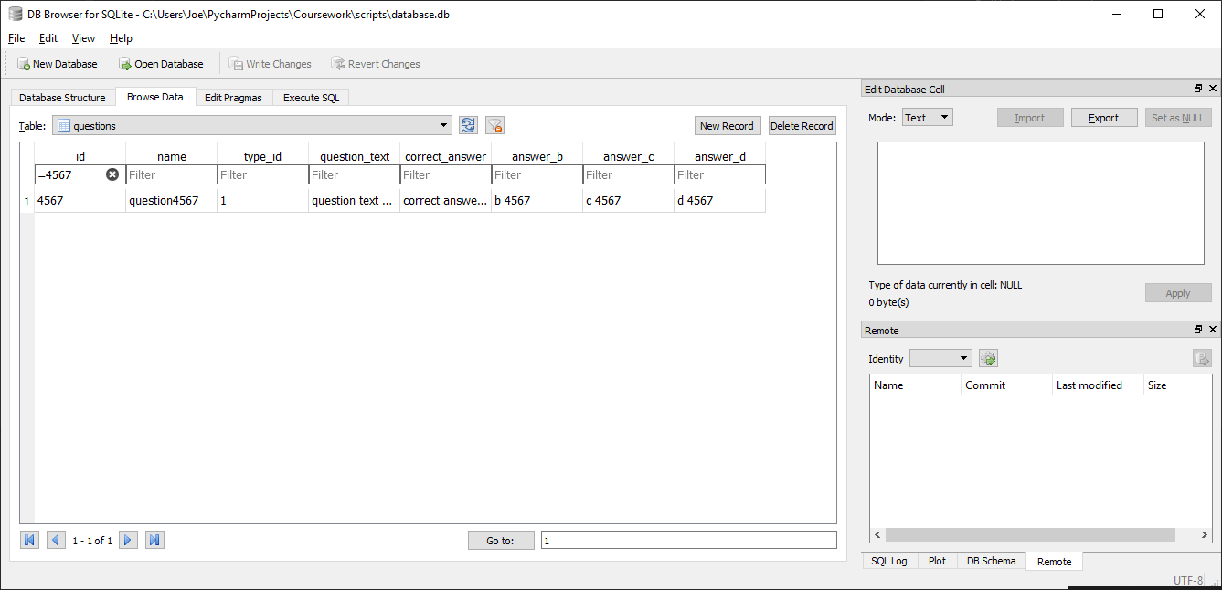

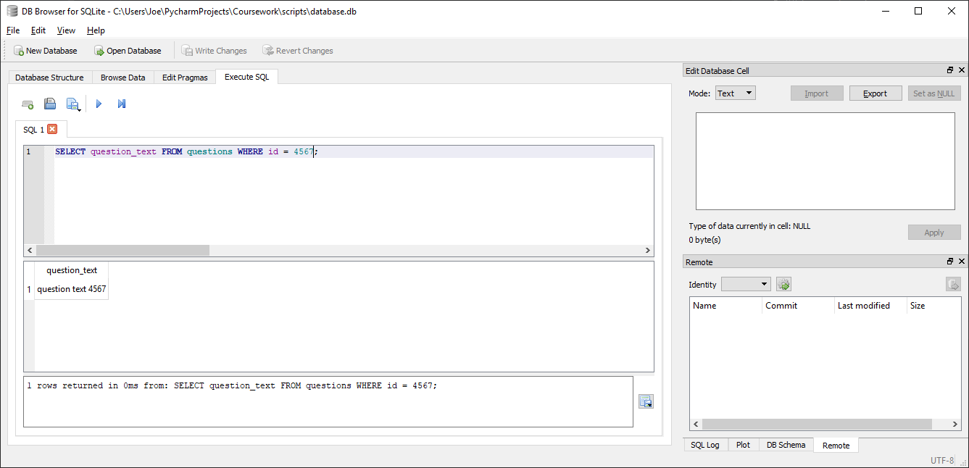

Correctly returns correct question text (question text 4567) for given question id (4567)

##### Test code



##### With valid data:



Correctly returns matching question text (question 6782) for given question id (6782)

##### With Invalid data:

N/A, any errors should be addressed before calling function by verifying question id in advance

##### Evaluation

Correctly returns matching question text for a given valid question id

### Function to get the correct answer for a given question

#### Final Code



#### Testing

##### SQL

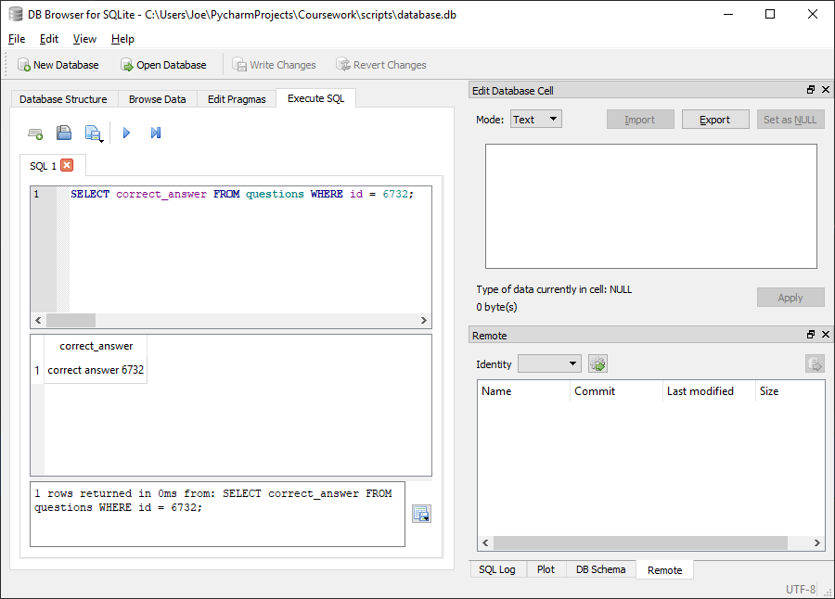

Correctly returns matching correct answer (correct answer 6732) for given question id (6732)

##### Test code



##### With valid data:



Correctly returns matching correct answer (correct answer 8245) for given question id (8245)

##### With Invalid data:

N/A, any errors should be addressed before calling function by verifying question id in advance

##### Evaluation

Correctly returns matching correct answer for given question id

### Function to remove a question from a homework

#### Final Code



#### Testing

##### SQL

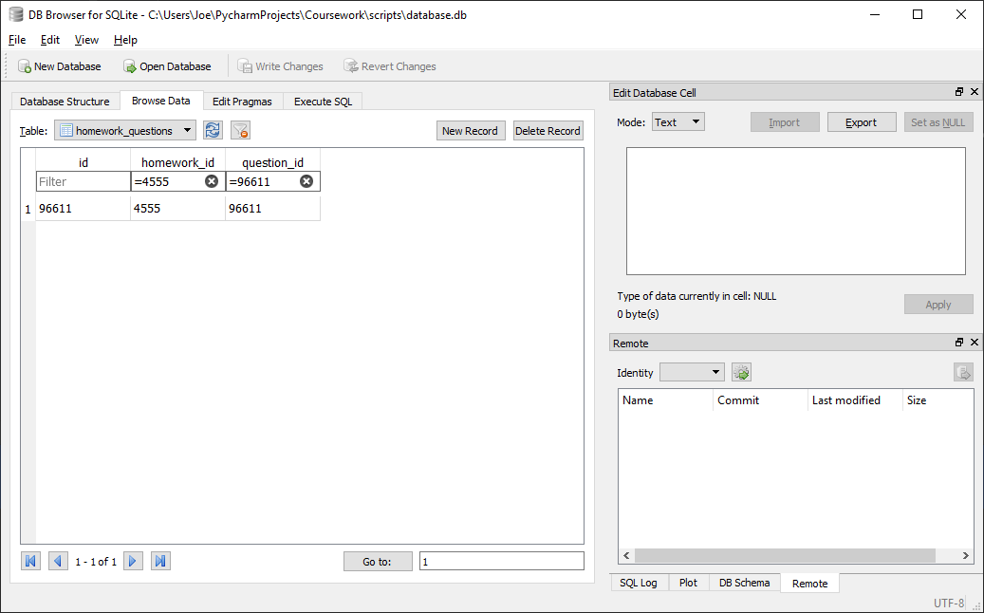

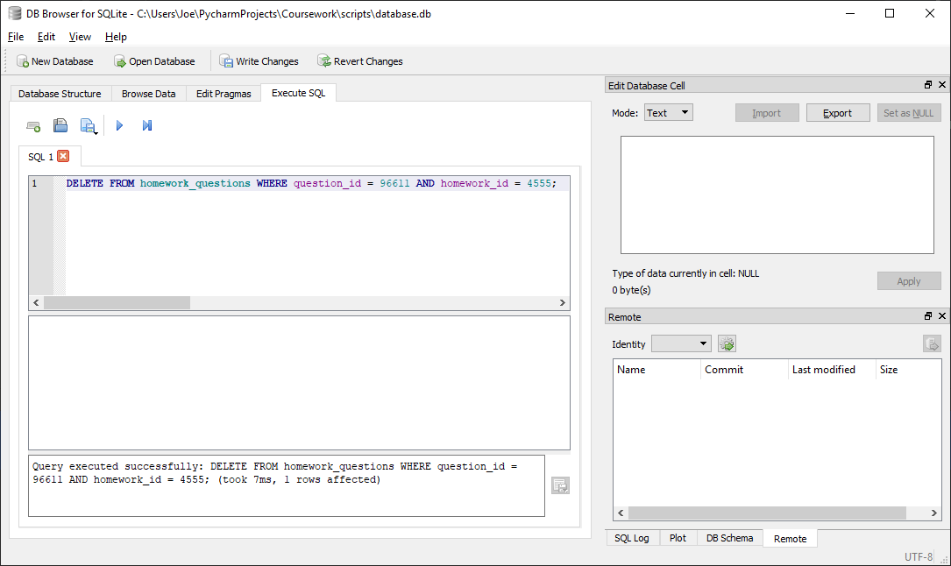

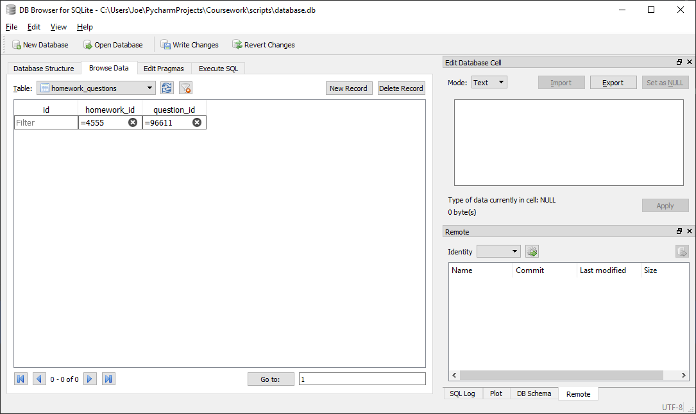

Correctly removes entry in database linking given question (96611) to given homework (4555)

##### Test code



##### With valid data:

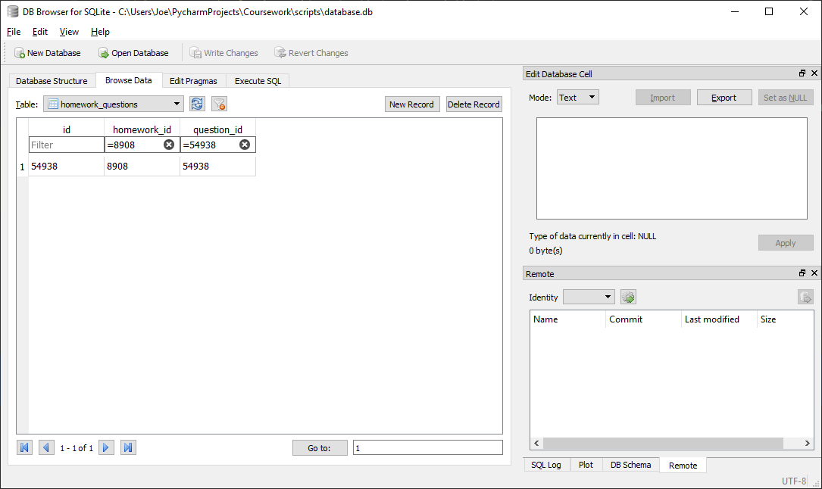



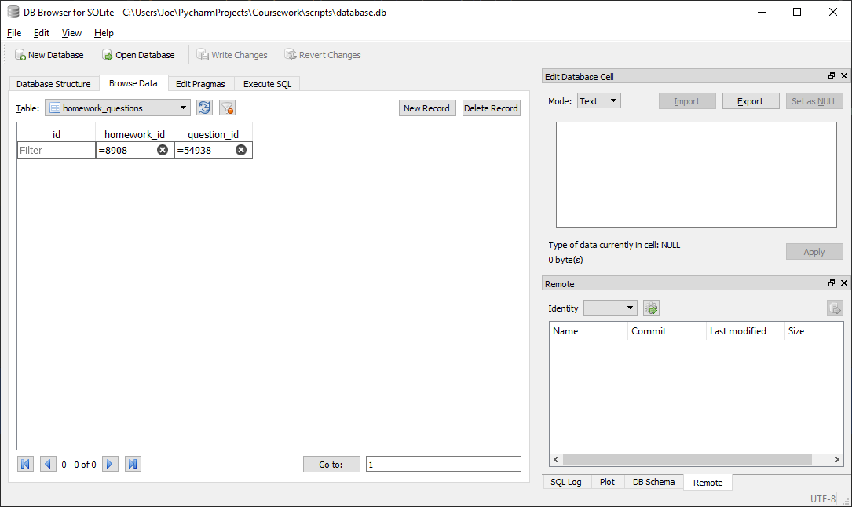

Correctly removes entry in database linking given question (54938) to given homework (8908)

##### With Invalid data:

N/A, any errors should be addressed before calling function by verifying question belongs to homework and both are valid in advance

##### Evaluation

Correctly removes entry in database linking given question to given homework

### Function to insert a question into a homework

#### Final Code



#### Testing

##### SQL

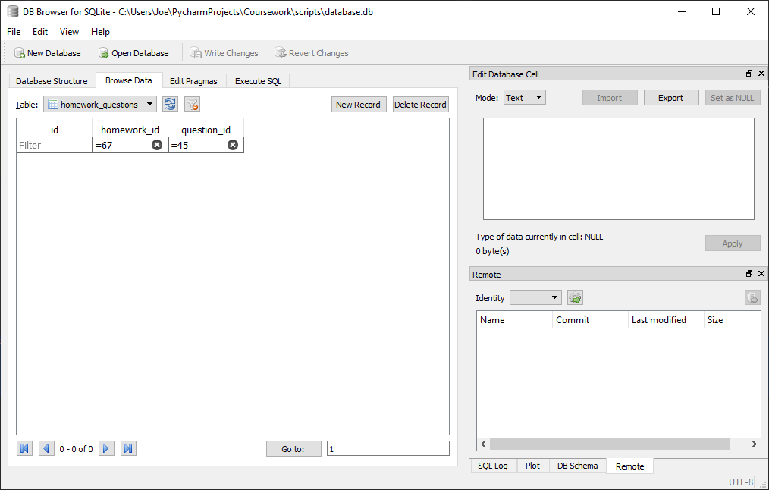

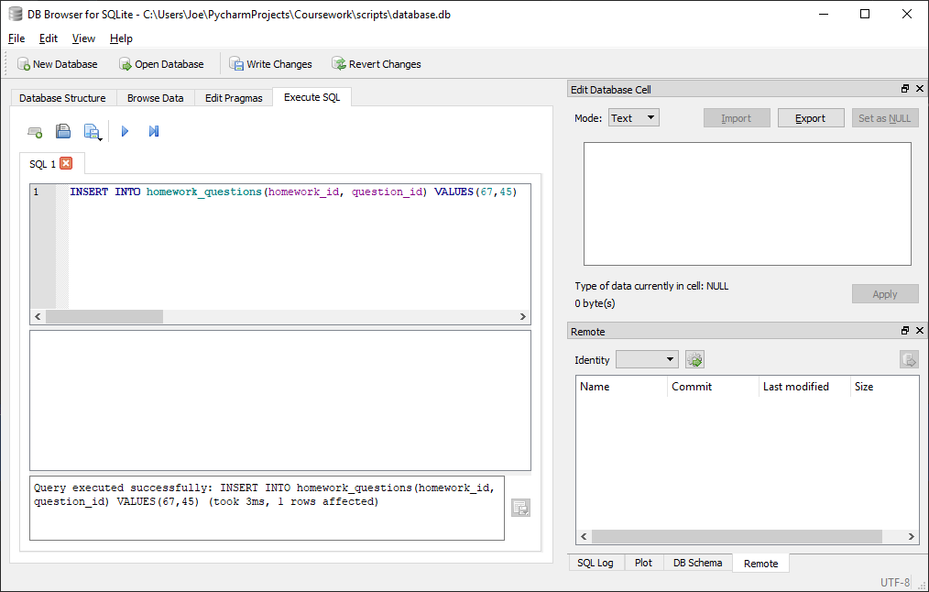

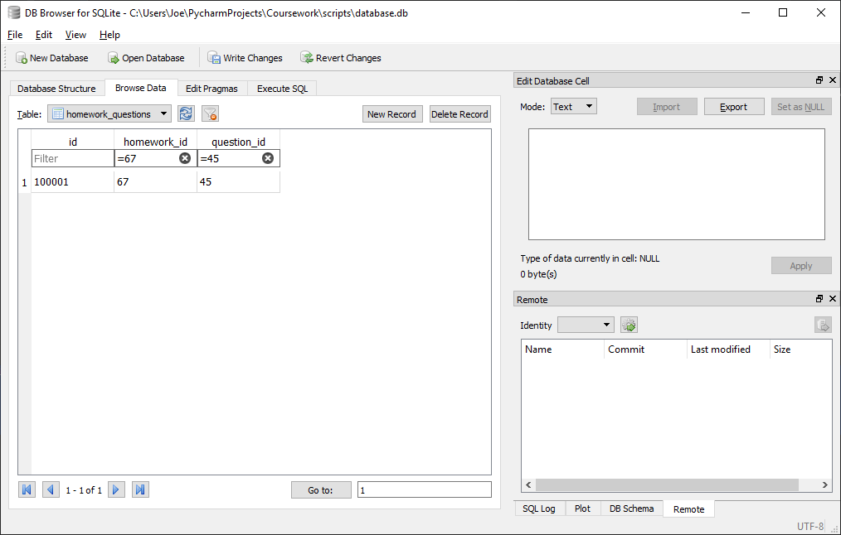

Correctly inserts new entry into homework_questions linking given homework (67) to given question (45)

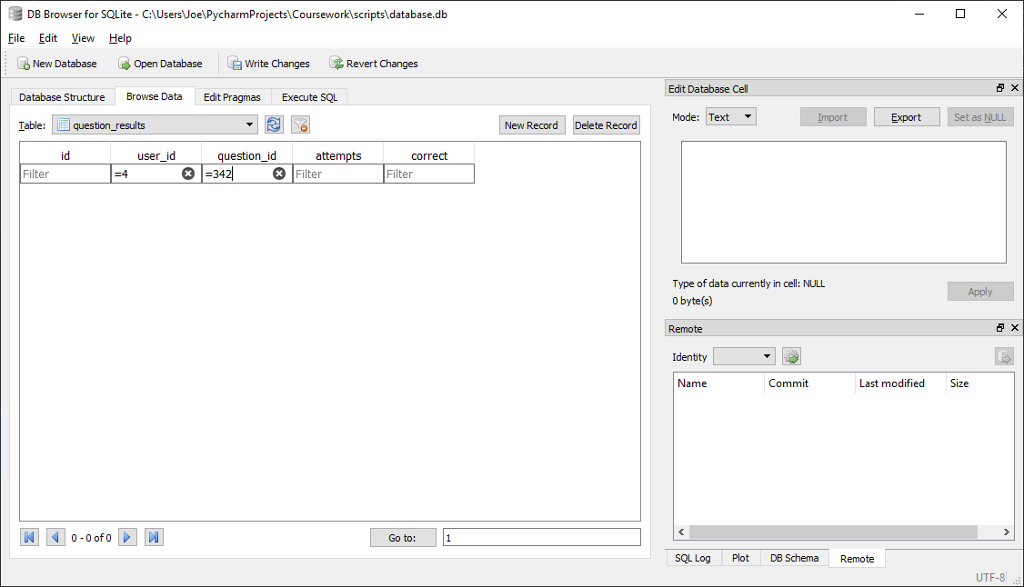

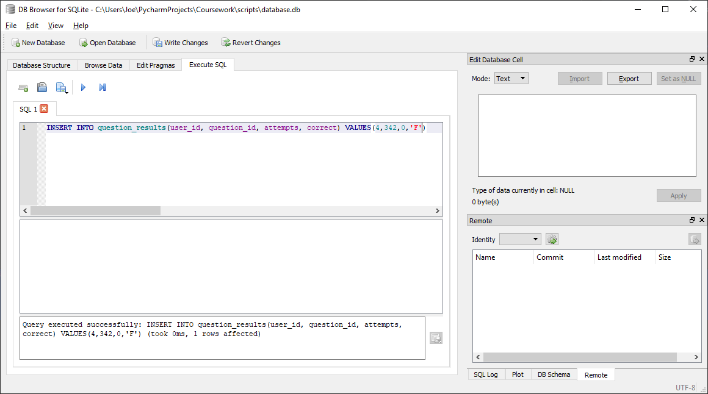

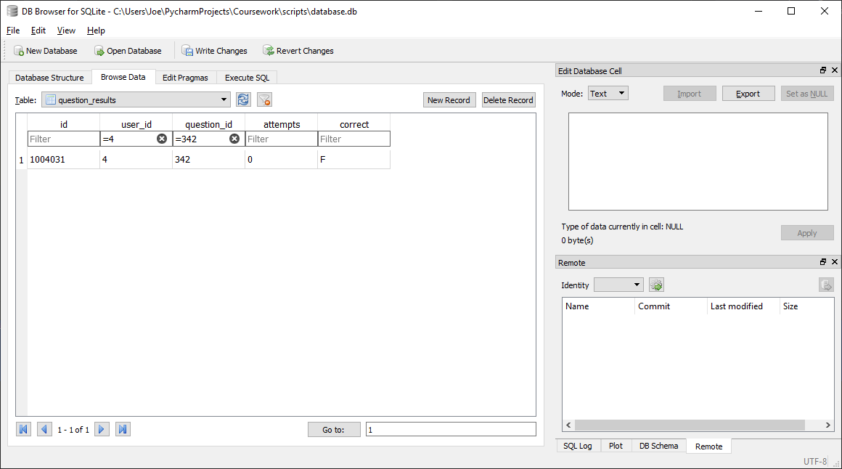

Correctly inserts new entry into question_results linking given question (342) to given user (4) along with the given attempts count (0) and correct status (F)

##### Test code



##### With valid data:

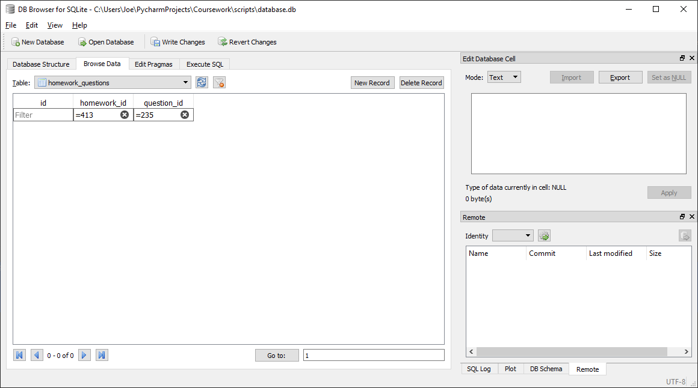

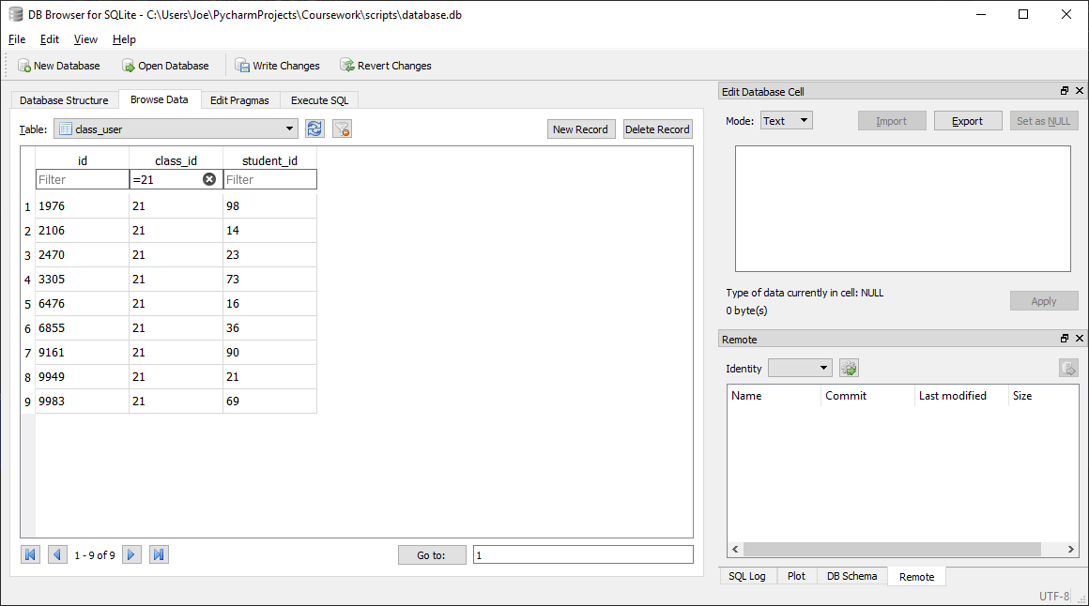

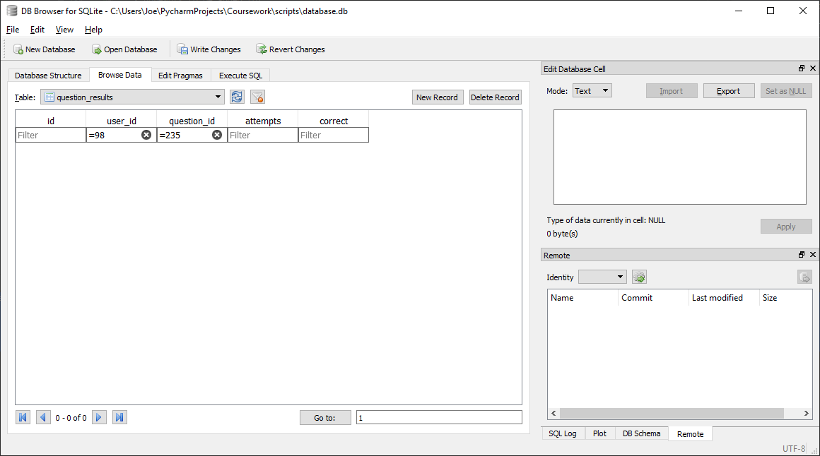

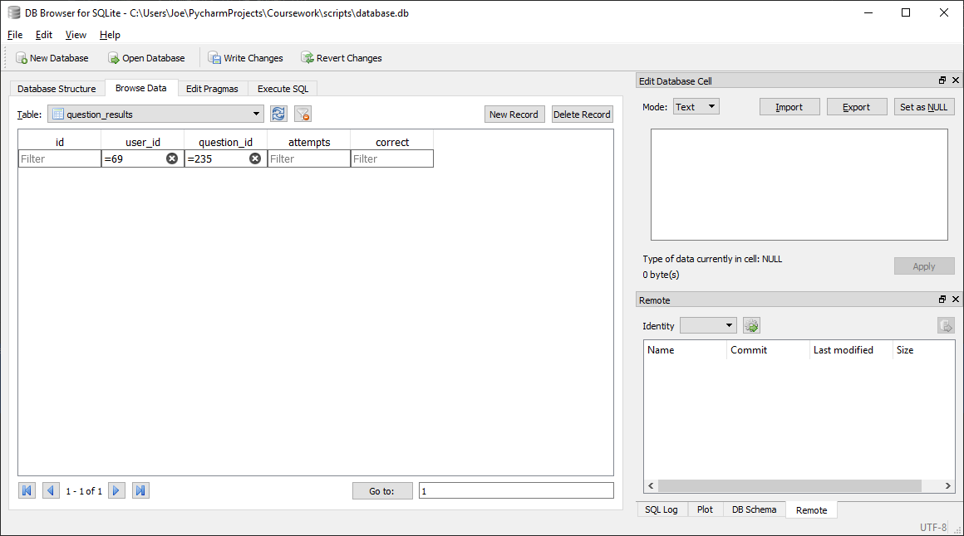



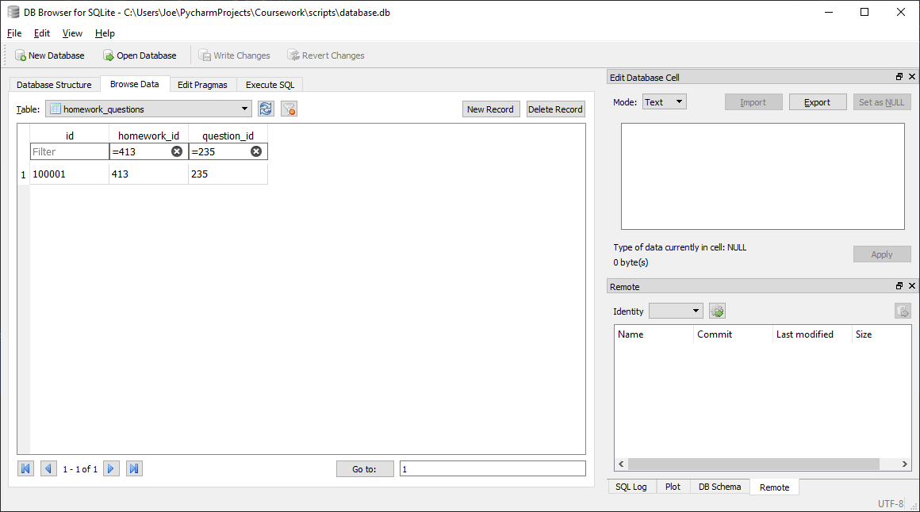

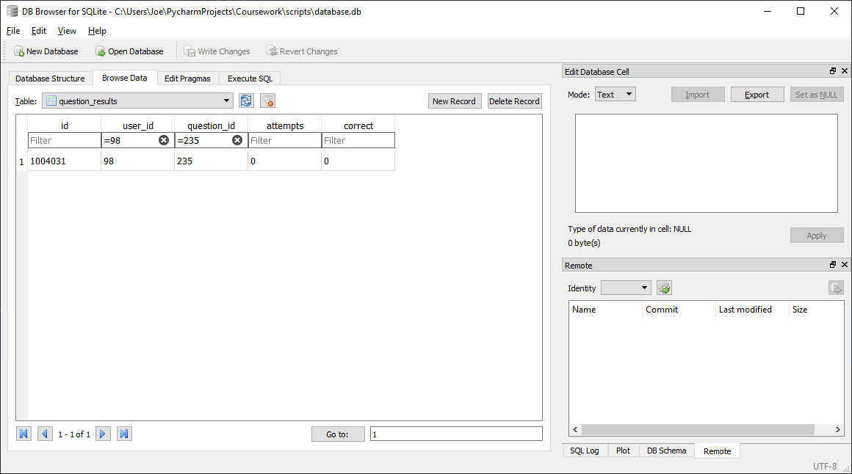

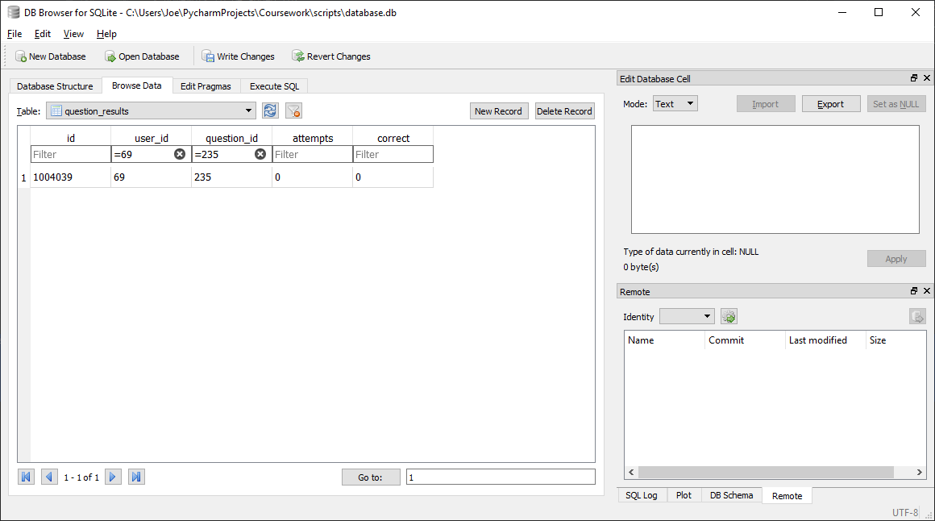

Correctly links given question (235) to given homework (413) in homework_questions and creates a valid entry in question_results for each member of given class

##### With Invalid data:

N/A, any errors should be addressed before calling function by verifying class id, homework id and question id are valid and homework is not already set

##### Evaluation

Correctly links given question to given homework in homework_questions and creates a valid entry in question_results for each member of given class

### Function to get the incorrect answers for a given question

#### Final Code



#### Testing

##### SQL

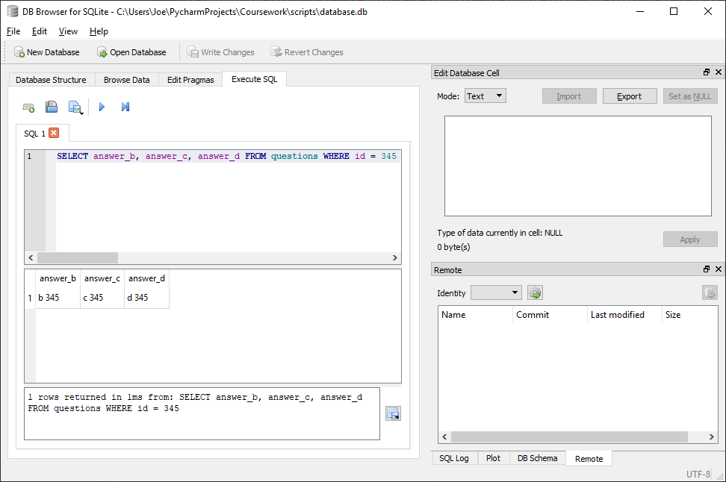

Correctly returns matching incorrect answer (b 345, c 345, d 345) for given question id (345)

##### Test code



##### With valid data:



Correctly returns matching correct answer (b 67845, c 67845, d 67845) for given question id (67845)

##### With Invalid data:

N/A, any errors should be addressed before calling function by verifying question id in advance

##### Evaluation

Correctly returns matching incorrect answers for given question id

### Function to get the correct status for a given question and user

#### Issues during development

Initially the below code was written:



This would result in the following output:

While the correct status is correctly indicated to be False, the character F is itself not actually a Boolean value, but a string so is unusable without conversion. This was done by removing the final line and replacing it with:



The function now returns a correct Boolean value (see final testing of function)

#### Final Code



#### Testing

##### SQL

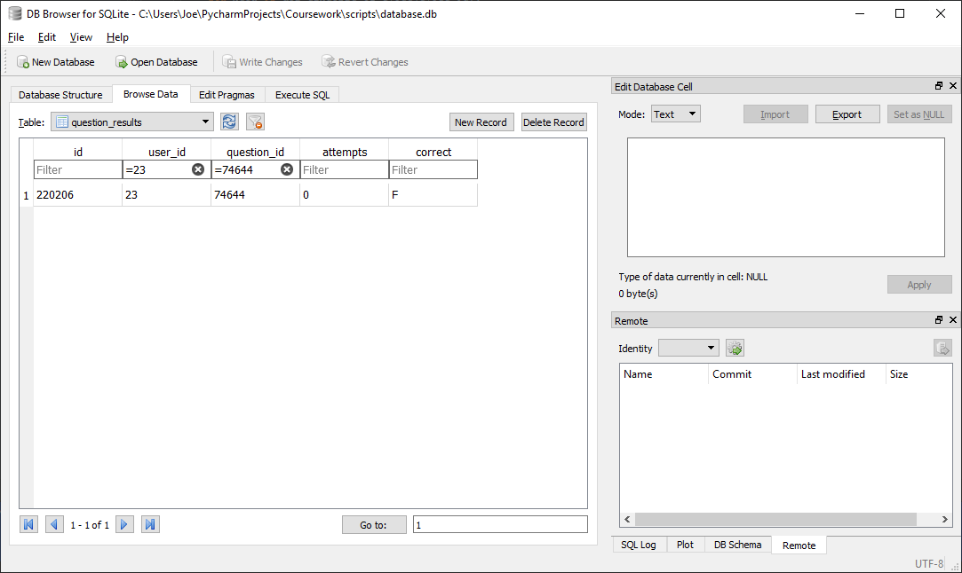

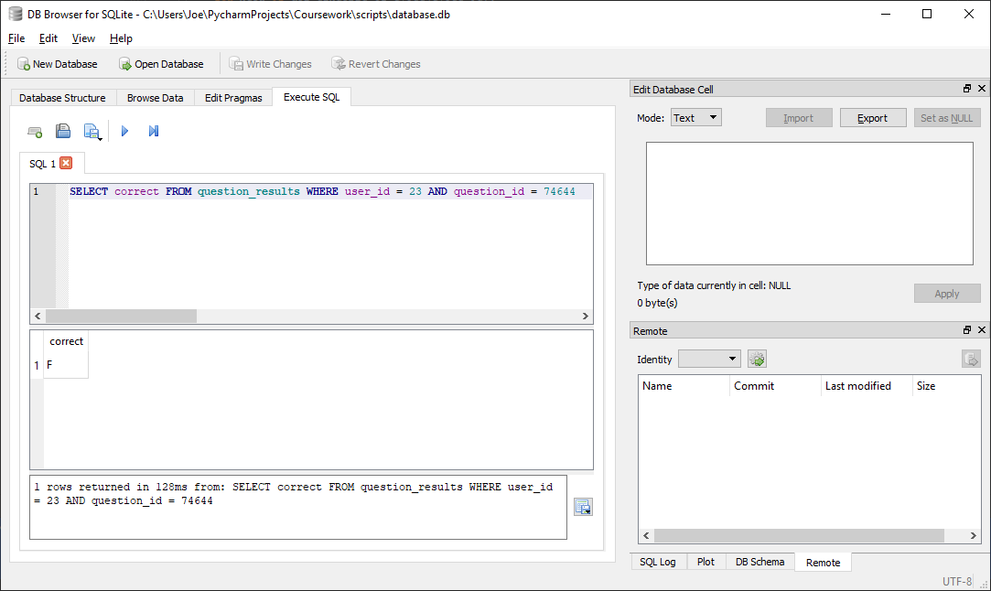

Correctly returns matching correct status (F) for given question id (74644) and user id (23)

##### Test code



##### With valid data:

###### Stored value is True

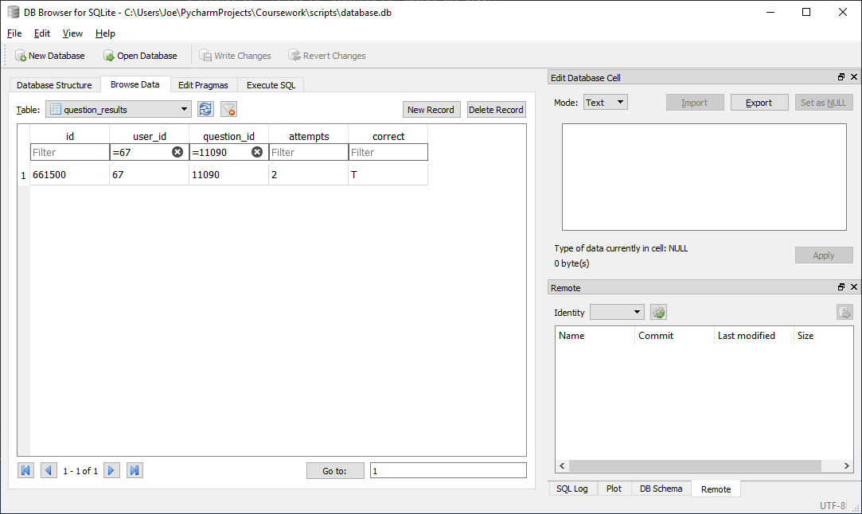



Correctly returns correct Boolean correct status (True) for given question id (11090) and user id (67)

###### Stored value is False

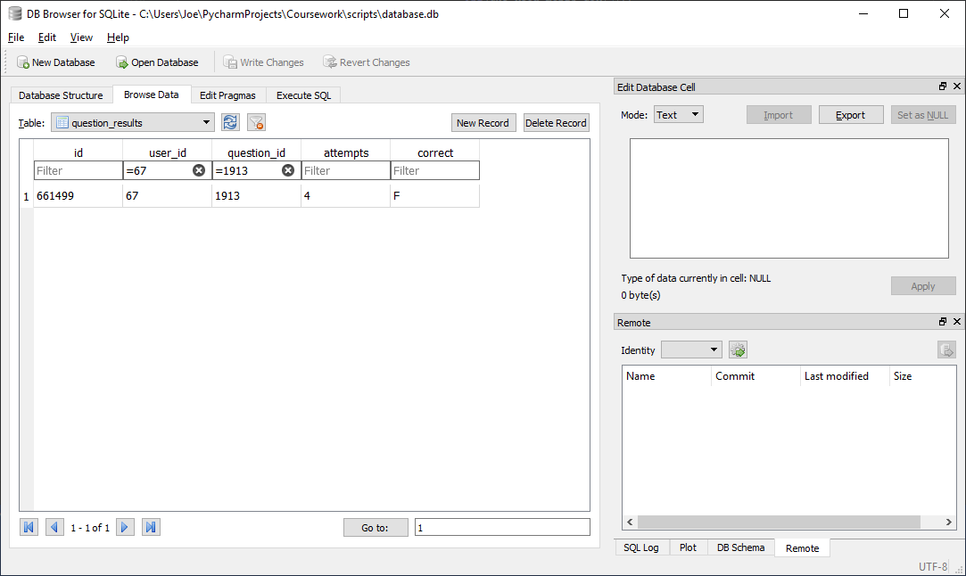



Correctly returns correct Boolean correct status (False) for given question id (11090) and user id (1913)

##### With Invalid data:

N/A, any errors should be addressed before calling function by verifying question id and user id are valid and question and user are related in advance

##### Evaluation

Correctly returns Boolean correct status for a given question id and user id

### Function to increment user attempts at question

#### Final Code



#### Testing

##### SQL

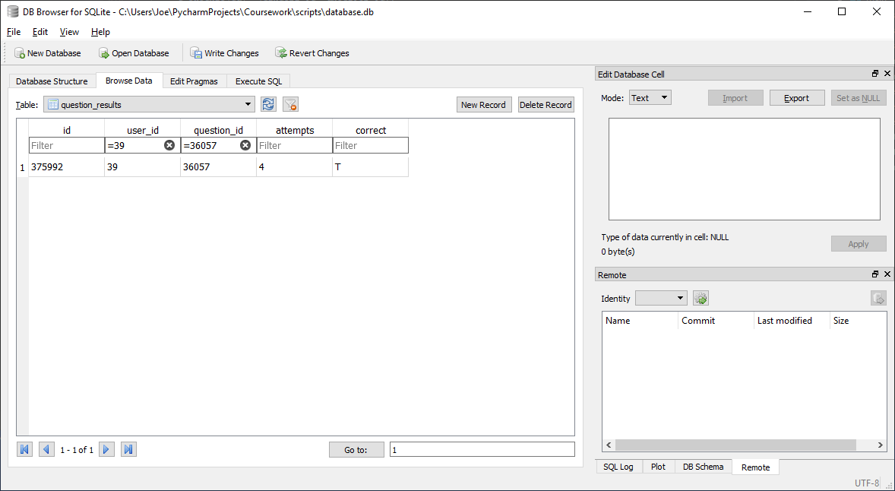

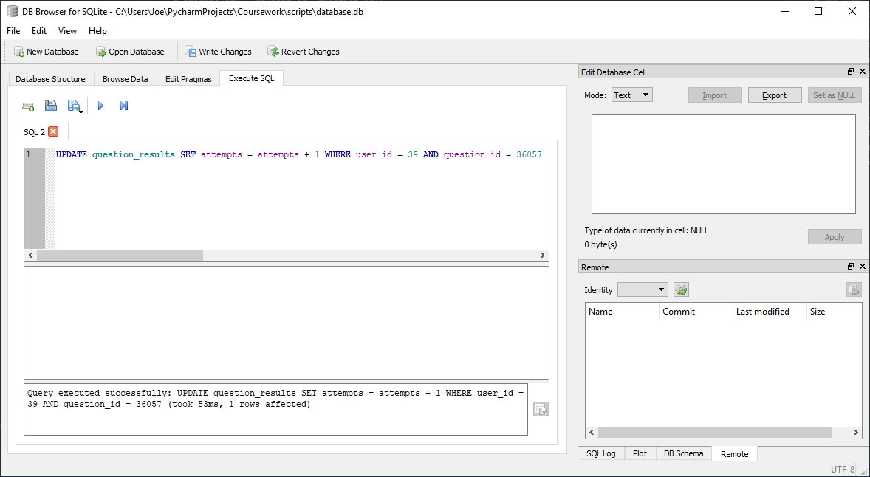

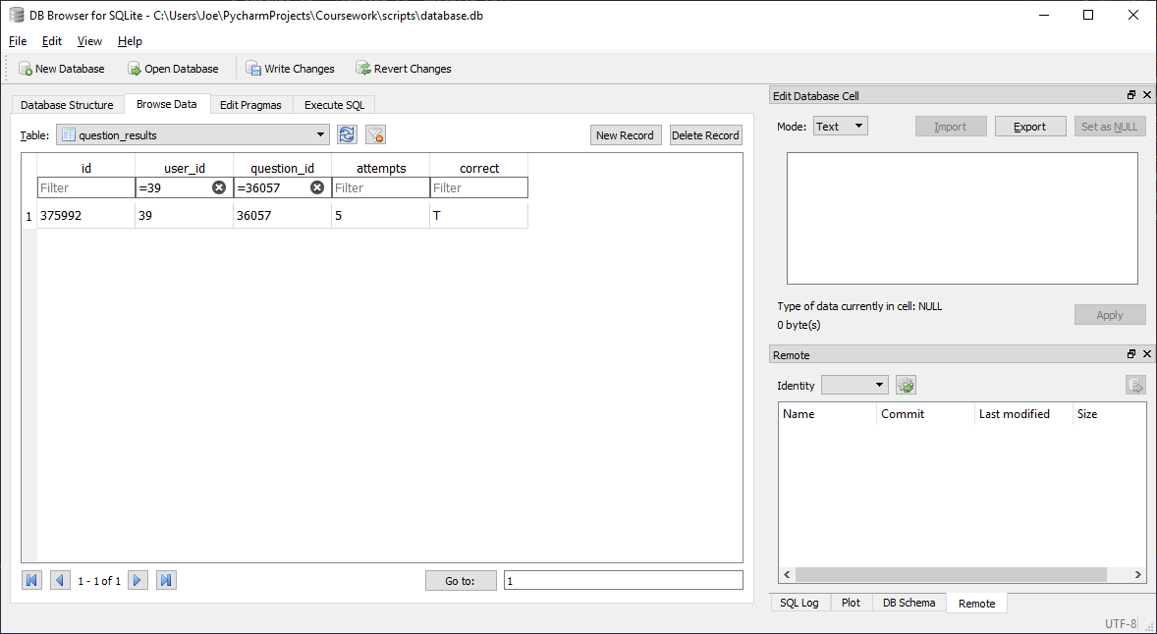

Correctly incremented attempts count (from 4 to 5) for given question id (36057) and user id (39)

##### Test code



##### With valid data:

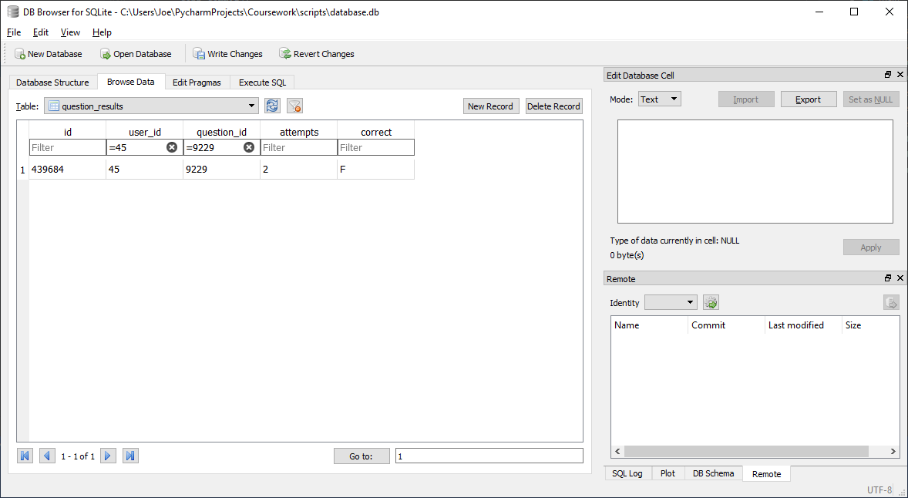



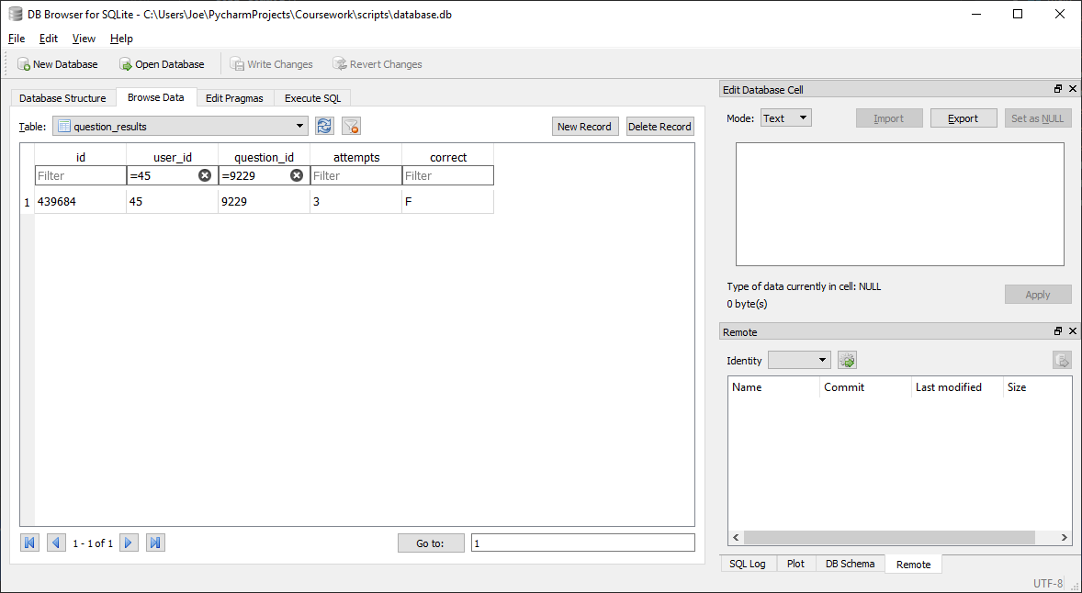

Correctly incremented attempts count (from 2 to 3) for given question id (9229) and user id (45)

##### With Invalid data:

N/A, any errors should be addressed before calling function by verifying question id and user id are valid and question and user are related in advance

##### Evaluation

Correctly incremented attempts count in question_results for given question id and user id (45)

### Function to mark question as correct

#### Final Code



#### Testing

##### SQL

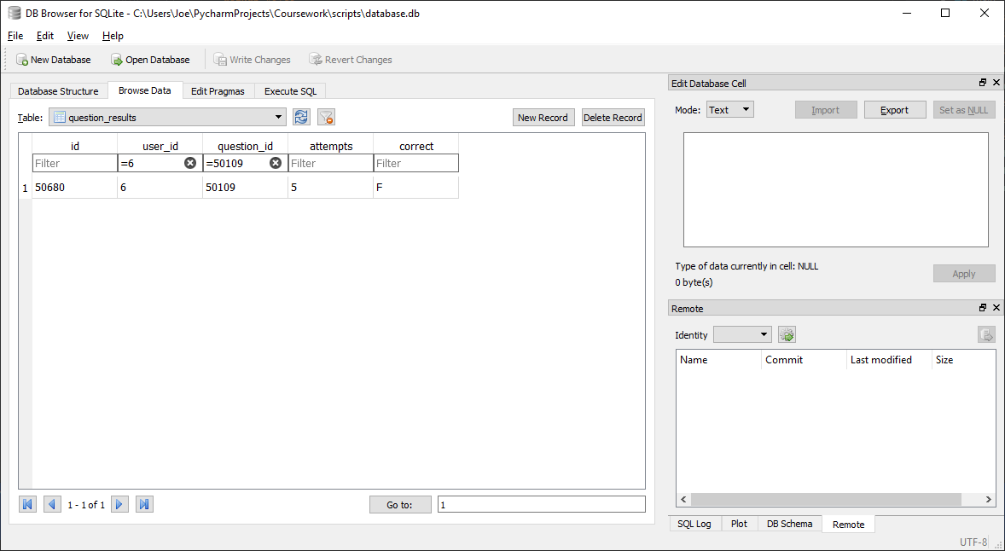

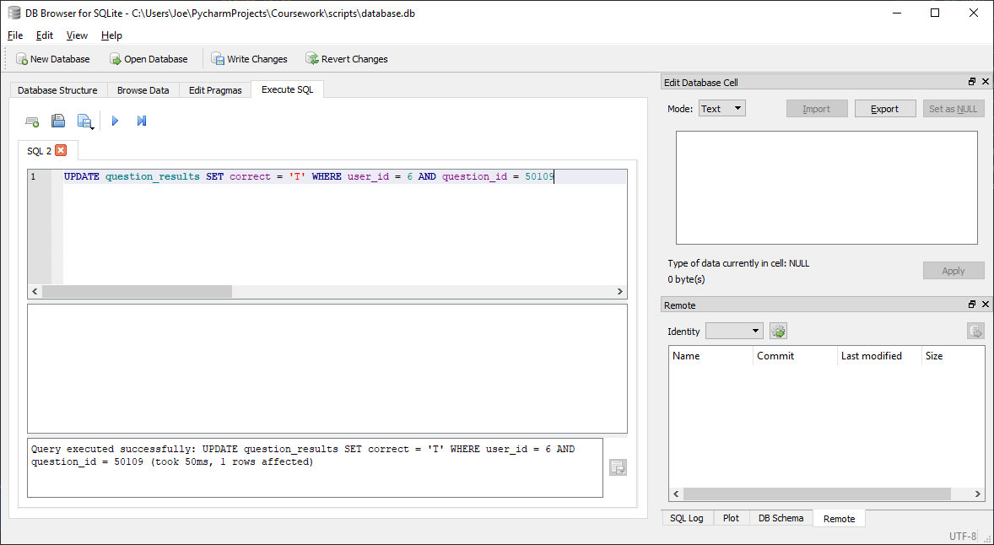

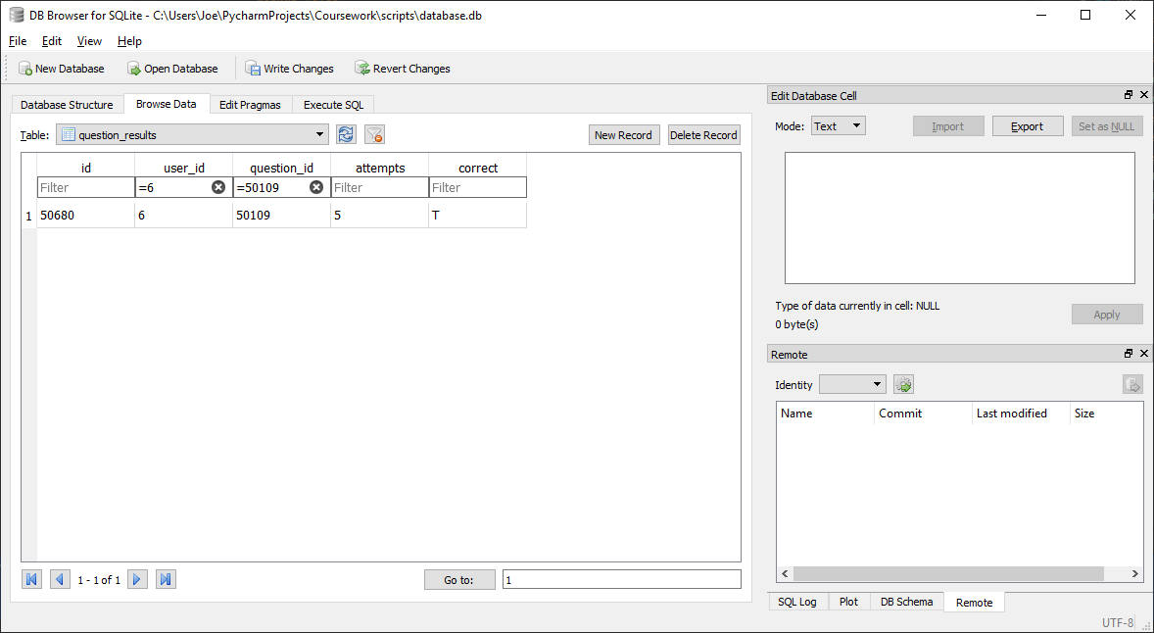

Correctly set correct status to ‘T’ for given question id (50109) and user id (6)

##### Test code



##### With valid data:

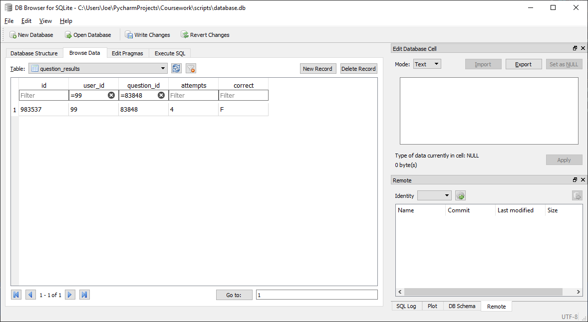





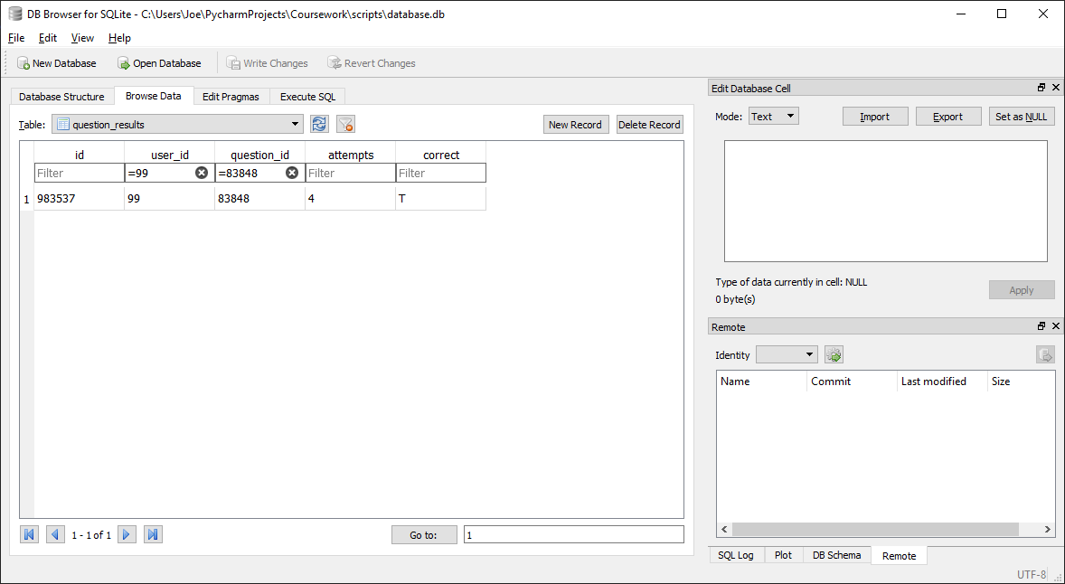

Correctly set correct status to ‘T’ for given question id (83848) and user id (99)

##### With Invalid data:

N/A, any errors should be addressed before calling function by verifying question id and user id are valid and question and user are related in advance

##### Evaluation

Correctly sets correct status to ‘T’ for given question id and user id

### Function to insert a new homework into database

#### Final Code



#### Testing

##### SQL

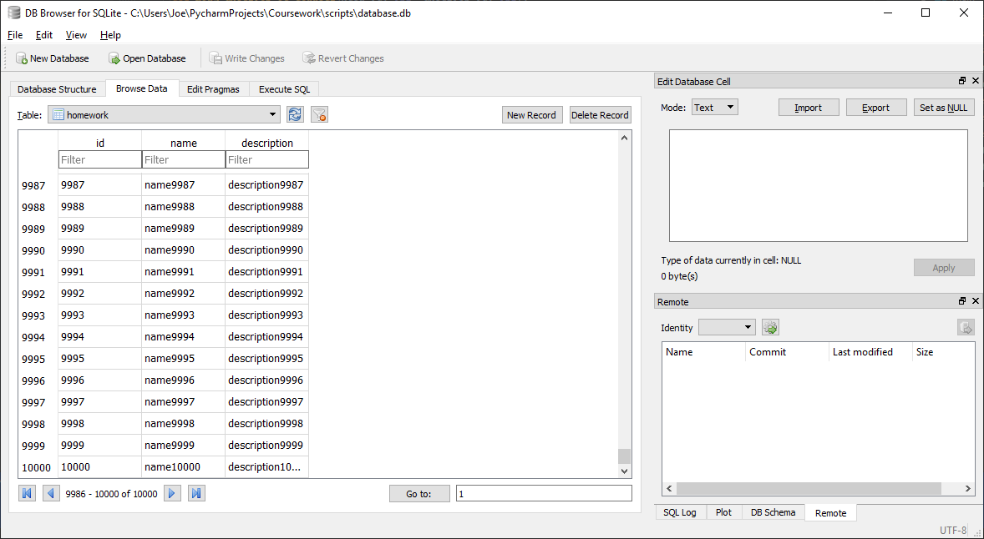

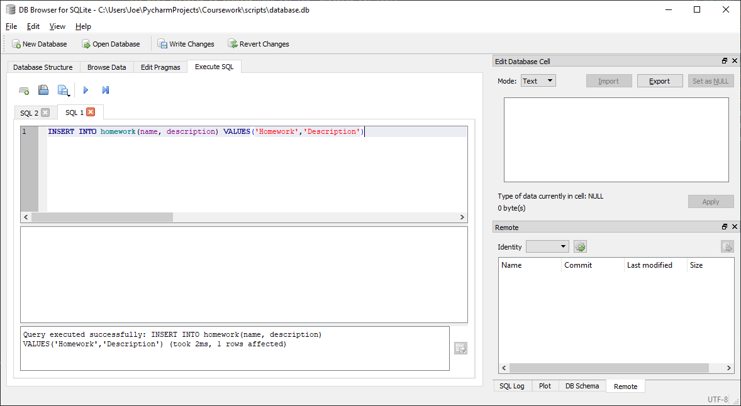

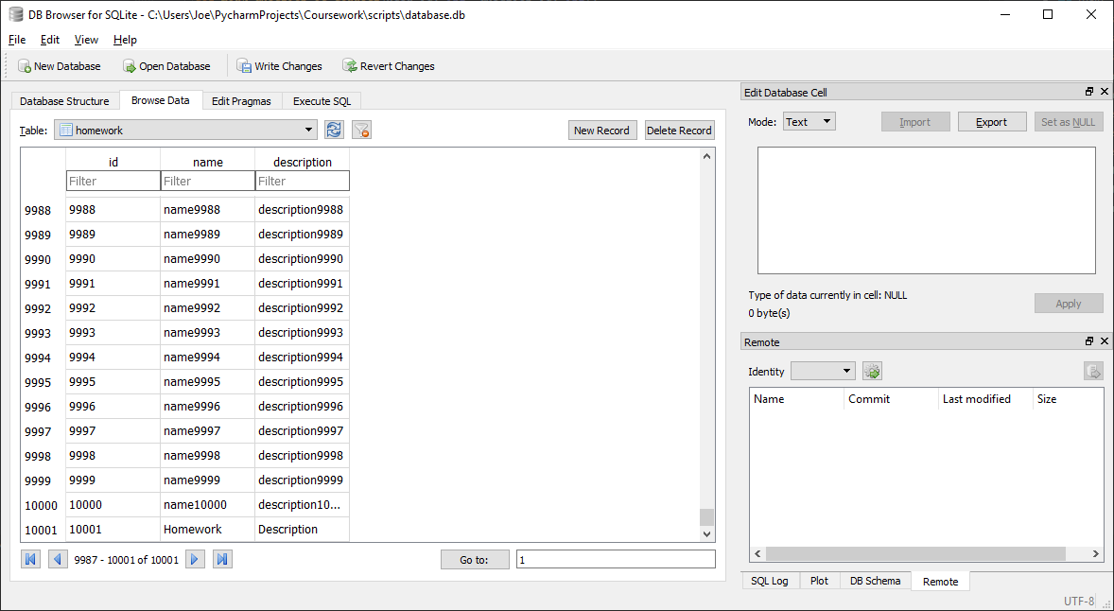

Correctly inserts a new entry into homework table with given name (homework) and description (description)

##### Test code



##### With valid data:

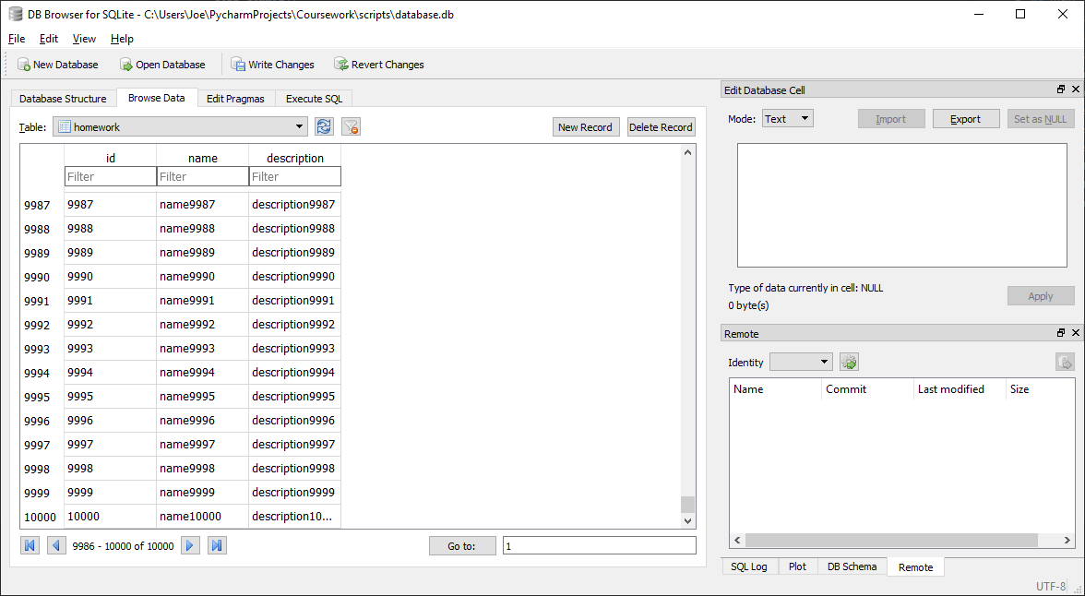



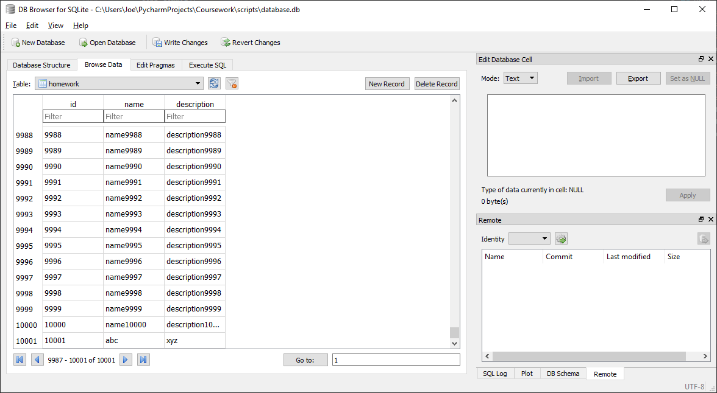

Correctly inserts a new entry into homework table with given name (abc) and description (xyz) and returns its id in the homework table

##### With Invalid data:

N/A, any errors should be addressed before calling function by verifying homework name and description are strings before passing to function

##### Evaluation

Correctly inserts a new entry into homework table with given name and description and returns its id in the homework table

### Function to add a homework to a class

#### Final Code



#### Testing

##### SQL

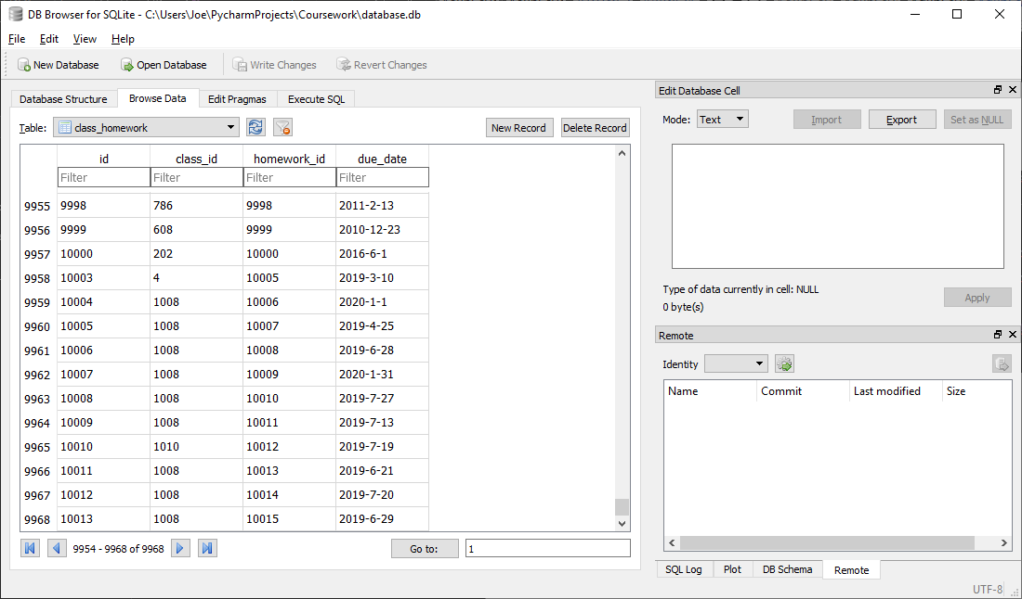

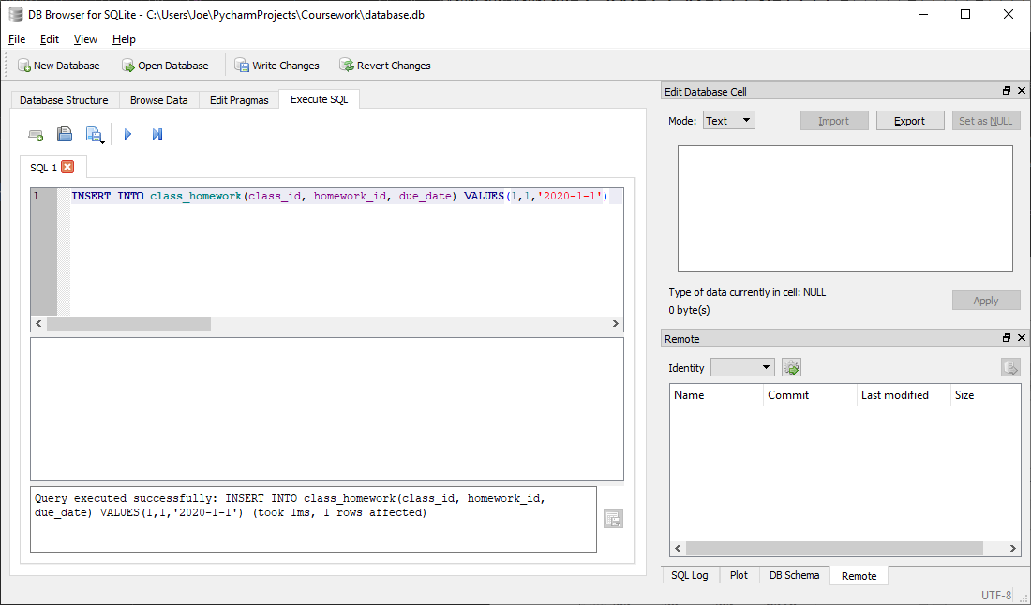

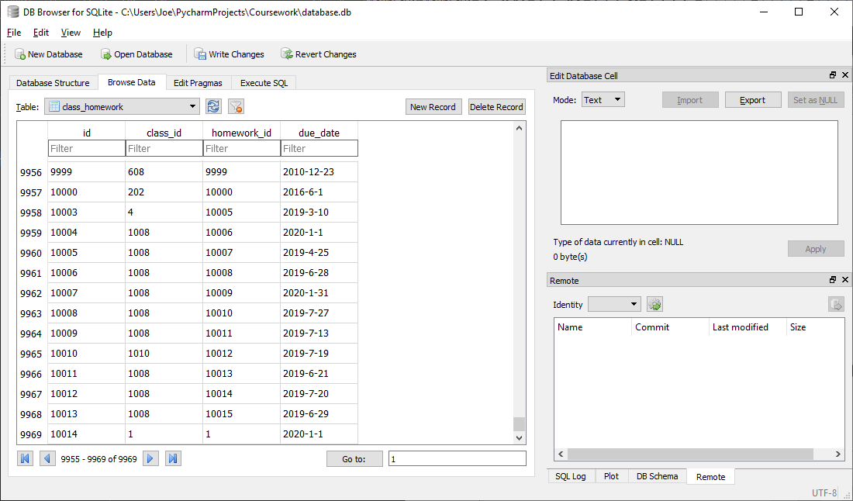

Correctly inserts a new entry into class homework table relating given class id (1) and homework id (1) with the given due date (2020-1-1)

##### Test code



##### With valid data:

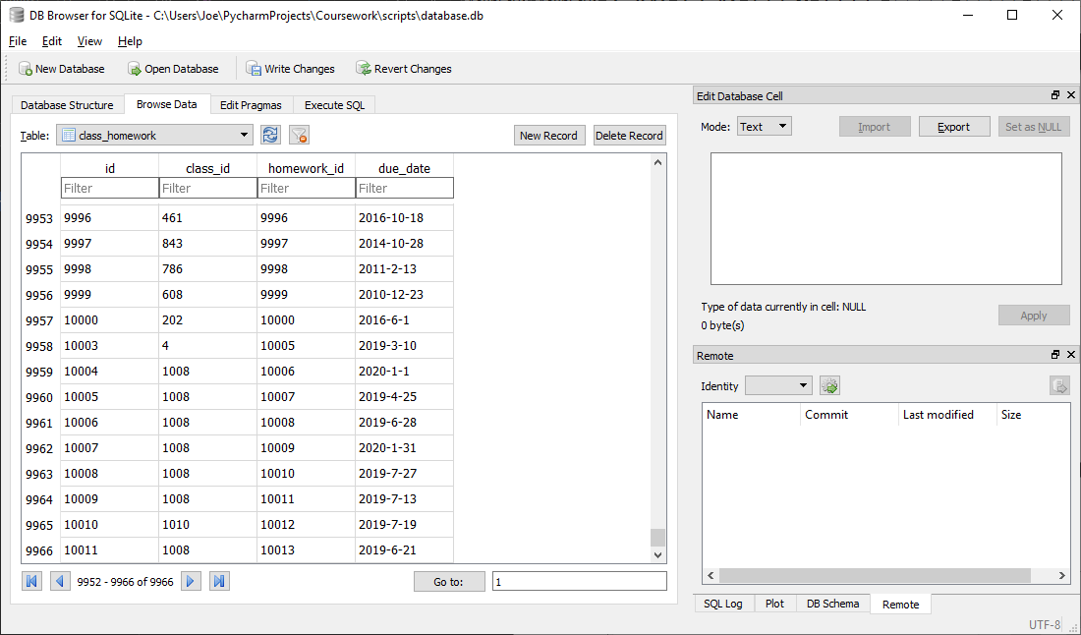



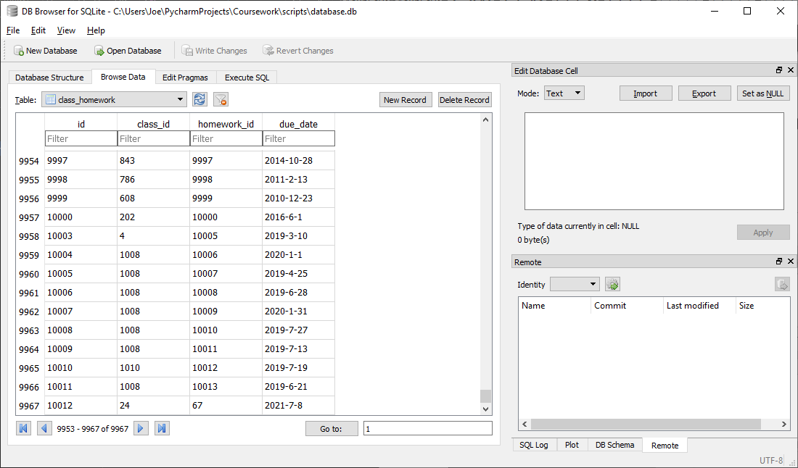

Correctly inserts a new entry into class homework table relating given class id (24) and homework id (67) with the given due date (2021-7-8)

##### With Invalid data:

N/A, any errors should be addressed before calling function by verifying homework id and class id exist and are valid integers and that due date is in the future before calling function

##### Evaluation

Correctly inserts a new entry into class homework table relating given class id and homework id with the given due date

### Function to remove a homework from database

#### Final Code



#### Testing

##### SQL

###### Remove from homework table

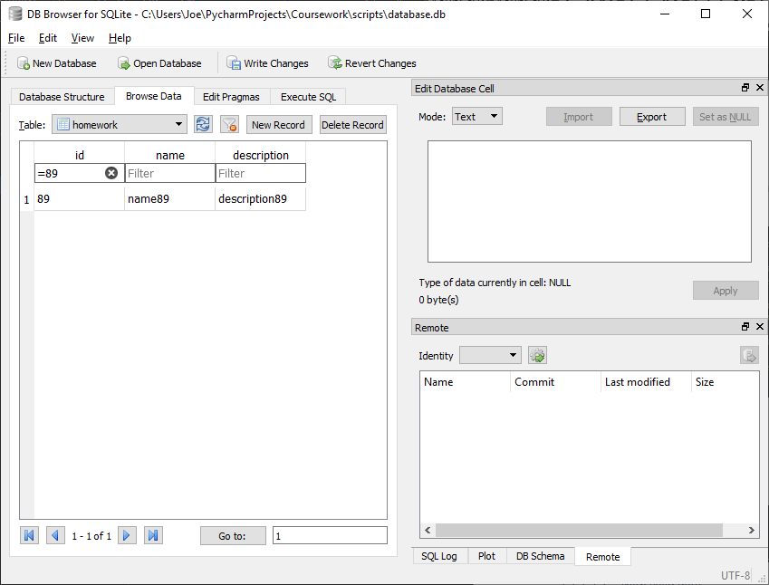

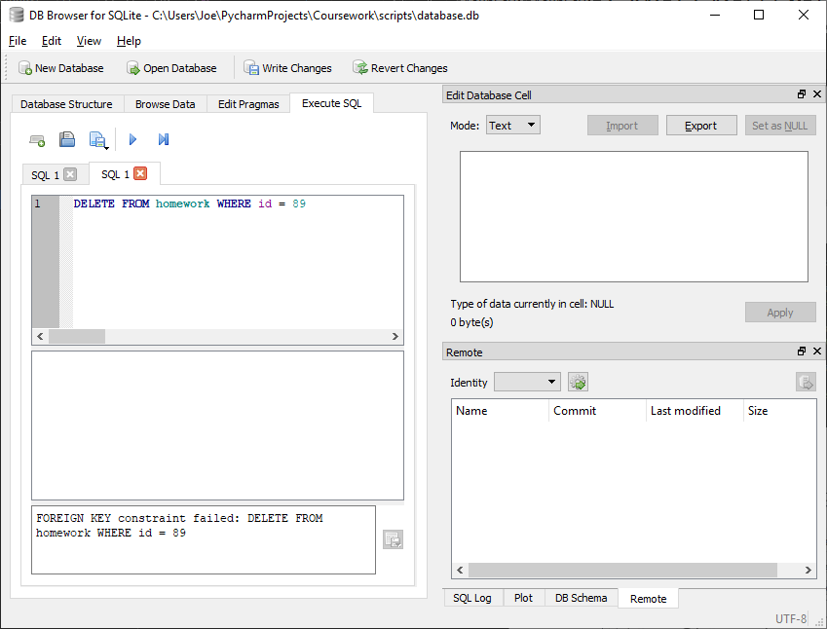

This SQL statement produces an error when run as the current homework id (89) is used as a foreign key elsewhere. This means this statement to remove from the homework table should not be carried out until all references have first been removed in the final python code.

###### Remove from class homework

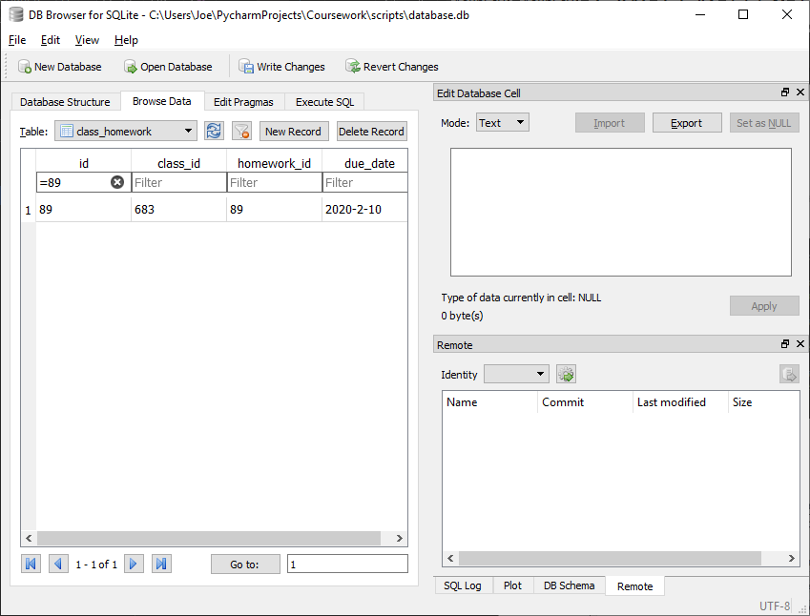

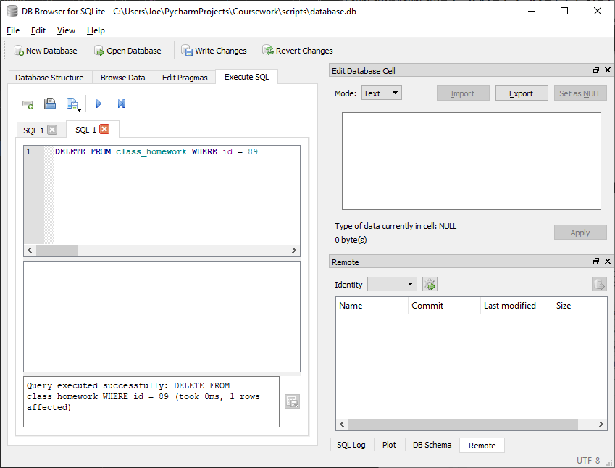

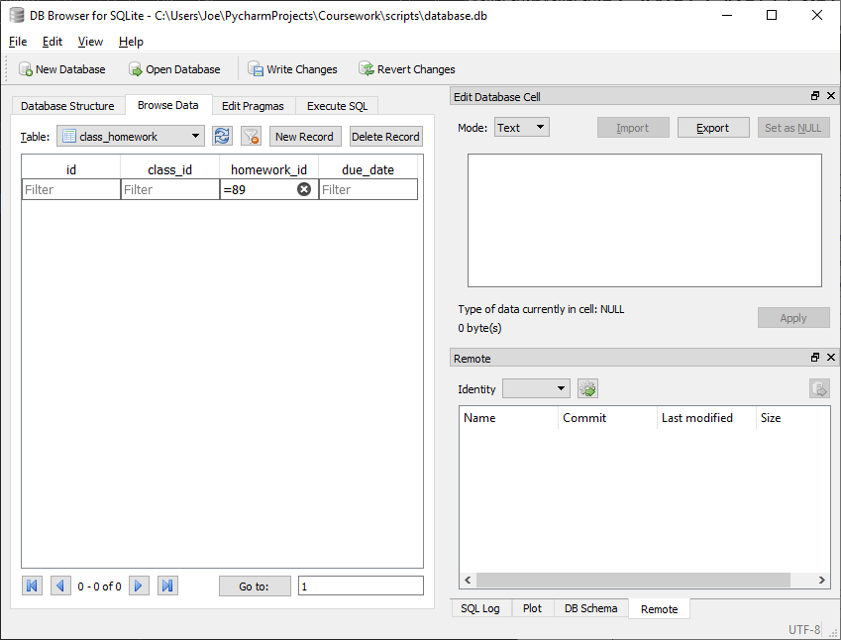

Correctly removes entry in class homework table for the entry with homework id given (89)

###### Remove from homework questions

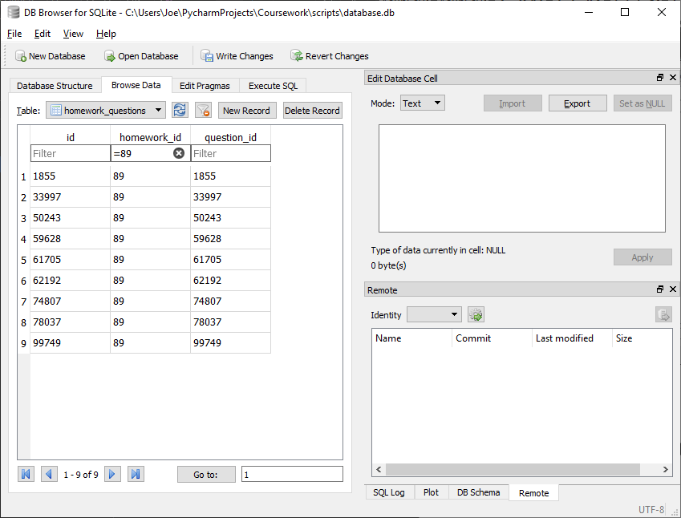

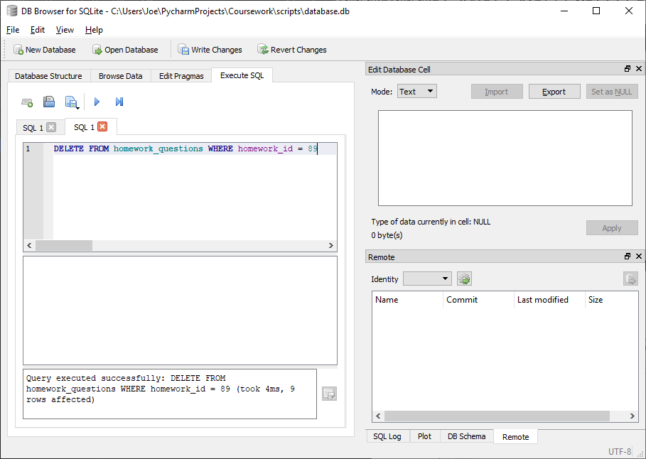

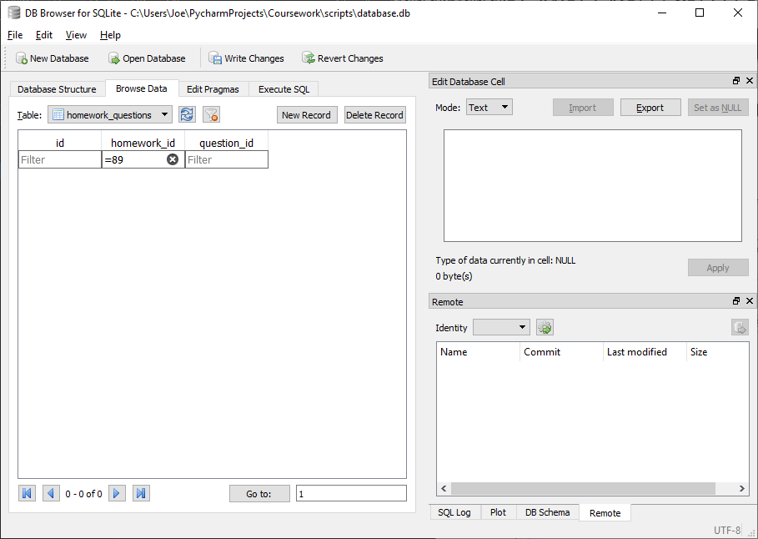

Correctly removes each entry in homework questions table for the entries with homework id given (89)

###### Remove from homework second attempt

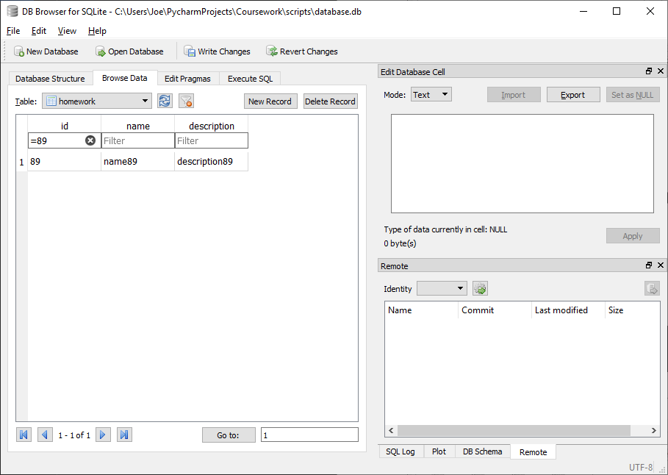

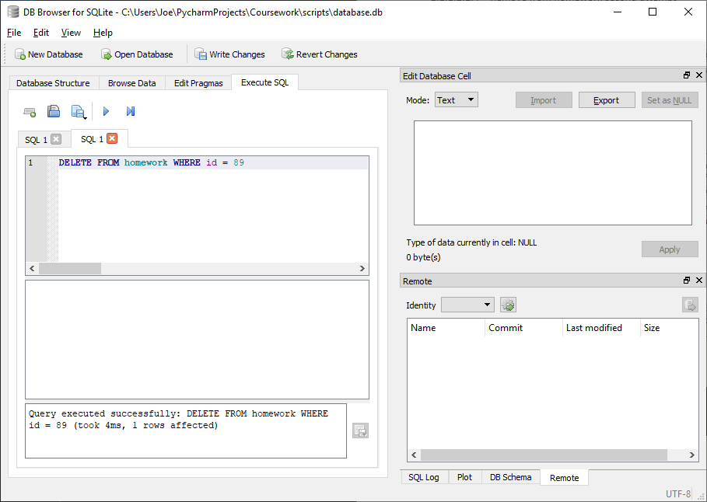

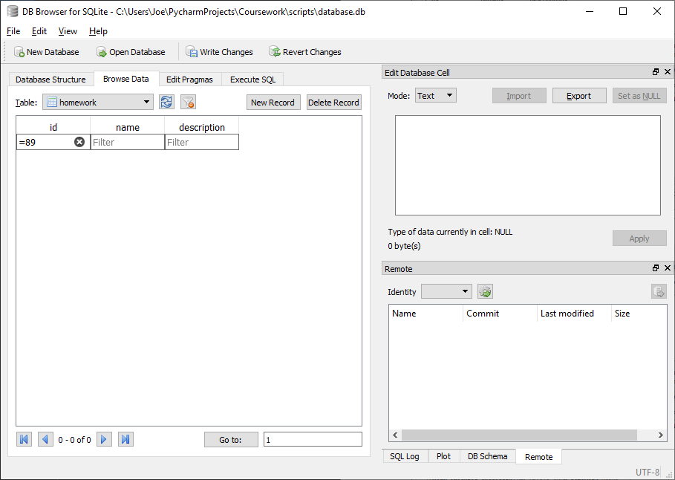

Correctly removes entry in homework table for the entry with homework id given (89)

##### Test code



##### With valid data:

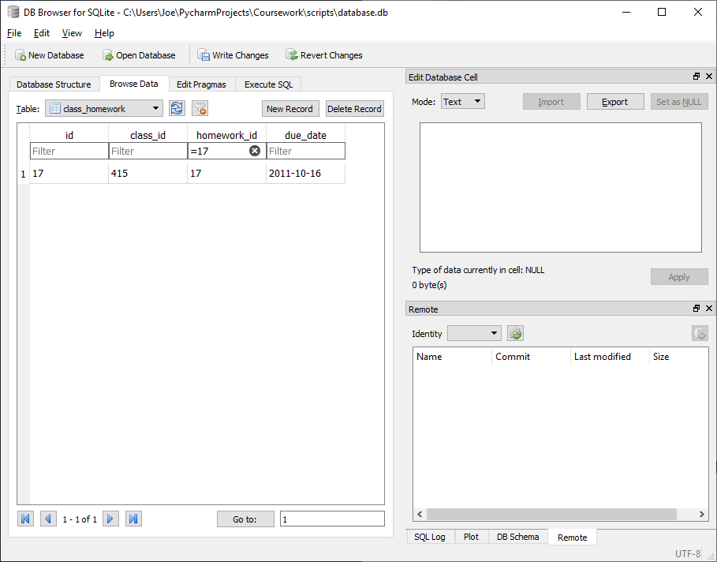

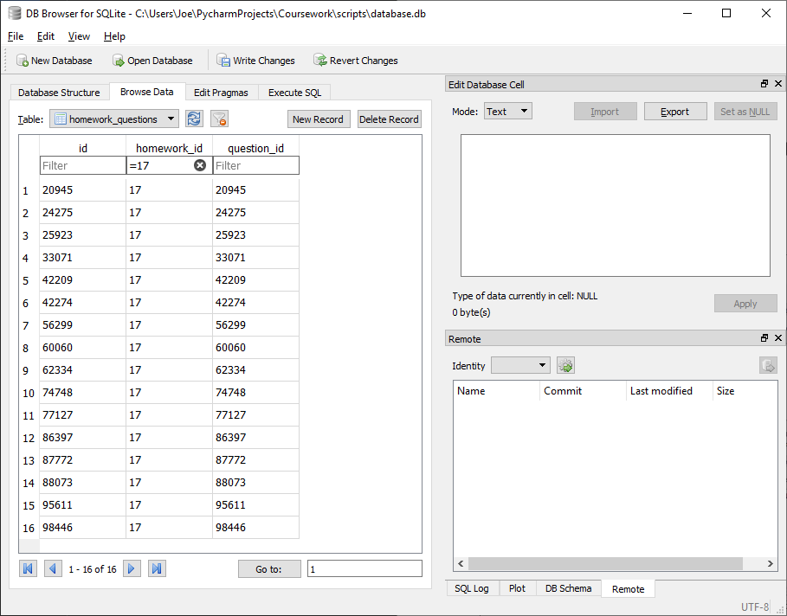

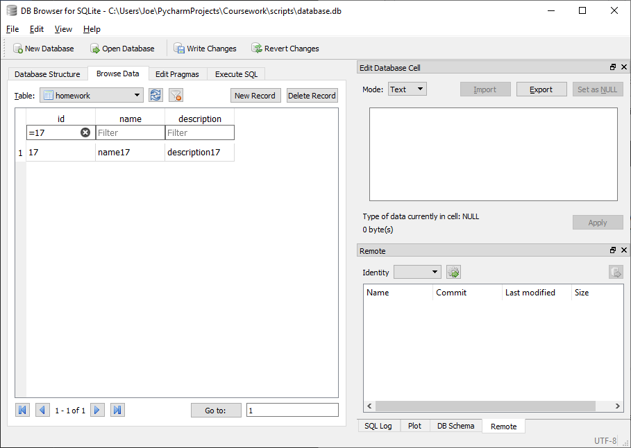



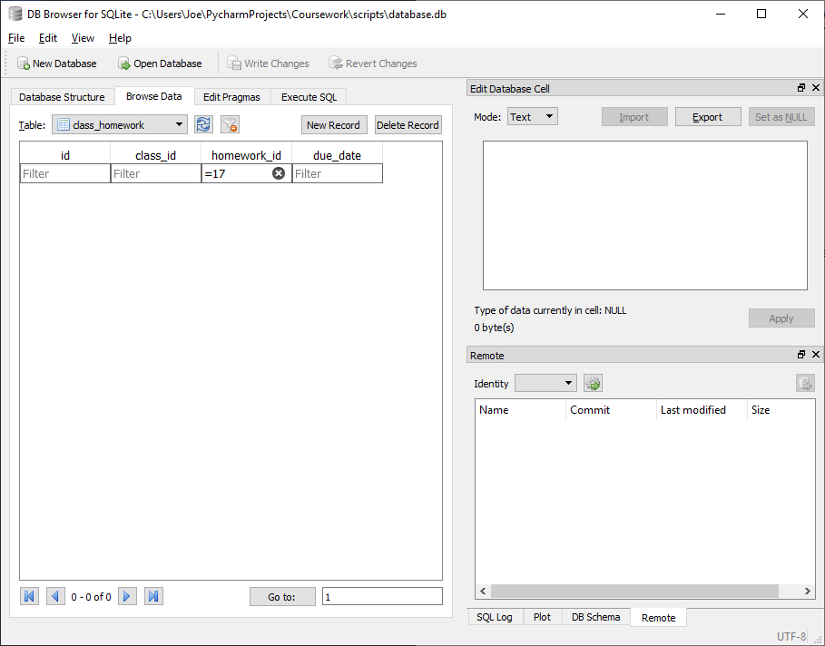

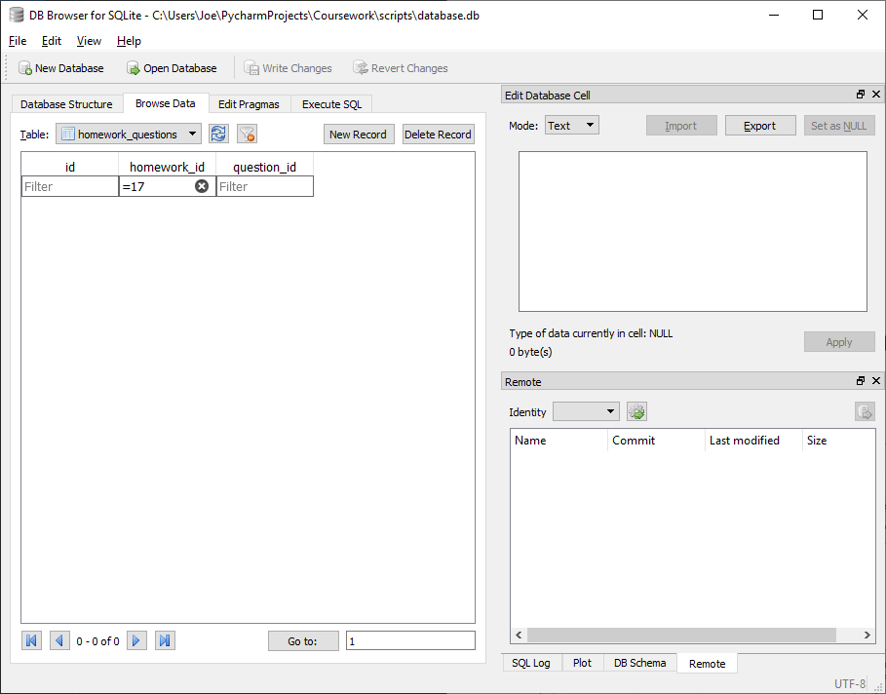

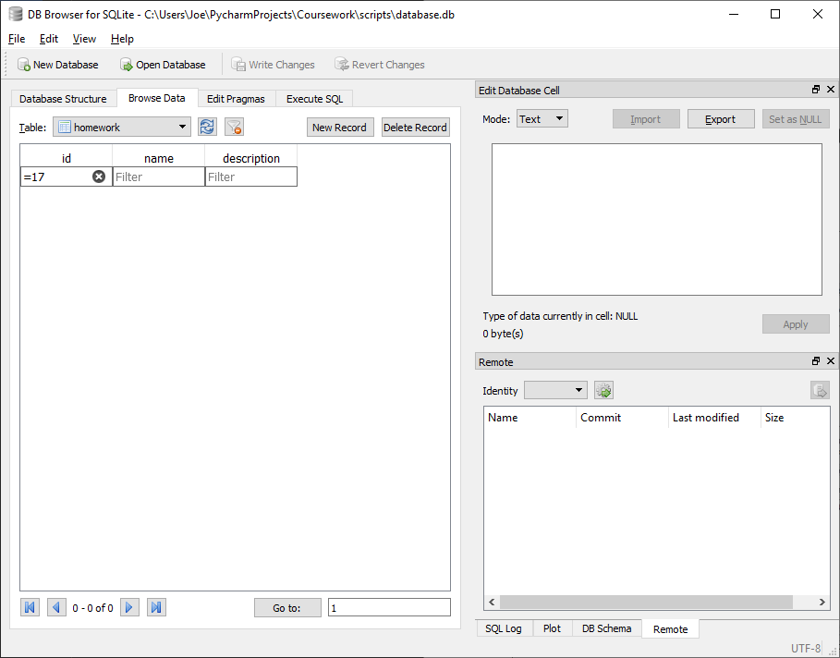

Correctly removes all references to given homework (17) in homework, homework questions and class homework table

##### With Invalid data:

N/A, any errors should be addressed before calling function by verifying homework id exists and is a valid integer before calling function

##### Evaluation

Correctly removes all references to given homework in homework, homework questions and class homework table

### Function to get type of a question

#### Final Code



#### Testing

##### SQL

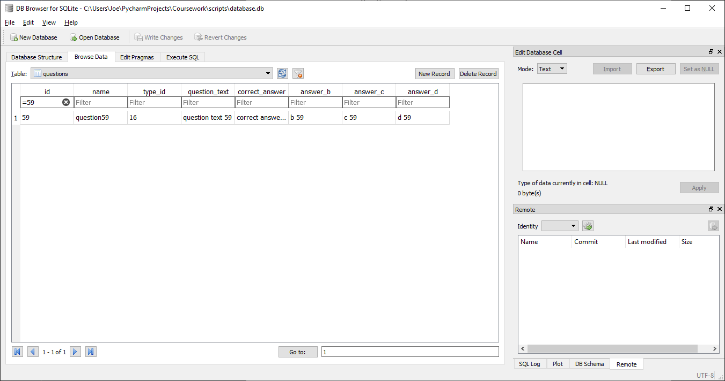

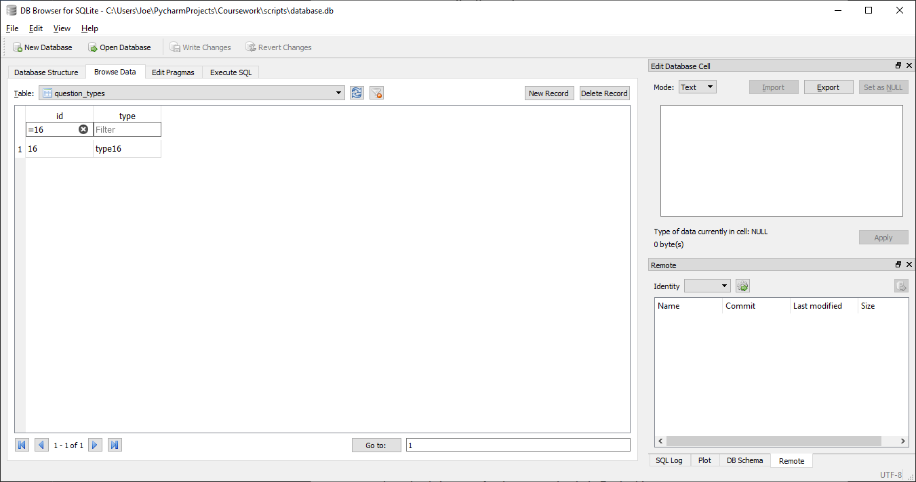

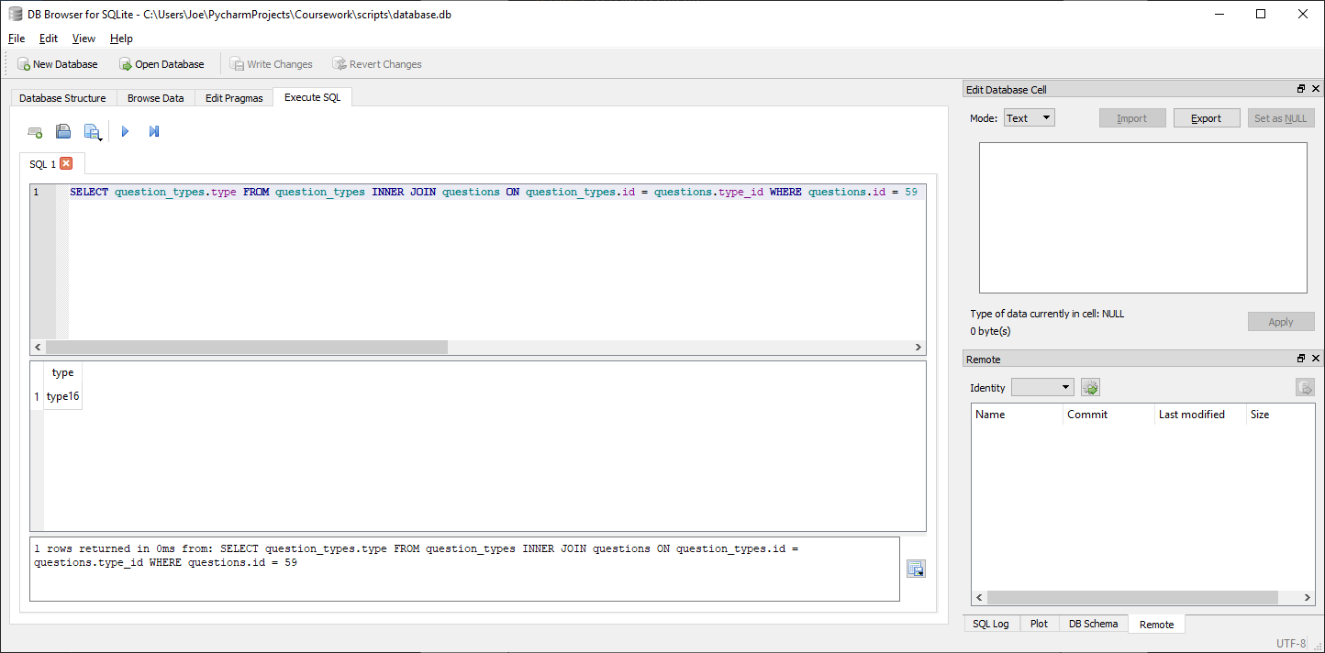

Correctly returns correct question type (type16) for given question id (16)

##### Test code



##### With valid data:

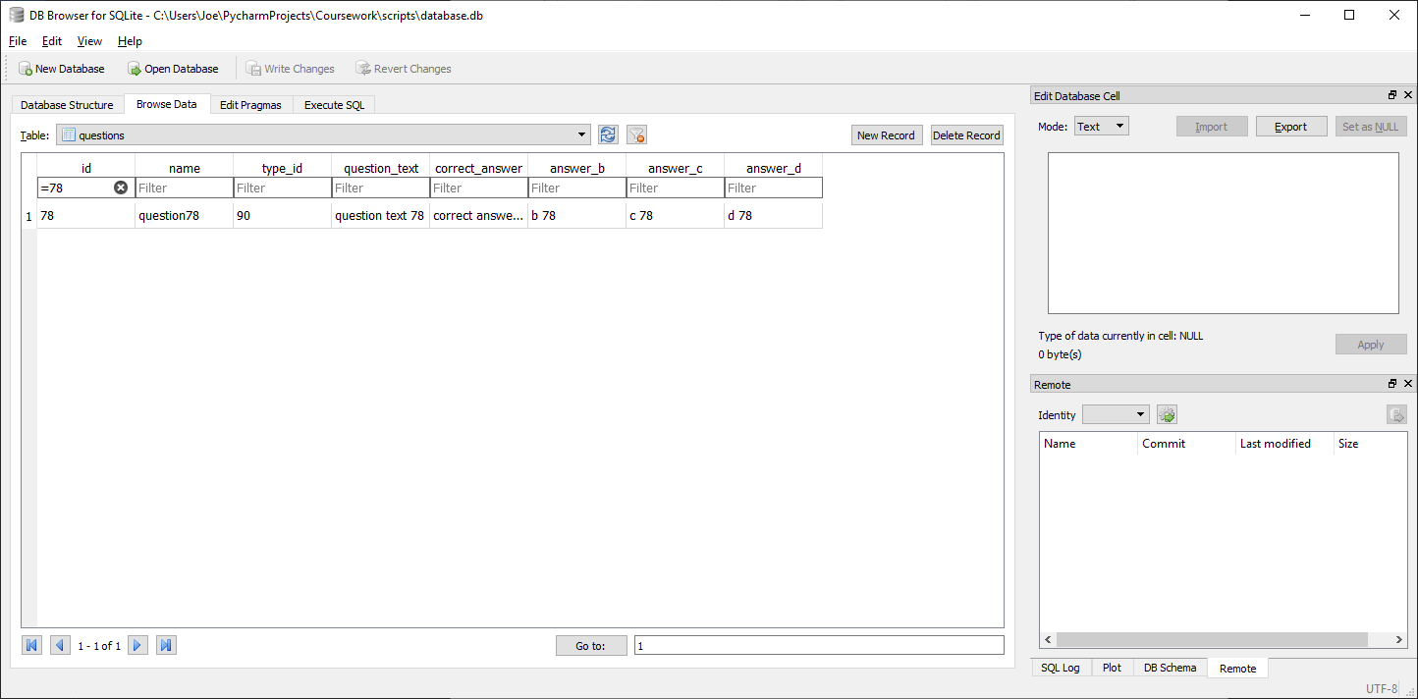

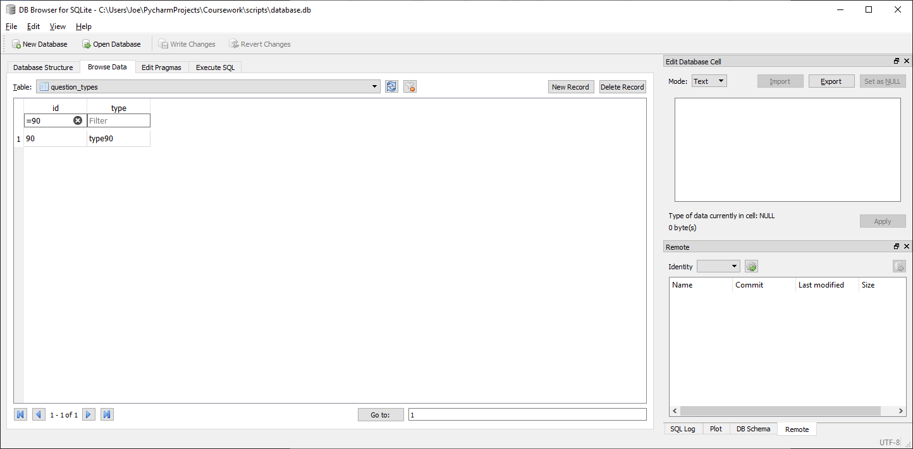



Correctly returns correct question type (type90) for given question id (78)

##### With Invalid data:

N/A, any errors should be addressed before calling function by verifying question id exists and is a valid integer before calling function

##### Evaluation

Correctly returns correct question type for given question id

### Function to get graph equation for a question

#### Final Code



#### Testing

##### SQL

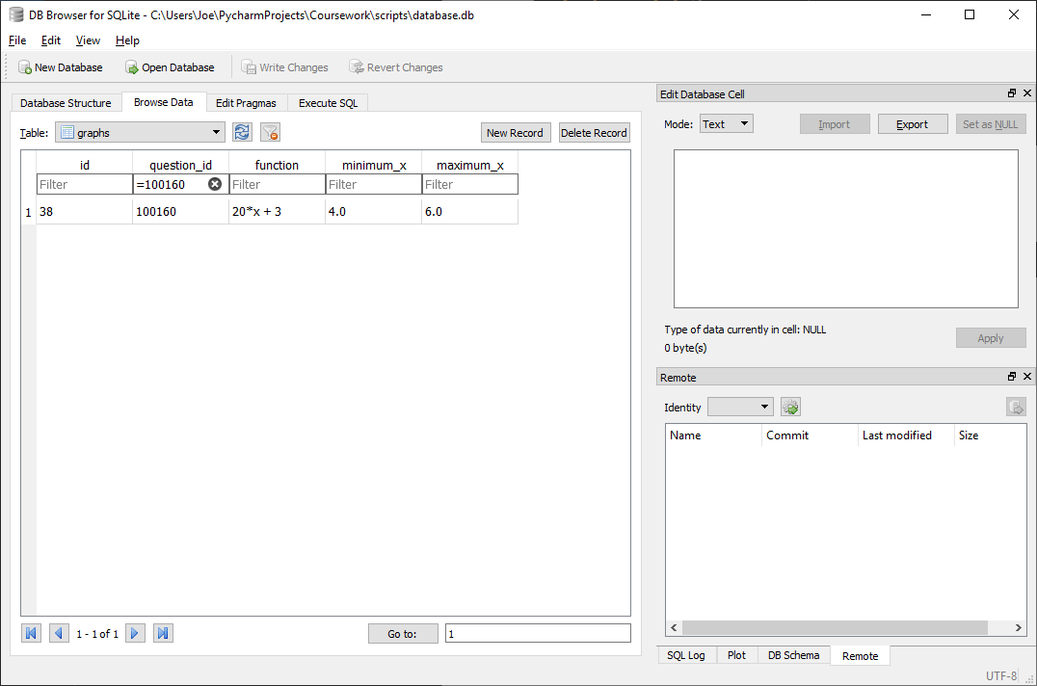

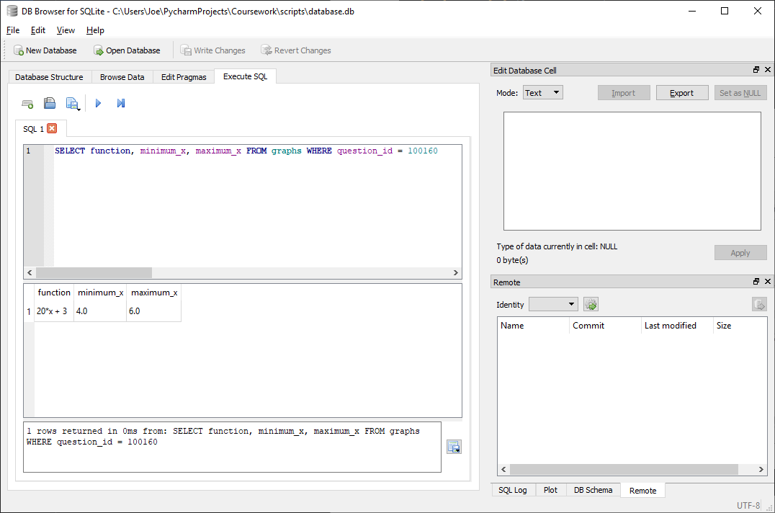

Correctly returns matching function (20x + 3), minimum x (4) and maximum x (6) for given question id (100160)

##### Test code



##### With valid data:

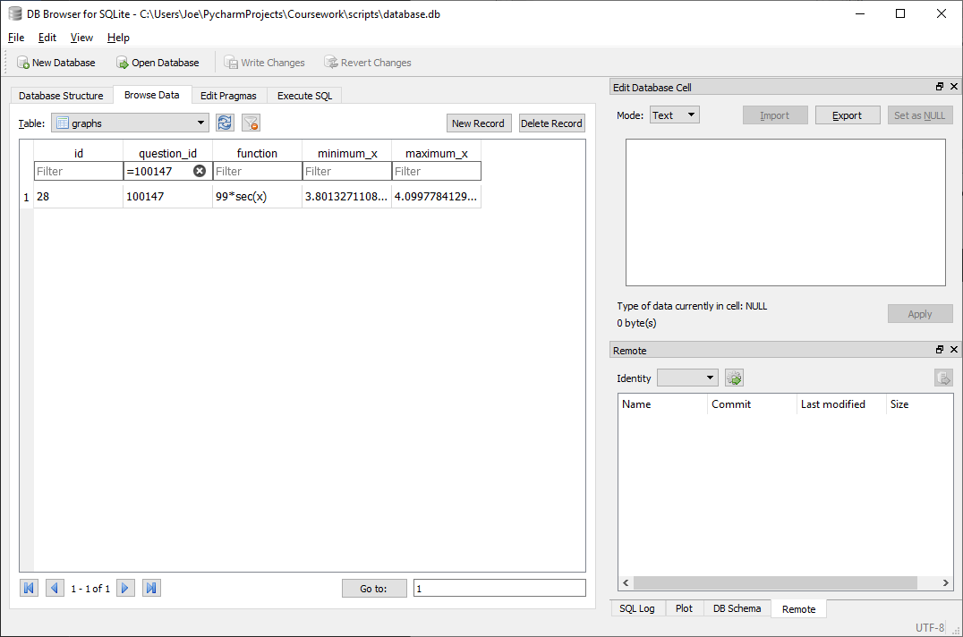



Correctly returns matching function (99sec(x)), minimum x (3.801…) and maximum x (4.099…) for given question id (100147)

##### With Invalid data:

N/A, any errors should be addressed before calling function by verifying question id exists and is a valid integer before calling function

##### Evaluation

Correctly returns matching function, minimum x and maximum x for given question id

### Function to set graph equation for a question

#### Final Code



#### Testing

##### SQL

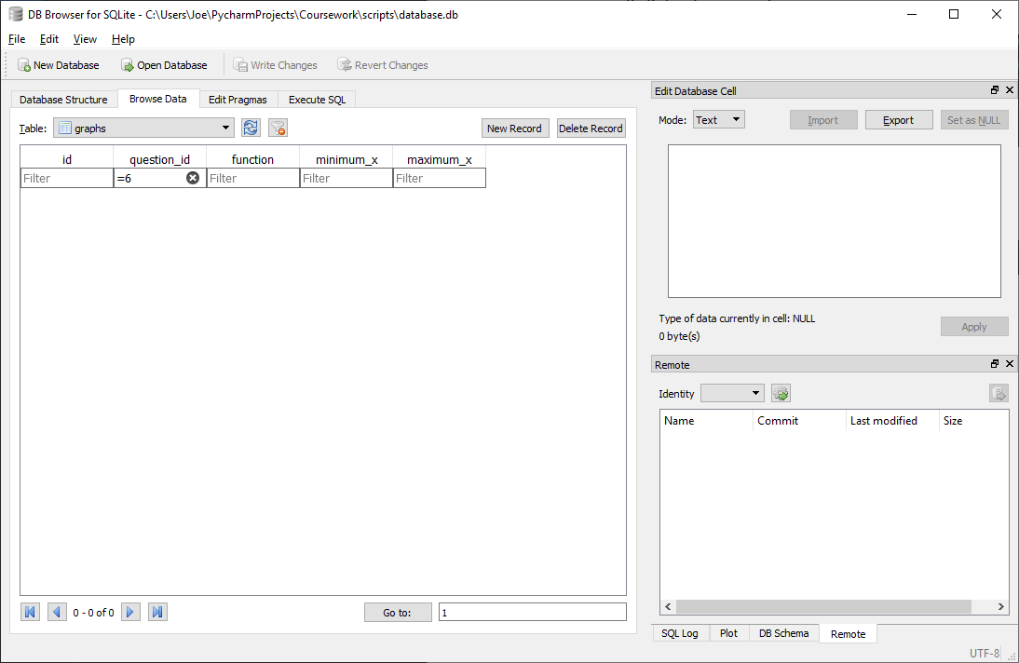

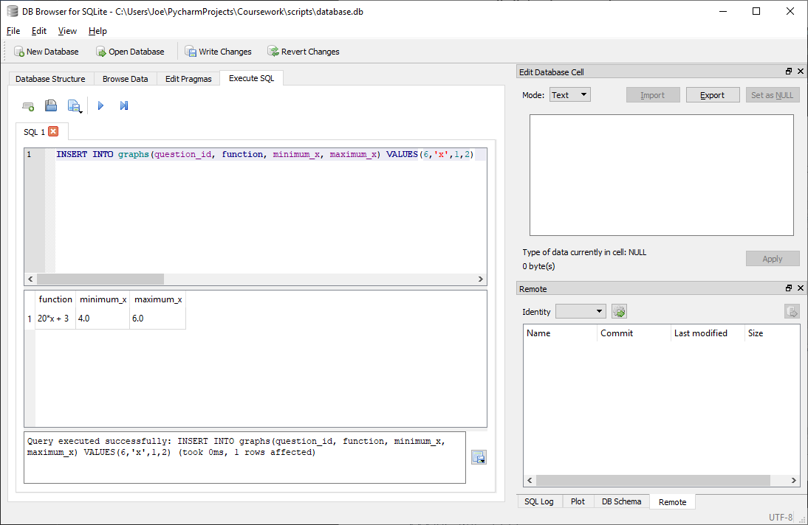

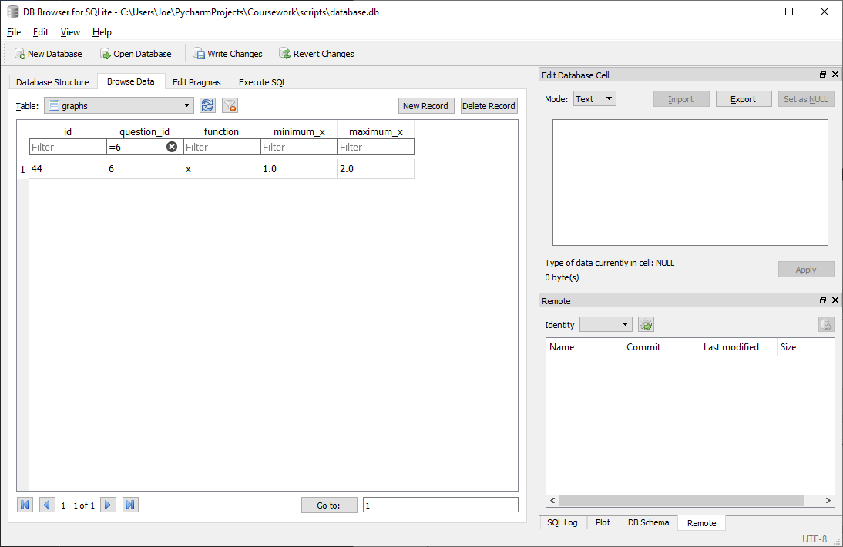

Correctly inserts given question id (6), function (x), minimum x (1) and maximum x (2) into graphs table

##### Test code



##### With valid data:

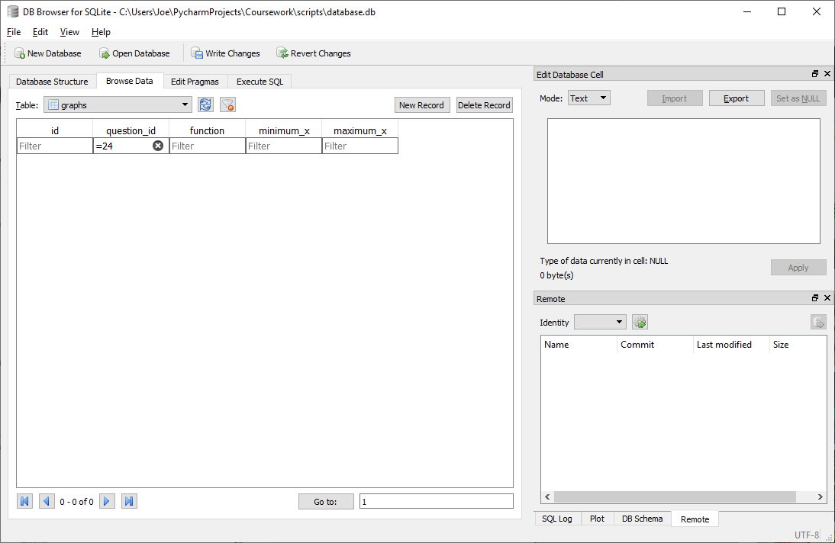



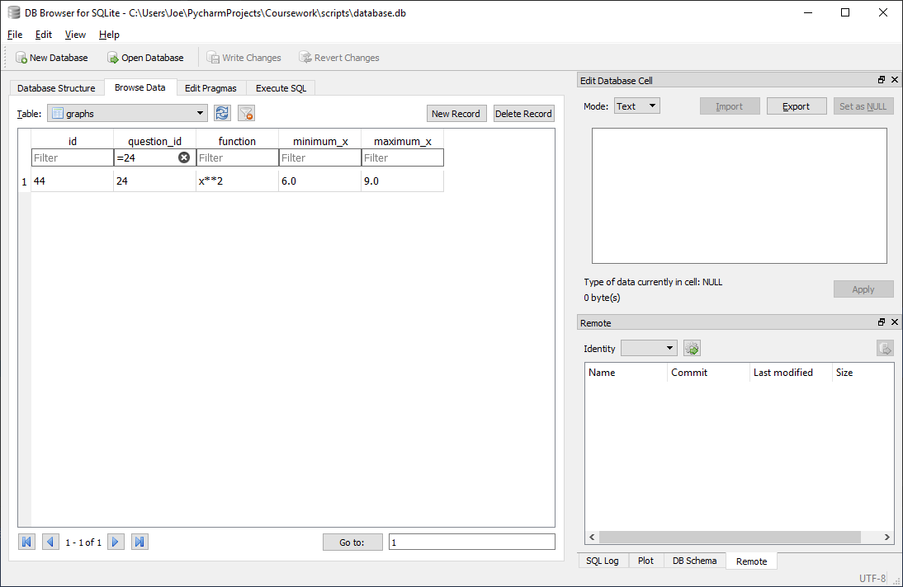

Correctly inserts given question id (24), function (x**2), minimum x (6) and maximum x (9) into graphs table

##### With Invalid data:

N/A, any errors should be addressed before calling function by verifying question id exists and is a valid integer before calling function, function is of valid from and minimum and maximum x are both floats with minimum x less than maximum x

##### Evaluation

Correctly inserts given question id, function, minimum x and maximum x into graphs table

## UI Programming (main)

### Function to initialise program UI and halt program

#### Final Code



#### Testing

Notes:

* Create database function and testing will be shown later
* Windows class code setup and testing will be shown later
* Code used is generic to all PyQT programs so can be assumed to be well tested, so it will only be checked that the code has been implemented correctly

##### With valid data:

When program is run correctly shows the program window:

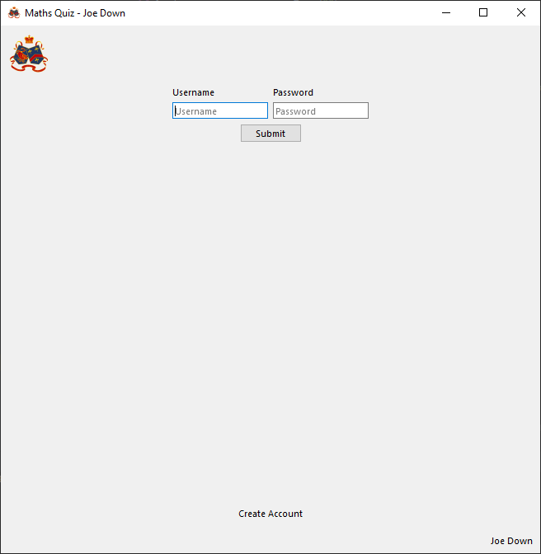

When close button pressed, correctly ends program execution:

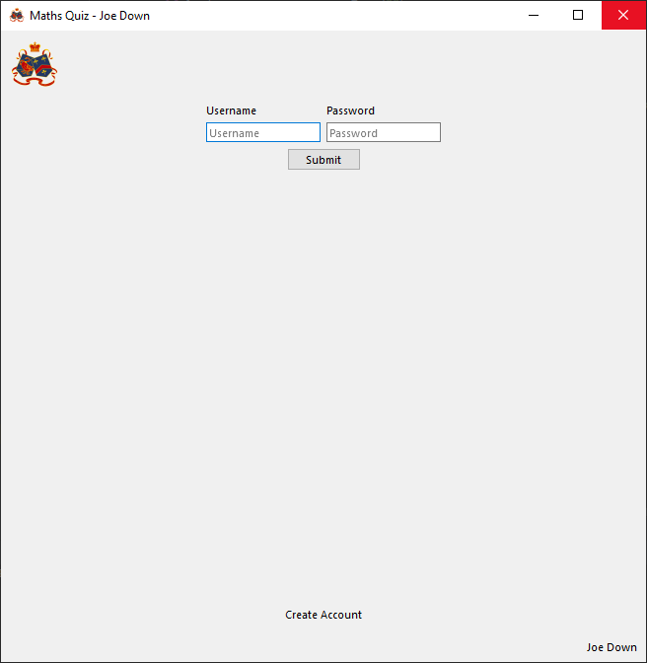



##### With Invalid data:

N/A, no user input required, and this code can only ever execute in the same way

##### Evaluation

Correctly initialises UI and ends program when UI closed. No errors occur during the imports as python environment is correctly set up

### Function to setup database or, if already present, make sure database structure is correct

#### Issues during development

Initially, the following code was not included:



This is because this table was not specified to be included as part of the data structure during design. However, during development, it was decided to implement graphs for questions containing a graphable mathematical function of some sort and so this graph equation would need to be stored somewhere, along with the range of x values for which this graph should be drawn. This was done by creating a new graphs table with a question id as a foreign key identifying to what questions graph belongs. This way, the questions table does not need to be changed and so code existing code using this table does not need to be retested. To get a graph, the graphs table can simply be searched for the question id. If there are no occurrences in the table, there is no graph, and if there is a record found, the relevant graph equation and boundaries can be utilised in the graph drawing code.

#### Final Code





#### Testing

##### With valid data:

###### Database does not already exist

Before program is run:

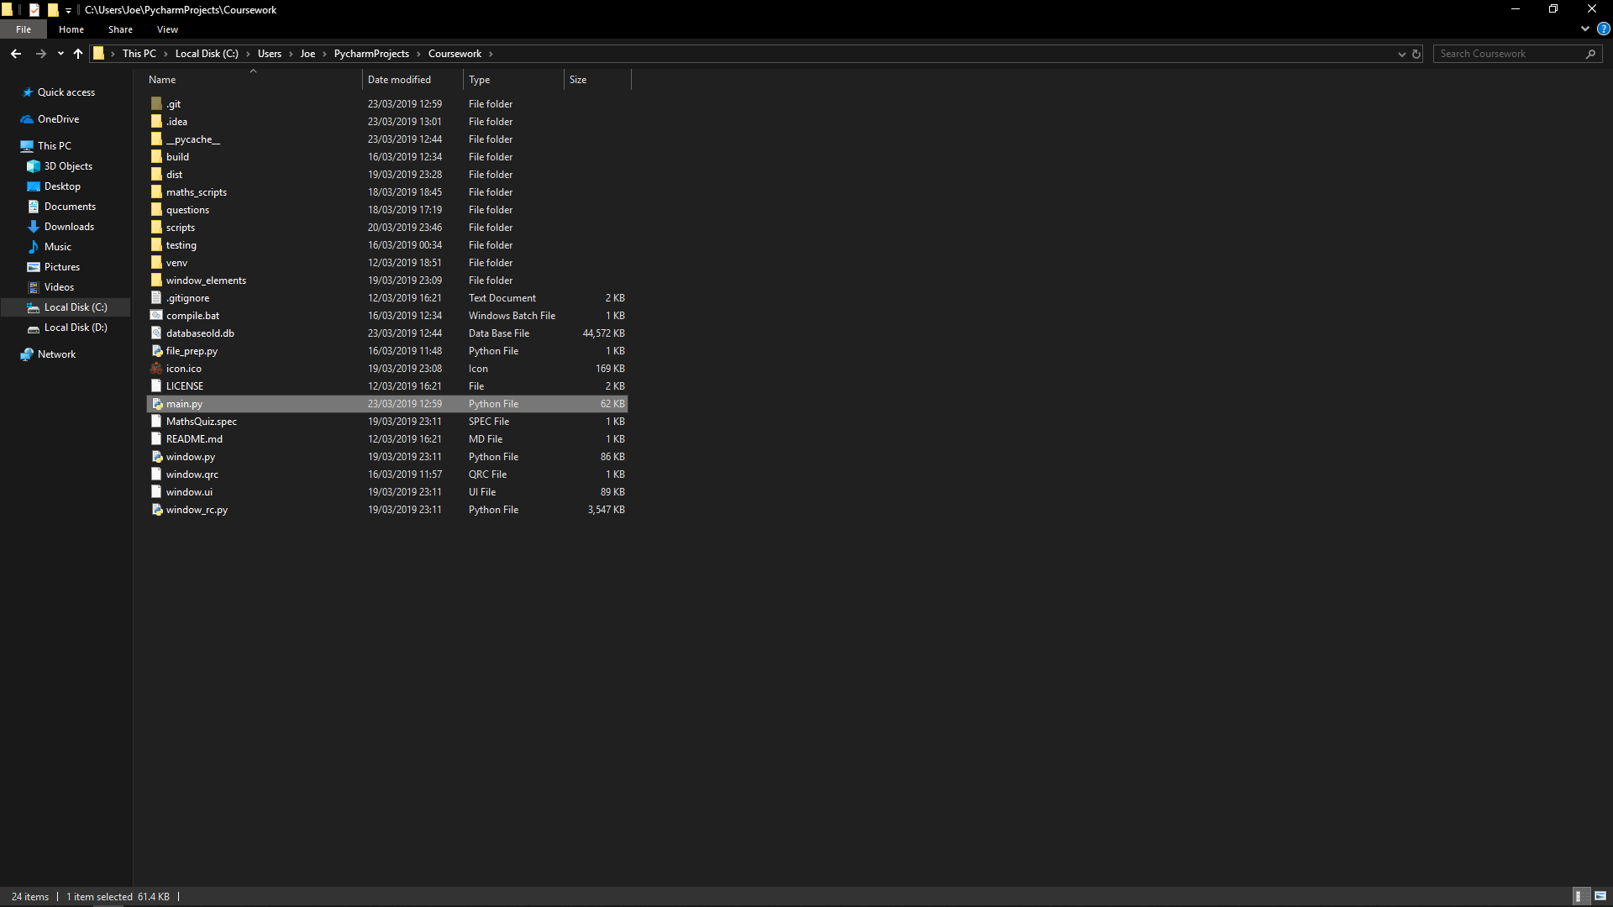

After program is run:

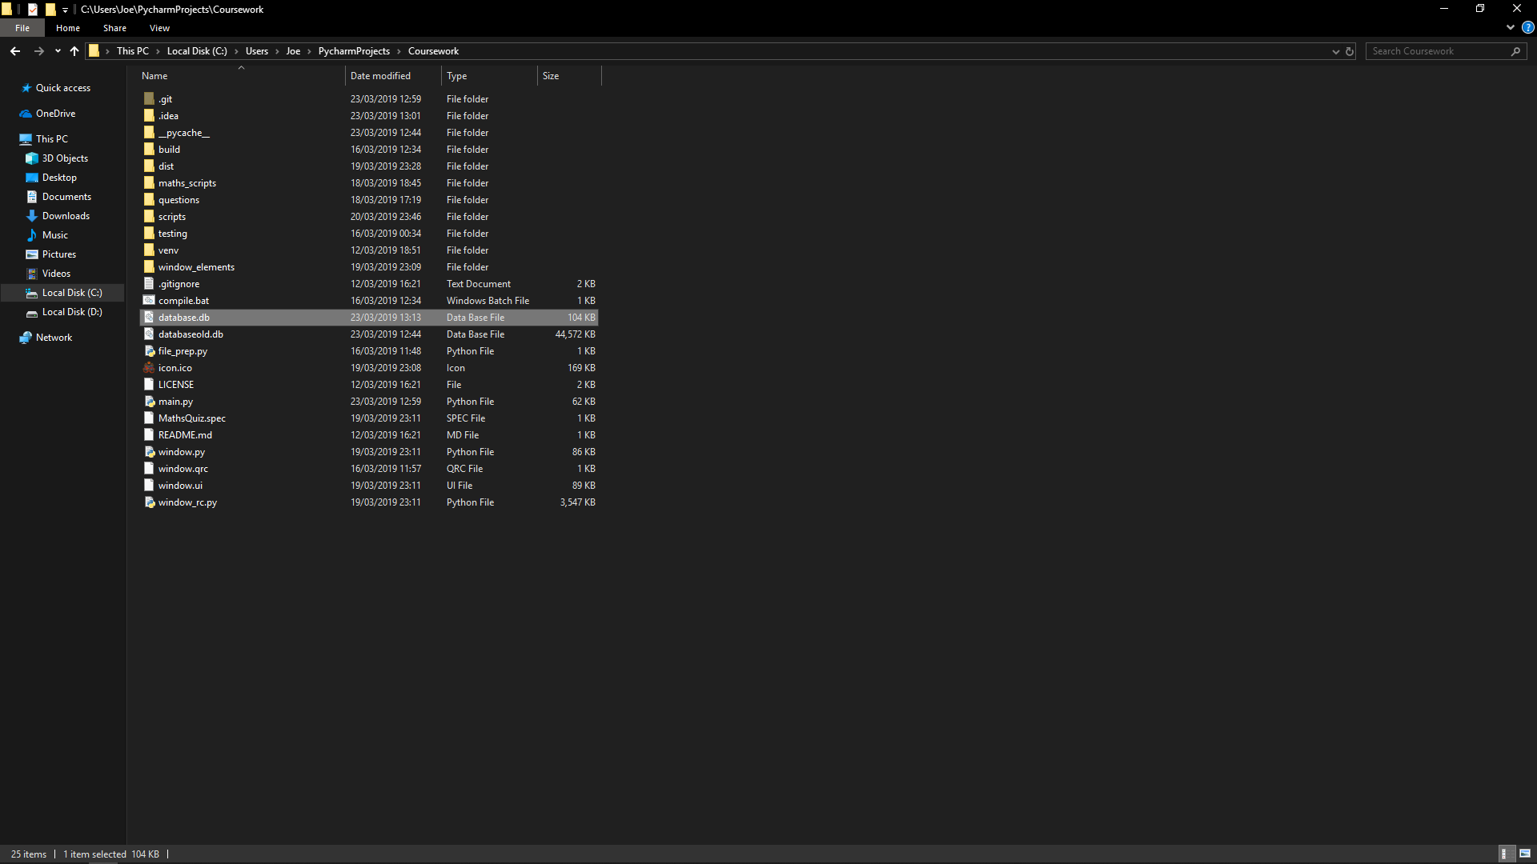

Correctly creates database.db file

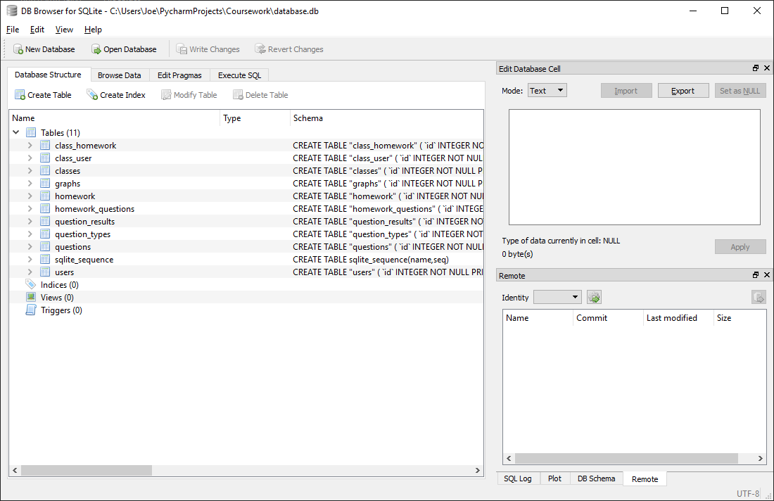

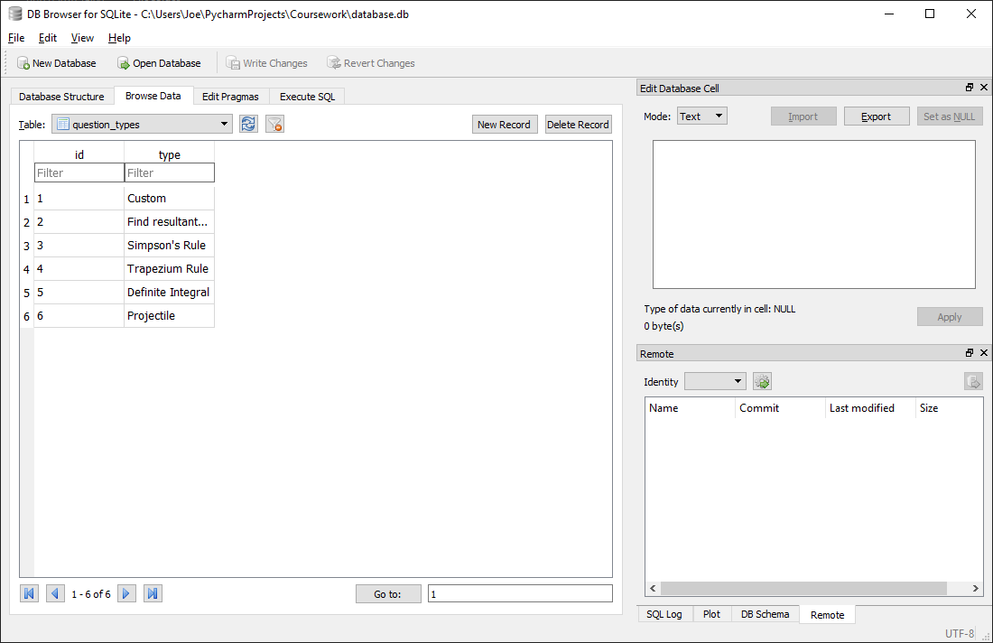

Created database has all required tables and table relations. All predefined data is included as needed

###### Database already exists

Before program is run:

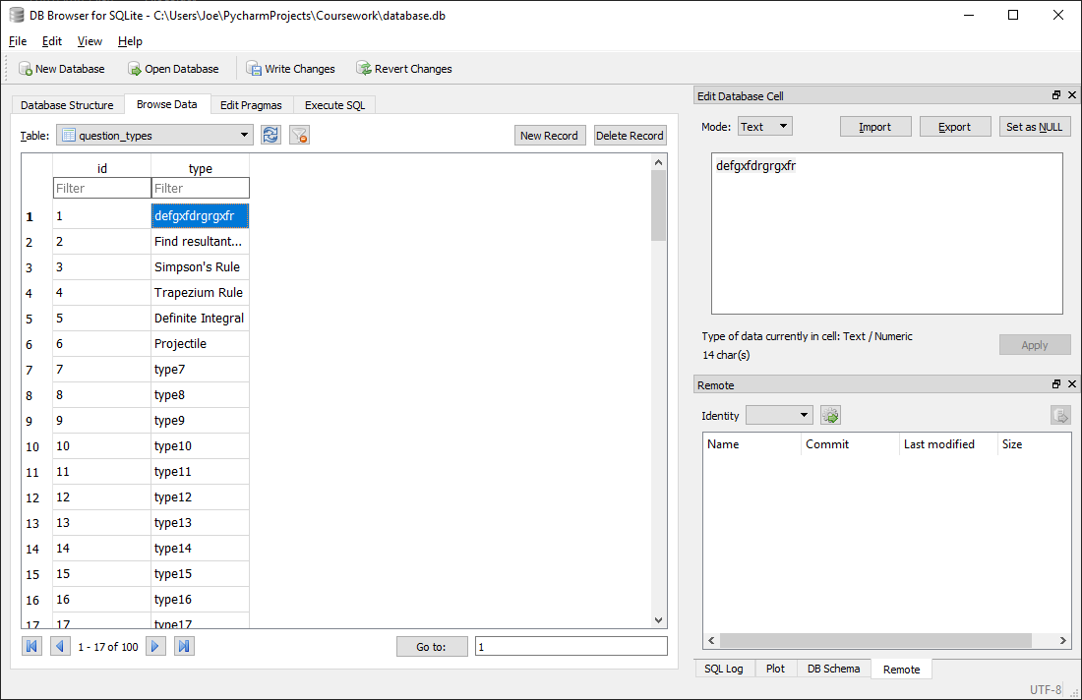Database contains existing data and has a mistake in the type name for type with id 1 (should be ‘Custom’)

After program is run

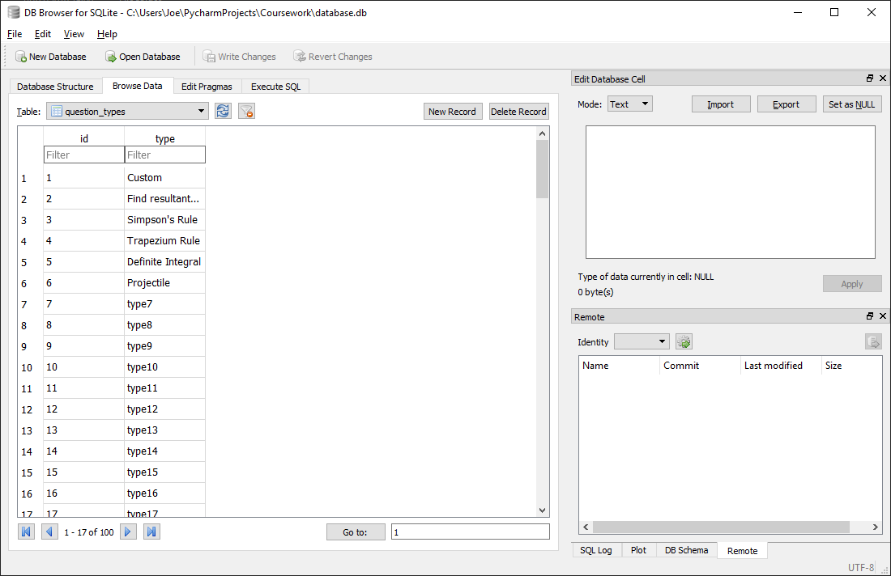All data already in database is preserved and incorrect data fixed (type with is 1 changed to ‘Custom’)

##### With Invalid data:

N/A, no user input required, and this code can only ever execute in the same way

##### Evaluation

Successfully creates the relevant database file if not present with all required table relations and pre-inserted data or, if the database already exists, ensures it fits the expected database structure and changes it as/if needed

### Window class

#### Function to initialise class

##### Final Code



##### Testing

###### With valid data:

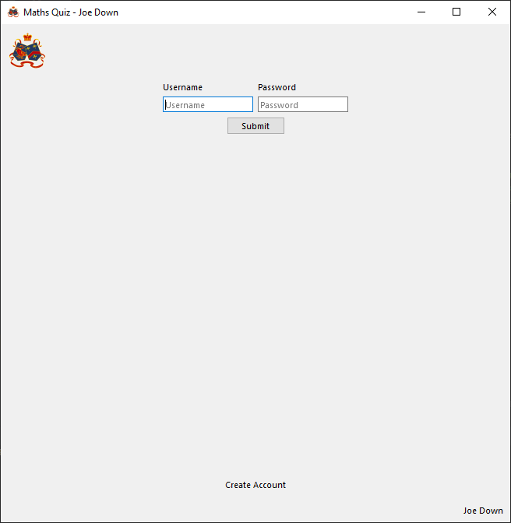

Correctly initialises program at login page with logout and main menu buttons hidden (sets program to logged out state)

###### With Invalid data:

N/A, no user input required, and this code can only ever execute in the same way

###### Evaluation

Correctly initialises program at login page with logout and main menu buttons hidden (sets program to logged out state)

#### Function to change page to a given index and update logout button, main menu button and name display accordingly

##### Issues during development

Initially the following code was implemented:



This resulted in the following error upon running the program:

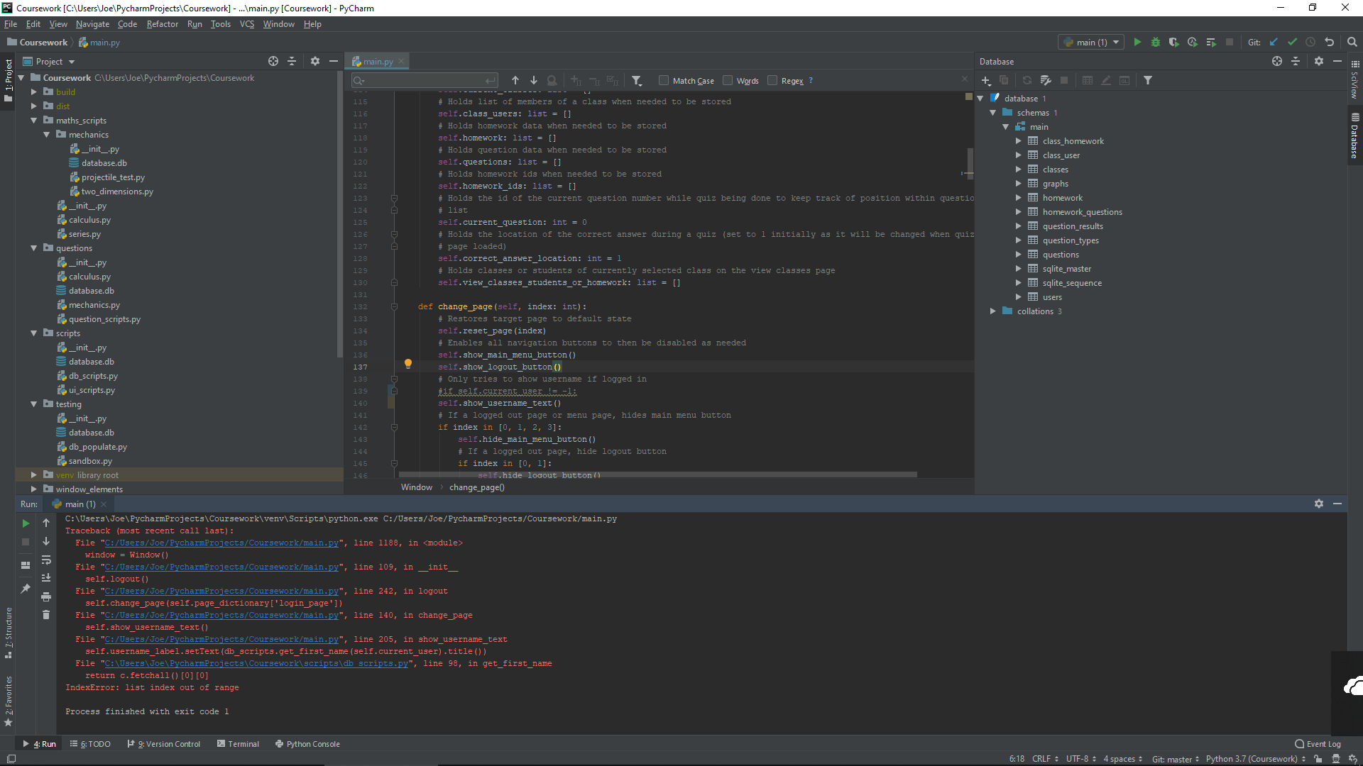

This is because when initially loading the login page, an attempt is made to display the current username. As when a user isn’t logged in, the current user id is set to -1, there is no corresponding username in the database and so a crash occurs. This will be fixed by checking if the current user id is -1 before attempting to show the username. If it is -1, it is known no user is logged in at the time and so the username display is not needed. The code was changed to include the following:



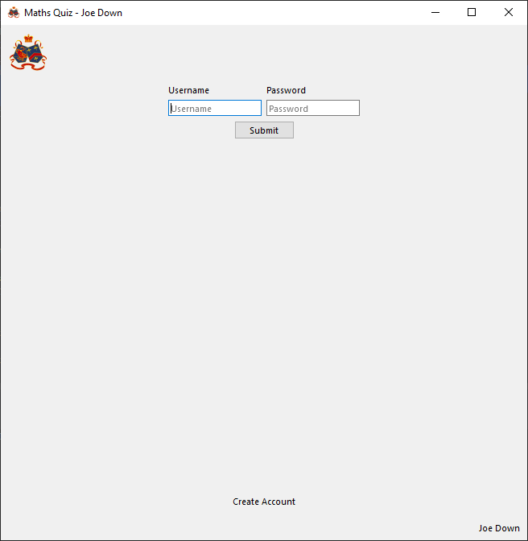

The program now loads correctly, displaying no username until the user logs in

##### Final Code



##### Testing

Notes:

* Reset page function testing shown later in development
* Show main menu button function testing shown later in development
* Show logout button function testing shown later in development
* Show username text function testing shown later in development
* Hide main menu button function testing shown later in development
* Hide logout button function testing shown later in development
* Hide username text function testing shown later in development

###### With valid data:

Load page 0



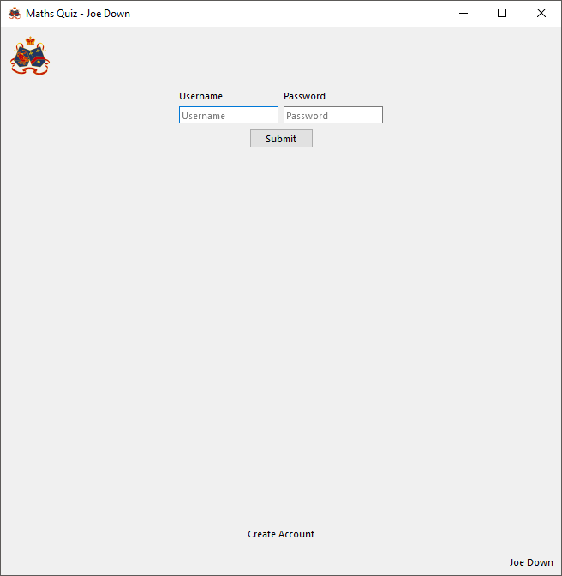

Loads correct screen and hides username, main menu button and logout button

Load page 1



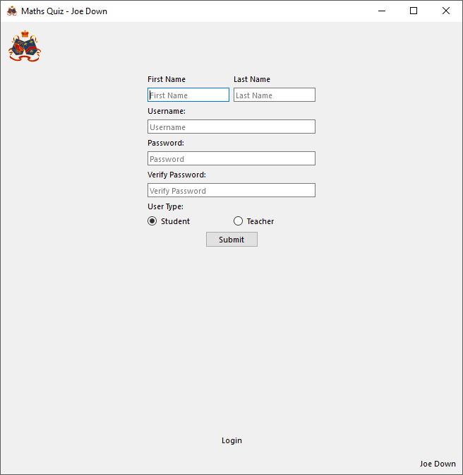

Loads correct screen and hides username, main menu button and logout button

Load page 2



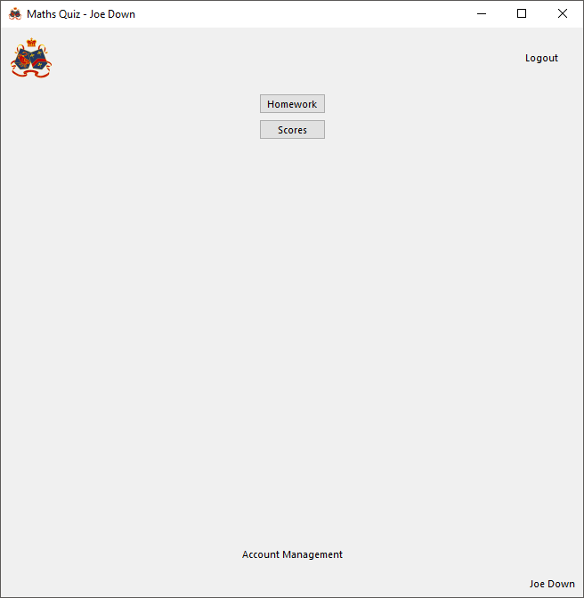

Loads correct screen and shows username and logout button

Load page 3



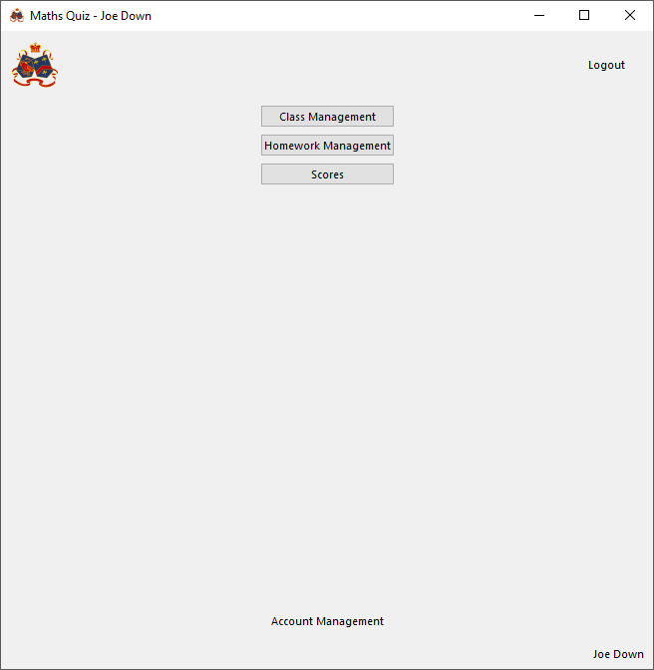

Loads correct screen and shows username and logout button

Load page 5



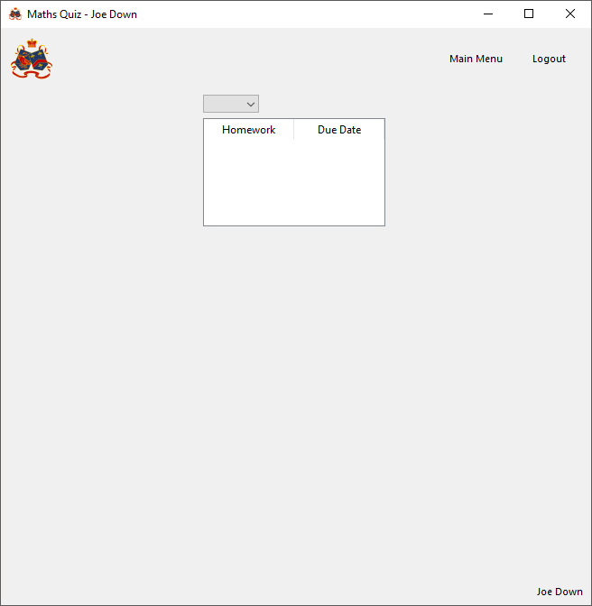

Loads correct screen and shows username, main menu button and logout button

Load page 6



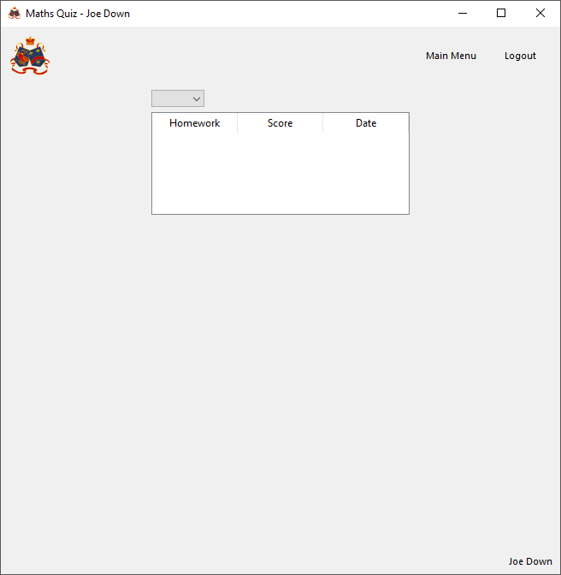

Loads correct screen and shows username, main menu button and logout button

Load page 7



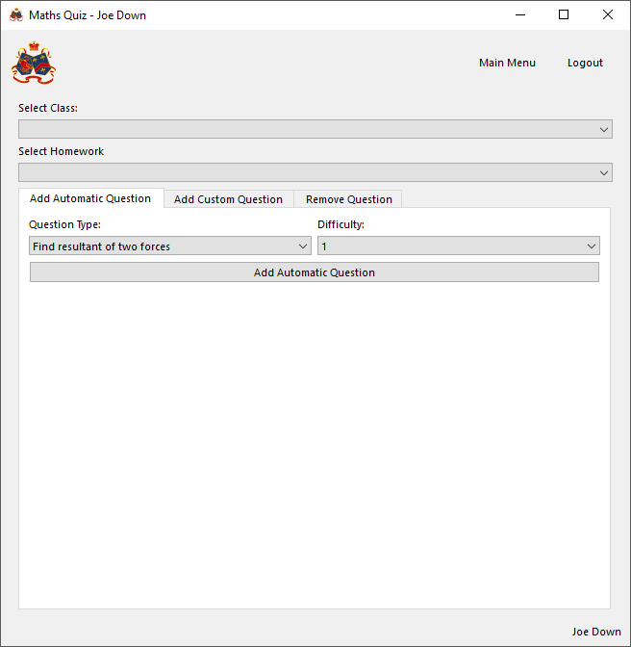

Loads correct screen and shows username, main menu button and logout button

Load page 8



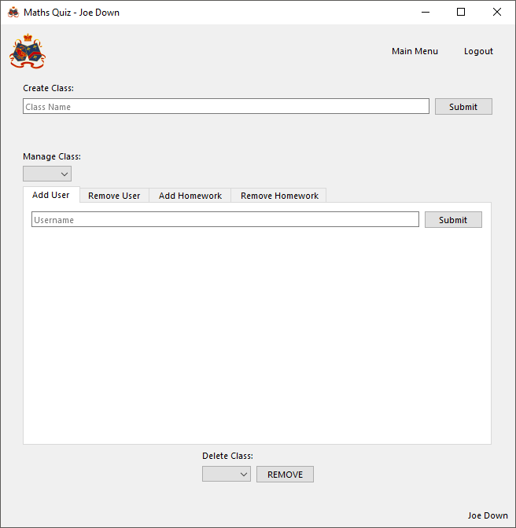

Loads correct screen and shows username, main menu button and logout button

Load page 9



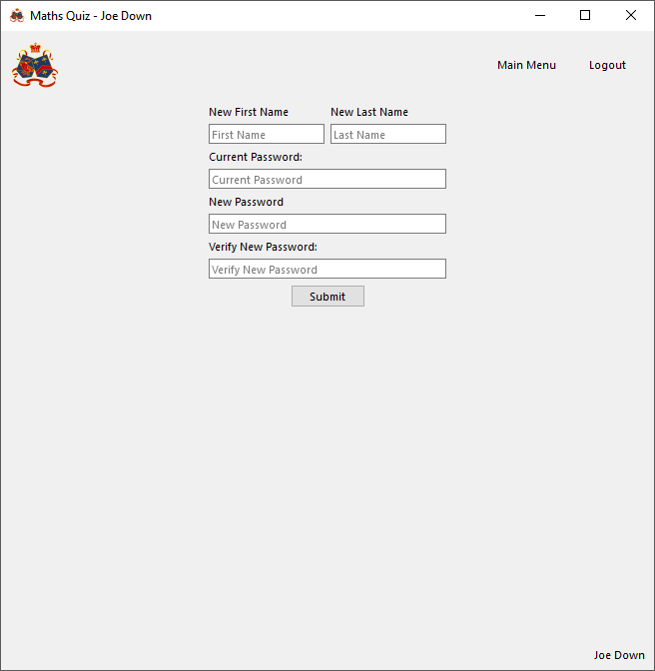

Loads correct screen and shows username, main menu button and logout button

Load page 10



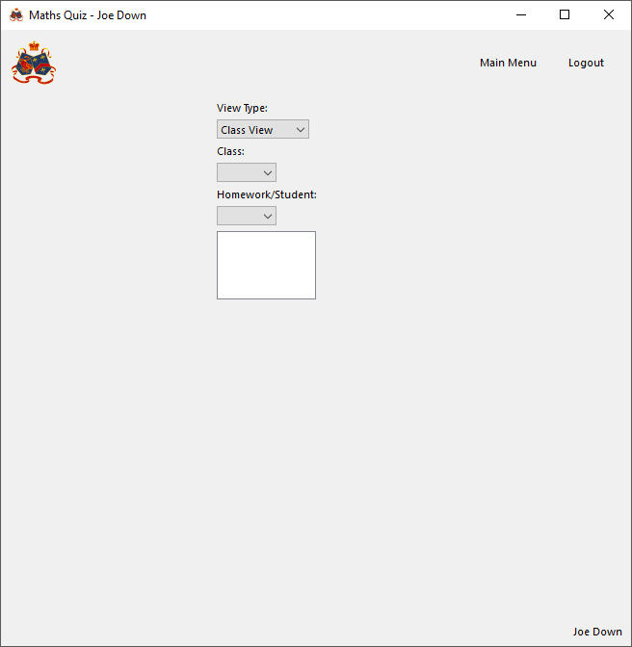

Loads correct screen and shows username, main menu button and logout button

###### With Invalid data:

N/A, page index should be validated to exist and be an integer before calling function

###### Evaluation

Correctly changes to the correct page index and sets it to its initial state. Correctly hides/shows logout and main menu buttons and user’s name depending on the page selected

#### Function to set up buttons

##### Final Code



##### Testing

As this function simply calls each button setup function when the program is run, it can be tested later by simply checking buttons work as intended after writing the button setup functions for each page. No inputs are taken and so the script will always run the same way and so testing for incorrect usage does not need to be done

#### Function to reset a page

##### Final Code



##### Testing

As this function is simply used to take a page index and select the script to setup the page for the given index, it can be tested to be working later as each full individual page reset script is written and will be verified to work on a case by case basis there. Testing of incorrect inputs cannot cause an error as the if statements will simply end up in a pass and the program will not respond. Additionally, the way the program is to be written, and incorrect target page index will not be inputted to the function as it will be verified before this stage.

#### Navigation bar

##### Function to hide/show main menu button

###### Final Code



###### Testing

With valid data:

Show button



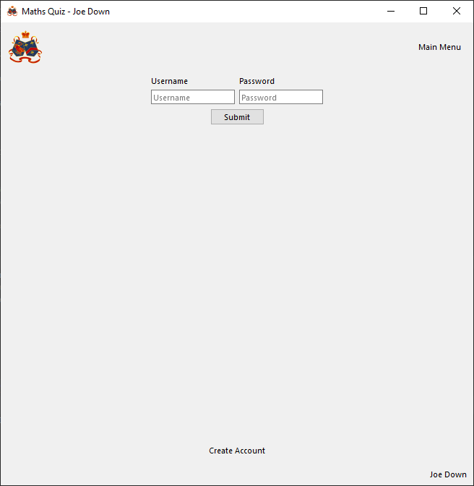

Button successfully shows

Hide button



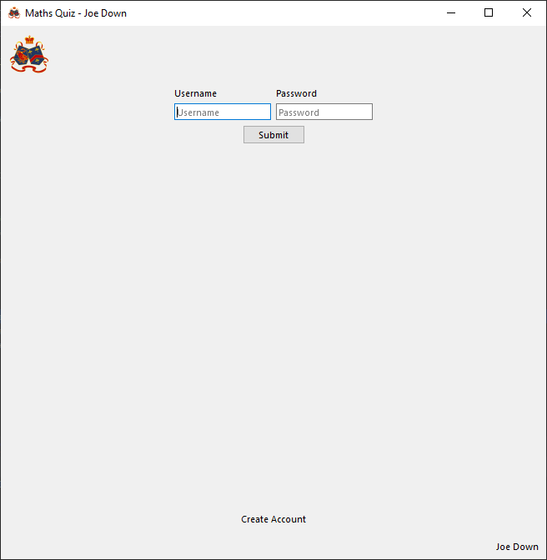

Button is successfully hidden

With Invalid data:

N/A, functions take no inputs and so button can only ever be enabled or disabled

###### Evaluation

Functions successfully hide or show button when called

##### Function to hide/show username

###### Final Code



###### Testing

With valid data:

Show



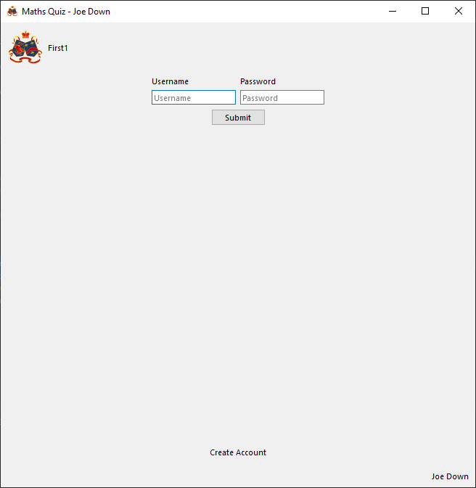

Label successfully shows

Hide



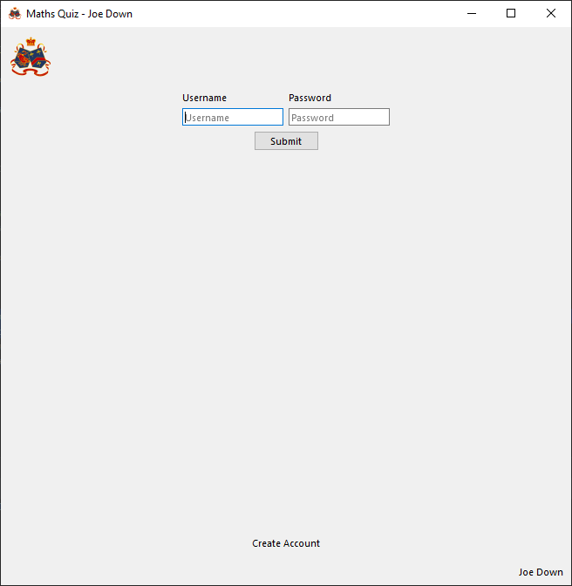

Label is successfully hidden

With Invalid data:

N/A, functions take no inputs and so output can only ever be enabled or disabled

###### Evaluation

Functions successfully hide or show username output when called

##### Function to hide/show logout button

###### Final Code



###### Testing

With valid data:

Show



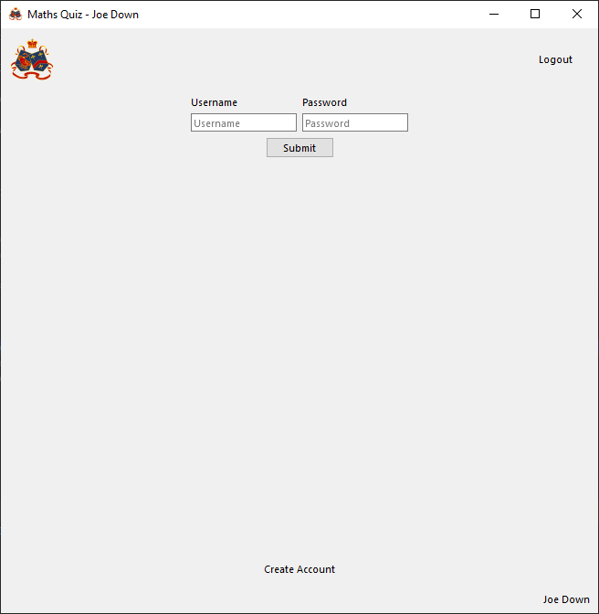

Button successfully shows

Hide



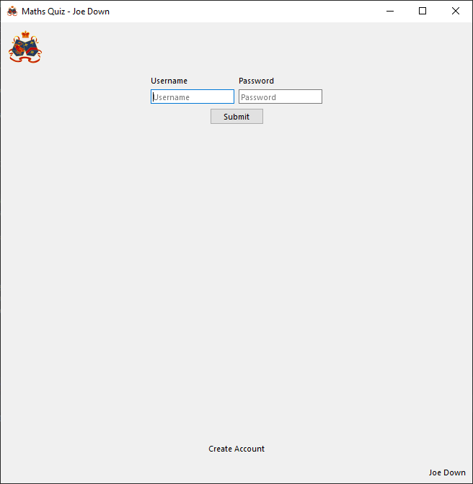

Button is successfully hidden

With Invalid data:

N/A, functions take no inputs and so button can only ever be enabled or disabled

###### Evaluation

Functions successfully hide or show button when called

##### Function to set up buttons

###### Final Code



###### Testing

With valid data:

Functionality of buttons will be verified to work during code for respective functions later in development and this section will be updated if changes are required

With Invalid data:

N/A, button is either pressed or not pressed, cannot give invalid inputs to function (as none are taken)

##### Function to go to main menu

###### Final Code



###### Testing

With valid data:

Student account

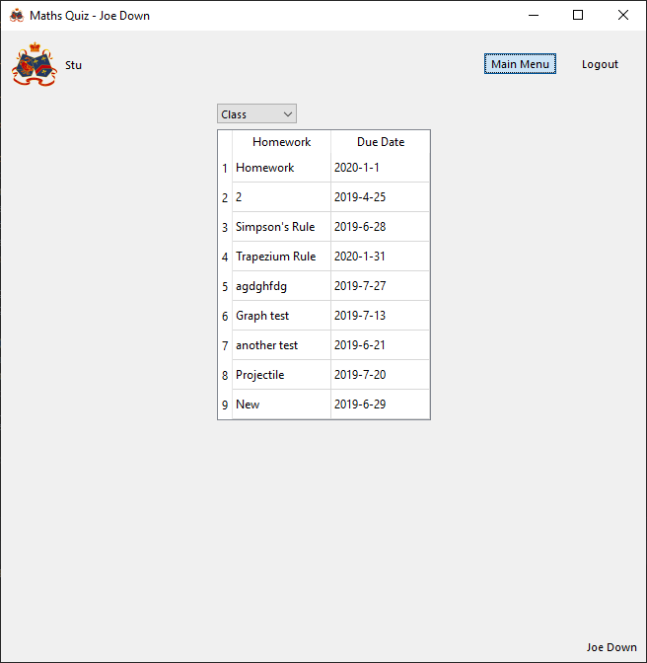

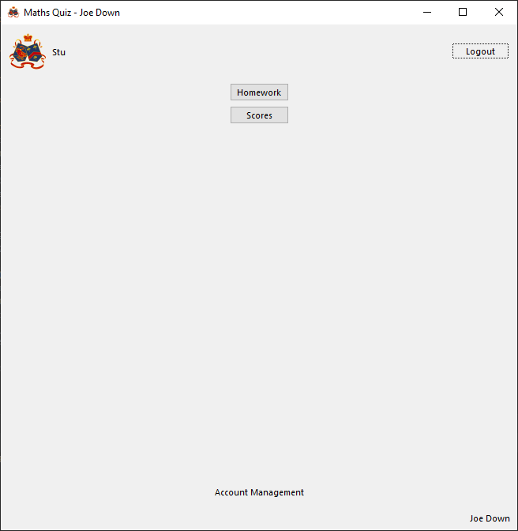

Pressing main menu button successfully navigates to student main menu

Teacher account

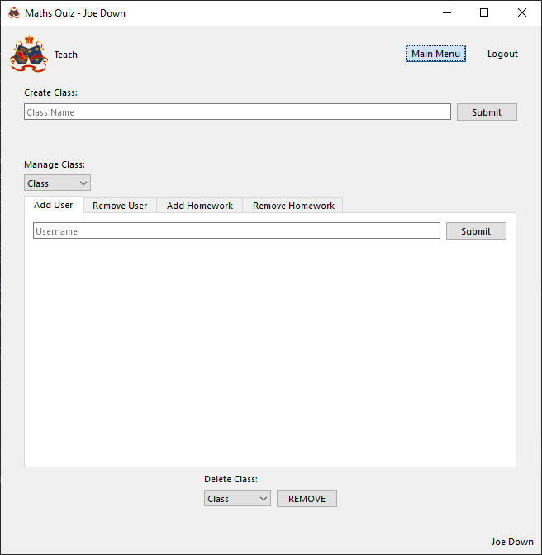

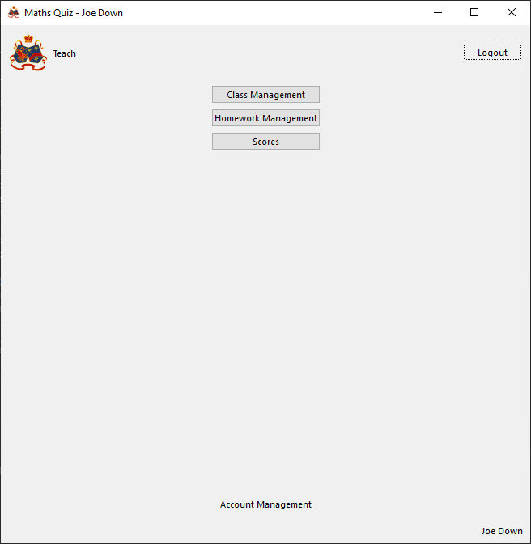

Pressing main menu button successfully navigates to teacher main menu

With Invalid data:

N/A, an invalid user type will be verified to be invalid before user can ever log in and at account creation and so no screen with the main menu button will ever be reached before it is validated to be compatible with this function

###### Evaluation

Main menu button successfully navigates to correct main menu page for given user

##### Function to go to log out

###### Final Code



###### Testing

With valid data:

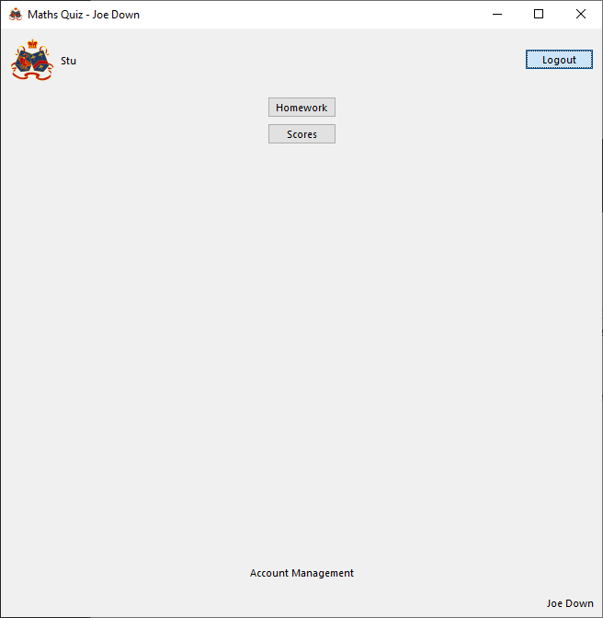

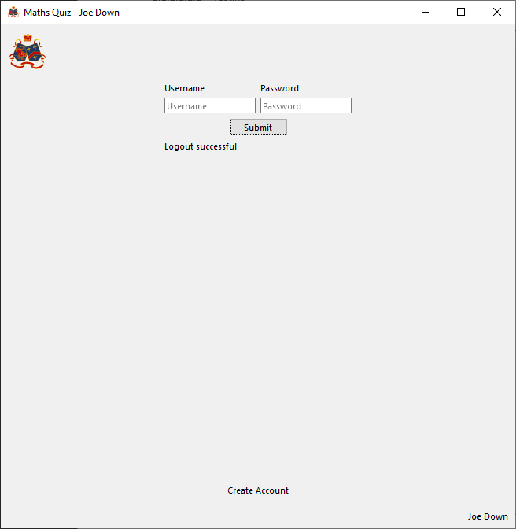

Successfully returns to login page, informs user they have been logged out and sets current user id back to a placeholder value

With Invalid data:

N/A, no data inputted to function and so function will always run the same way when called

###### Evaluation

Successfully returns to main menu and logs out of account

#### Login page

##### Functions to reset page to default state

###### Final Code



###### Testing

With valid data:

Input boxes have been filled and success output set to an error message:

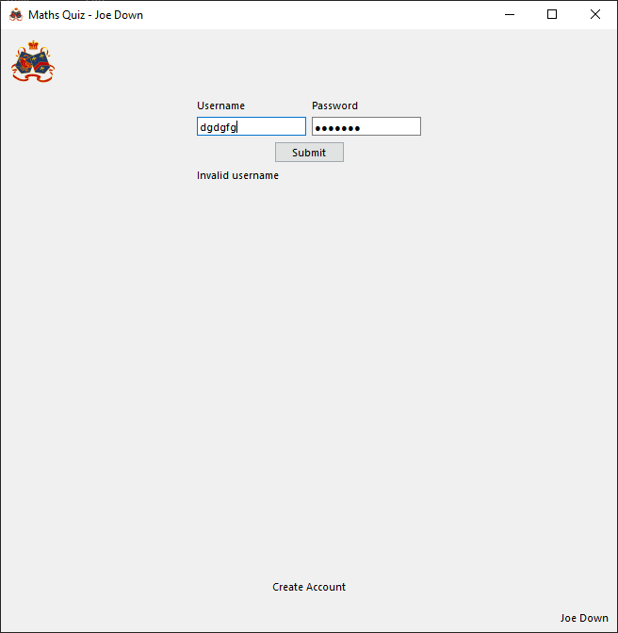

On leaving page then returning page is successfully reset to default state (empty input boxes and output labels):

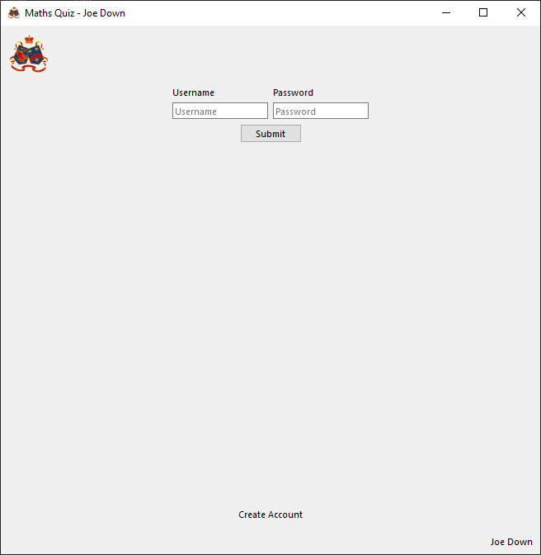

With Invalid data:

N/A, no data input or processing so function will always run the same way each time it is run

###### Evaluation

Correctly clears all labels and inputs as required when page is in its default state

##### Functions to verify username and password and login

###### Issues during development

Initially, no casefold() was applied to the inputs, meaning it was easy to mistakenly be denied access to an account with any variation of the username but all lowercase (as it is stored this way in the database). A casefold was therefore applied when taking input in order to ensure all variations in capitalisation are handled in the same way

###### Final Code



###### Testing

For testing here, valid username entered will be ‘student1’ and valid password will be ‘password’. Invalid inputs will be random long strings of characters of varying types. To login as a teacher the username ‘teacher1’ will instead be used

Notes:

* The nature of an input box means anything entered is always treated as a string, so data type validation is not needed before passing username or password to the database interaction functions used, it can simply be assumed to be of a usable type as they all take in strings
* Code to set up page buttons is given later

With valid data:

Student

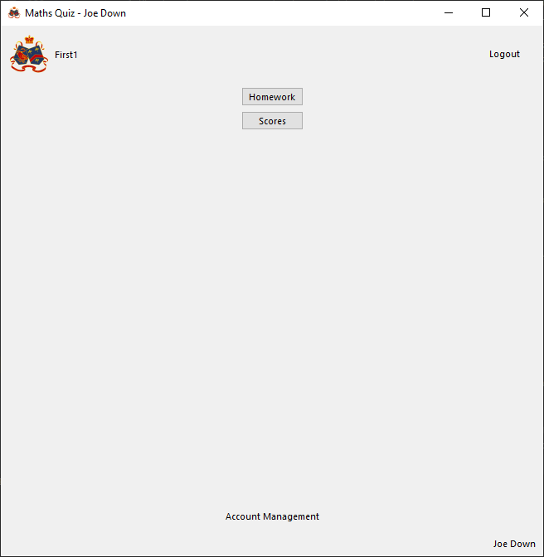

Successfully loads student main menu page as correct user (as indicated by correct first name in top right)

Teacher

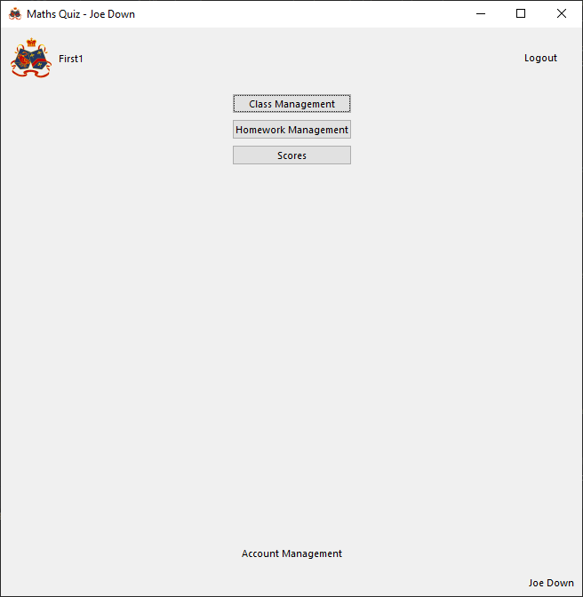

Successfully loads teacher main menu page as correct user (as indicated by correct first name in top right)

With Invalid data:

Invalid username

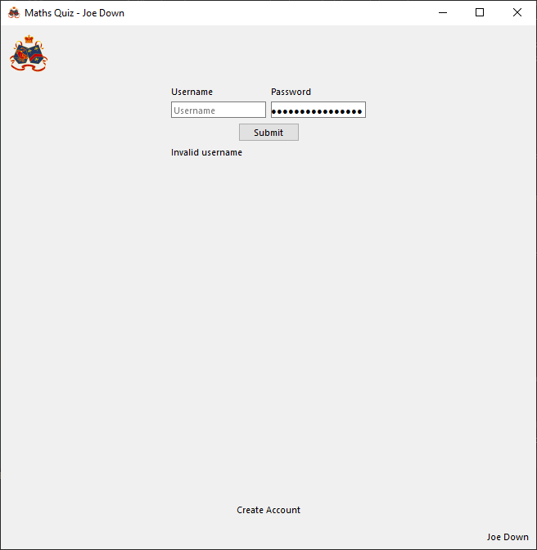

Successfully indicates invalid username and clears username input box

Invalid password

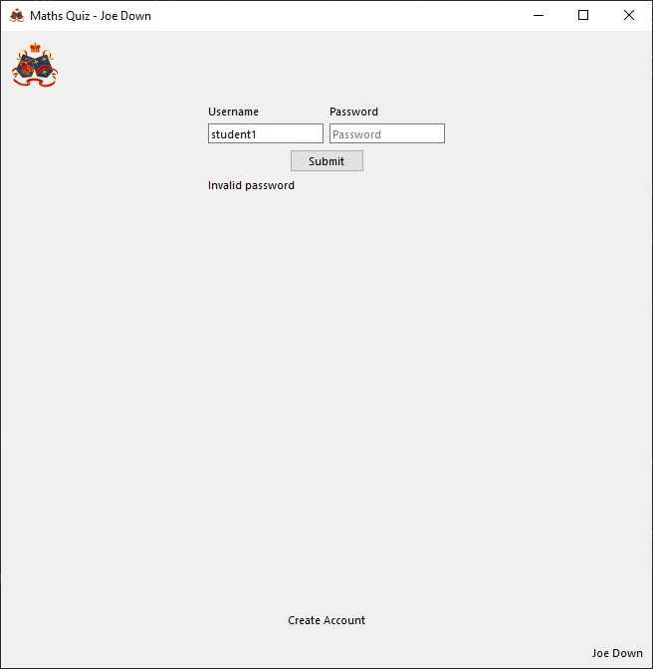

Successfully indicates invalid password and clears password input box

No username

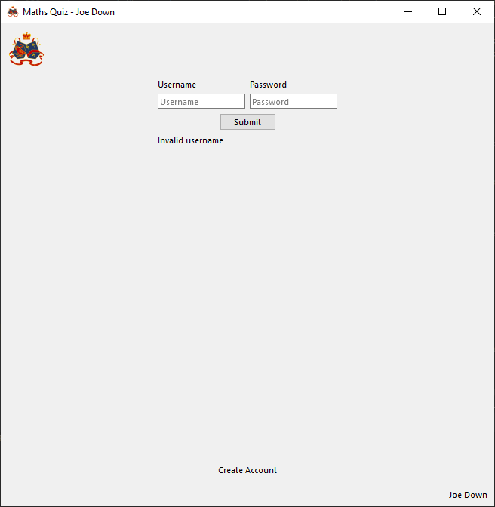

Successfully indicates no valid username entered

No password

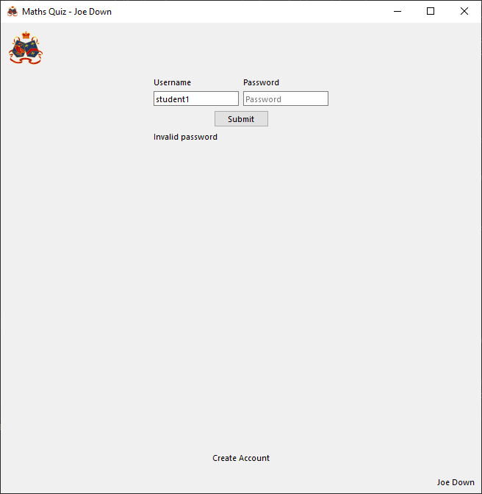

Successfully indicates invalid password

Evaluation

Correctly rejects login if not completely correct and outputs to user what is wrong with their login attempt. If login is valid, login takes user to the correct main menu for their user type and sets the logged in user id accordingly

##### Functions to set up page buttons

###### Issues during development

Initially the below code was implemented:



This would result in the following error:



As researched here (<https://stackoverflow.com/questions/45793966/clicked-connect-error>), this is due to the create account button’s code in window.py being unable to call a function from externally with an argument and so the code was changed to utilise a lambda expression to essentially create a virtual function with no parameters that can be called by the button which internally is passed the given argument.

The create account button was changed to instead be defined with the following code:



###### Final Code



###### Testing

With valid data:

Submit button clicked

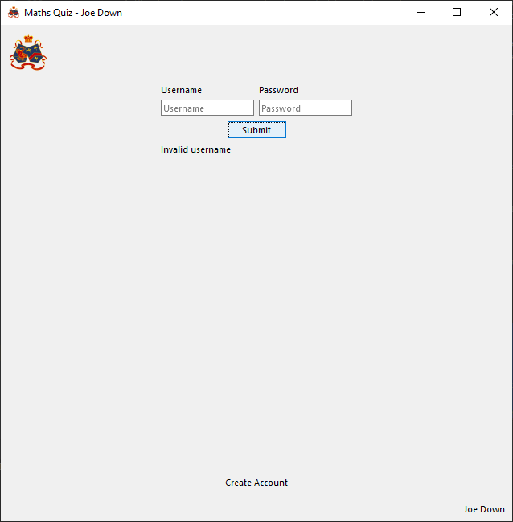

Successfully runs login function

Create account button clicked

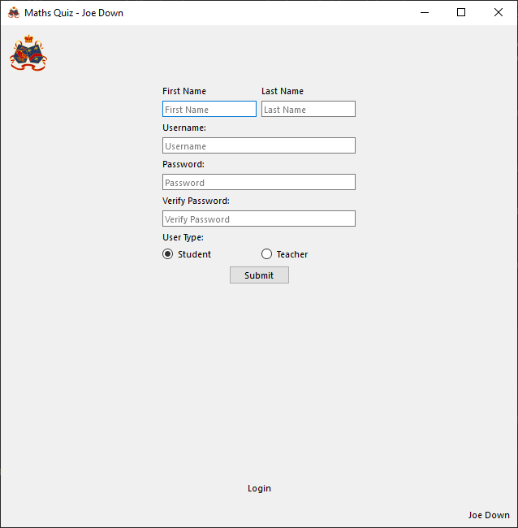

Successfully loads create account page

With Invalid data:

N/A, the nature of a button means it is either pressed or not pressed so there is no way of making an incorrect data. Additionally, this function performs no data manipulation so will always execute the same way

###### Evaluation

Buttons successfully perform assigned tasks

#### Create account page

##### Functions to reset page to default state

###### Final Code



###### Testing

With valid data:

Input boxes have been filled, success output set to an error message and the non-default radio selection selected:

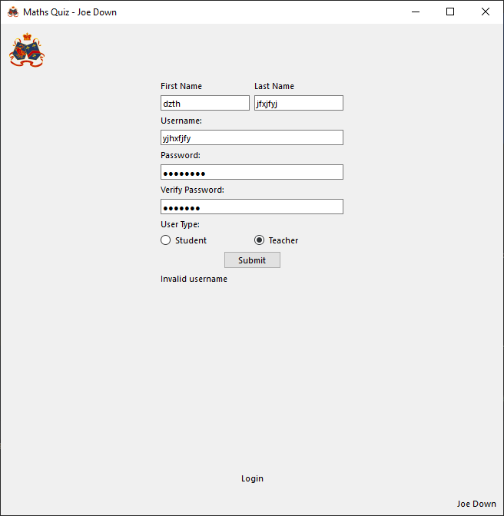

On leaving page then returning, page is successfully reset to default state (empty input boxes and output labels and radio button reset to default selection):

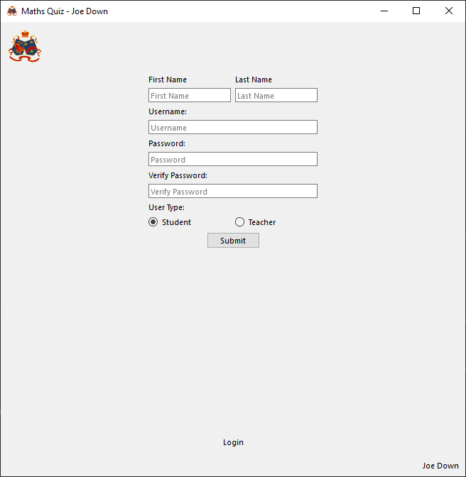

With Invalid data:

N/A, no data input or processing so function will always run the same way each time it is run

###### Evaluation

Correctly clears all labels, inputs and radio buttons as required when page is in its default state

##### Create an account

###### Final Code



###### Testing

With valid data:

Student

Username ‘student12345’ and password ‘password’ used

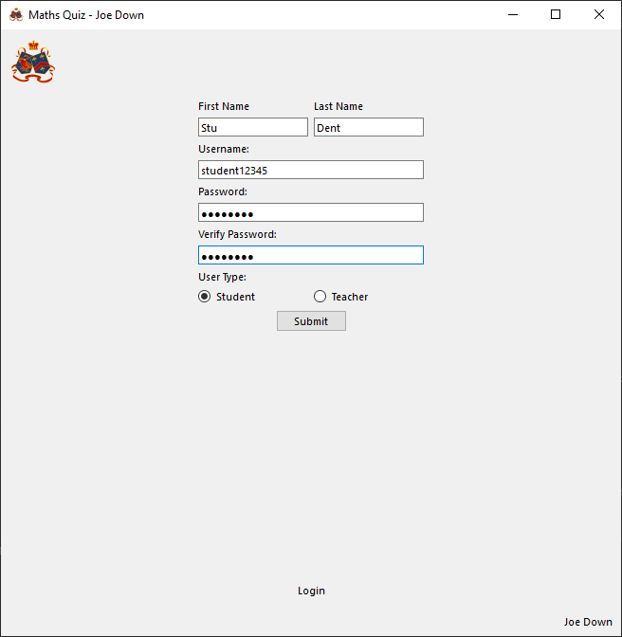

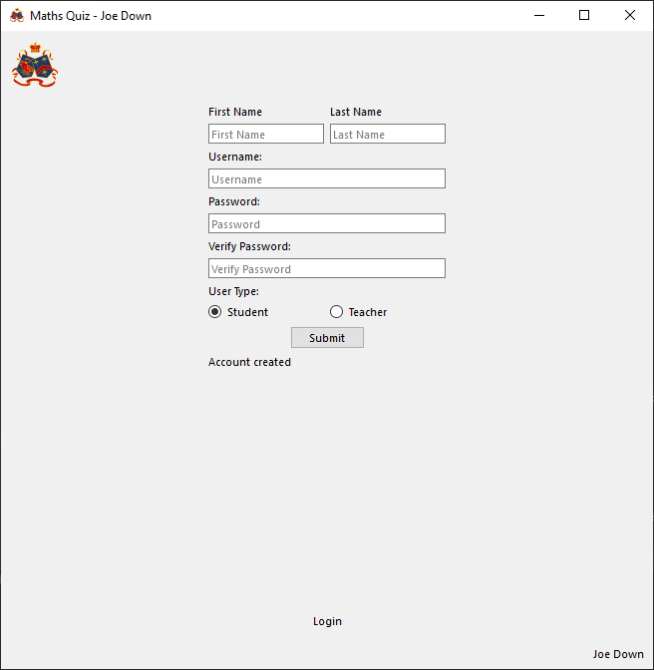

Account created output line runs so data should have been inserted into database. Logging in with the account details used now successfully goes to the student main menu page and the correct first name is shown:

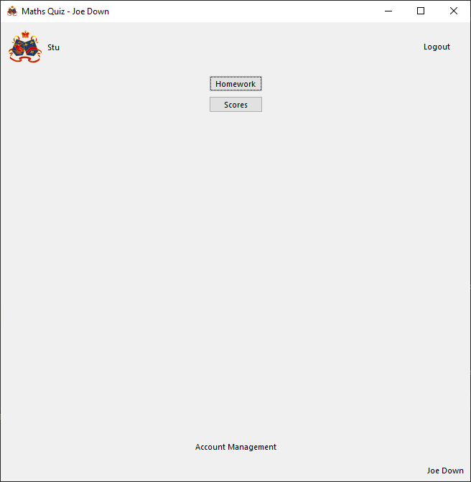

Teacher

Username ‘teacher12345’ and password ‘password’ used

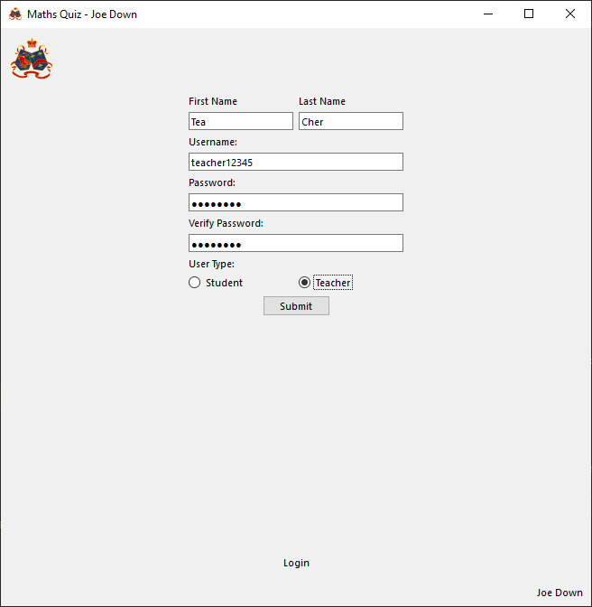

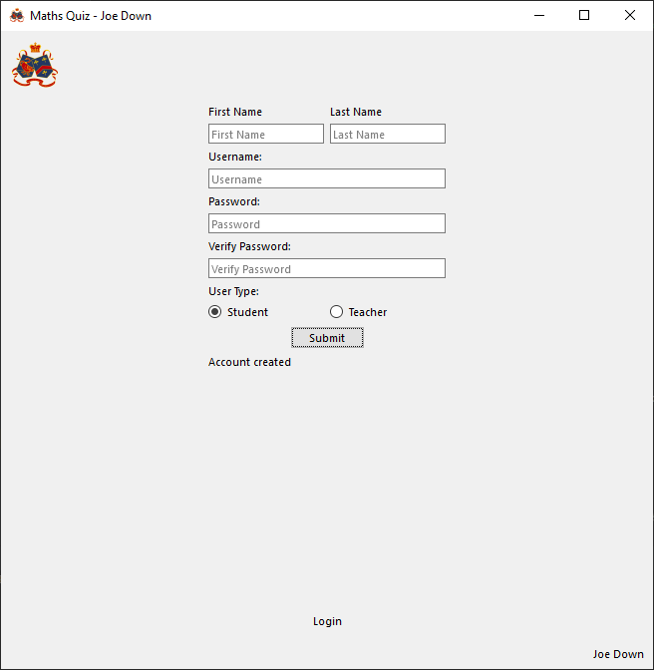

Account created output line runs so data should have been inserted into database. Logging in with the account details used now successfully goes to the teacher main menu page and the correct first name is shown:

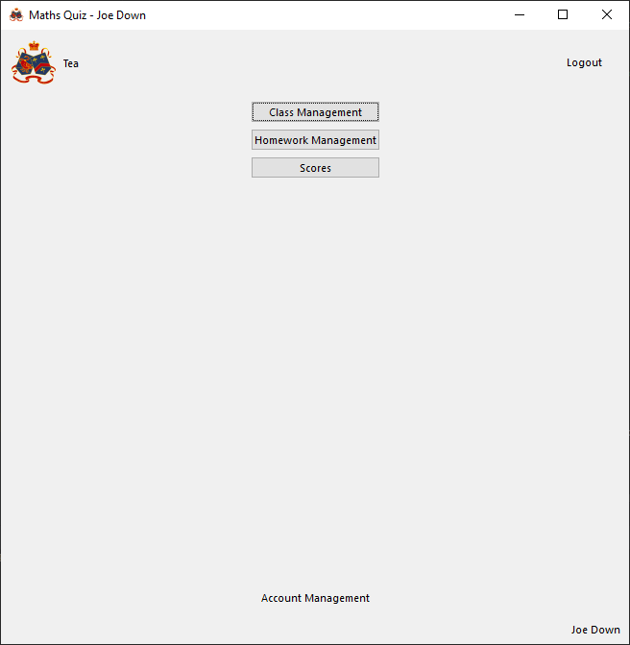

With Invalid data:

Invalid username (Blank)

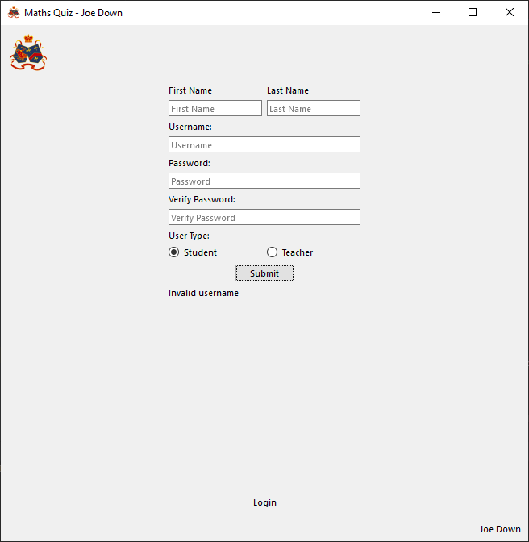

Correctly outputs that an invalid username is entered

Existing username used

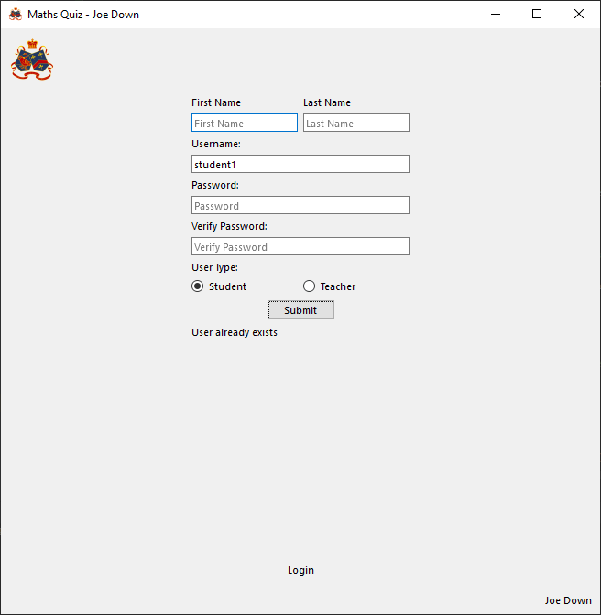

Correctly outputs that user already exists

Invalid first name

Blank

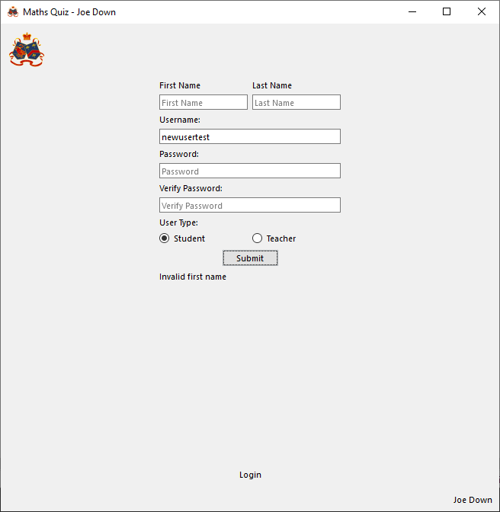

Successfully outputs that first name is invalid

Name longer than 100 characters

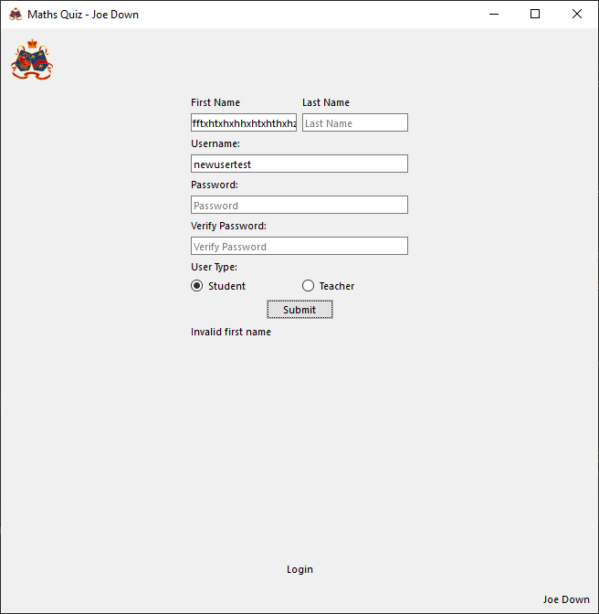

Successfully outputs that first name is invalid

Invalid last name

Blank

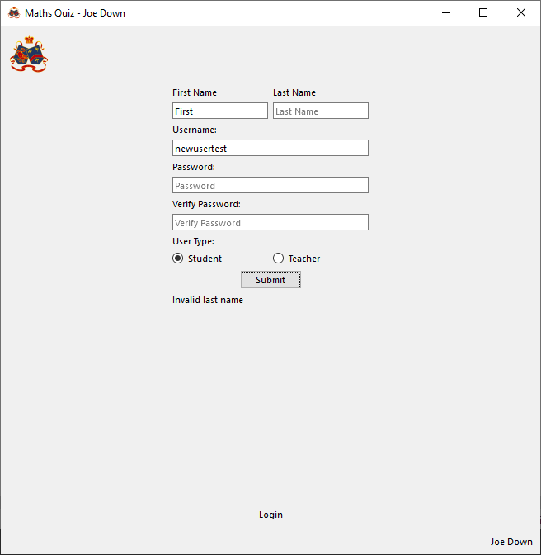

Successfully outputs that last name is invalid

Name longer than 100 characters

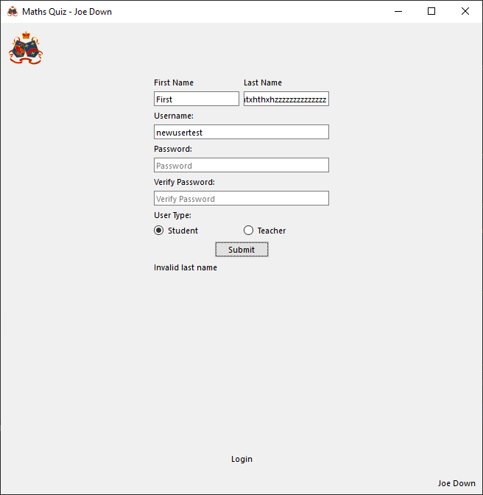

Successfully outputs that last name is invalid

Invalid password (less than 8 characters)

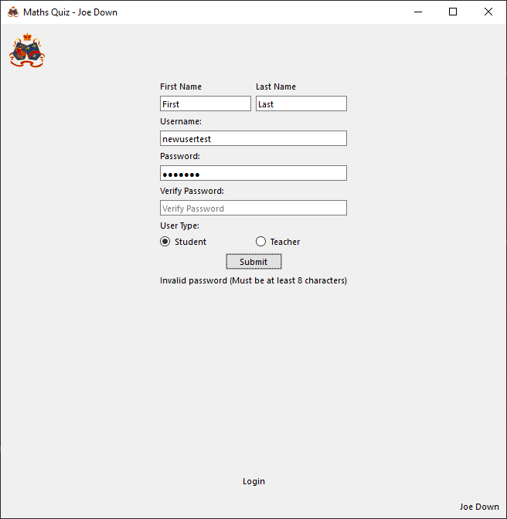

Successfully outputs that password is invalid

Non-matching password verification

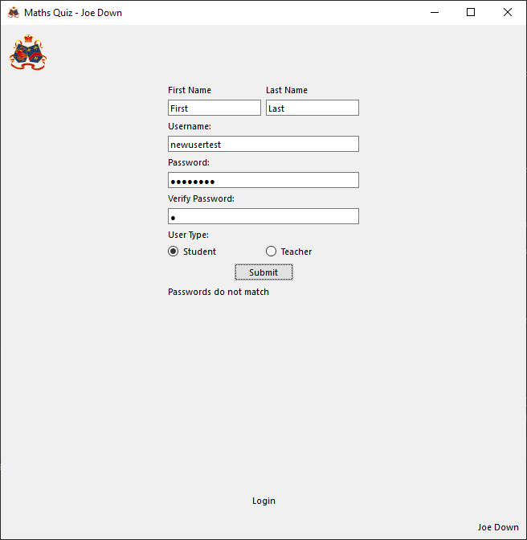

Successfully outputs that passwords do not match

###### Evaluation

Successfully creates a new account if valid details entered

##### Function to set up page buttons

###### Final Code



###### Testing

With valid data:

Submit button clicked

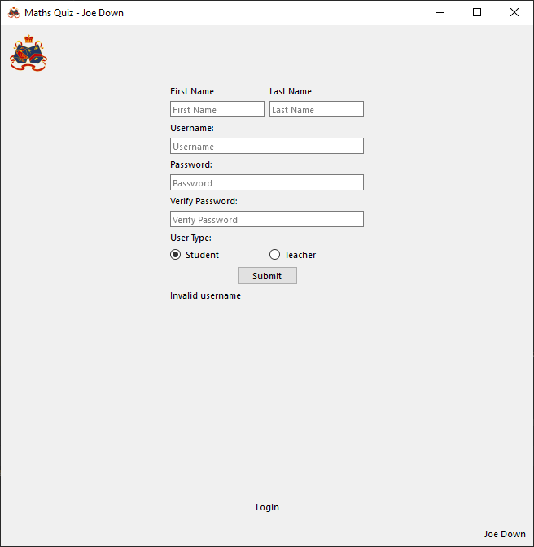

Successfully runs create account function

Login page button clicked

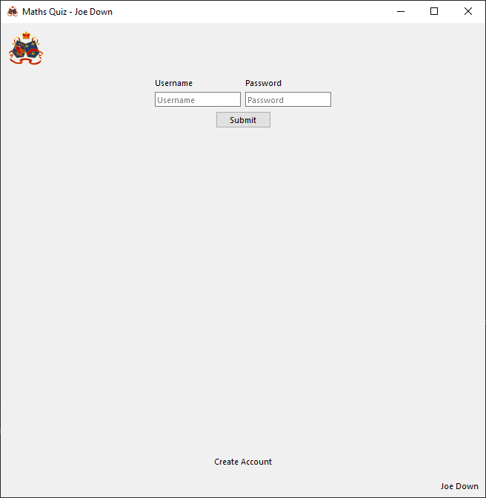

Successfully loads login page

With Invalid data:

N/A, the nature of a button means it is either pressed or not pressed so there is no way of making an incorrect data. Additionally, this function performs no data manipulation so will always execute the same way

###### Evaluation

Buttons successfully perform assigned tasks

#### Student main menu page

##### Set up buttons

###### Final Code



###### Evaluation

Clicking all buttons leads to the relevant page

#### Teacher main menu page

##### Set up buttons

###### Final Code



###### Evaluation

Clicking all buttons leads to the relevant page

#### Question page

##### Function to reset page

###### Final Code





###### Testing

With valid data:

Loading first page, previous question button is hidden:

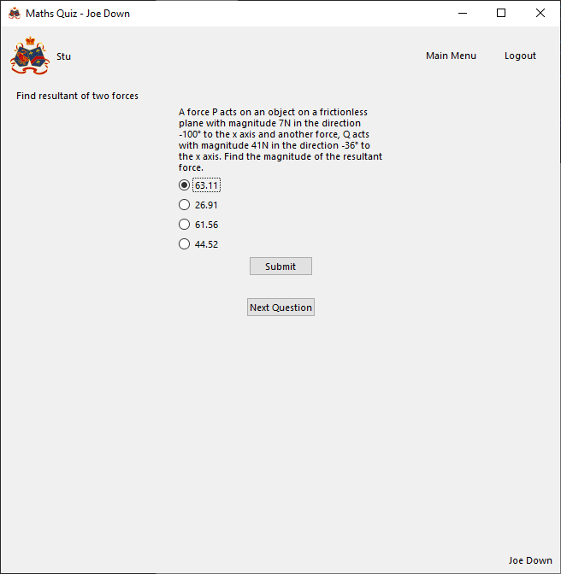

Reloading page after correctly answering selects correct answer, disables all question response inputs and outputs that question is correct:

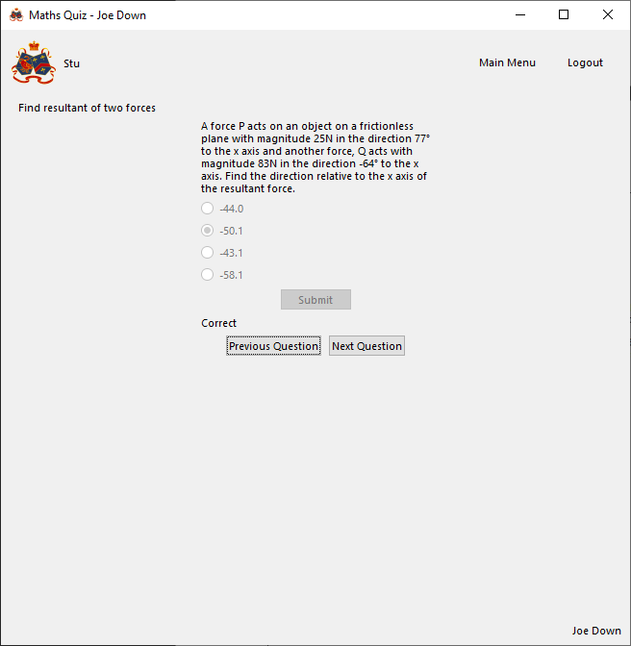

Loading a question with a graph loads and draws the graph:

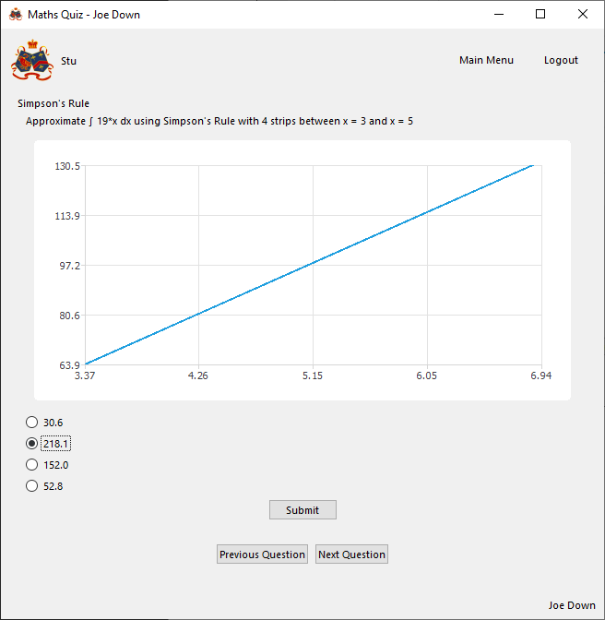

Reloading page (going to next page and returning) results in different answer ordering and selection is reset to first item:

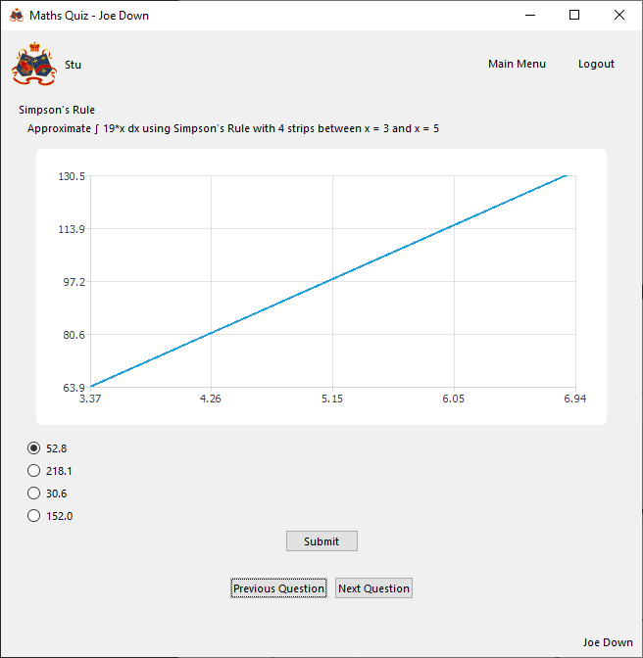

Loading last page, next question button is hidden:

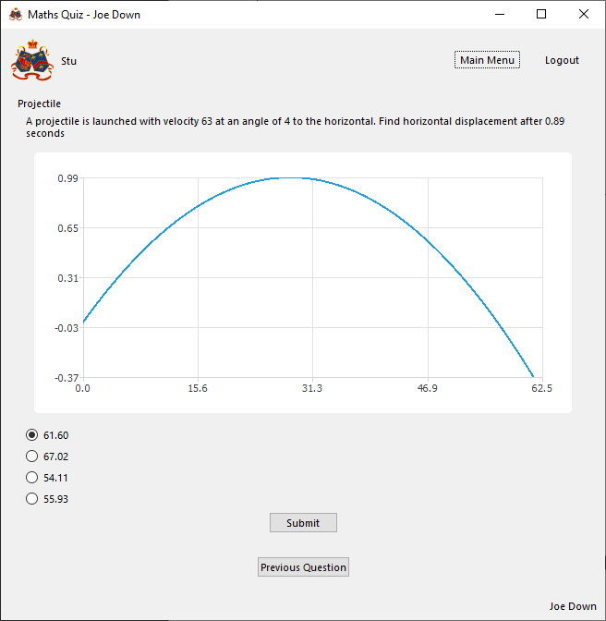

With Invalid data:

N/A, page is either loaded correctly or not, it cannot be made to load incorrectly as all question data is pre-validated by the question class

###### Evaluation

Question page correctly loads with buttons enabled/disabled as required, question order randomised, and a graph drawn where applicable

##### Function to set up buttons

###### Final Code



###### Testing

With valid data:

Previous question clicked

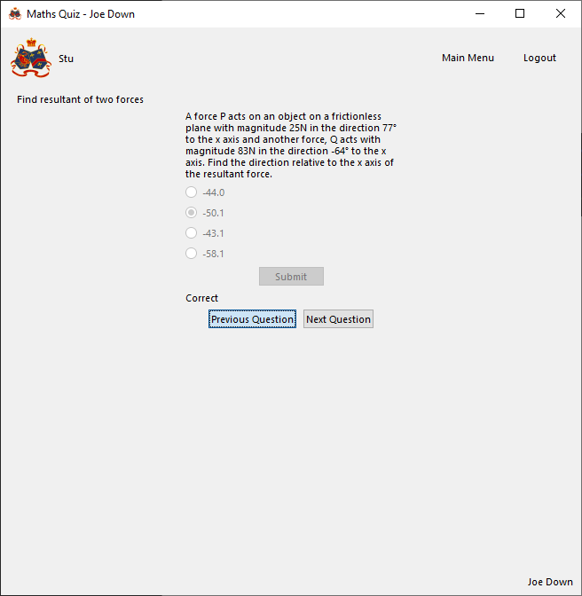

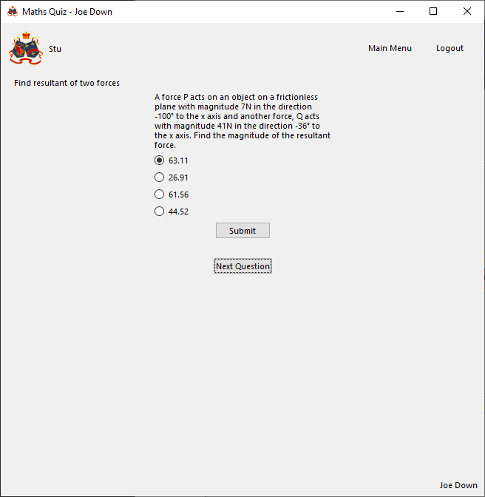

Correctly loads previous page

Next question clicked

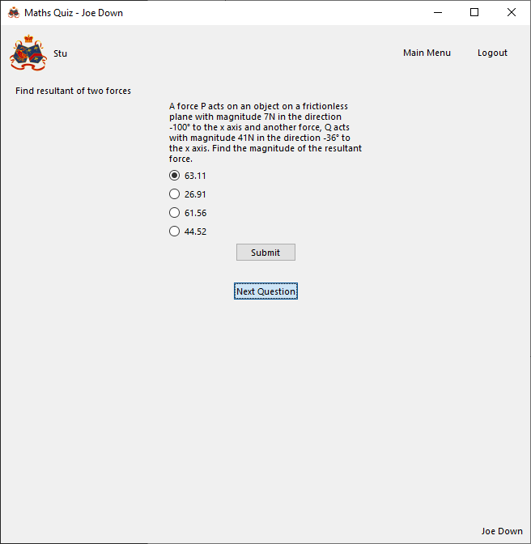

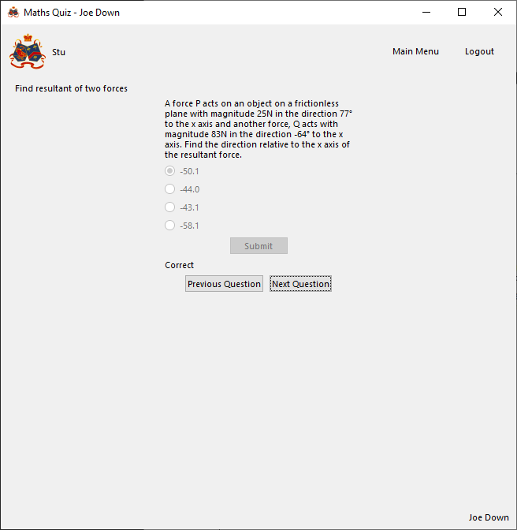

Correctly loads next page

Submit button clicked

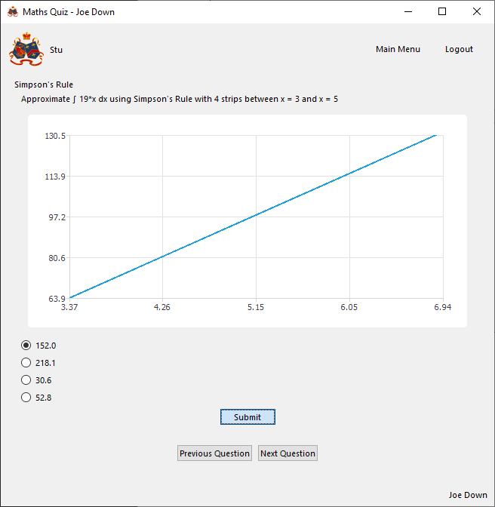

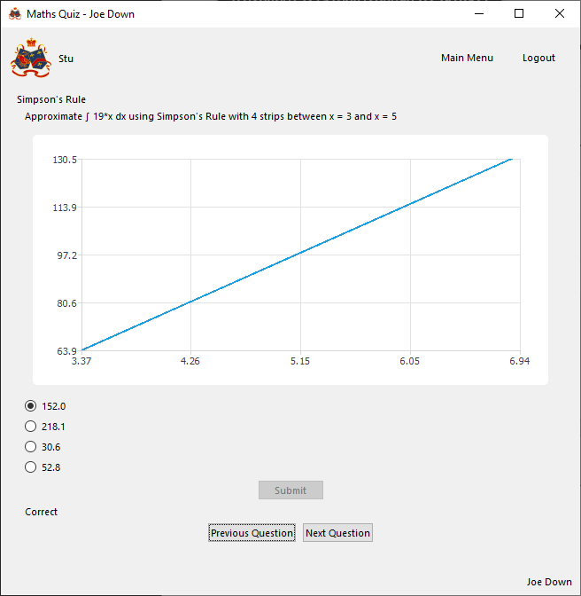

Correctly runs code to check given answer

With Invalid data:

N/A, button is either clicked or not clicked, cannot be given invalid input

Evaluation

All buttons on page correctly perform required functions

##### Function to load next question page

###### Final Code



###### Testing

With valid data:





Correctly loads next page

With Invalid data:

N/A, button is either clicked or not clicked, cannot be given invalid input

Evaluation

Next page correctly loaded

##### Function to load previous question page

###### Final Code



###### Testing

With valid data:





Correctly loads previous page

With Invalid data:

N/A, button is either clicked or not clicked, cannot be given invalid input

Evaluation

Previous page correctly loaded

##### Function to submit question response

###### Final Code



###### Testing

With valid data:

Incorrect response

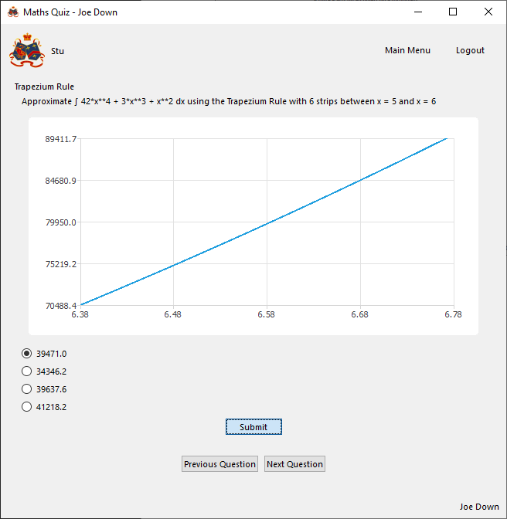

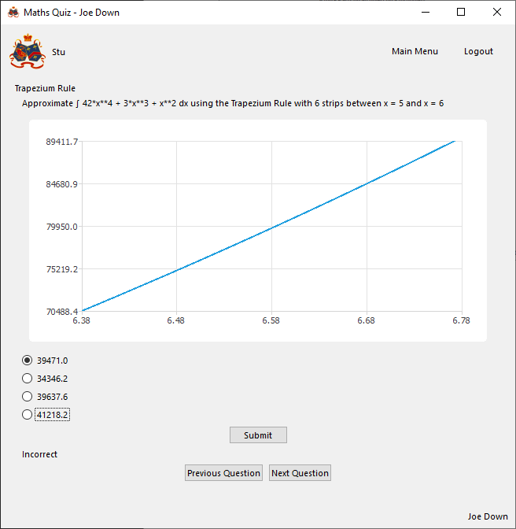

Correctly outputs that response was incorrect

Correct response

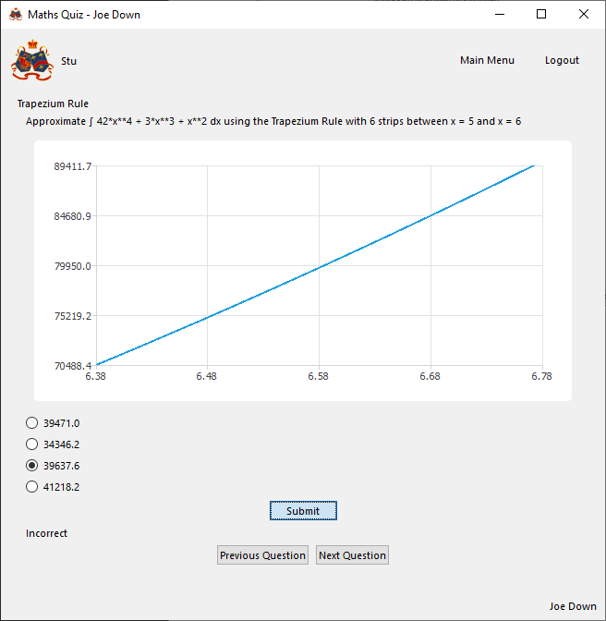

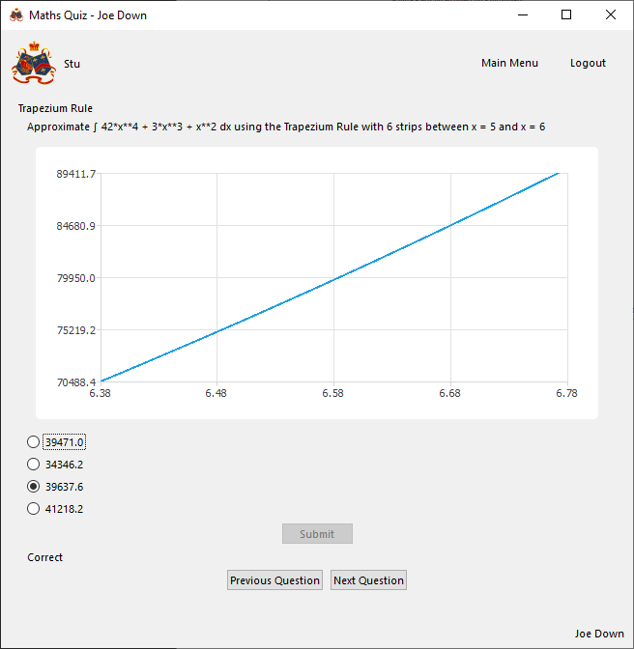

Correctly outputs response was correct and stores status in database

With Invalid data:

N/A, can only select either a correct radio button or an incorrect one (cannot select none) and submit button is either clicked or not, cannot be clicked incorrectly

Evaluation

Function correctly marks submission to question and stores result as needed

##### Function to set up and output chart

###### Issues during development

Initially the following code was implemented:



This would result in the following error when loading a question with no graph:

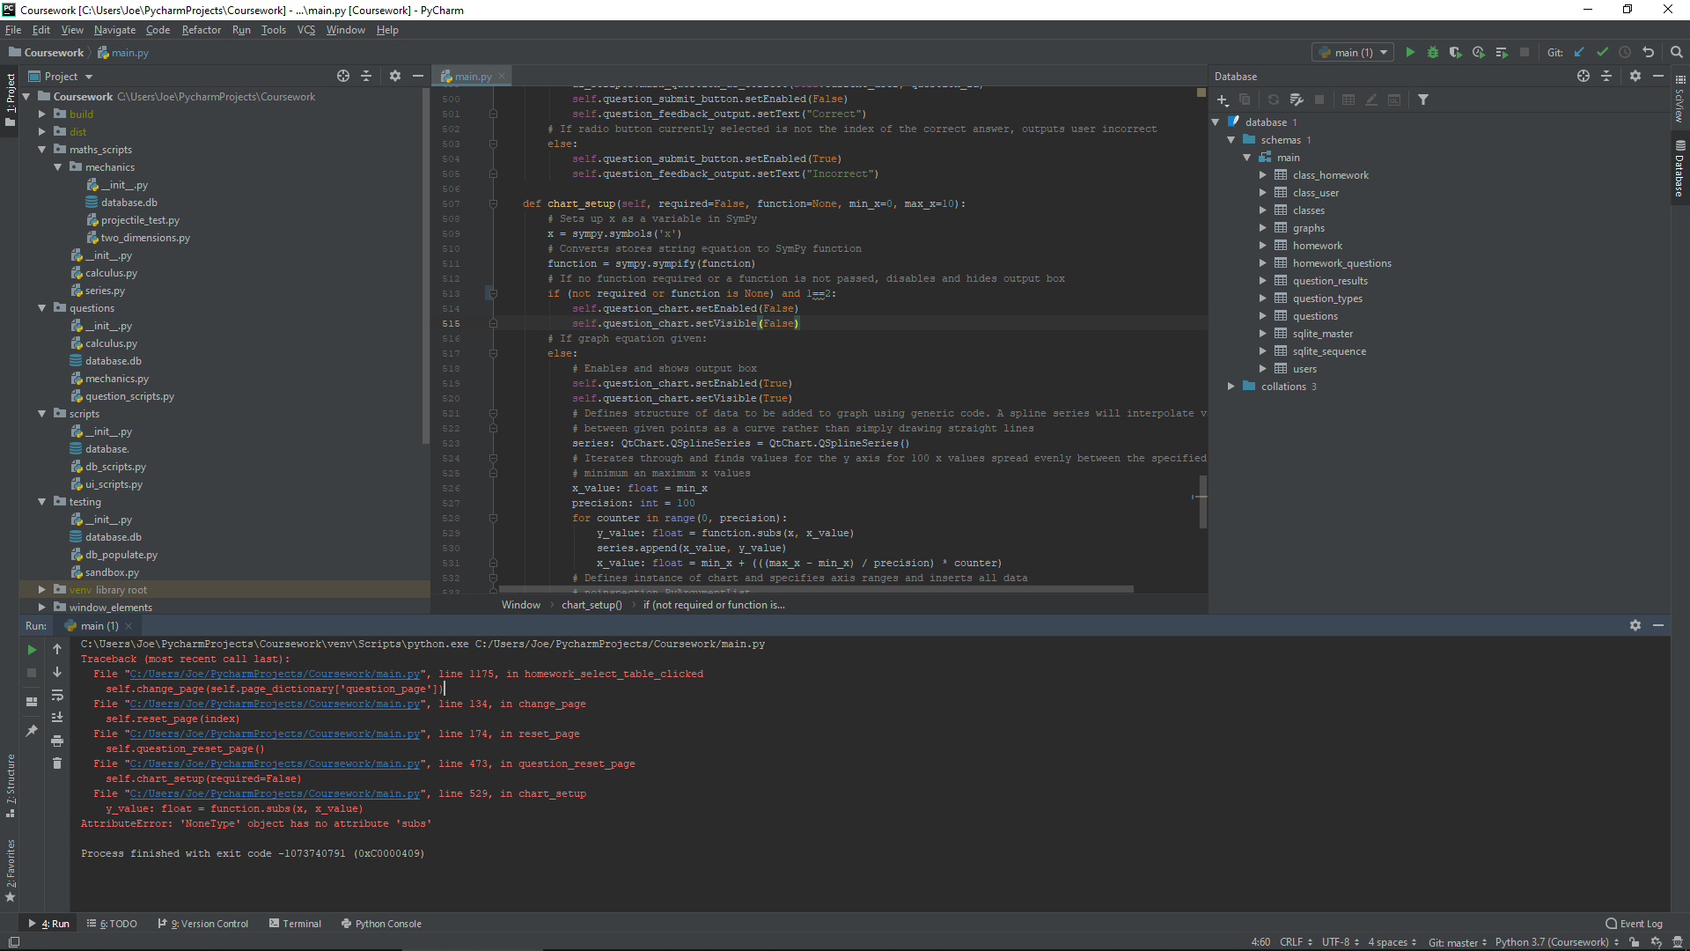

This is because there is no graph equation to be found and so when inserting data into the graph there is no equation from which to derive y values and so the code breaks. This was fixed by implementing the following if statement with code contained within the else for drawing the graph so it is only attempted if a graph is present:



###### Final Code



###### Testing

With valid data:

No graph provided

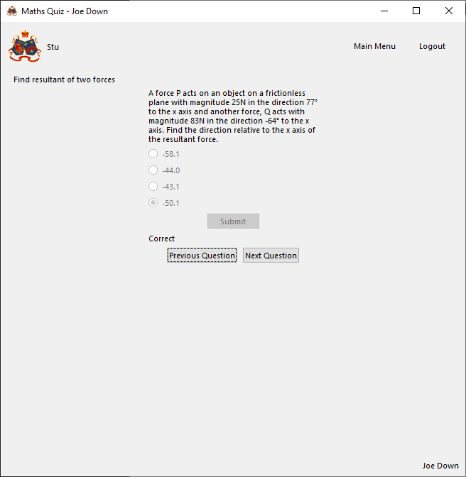

Graph output is disabled

Graph provided

Generated graph:

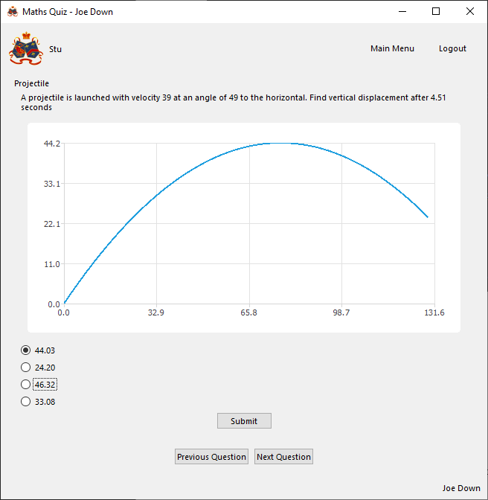

Correct graph according to online graphing tool (<https://www.geogebra.org/graphing>):

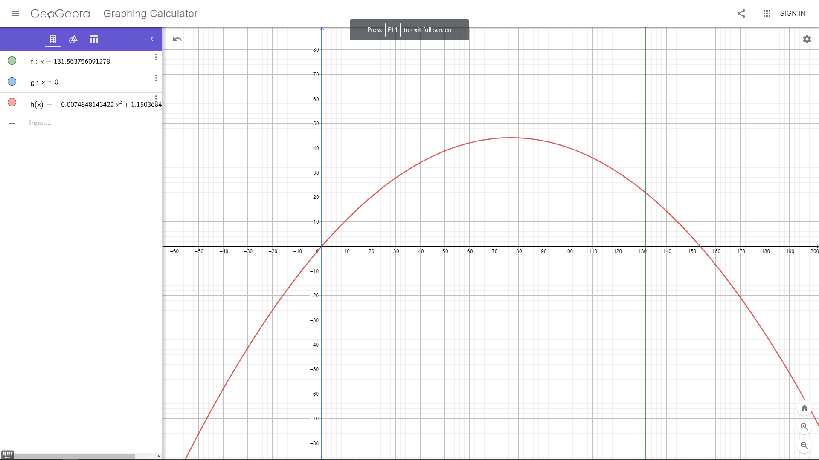

Correct graph is successfully output within correct range (-0.0074848143421616*x**2 + 1.15036840722101*x between x = 0 and x = 131.563756091278)

With Invalid data:

N/A, graph is either provided or not provided and equation and limits are verified when storing graph

Evaluation

Function correctly outputs a graph under defined parameters, or hides the graph if none is defined for given question

#### Set homework page

##### Function to remove question

###### Final Code



###### Testing

With valid data:

Homework contains questions

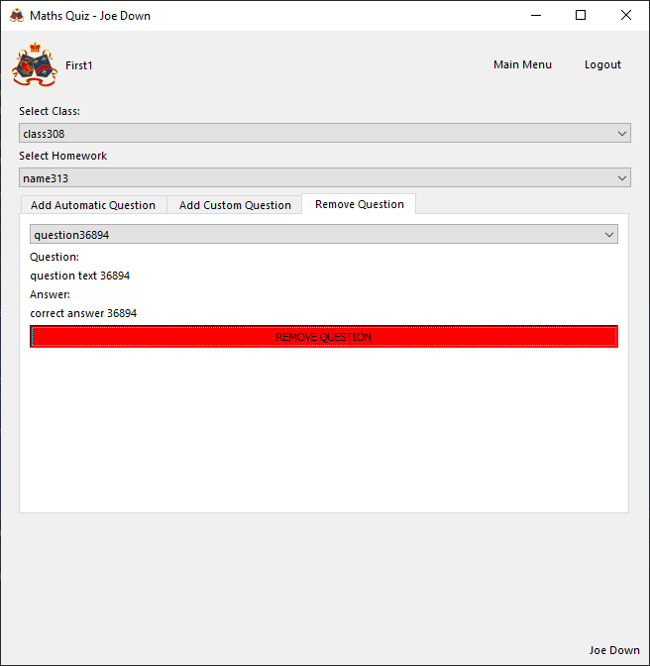

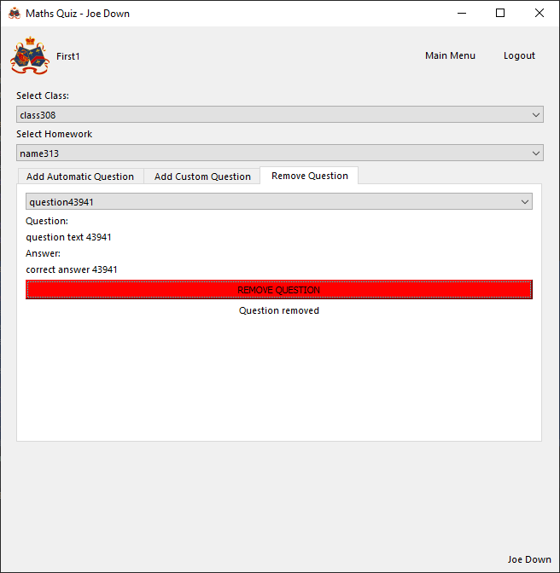

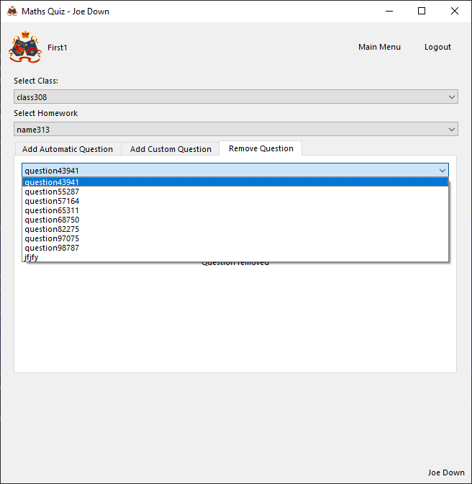

Successfully removes question

Homework has no questions

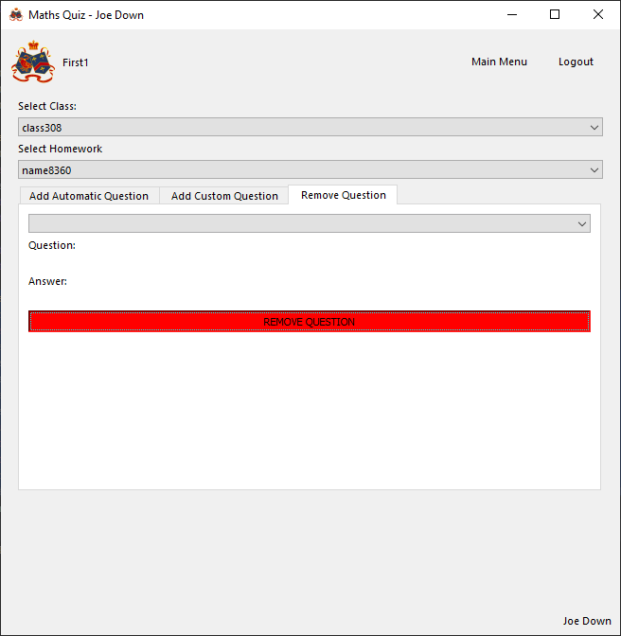

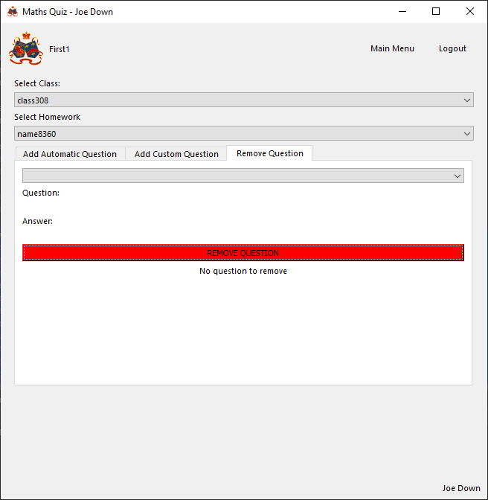

Informs user there are no questions to remove

With Invalid data:

N/A, invalid data cannot be entered intentionally by nature of a dropdown menu and a button blocking invalid data input

###### Evaluation

Function correctly removes the selected question from the selected homework

##### Function to add a custom question

###### Final Code





###### Testing

With valid data

1 incorrect answer given

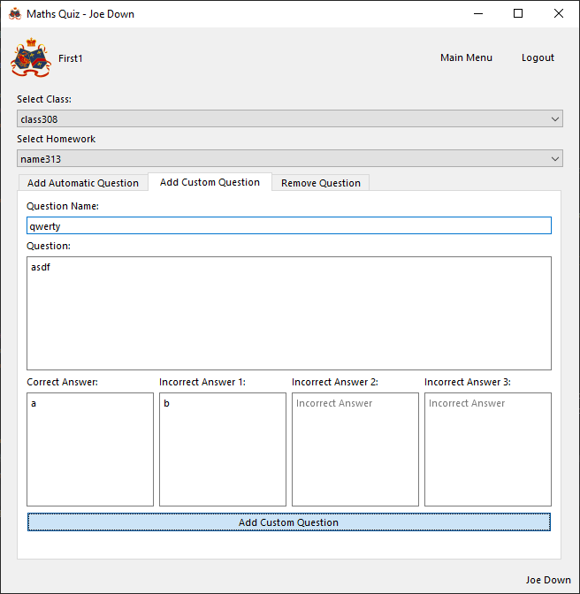

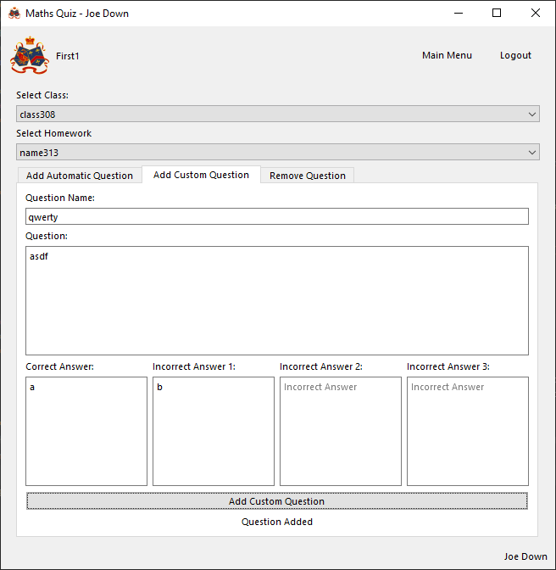

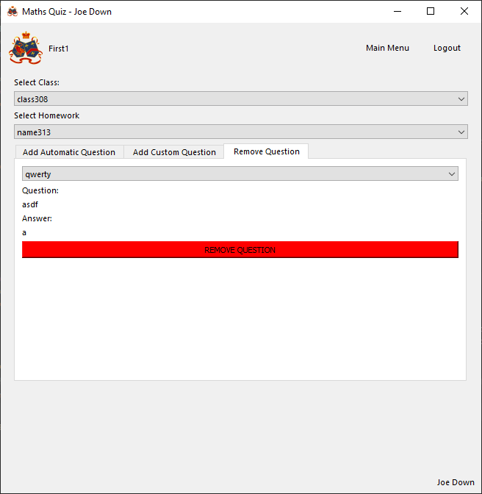

Correctly informs user adding question was a success and inserts it into database

3 incorrect answers given

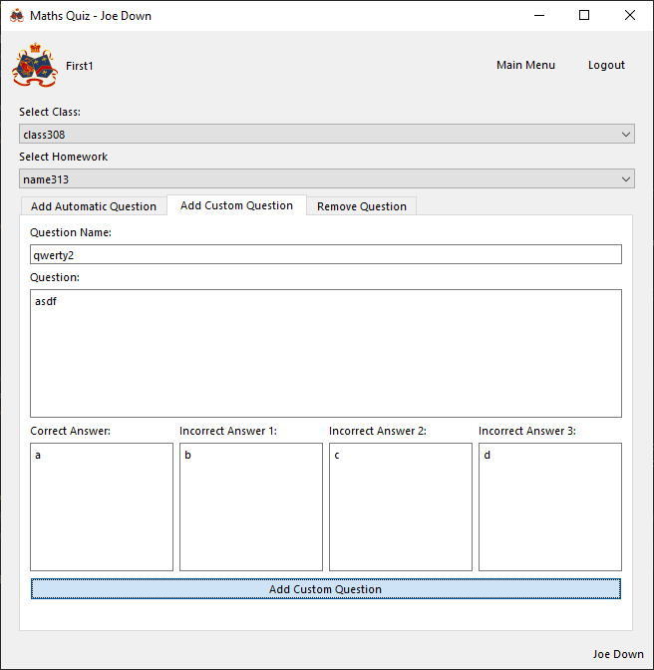

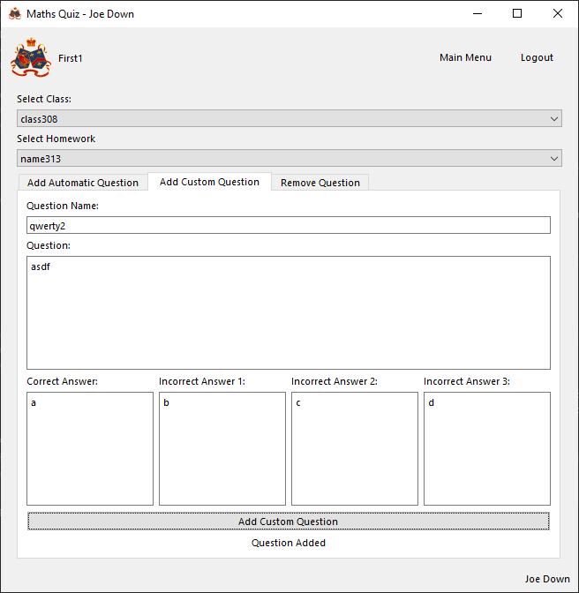

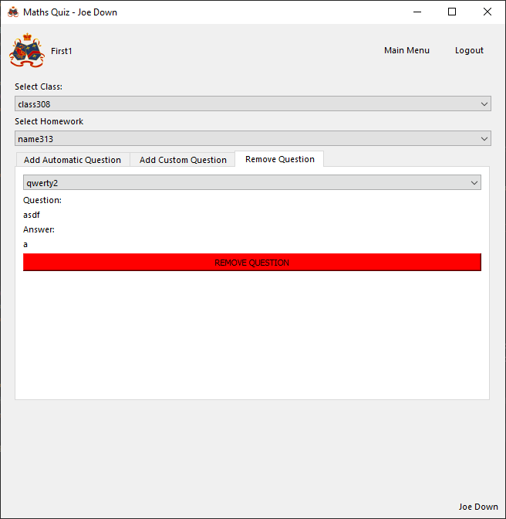

Correctly informs user adding question was a success and inserts it into database

With invalid data

No name given

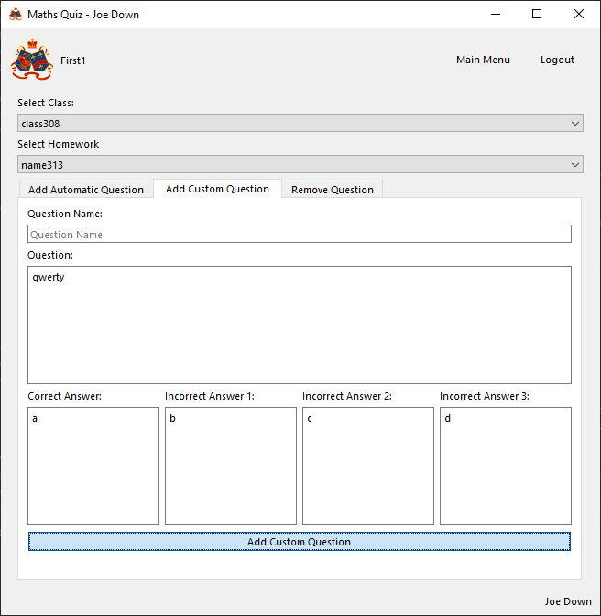

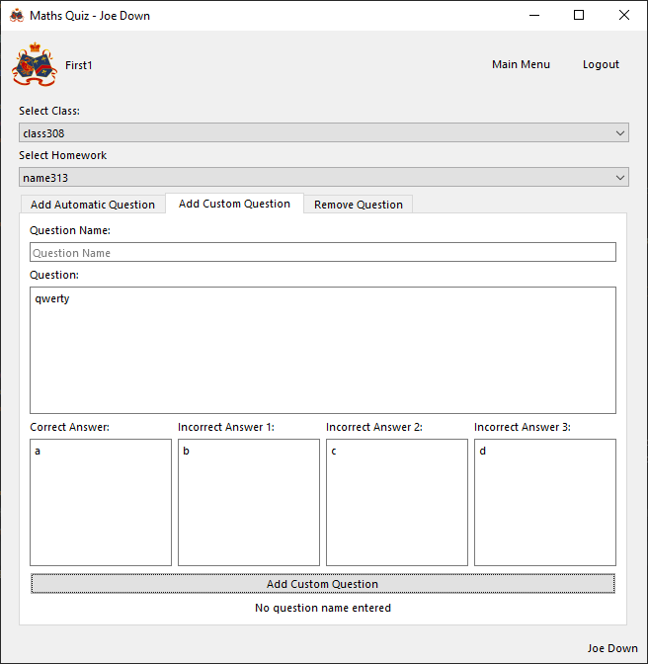

Correctly informs user that a question name is required

No question text given

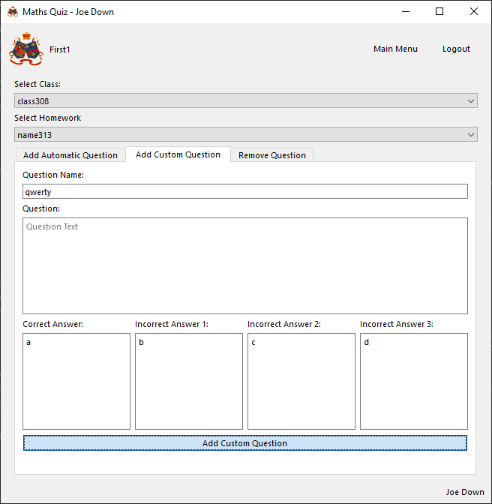

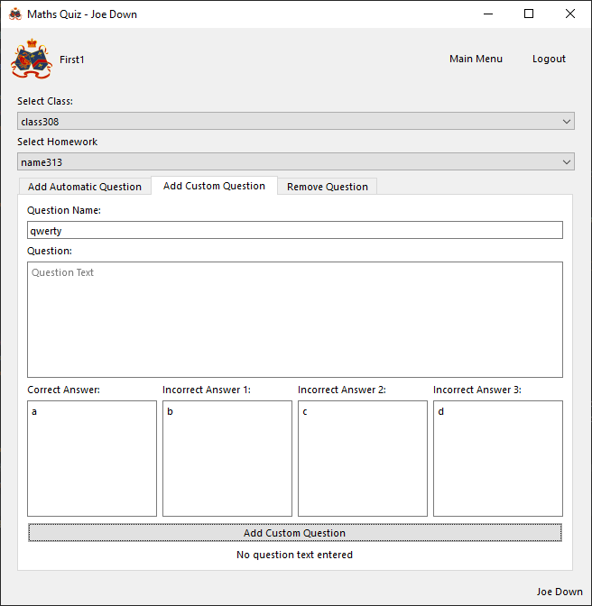

Correctly informs user that question text is required

No correct answer given

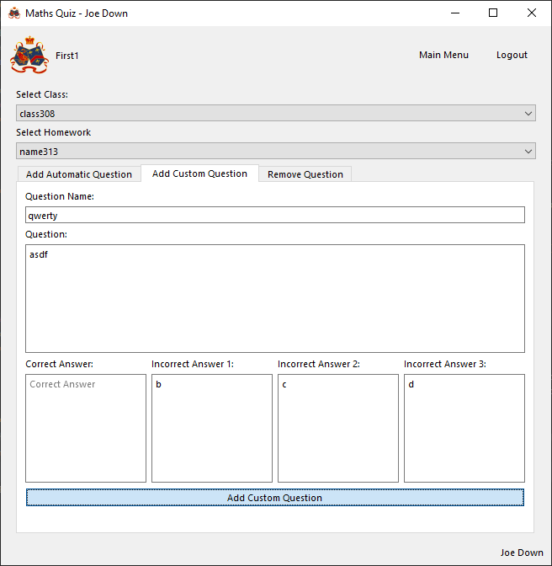



Correctly informs user that a correct answer is required

No incorrect answers given

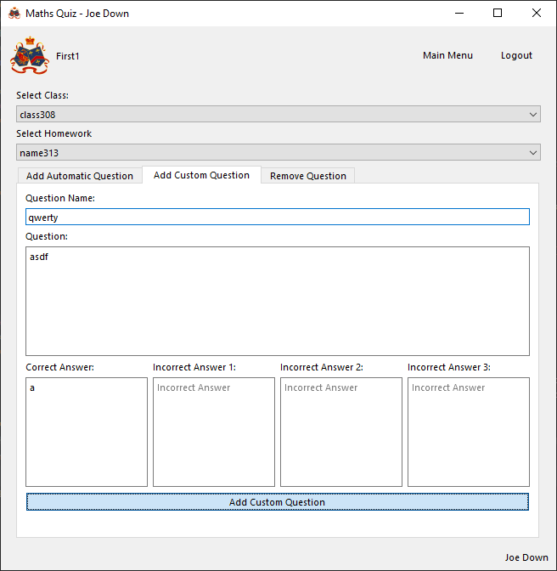

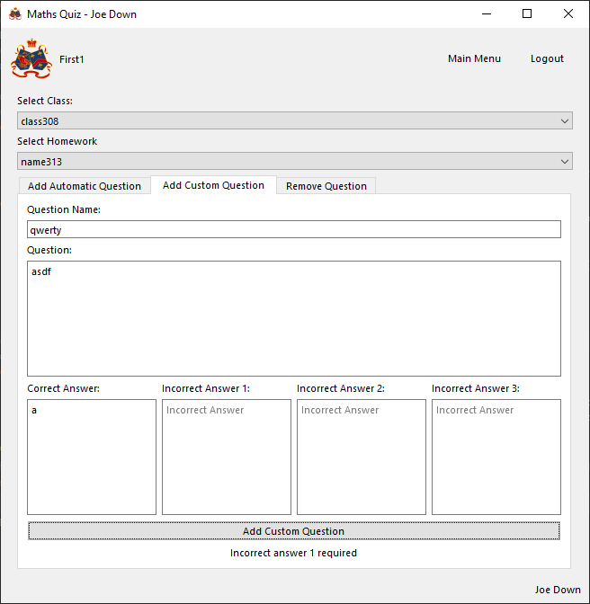

Correctly informs user that an incorrect answer is required

Matching answers inputted

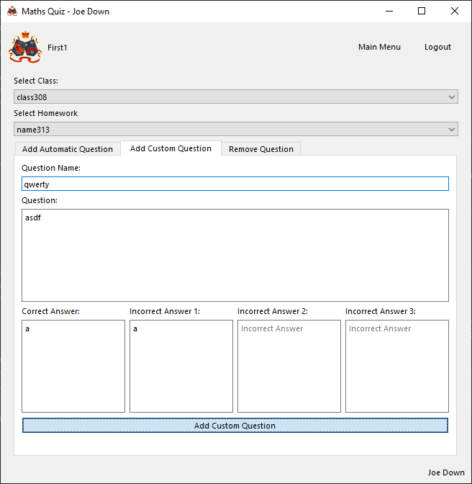

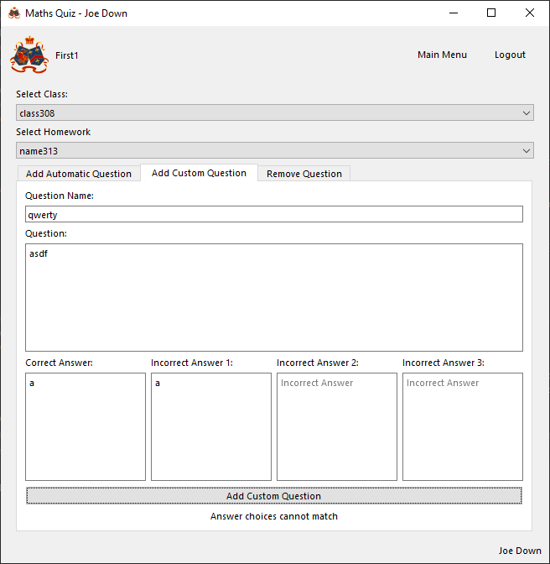

Correctly informs user that all potential answers should be unique

###### Evaluation

Successfully validates inputs and, if valid, inserts question into database and establishes question to homework relationship

##### Function to add automatic question

###### Final code



###### Testing

With valid data

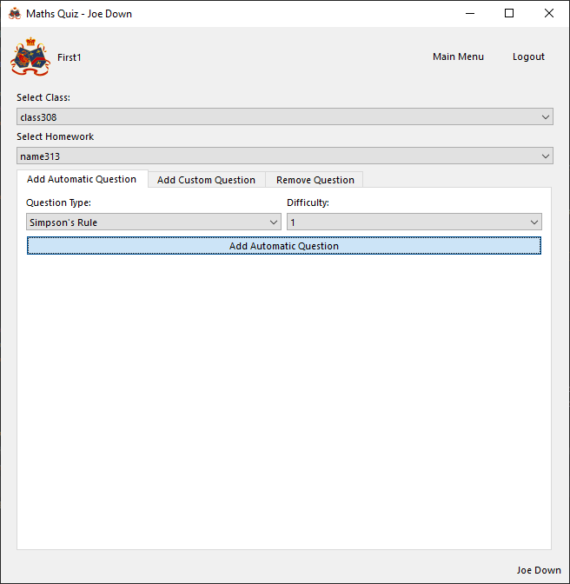

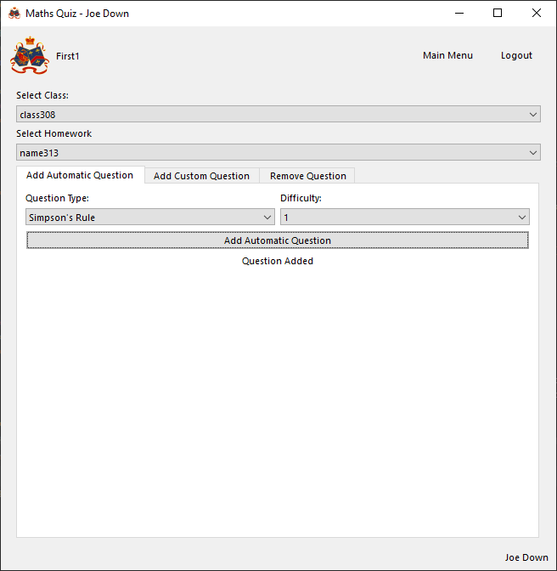

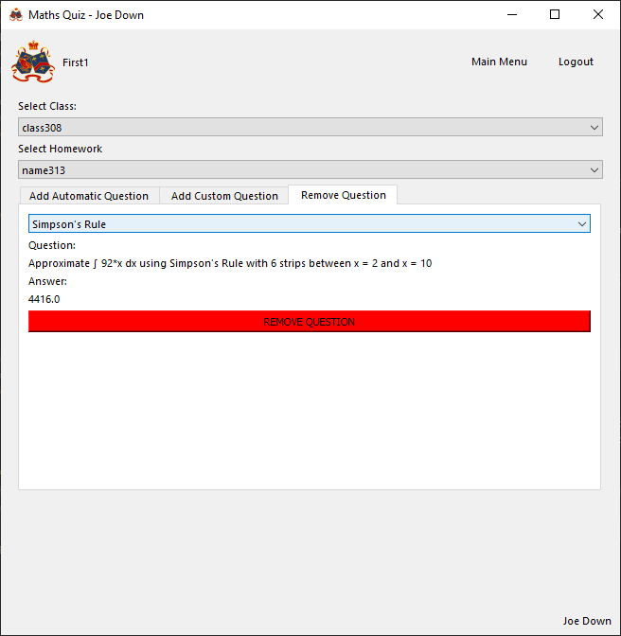

Correctly generates and inserts question of selected topic into homework and informs user adding question was successful

With invalid data

N/A, nature of dropdown box means an incorrect input cannot be given

###### Evaluation

Successfully generates question of the selected type, inserts question into database and establishes question to homework relationship

#### Previous scores page

##### Function to fill scores table

###### Final Code



###### Testing

With valid data

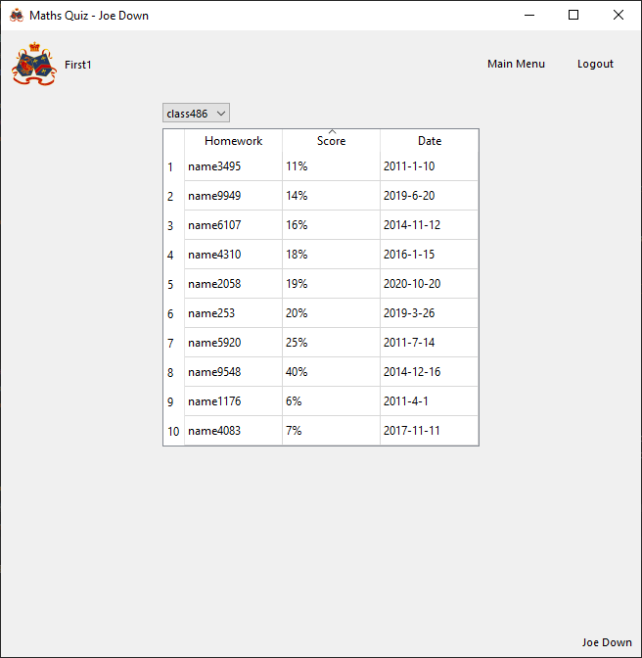

Loading page successfully lists all homework for the given class along with the date and the correctly calculated score (for detail on score calculation see database scripts section)

With invalid data

N/A, no user inputs

###### Evaluation

Successfully fills scores table with appropriate data relating to the current student for each homework in the class

#### Admin page

##### Function to add user to class

###### Final Code



###### Testing

With valid data

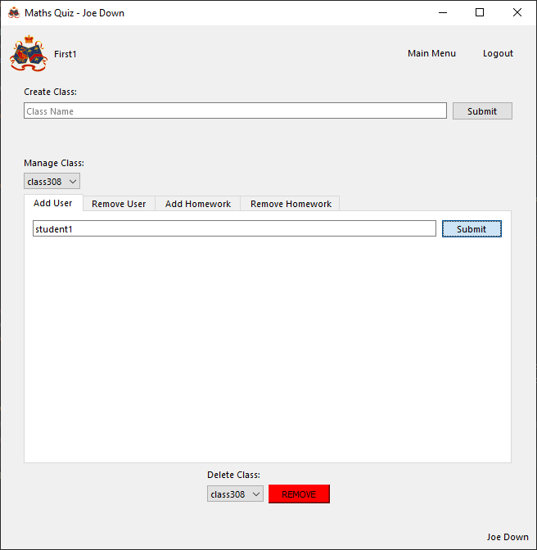

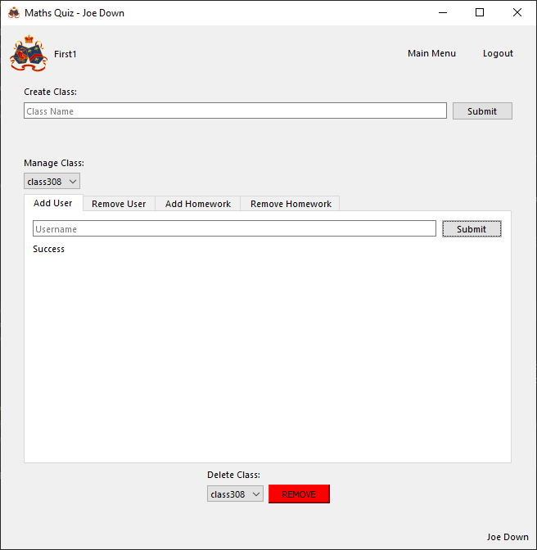

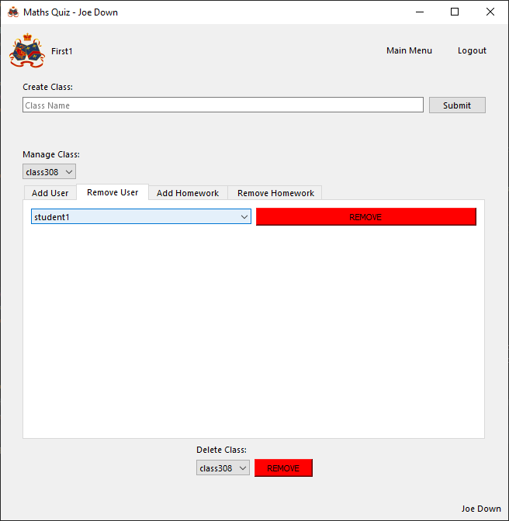

Successfully adds given student to class and informs user of success

With invalid data

Non-existent user

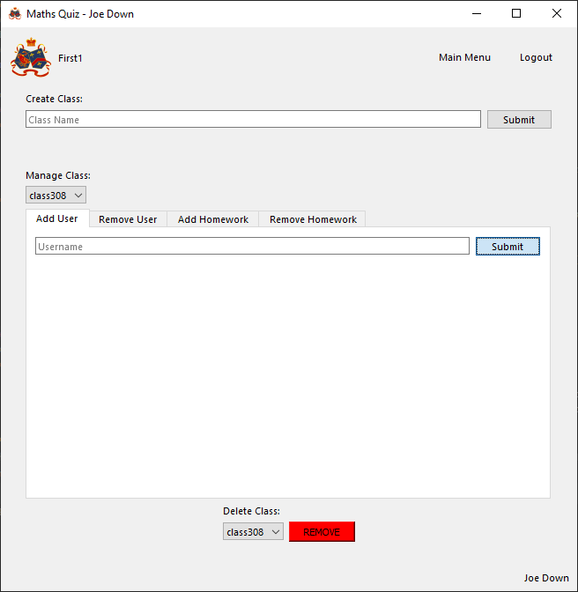

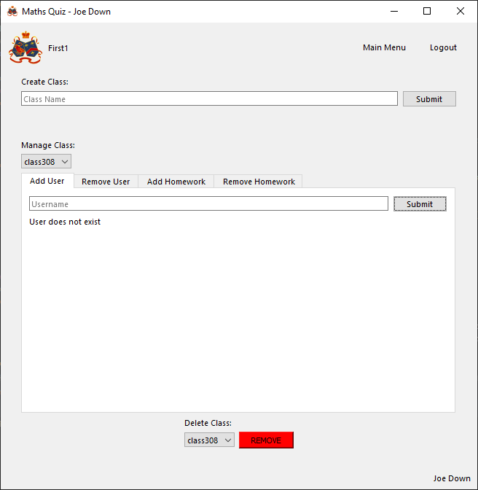

Successfully informs user that no such student exists

User already in class

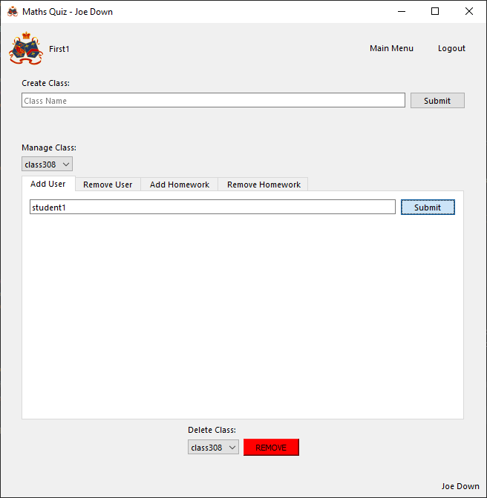

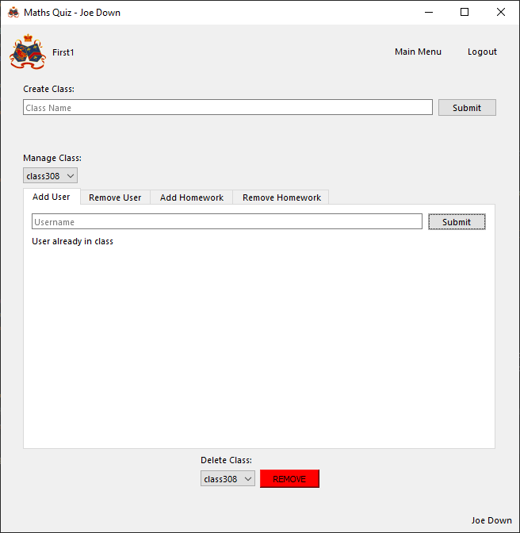

Successfully informs user that student is already in class

###### Evaluation

Successfully validates and then adds the user matching the inputted username to the selected class

##### Function to remove user from class

###### Final Code



###### Testing

With valid data

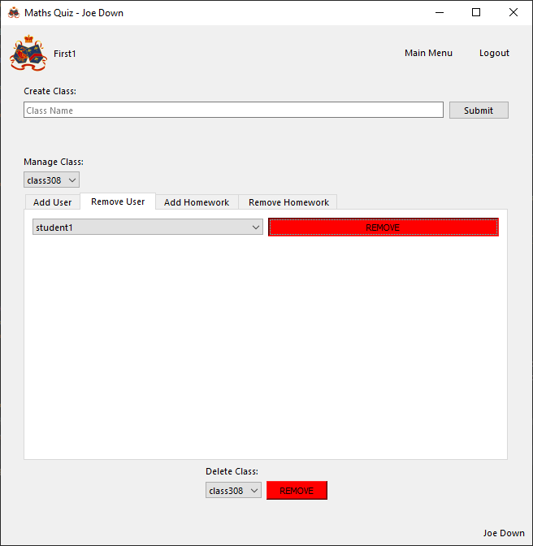

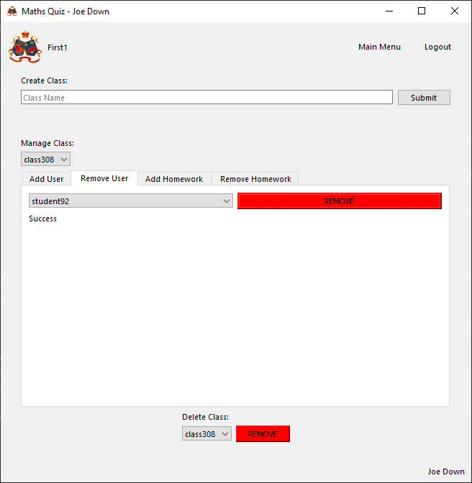

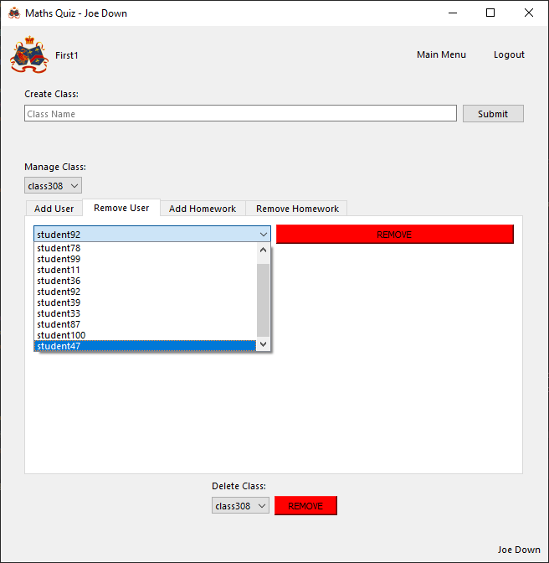

User selected is successfully removed from class

With invalid data

N/A, nature of dropdown menu means invalid removal cannot occur

###### Evaluation

Successfully removes the selected user from the class

##### Function to create class

###### Final Code



###### Testing

With valid data

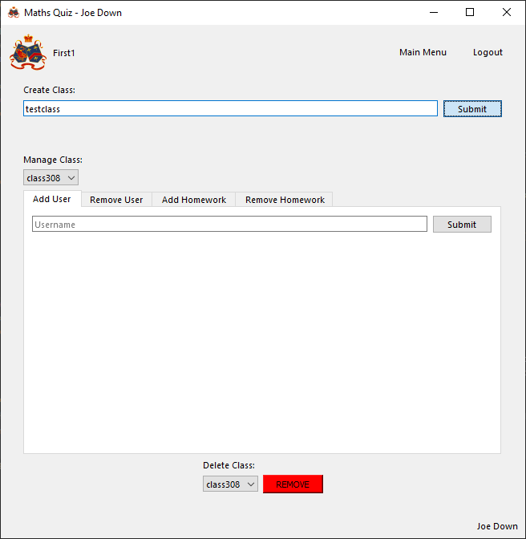

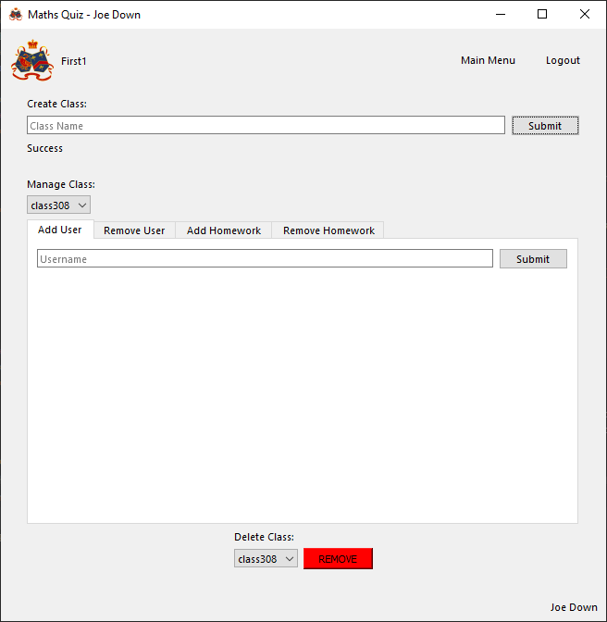

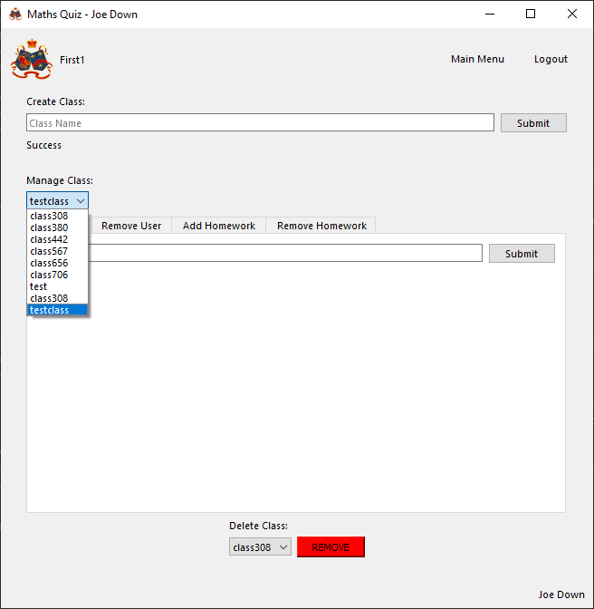

Successfully creates new class with given name under current teacher

With invalid data

No name given

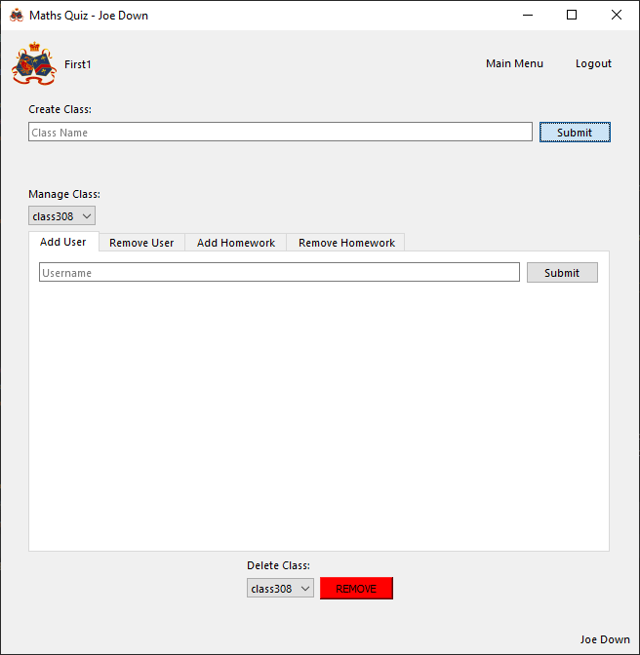

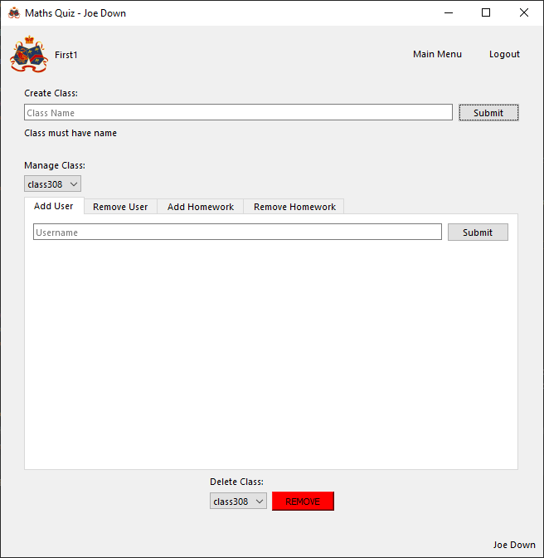

Successfully informs user that class to be added must be named

###### Evaluation

Successfully validates class name and then creates class using given name with the current user as teacher

##### Function to remove class

###### Final Code



###### Testing

With valid data

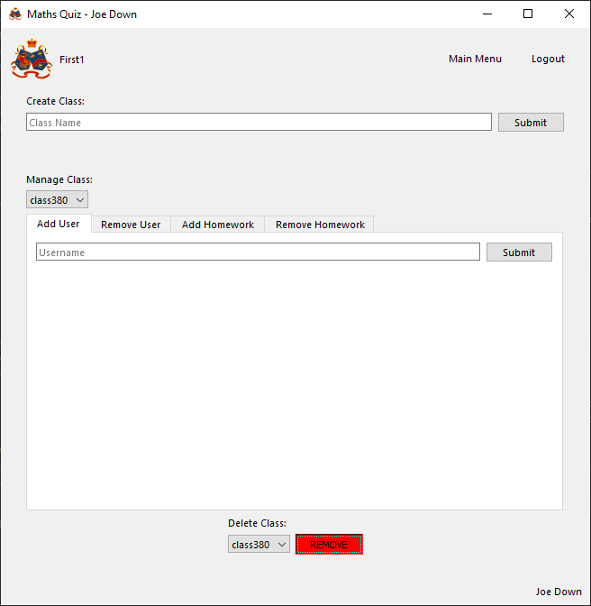

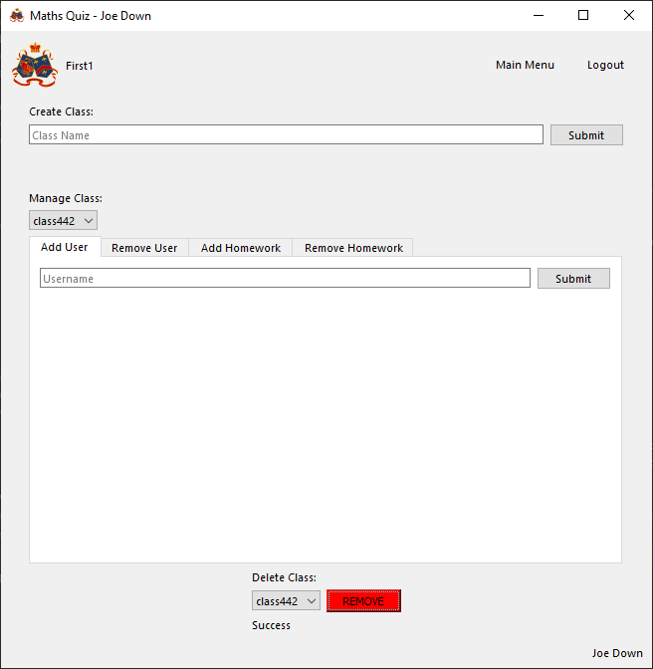

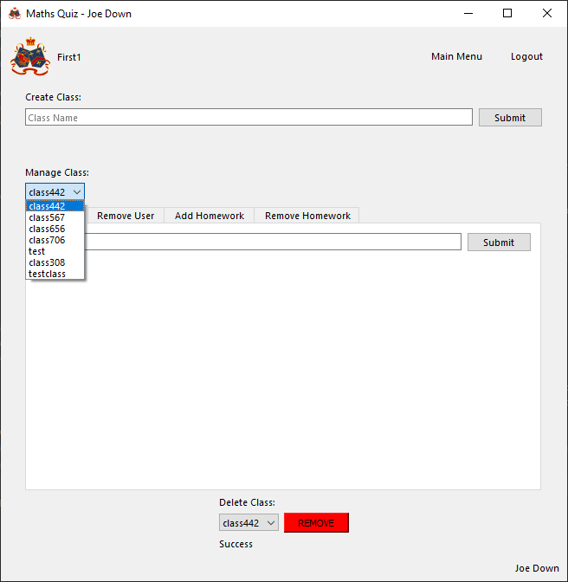

Successfully removes selected class

With invalid data

N/A, nature of dropdown menu means invalid removal cannot occur

###### Evaluation

Successfully removes the selected class

##### Function to create homework

###### Final Code



###### Testing

With valid data

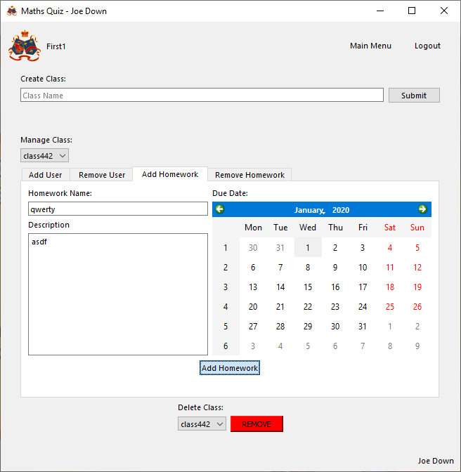

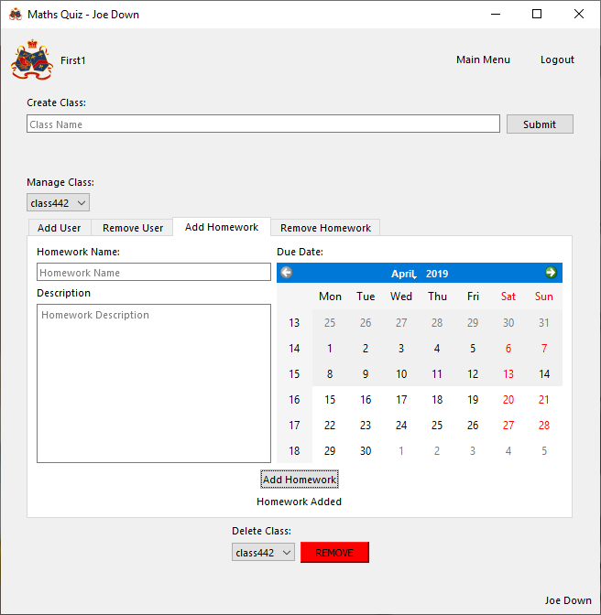

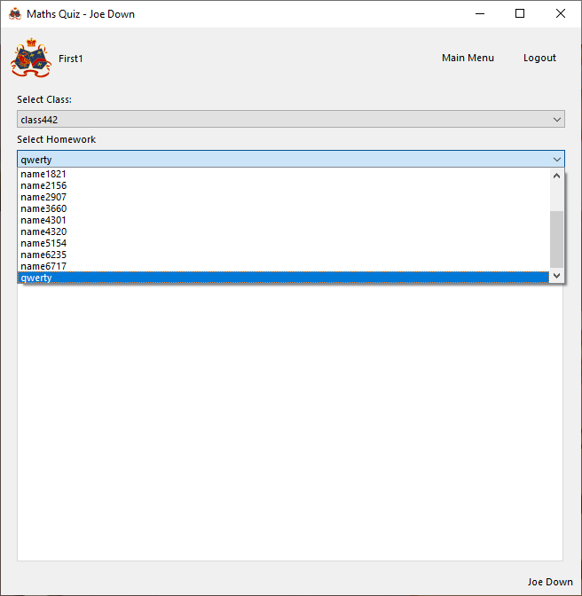

Successfully inserts new homework into class with given name, description and due date

With invalid data

No name

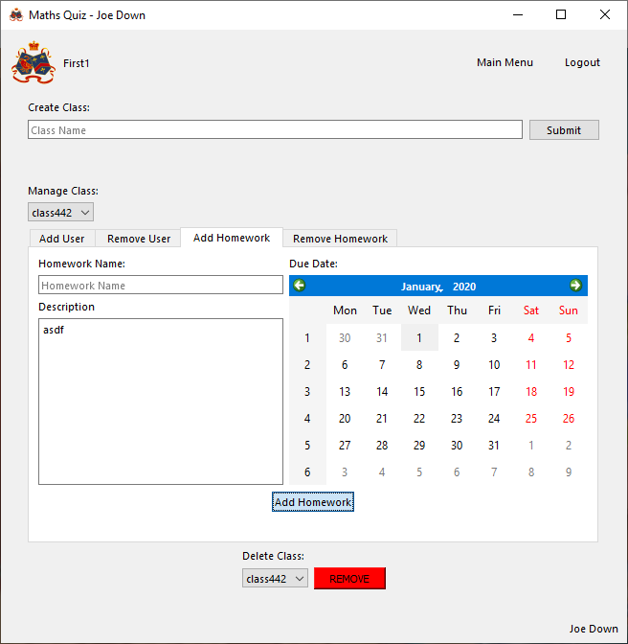

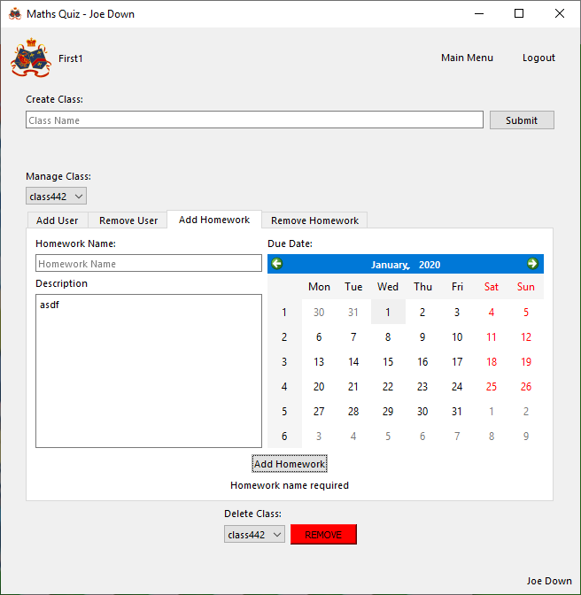

Successfully informs user that a name is required

No description

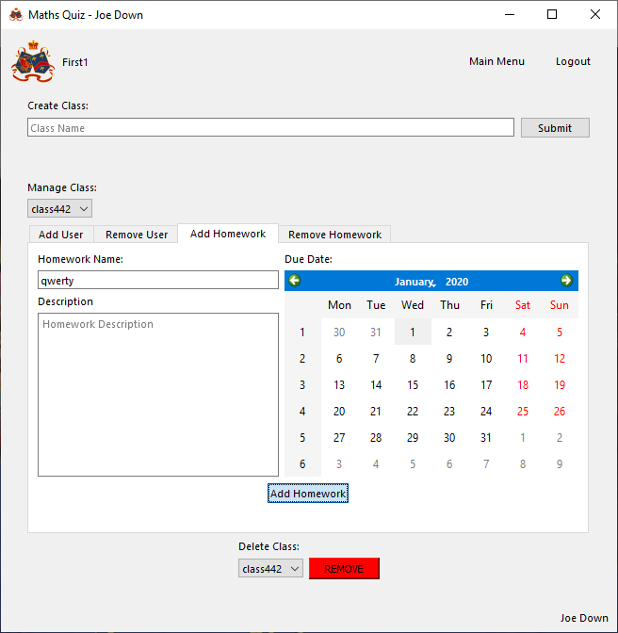

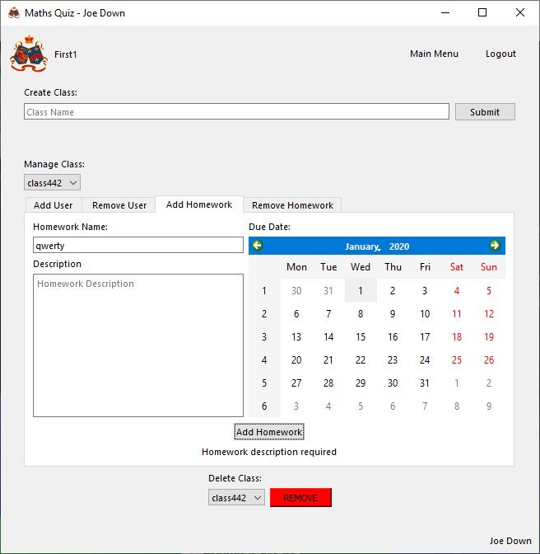

Successfully informs user that a description is required

Due date in the past

Dates in the past cannot be selected

###### Evaluation

Successfully validates all inputs and then creates a new homework in the selected class using the user inputted parameters

##### Function to delete homework

###### Final Code



###### Testing

With valid data

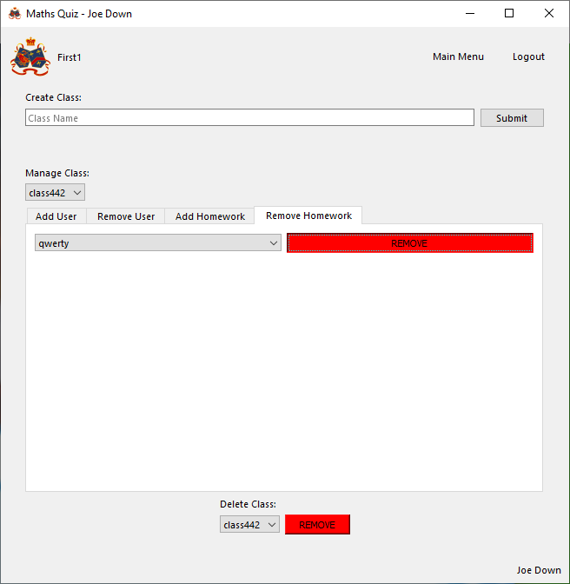

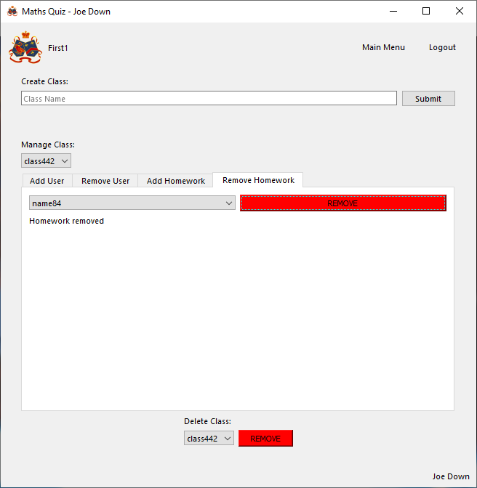

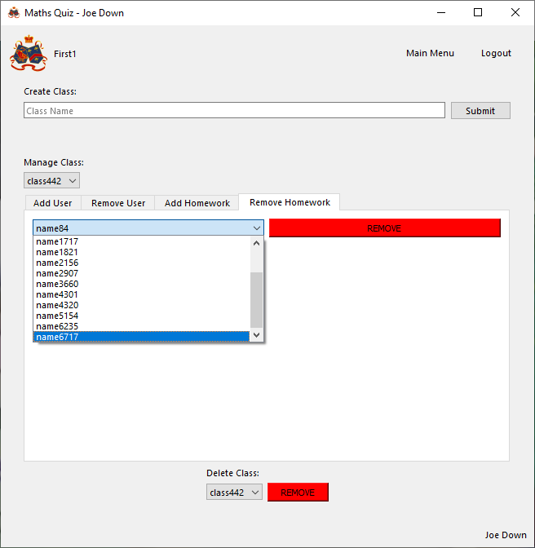

Successfully removes selected homework from class

With invalid data

N/A, nature of dropdown menu means invalid removal cannot occur

###### Evaluation

Successfully removes the relationship between the selected class and homework

#### Account management page

##### Function to update account details

###### Final Code



###### Testing

With valid data

No new first name

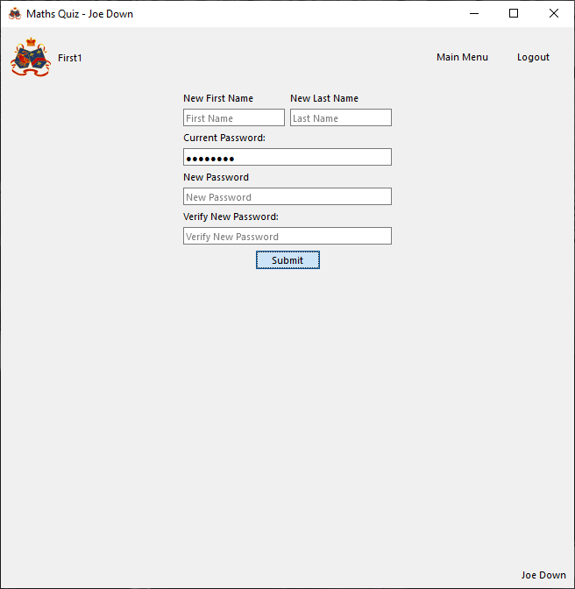

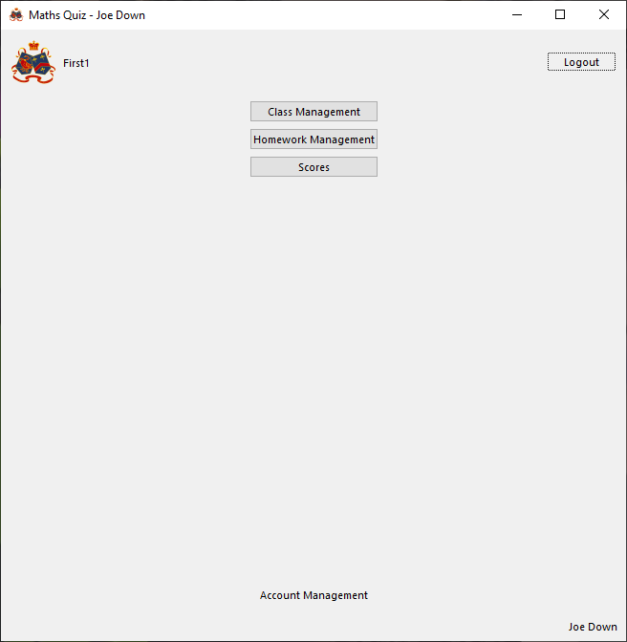

Successfully leaves first name unchanged

No new last name



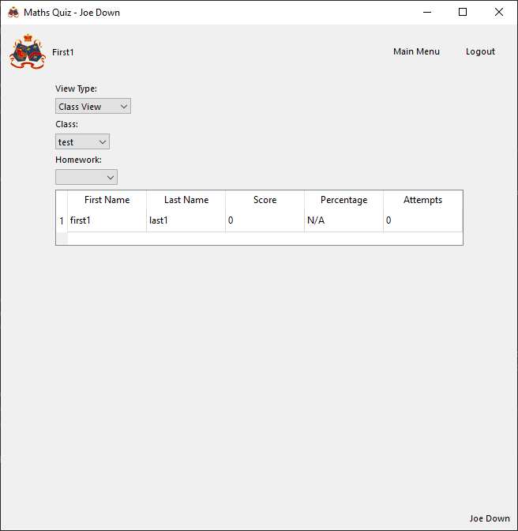

Successfully leaves last name unchanged

No new password



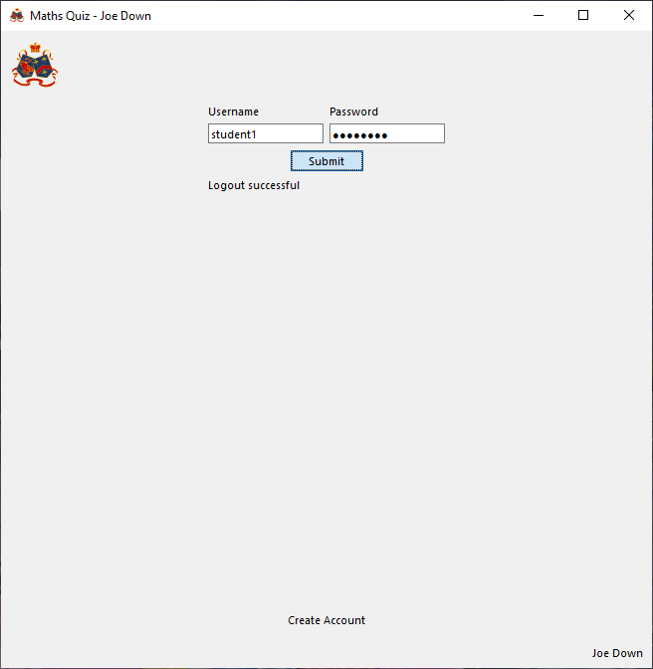

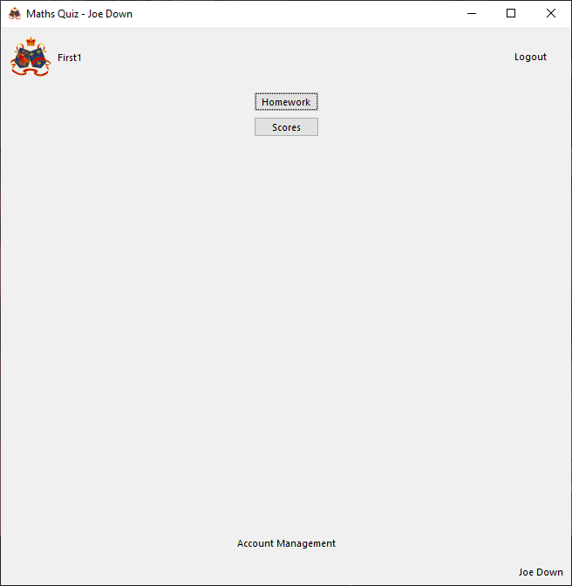

Successfully leaves password unchanged

New first name

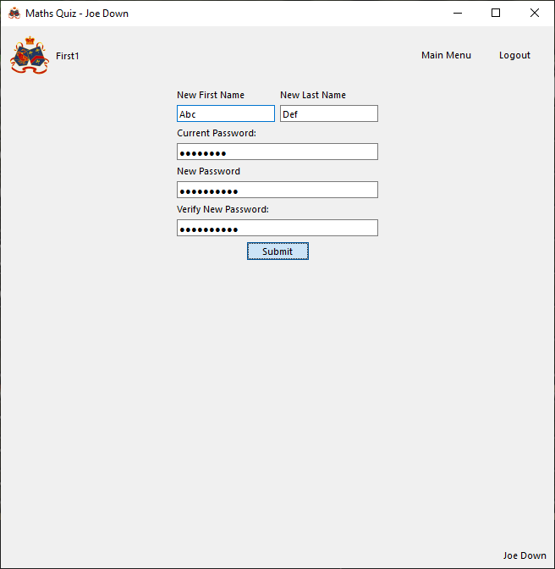

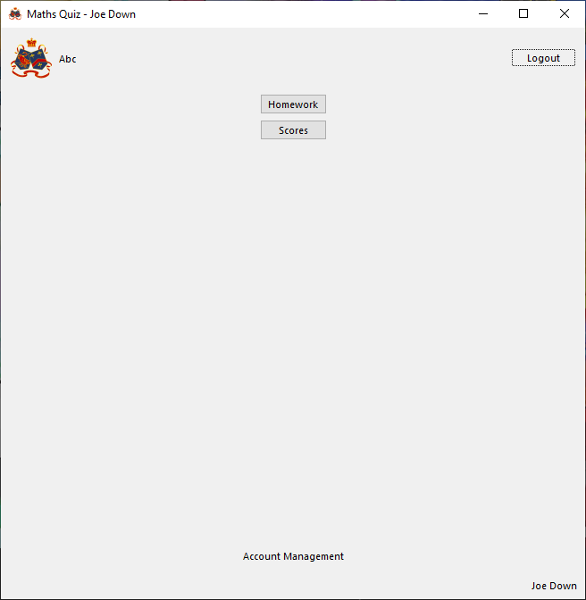

Successfully updates first name

New last name



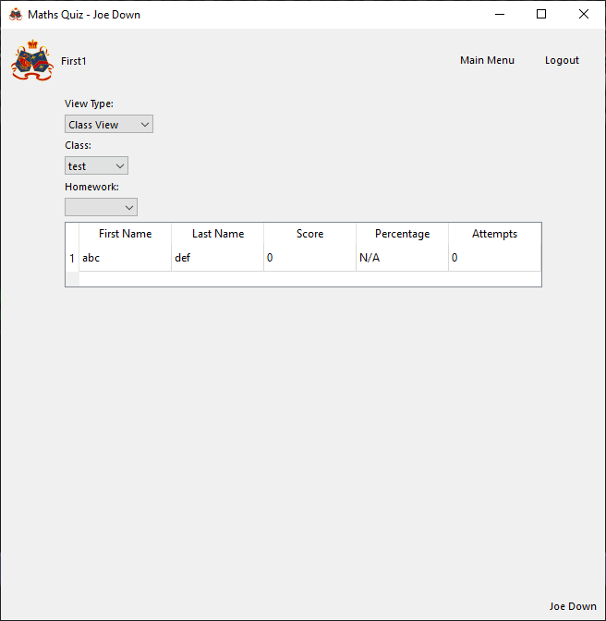

Successfully updates last name

New password



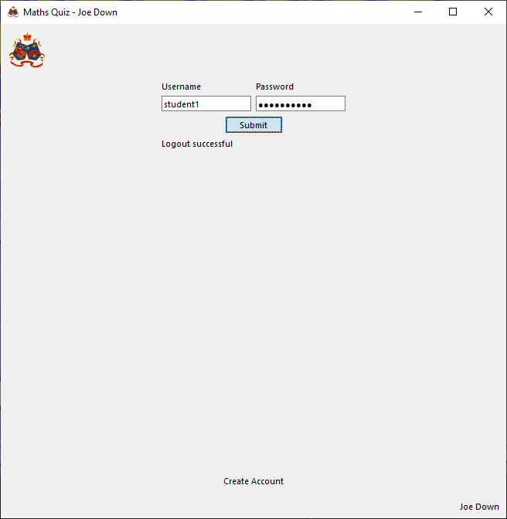

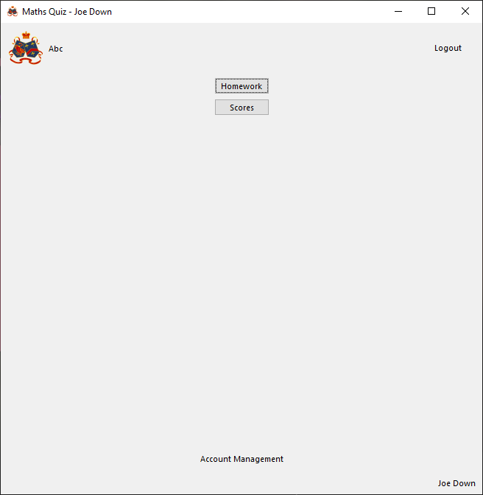

Successfully updates password

With invalid data

Current password incorrect

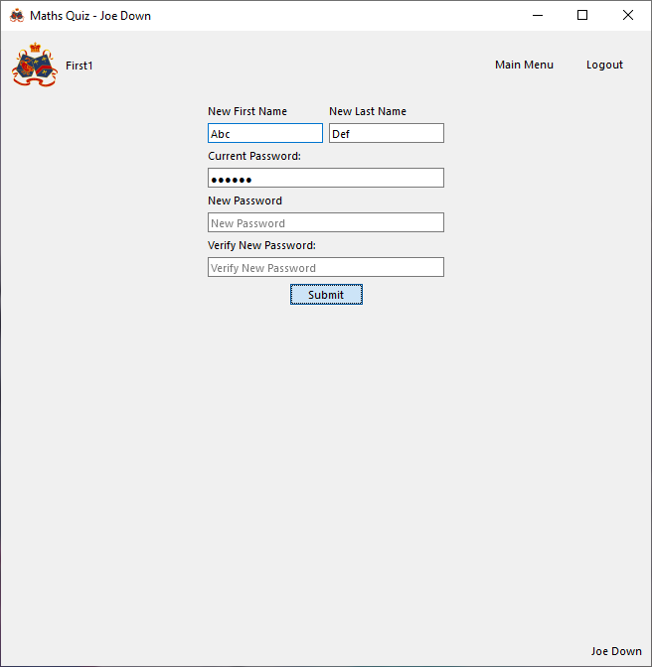

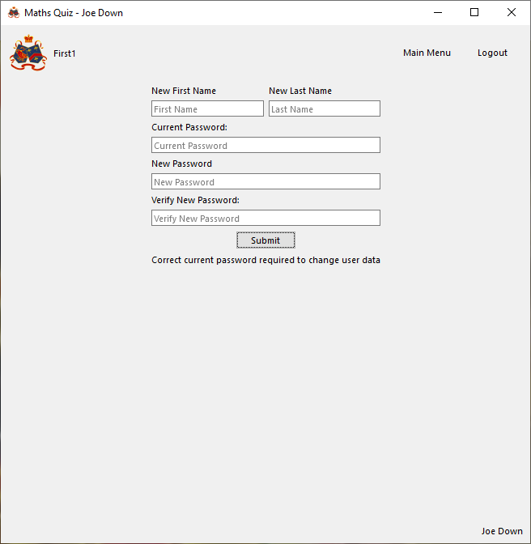

Successfully refuses to apply any changes and informs user password is incorrect

Mismatching new password verification

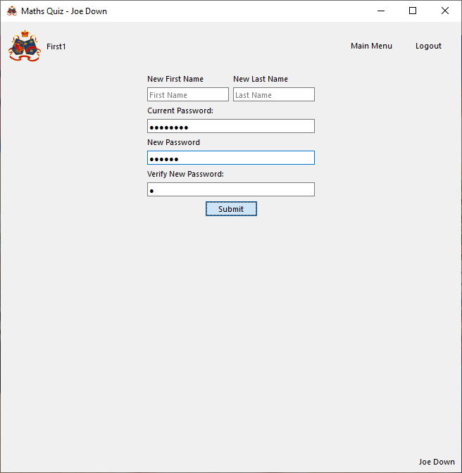

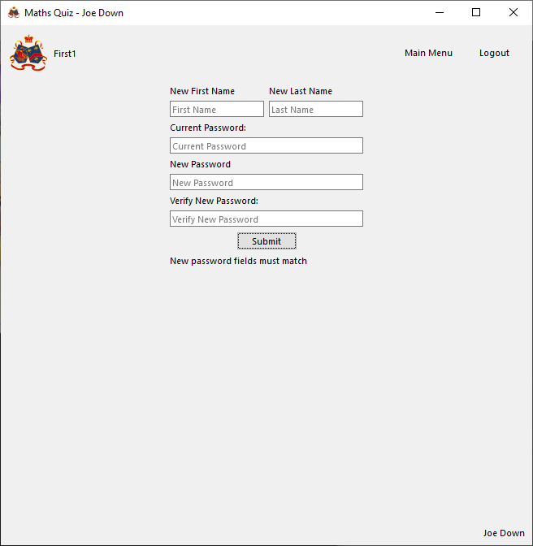

Successfully informs user new passwords do not match and does not update password

New password invalid

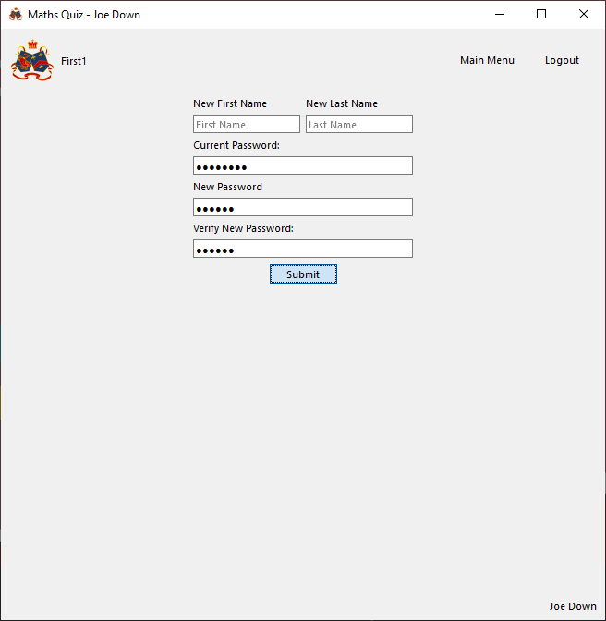

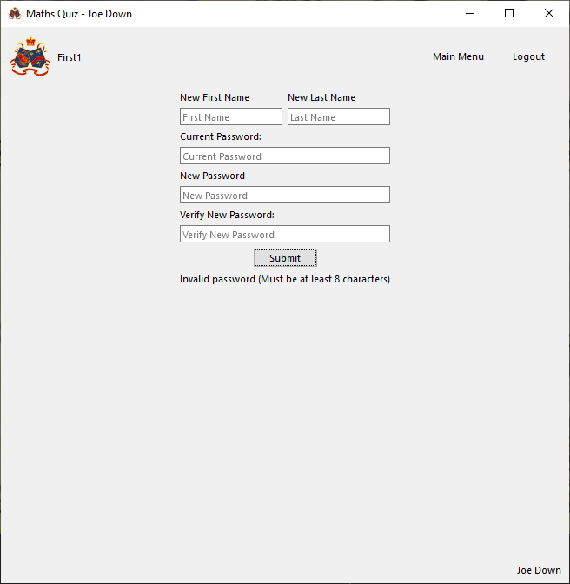

Successfully informs user password is invalid

###### Evaluation

Successfully validates that the password given is correct and if so, validates all inputs and updates the user’s details using the given parameters (only if given)

#### View classes page

##### Function to update results table

###### Final Code



###### Testing

With valid data

Class view

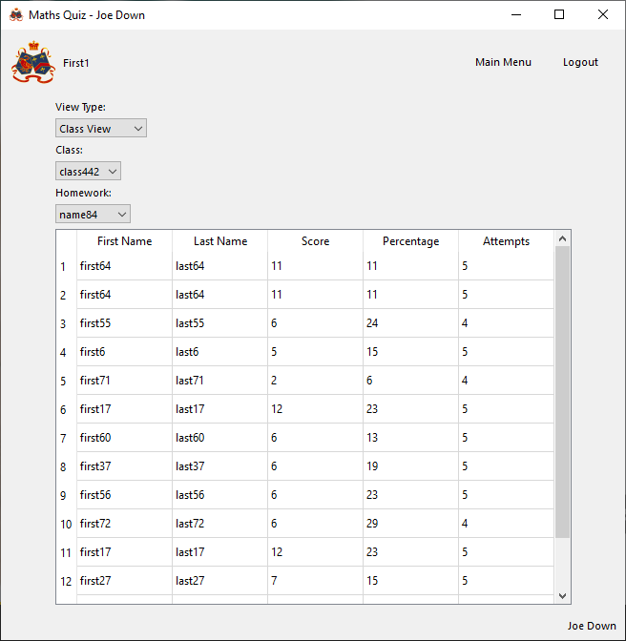

Successfully calculates and outputs all required score data for selected class and homework

Student view

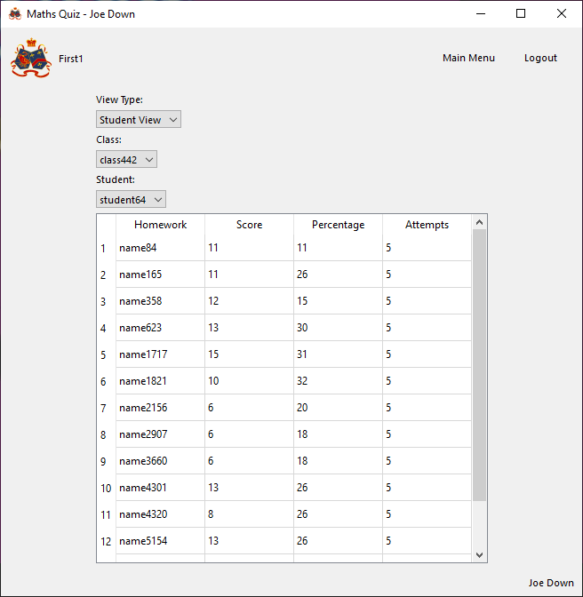

Successfully calculates and outputs all required score data for selected class and student

With invalid data

N/A, nature of dropdown menu means invalid selections cannot occur

###### Evaluation

Successfully takes all the data for either students in a class or homework of a student and displays it in a table, with what is displayed correctly matching the selected view type

#### Homework select page

##### Function to update homework list

###### Final Code



###### Testing

With valid data

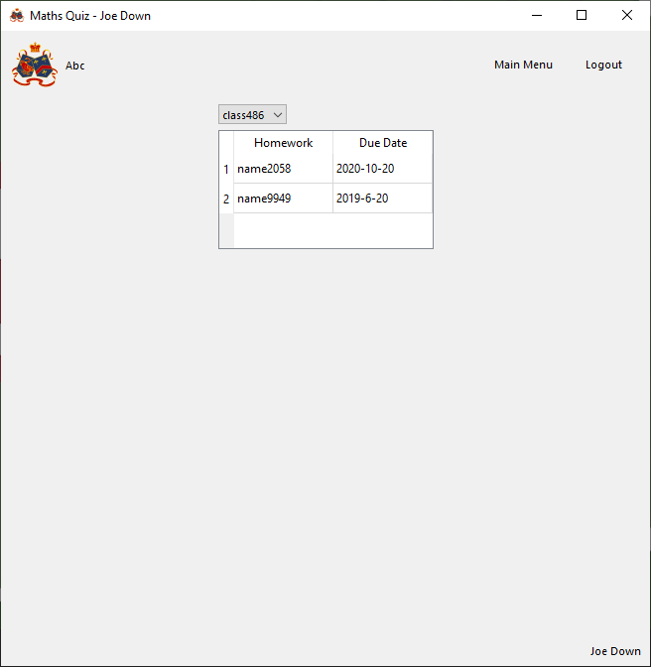

Successfully loads all homework for selected class with future due date

With invalid data

N/A, no user inputs

###### Evaluation

Successfully collects data relating to each homework and outputs each homework in the table for which the due date has not yet passed

##### Function to load homework

###### Final Code



###### Testing

With valid data

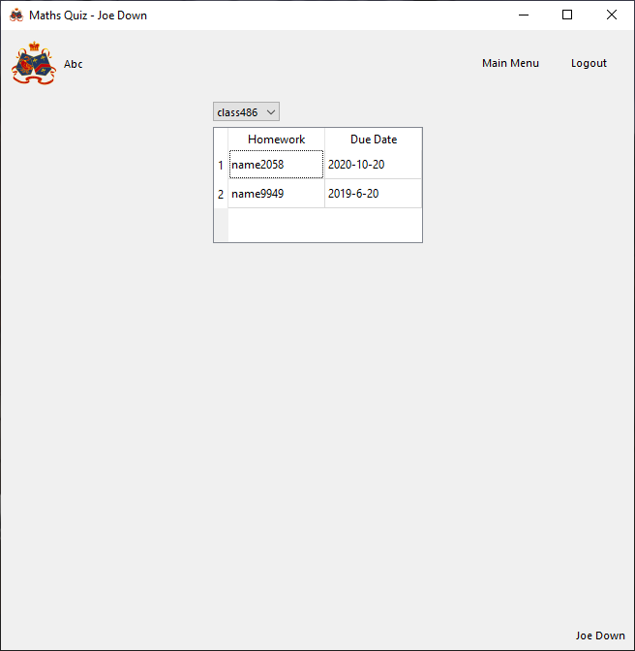

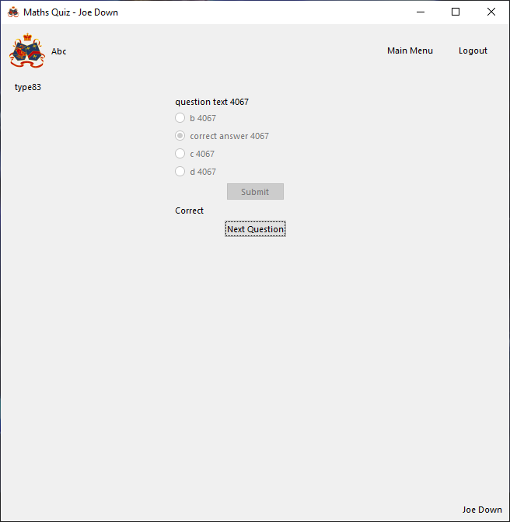

Successfully loads selected homework

With invalid data

N/A, no invalid selections possible due to nature of table

###### Evaluation

Successfully loads the first question in a matching homework when a homework in the table is selected unless there are no questions (in which case no attempt is made to load)

## Series Scripts (maths_scripts.series)

### Taylor Series Class

For further explanation of how a Taylor series works, see design section

#### Function to initialise class

##### Issues during development

Initially, the below code was used:



This resulted in errors later when developing code to evaluate functions as it meant invalid centres of expansion could be used, resulting in any value substituted into the function being approximated as equal to infinity:





While the function and centre are always to be verified before usage in the main program, in case of incorrect usage, it was decided to include an exception which ends the program if an incorrect centre is entered to prevent an incorrect question result being generated later



##### Final Code



##### Testing

###### With valid data:

e^0 is valid (equal to 1), so expansion is valid as f (0) is defined:





No error occurs

###### With Invalid data:

Log (0) is undefined for a log of any base, so expanding the below function about x=0 should result in an error as f(0) is undefined:





Correctly returns an error if an expansion about an invalid centre is attempted (This should really be verified before calling function and should not need to occur in practise)

###### Evaluation

Correctly initialises class and verifies valid centre is used

#### Function to generate an expansion with a given number of terms

##### Final Code



##### Testing

###### With valid data:

e^x

Correct expansion with 4 terms:

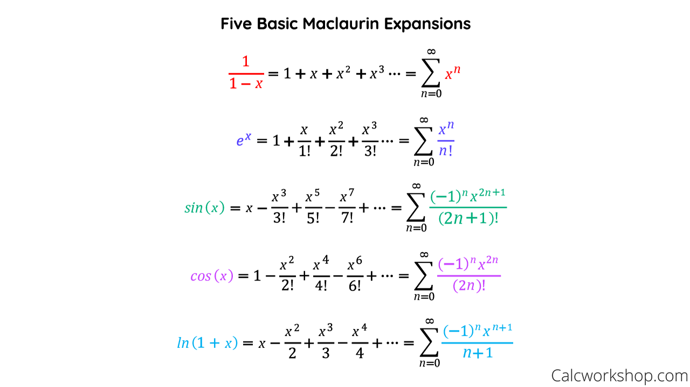

Program’s expansion:





Expansions successfully match

1/(1-x)

Correct expansion with 4 terms:



Program’s expansion:





Expansions successfully match

Ln(1+x)

Correct expansion with 4 terms:



Program’s expansion:





Expansions successfully match

###### With Invalid data:

Function and centre are validated during class declaration, before equation can be generated, and so invalid expansion cannot occur

###### Evaluation

Correctly generates the correct Taylor series for a given function and centre of expansion

#### Function to evaluate a function at a given value from its Taylor series

##### Final Code



##### Testing

###### With valid data:

e^x

Correct value of e^5:

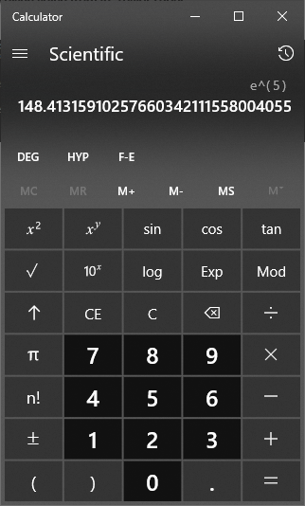

Program’s value (using 500 terms in the expansion):





Percentage difference compared to true value:

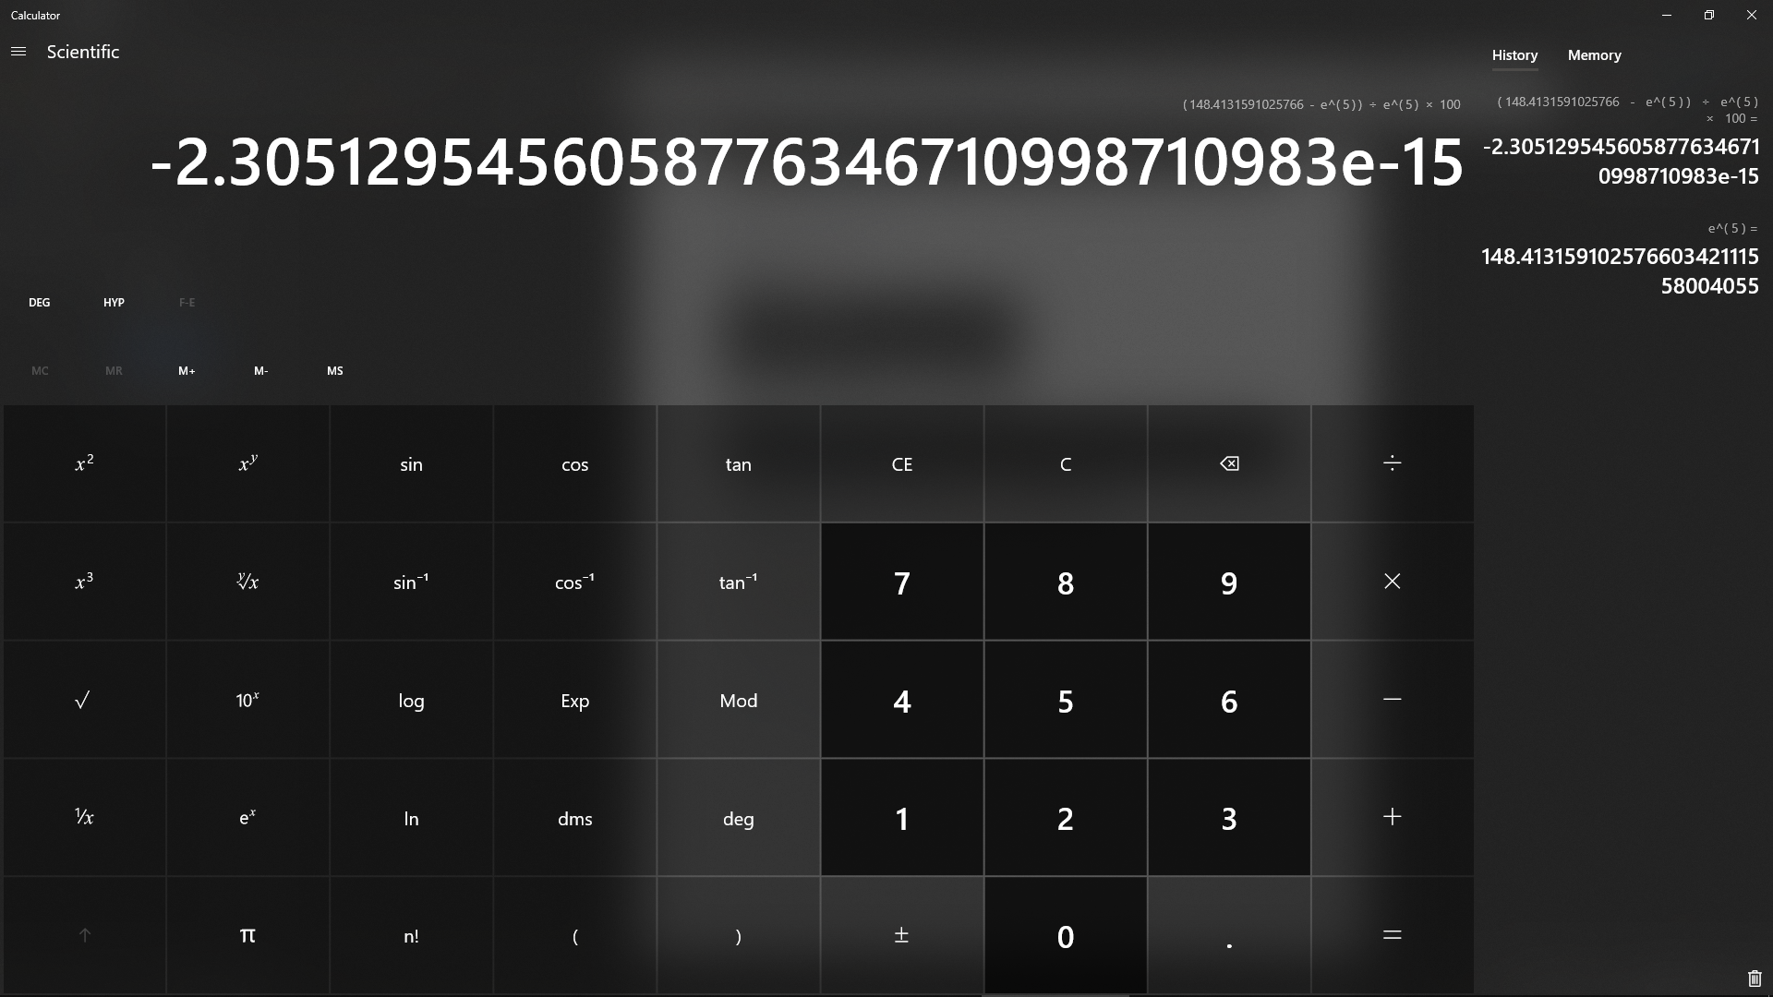

In this case, the generated value is an underestimate within 0.000000000000003 % of the true value (approximation is therefore very accurate)

1/(1-x)

Correct value of 1 / (1 – 0.23):

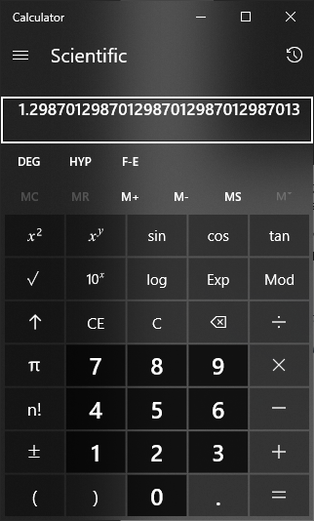

Program’s value (using 500 terms in the expansion):





Percentage difference compared to true value:

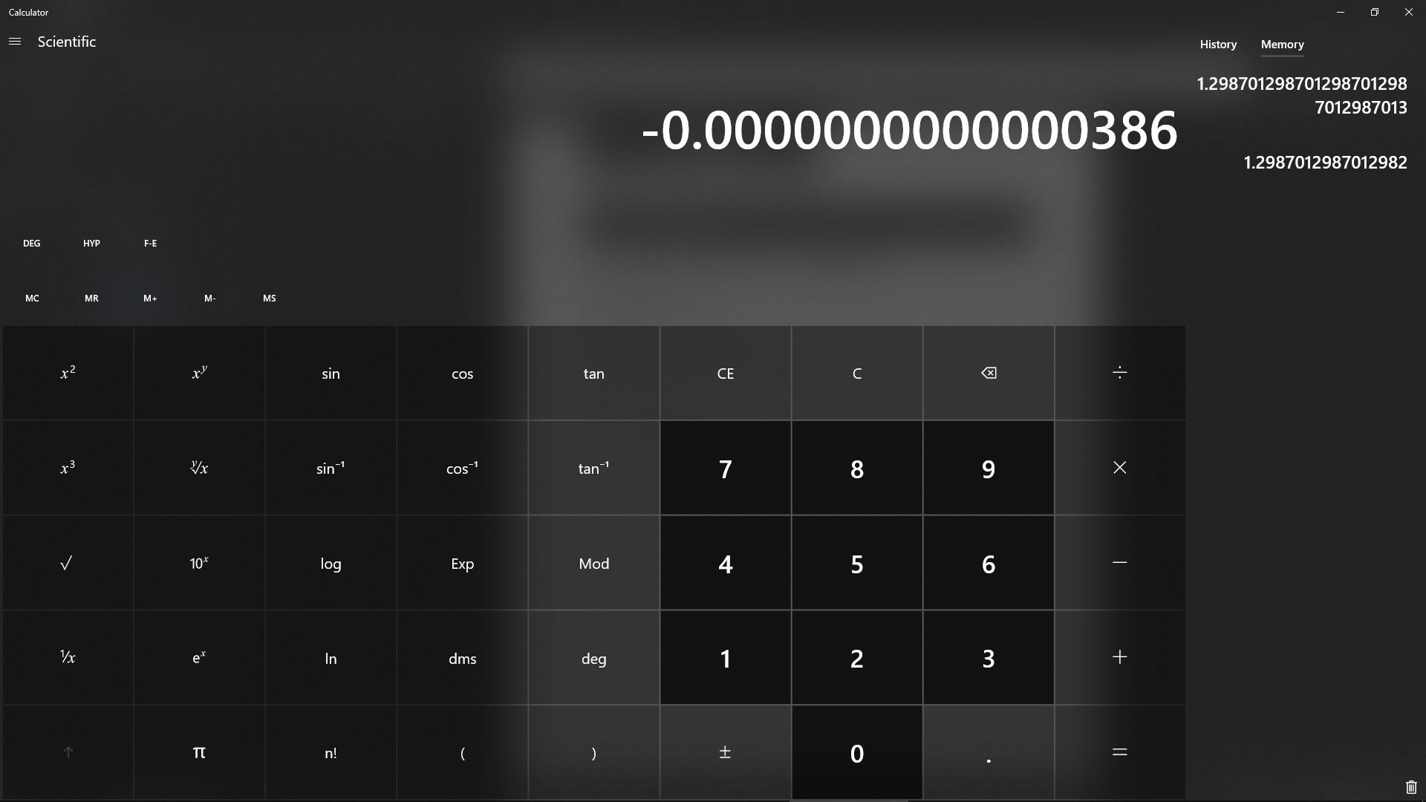

In this case, the generated value is an underestimate within 0.00000000000004% of the true value (approximation is therefore very accurate)

Ln(1+x)

Correct value of ln(1+0.663):

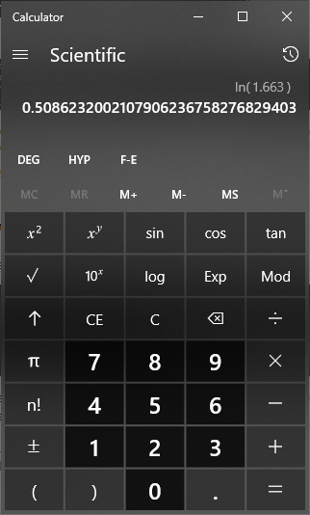

Program’s value (using 500 terms in the expansion):





Percentage difference compared to true value:

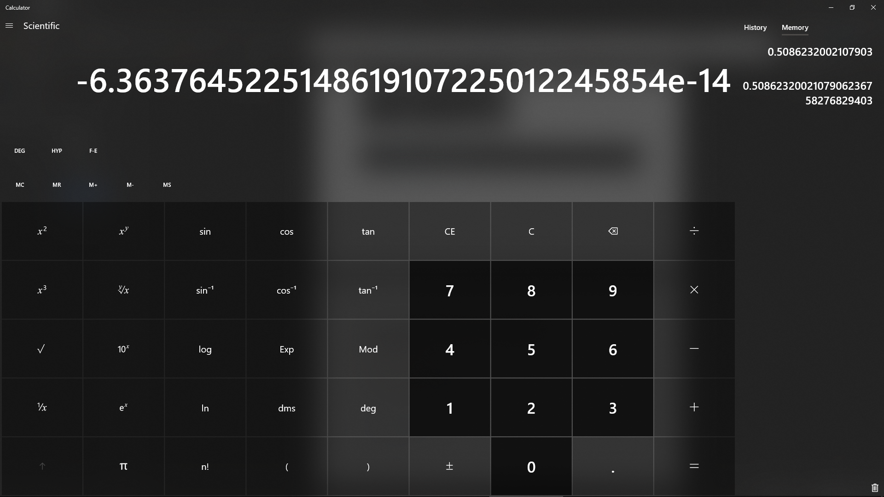

In this case, the generated value is an underestimate within 0.00000000000007% of the true value (approximation is therefore very accurate)

###### With Invalid data:

In theory, no values are invalid for usage in the Taylor series, however accuracy will decrease as values move away from the centre of expansion. This can however be addressed by selecting a different centre of expansion when defining the initial Taylor series to one closer to the value to be checked. Validation should therefore be carried out before using function.

###### Evaluation

Correctly computes value approximations of function to a very high degree of accuracy for values close to the centre of expansion

### Maclaurin Series Class

#### Final code



#### Testing

Testing not required as Maclaurin series is simply a special case of the already tested Taylor series

#### Evaluation

Maclaurin series works as intended as a special case of the Taylor series

### Sine function

#### Issues during development

Initially the following code was implemented:



This would result in very inaccurate results being calculated for values of x greatly outside the region 0<=x<2pi (as x increases, generated value rapidly tends towards infinity when by the definition of a sine function they should not ever exceed 1 or fall below -1):





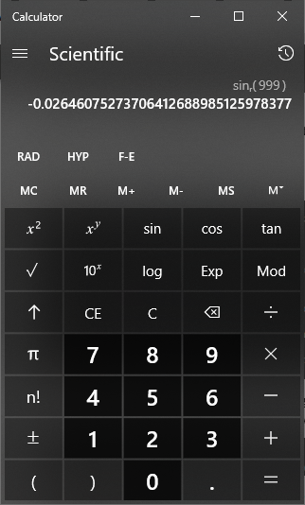

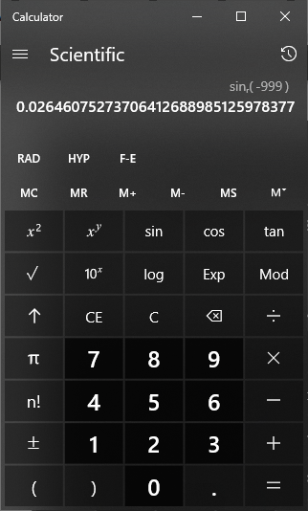

This is a limitation of the Maclaurin expansion as it requires more and more terms to accurately approximate a function further and further from the centre of expansion. As sine is a repeating function at intervals of 2pi however, 2pi can simply be taken away from or added to any value of x until it falls within the range 0<=x<2pi which can be approximated accurately with far fewer terms (see final testing), allowing much more accurate approximations to be generated in less time. The following code was implemented:



This produces vastly more accurate results:



#### Final Code

The code implemented is simply a variation of the code developed for a Maclaurin series. The derivatives of sin follow the following pattern: sin, cos, -sin, -cos, sin. This means the pattern repeats and so as sin and cos of 0 are known to be 0 and 1 respectively, derivatives do not need to be calculated, instead values of 0, 1, 0, -1 repeating can be substituted into consecutive terms of the expansion, meaning only every other term in the expansion needs to be calculated (as 0* anything =0) and all remaining terms can simply alternate between being positive and negative. This can be summarised with the following mathematical expression:

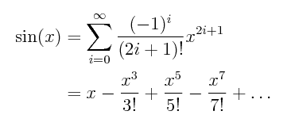

This allows a series to be calculated more efficiently than if the base Maclaurin series code were used as every second term (each term which will give 0) is ignored and no derivatives are calculated.



#### Testing

As all values can be brought within the range 0 to 2 pi of the function and the function is centred around 0, the worst-case scenario of this approximation can be considered to be when the value given is an integer multiple of 2 pi as the approximated polynomial is furthest from the true function:

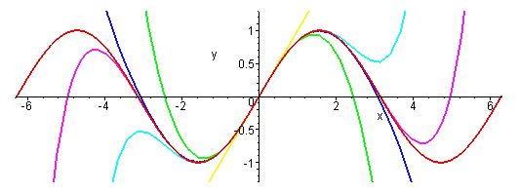

Therefore, testing of the accuracy of the function needs only to be carried out at x = 2pi all other values up to this will give a more accurate approximation. The true value was checked for sin(2pi) to be 0. The validation to bring a value down into the range 0<=x<2pi was temporarily removed for the sake of this one test as otherwise sin(2pi) will be identified to be equal to sin (0). The following test code was used to allow the precision to be varied and the accuracy of the approximation for given precision analysed:





All values in the program are outputted to 2 decimal places and as can be seen above, it takes only 10 terms in the series to get a correct value of 0.00 to 2d.p in the worst-case scenario of the algorithm. At 19 terms, any further approximations calculated output to the same value and so it can be assumed that the limitation of approximation using floating point values has been reached. This value is correct to 13 decimal places, more than enough for the purposes of this program. The precision level to be used universally by the function will therefore be set to 20 as it will approximate all values to a maximum level of precision using floating point in python (1 more than the actual limit of 19 is used to allow for any potential uncertainty in this statement and as the algorithm is a Maclaurin series and completes in O(n) time, the extra processing time is negligible).

Five further tests will be done using randomly generated floats and checked against a calculator to verify function further:





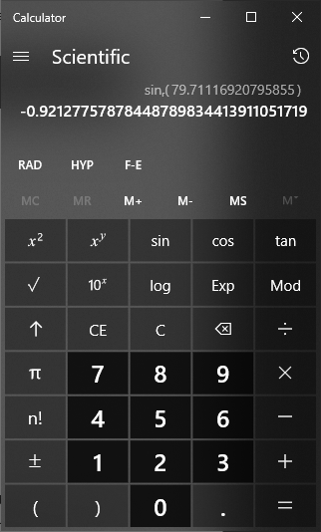

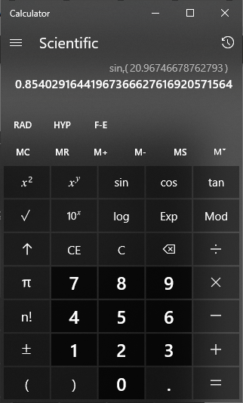

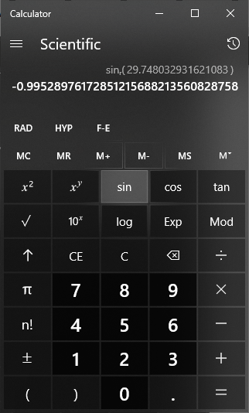

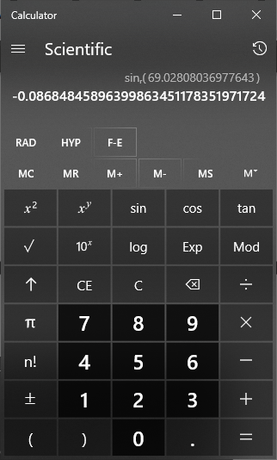

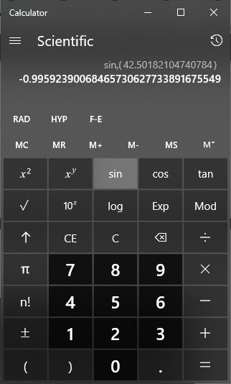

As can be seen, all values generated are identical to the true values to the number of decimal places provided by python’s floating-point implementation.

#### Evaluation

Function produces values of sin(x) for a given x to the maximum available level of accuracy

### Cosine function

#### Final code

The derivatives of cos follow the following pattern: cos, -sin, -cos, sin, cos. This means that the expansion of cosine works almost identically to that of a sine function except repeating values of 1, 0, -1, 0 are substituted instead of values of 0, 1, 0, -1. This can be summarised mathematically as:

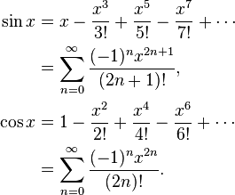

The code for sine was therefore for the most part copied, though with the equation for each term modified to fit the equation for cosine:



Precision has been set to equal to that of the sine function and so will be similarly accurate (see sine function testing for further elaboration)

#### Testing

Five tests will be done using randomly generated floats and checked against a calculator to verify function further:





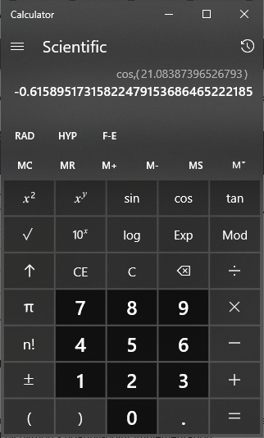

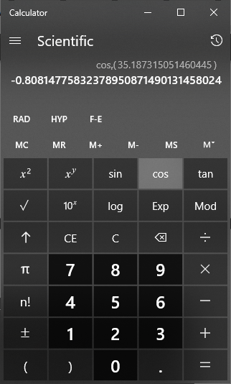

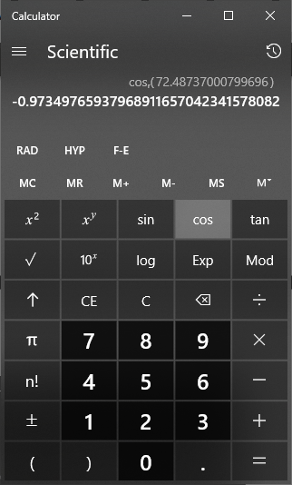

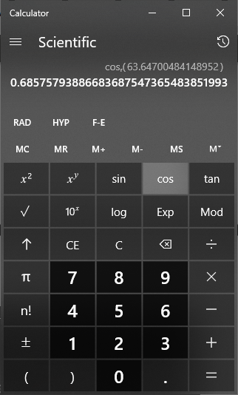

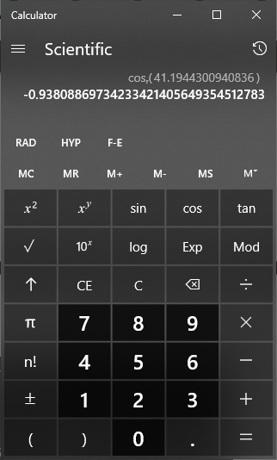

As can be seen, all values generated are identical to the true values to the number of decimal places provided by python’s floating-point implementation.

#### Evaluation

Function produces values of cos(x) for a given x to the maximum available level of accuracy

## Calculus Scripts (maths_scripts.calculus)

### Integral approximation base class

As both Simpson’s rule and the trapezium rule both work by splitting an area into a number of strips, a base class can be developed from which both Simpson’s rule and trapezium rule classes can inherit and build upon through polymorphism.

#### Function to initialise class

##### Final Code



##### Testing

Code to test generation of y list will be given after this function in documentation

###### With valid data:





Function correctly stores all attributes and correctly calculates strip width ((5-1)/5 = 0.8 as calculated by program)

###### With Invalid data:

N/A, values used to initialise instance of class should be verified before initialising instance

###### Evaluation

Class is correctly initialised with all required data stored and strip width correctly calculated

#### Function to generate y values

##### Final Code



##### Testing

###### With valid data:





Correct values:

|  |  |  |  |  |  |
| --- | --- | --- | --- | --- | --- |
| 1 | 1.8 | 2.6 | 3.4 | 4.2 | 5 |
| 2.718282 | 6.049647 | 13.46374 | 29.9641 | 66.68633 | 148.4132 |

Values generated match the actual values and there are the correct number of y values generated in the correct order

###### With Invalid data:

N/A, class properties should be verified when class is initialised

###### Evaluation

Correctly generates all required y values at the required intervals

### Trapezium rule class

#### Function to initialise class

##### Final Code



##### Testing

Further testing not required as no changes are made to instantiation of parent class

##### Evaluation

Correctly initialises class

#### Function to approximate integral

##### Final Code



##### Testing

###### With valid data:

The following application of the trapezium rule was found online (<https://revisionmaths.com/advanced-level-maths-revision/pure-maths/calculus/trapezium-rule>) as an example of how the trapezium rule is applied:

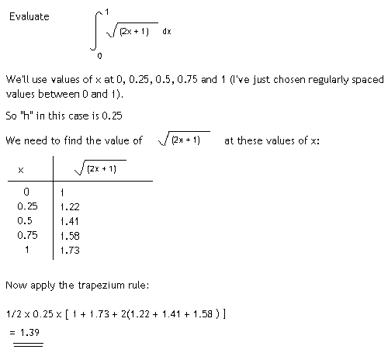

When the program was run using the same function (2x+1)^0.5, strip count (4) and boundaries (0 to 1) the following occurred:





The result generated matches the value calculated in the example to 3 significant figures, however, contains many further digits. This should not be treated as an error however as in the example workings, all y values have been rounded to 2 decimal places, whereas the program has left values unrounded, producing a more accurate result.

###### With invalid data

N/A, class properties should be verified when class is initialised

##### Evaluation

Correctly finds an approximation to the integral given using the level of precision defined

### Simpson’s rule class

#### Function to initialise class

##### Final Code



##### Testing

###### With valid data





No errors occur as strip count is even

###### With invalid data





Error raised as strip count is not even

##### Evaluation

Correctly initialises class after validating that a valid strip count was entered (even integer)

#### Function to approximate integral

##### Final Code



##### Testing

###### With valid data

The following application of Simpson’s rule was found online (<http://tutorial.math.lamar.edu/Classes/CalcII/ApproximatingDefIntegrals.aspx>) as an example of how Simpson’s rule is applied:

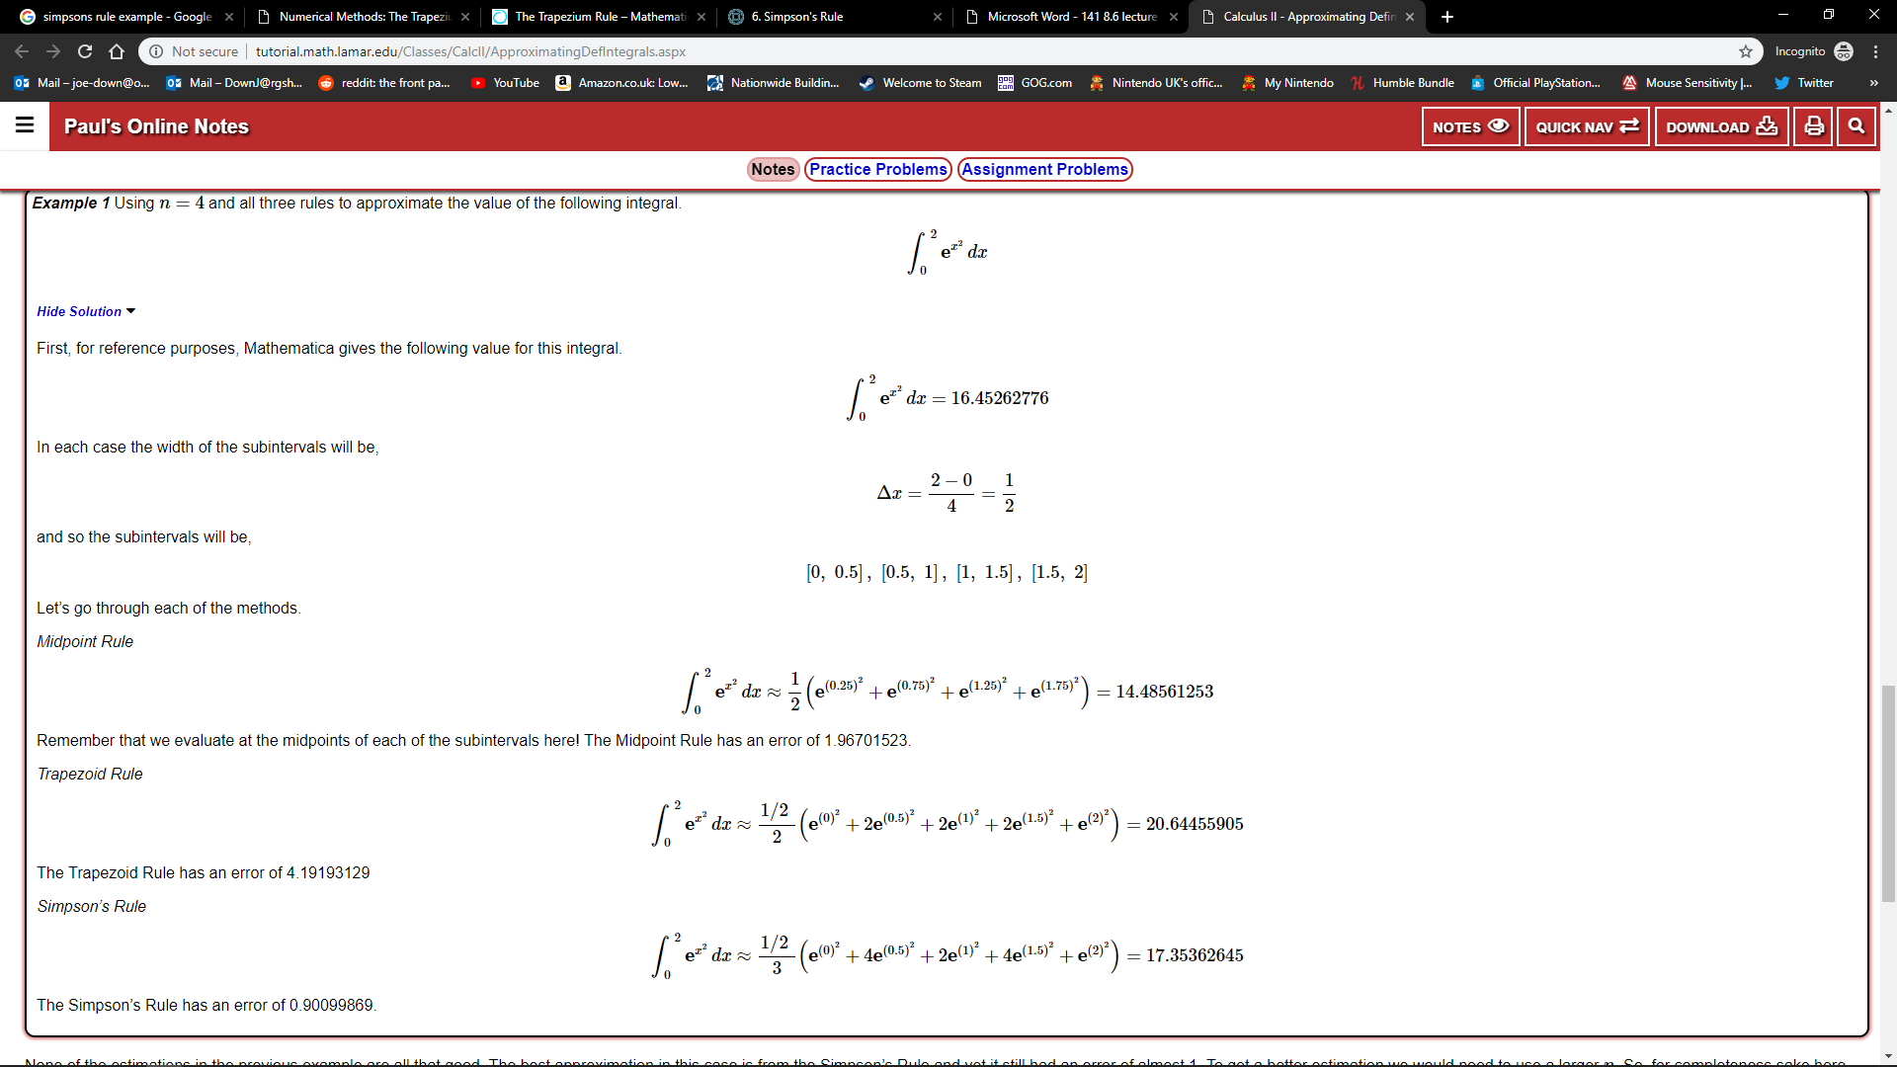

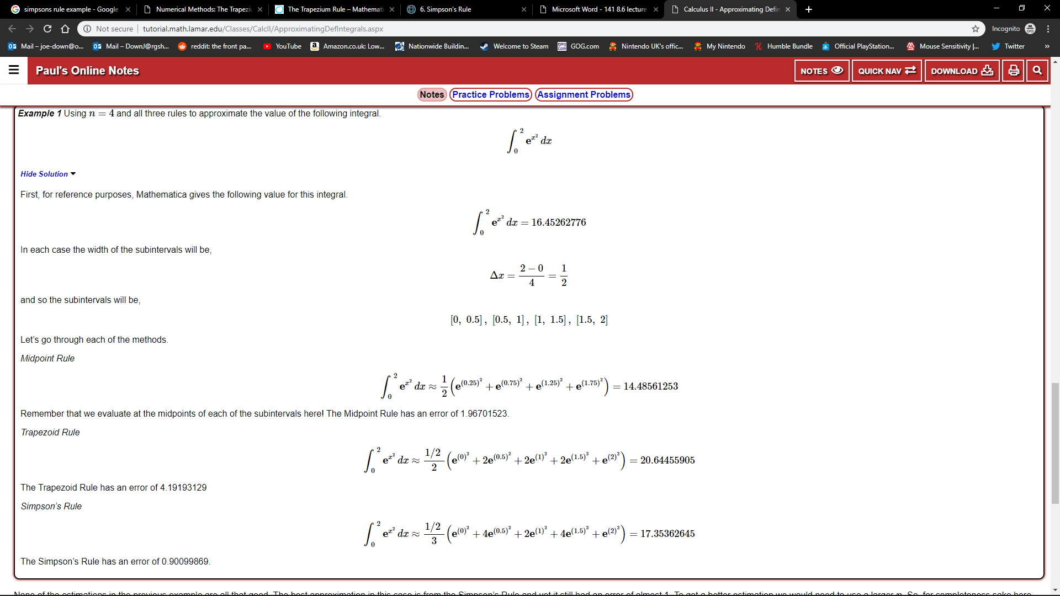

When the program was run using the same function e^(x^2), strip count (4) and boundaries (0 to 2) the following occurred:





The result generated matches the value calculated in the example, though includes additional significant figures compared to the example

###### With invalid data

N/A, class properties should be verified when class is initialised

##### Evaluation

Correctly finds an approximation to the integral given using the level of precision defined

### Comparison of Simpson’s rule to Trapezium rule

The following code was used to calculate the integral of e^x with limits of 0 and 5 with increasing strip counts upon each iteration. The true value was also calculated manually to be 147.41315910257660342111558004055 to 32 significant figures (more than enough for almost any usage. For comparison, NASA requires only 16 decimal places for their value of pi to precisely enough carry out all their work <https://www.jpl.nasa.gov/edu/news/2016/3/16/how-many-decimals-of-pi-do-we-really-need/>).





From the values seen above it is clear that Simpson’s rule will produce a much more accurate approximation of the integral than the trapezium rule given an equal strip count. The code was altered to better illustrate this by instead outputting the percentage difference between the approximations and the true value, as seen below:





As can be seen above, with only 2 strips, while the trapezium rule approximation falls within a relatively large 48% of the true value, Simpson’s rule is already within 13% of the true value. As more and more strips are used, Simpson’s rule also gains more accuracy at a faster rate, with the trapezium rule requiring only 4 more strips (6 in total) to beat the accuracy of Simpson’s rule with only 2 strips, but 10 more strips (14 in total) to beat the accuracy of Simpson’s rule with 4 strips. The gap only further widens as the number of strips further increases.

This does not yet provide enough information to guarantee that Simpson’s rule will produce a more accurate result in an equal amount of time to the Trapezium rule as it is possible that calculating a trapezium rule value with a far greater strip count may be faster than a Simpson’s rule value with a smaller strip count. Looking at the algorithms however indicates that this is not the case as both algorithms contain only a single loop proportional in number of iterations to the number of strips being used – 2, so each algorithm has a time complexity of O(n), where n is the number of strips used. While each loop of the Simpson’s rule algorithm requires an if statement to be carried out while the Trapezium rule does not, the time this would take is negligible when compared to how many fewer strips are needed to give an approximation of similar accuracy and so Simpson’s rule is still more effective.

Due to the above reasoning, it was decided that where definite integrals are required in the program, Simpson’s rule can be used as it will be able to very quickly approximate to the 2 decimal places used in the main program and require less processing power and time than if the trapezium rule were used.

# Evaluation

## Final Testing

Extensive testing was carried out on the code during development to the point where further direct testing of code and the potential incorrect usage of the program is redundant as it has been covered already. However, all functionality within the user interface itself should be retested now in order to assess usability and ensure all user accessible functions of the program work as intended and are clear how to use. While all tests will be specified by me, each test will be carried out by one of the stakeholders and their feedback analysed to determine success. For the most part, this will simply take the form of teacher and student creating accounts and utilising each feature of the program to set a quiz, attempt a quiz, and view results. The table of test criteria will be revisited throughout this process and will be included in documentation after the testing with it being labelled where criteria have been met, and if they haven’t why they haven’t.

### Testing

#### Robustness of program

##### Test plan

|  |  |  |  |
| --- | --- | --- | --- |
| Test Number | Test | Test method | Expected outcome |
| 1 | Pages change within a reasonable amount of time | All page transition buttons will be rapidly clicked when used and ensured to still complete in a reasonable amount of time to the stakeholder each time | Pages change near instantly any time transitions should occur |
| 2 | Deleting database while in use | Delete file using file explorer whilst a student is attempting a quiz | OS will block removal of file while in use |

##### Pages change within a reasonable amount of time (SUCCESS)

To ensure the act of loading a new page in the program is responsive, an easily accessible page change link will be selected with another page change link in roughly the same position and these will be rapidly clicked. It will then be checked if the number of page transitions matches the number of clicks and that the final page transition occurs within 1 second of the final click. The buttons to be used are the ‘change account’ button on the login page and ‘login’ button on the create account page.

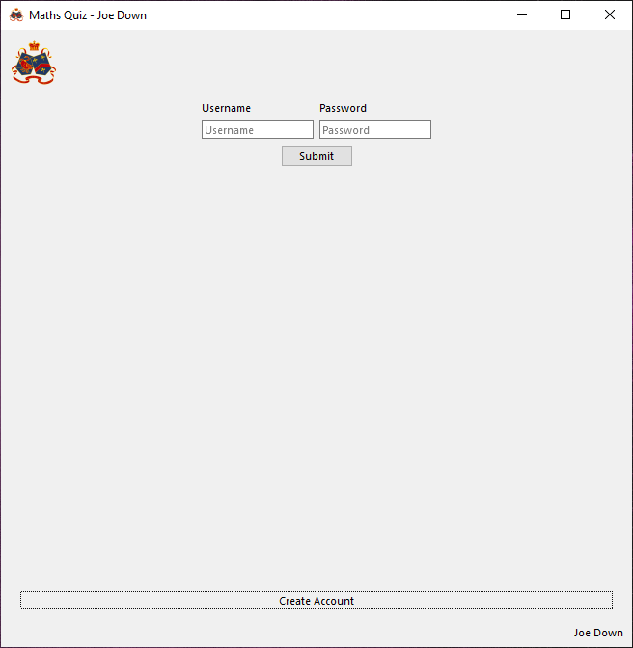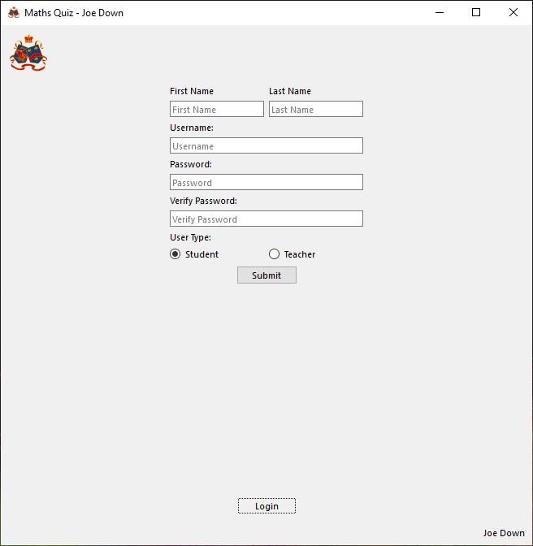

Stakeholder ‘Troy Garvin’ clicked each of the two buttons 10 times (20 clicks in total) and gave the following feedback:

“I clicked the buttons as quickly as I could while also still being able to even count the number of page changes I saw and counted exactly one change to the correct page for each of my 20 clicks. In terms of timings, all page changes appeared to me to be instant”

The response given by the stakeholder validates all aspects of the given criteria, indicating that page transitions in the program are sufficiently responsive. This will be re-tested on all buttons in the program during further testing and any issues that arise discussed further if/when they arise.

##### Deleting database while in use (SUCCESS)

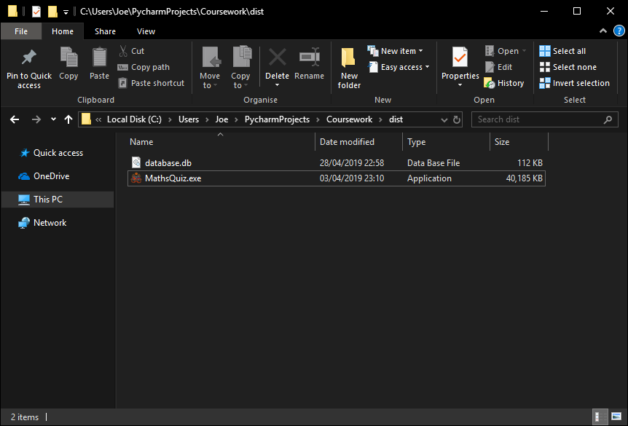

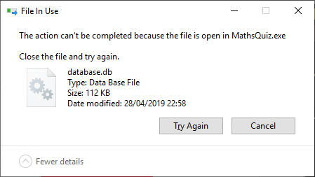

Database file cannot be removed through file explorer (may be possible to intentionally force removal through command line though this is very much not something which could be done unless intentionally trying to cause an error) while in use by the program and is simply rebuilt if not present when program starts (see previous testing).

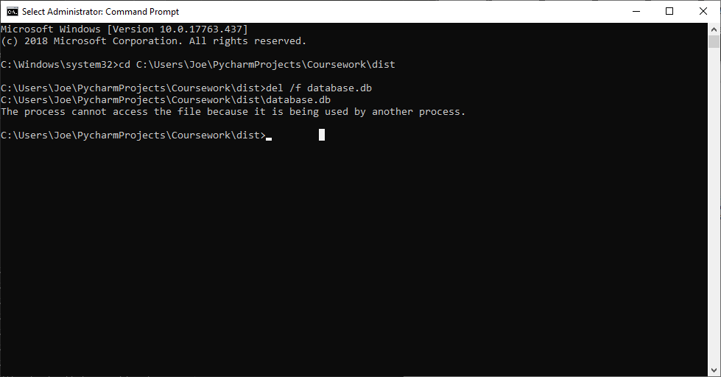

Further investigation reveals that even using an elevated command prompt and using the /f parameter to force deletion, the database cannot be deleted while the program is in use.

#### Usability

##### Test plan

|  |  |  |  |  |
| --- | --- | --- | --- | --- |
| Test Number | Test | Expected outcome | Stakeholder to perform test | Decomposition of problem area covered |
|  | Go to create account screen | Loads create account screen | Either | 1d |
|  | Create teacher account | Teacher account permanently created | Teacher | 6ai, 6aii, 6aiii, 6aiv, 6av |
|  | Create student account | Student account permanently created | Student |  |
|  | Return from account creation to login screen | Loads login screen | Either | 6e |
|  | Teacher login | Loads teacher main menu as relevant teacher | Teacher | 1a, 1b, 1c, 6d |
|  | Student login | Loads student main menu as relevant student | Student | 3 |
|  | Logout button | Returns to login screen and unselects current user | Either | 2a, 2b, 5a |
|  | Go to account management | Loads account management page | Either | 7ai |
|  | Set new first name, last name and password | Sets new first name and last name and only new password works when attempting to login with the edited account | Either | 7ai1, 7ai2, 7ai3, 7ai4, 7ai5 |
|  | Home button | When clicked returns to main menu | Either | 5b |
|  | Create class | Enter a class name and new class is created | Teacher | 7cii1a, 7cii1b |
|  | Add user to class | Enter username and adds given username to class | Teacher | 7cii2ai, 7cii2aiv |
|  | Remove user from class | Select student from list and removes user from class | Teacher | 7cii2bi, 7cii2bii |
|  | Add homework to class | Enter homework name, description and due date and inserts homework into class | Teacher | 7cii2ci, 7cii2cii, 7cii2ciii, 7cii2civ, 7cii2cv |
|  | Remove homework from class | Select from list of homework in class and remove homework from database and class | Teacher | 7cii2di, 7cii2dii, 7cii2diii |
|  | Delete class | Select from list of classes and remove from database | Teacher | 7cii3a, 7cii3b |
|  | Add automatic question to homework | Select class and homework to add question to and question topic and difficulty to add an automatically generated question to the class | Teacher | 7ciii1, 7ciii2, 7ciii3a, 7ciii3b, 7ciii3c, 7ciii3d |
|  | Add custom question to homework | Select class and homework to add question to and enter question name, text, answer and incorrect answers and add to homework | Teacher | 7ciii4a, 7ciii4b, 7ciii4c, 7ciii4d, 7ciii4e |
|  | Remove question from homework | Select question to remove from list, show question details and when remove selected remove from database | Teacher | 7ciii5a, 7ciii5b, 7ciii5c |
|  | Select homework | Select class to do homework from and select homework to do from a list of homework, showing the due date. Go to quiz when selected and show first question | Student | 7bii1, 7bii2, 7bii3, 7bii4, 8a |
|  | Navigate quiz | Next question loads next question and previous loads previous | Student | 8bi, 8bii |
|  | Question output | Must show question text and four potential answers, allowing only 1 to be selected, submitted and a response given | Student | 8c, 8di, 8dii, 8eii1, 8eii2 |
|  | View previous homework results | Show list of homework with name, score and date | Student | 7bi1a, 7bi1b, 7bi1c |
|  | View class scores | Select class view, select class, select homework and output a list of results showing for each student: first name, last name, raw score, weighted percentage and number of attempts | Teacher | 7ci1, 7ci2, 7ci3, 7ci4a, 7ci4b, 7ci4c, 7ci4d, 7ci4e |
|  | View user score | Select student view, select class, select student and output a list of results, showing for each homework: homework name, score, percentage and number of attempts | Teacher | ADDED SINCE DESIGN |

##### Go to create account screen (SUCCESS)

###### Attempt

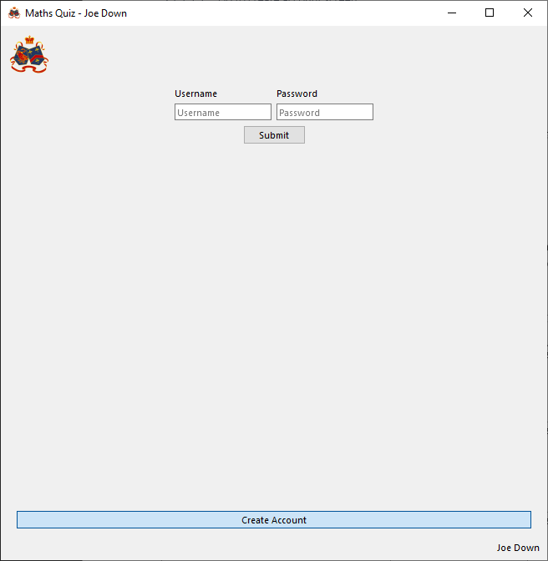

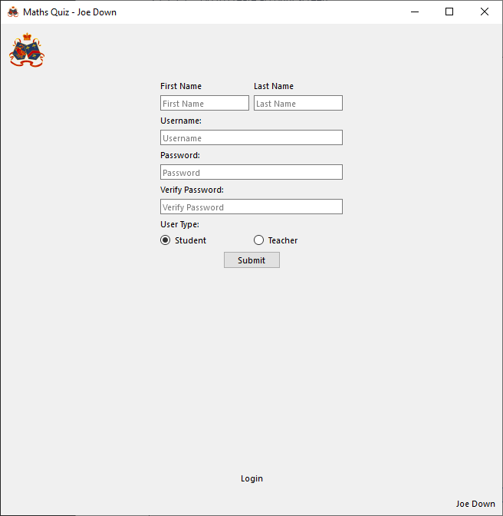

###### Response from tester (teacher)

Page successfully loaded instantly upon pressing the button

##### Create teacher account (SUCCESS)

###### Attempt

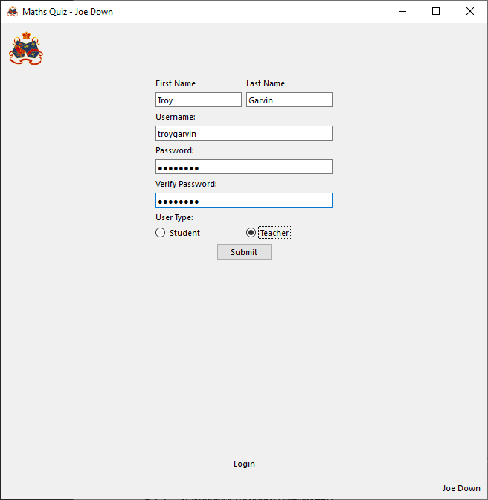

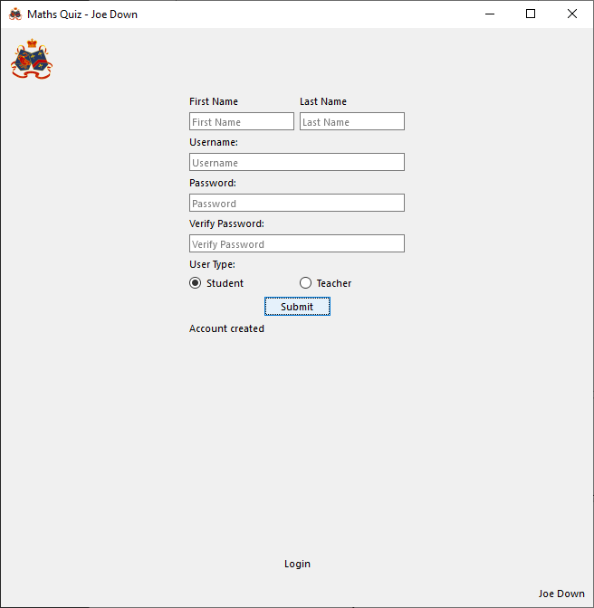

###### Response from tester (teacher)

I was able to enter details to create an account and was informed by the program my submission was successful

##### Create student account (SUCCESS)

###### Attempt

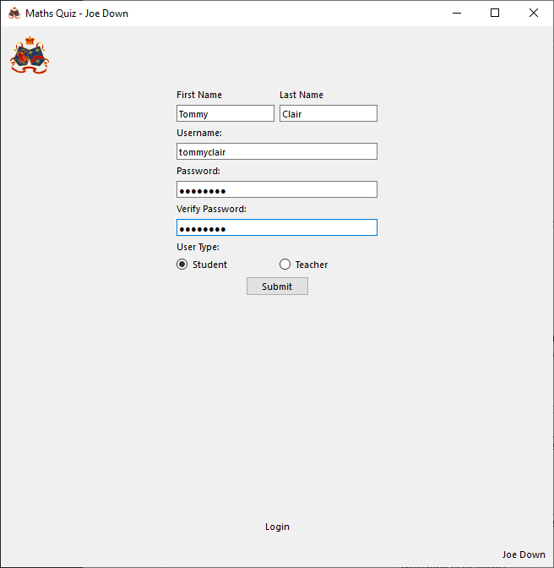

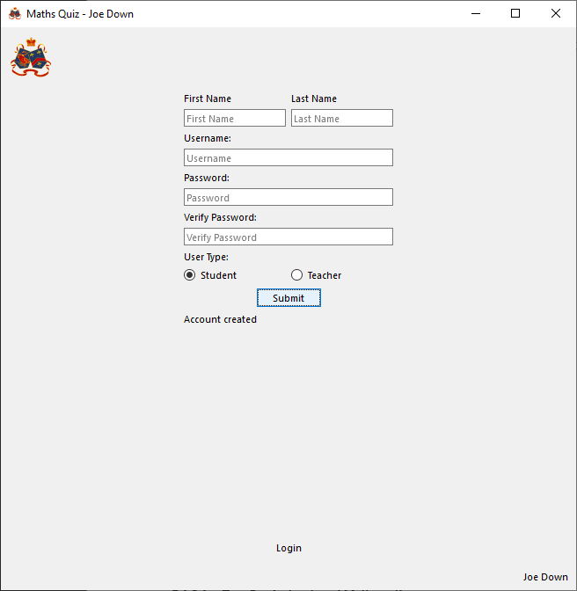

###### Response from tester (student)

I entered my details and was given a success message

##### Go to login screen from create account screen (SUCCESS)

###### Attempt

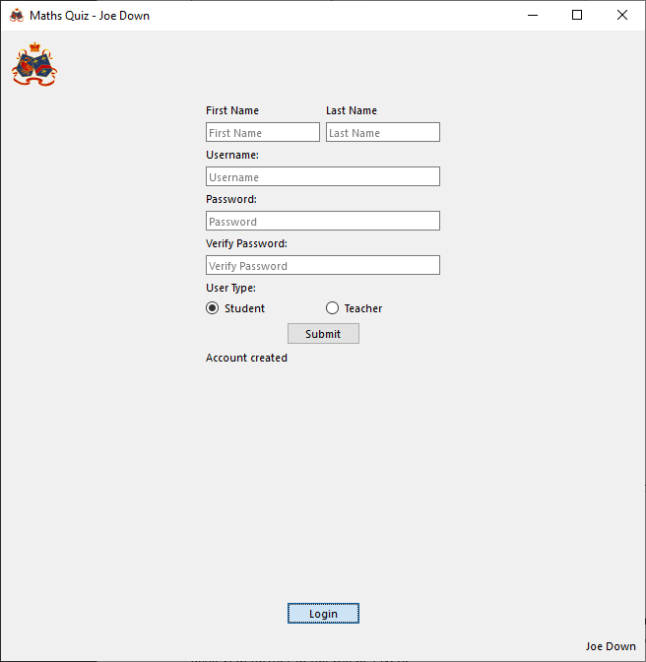

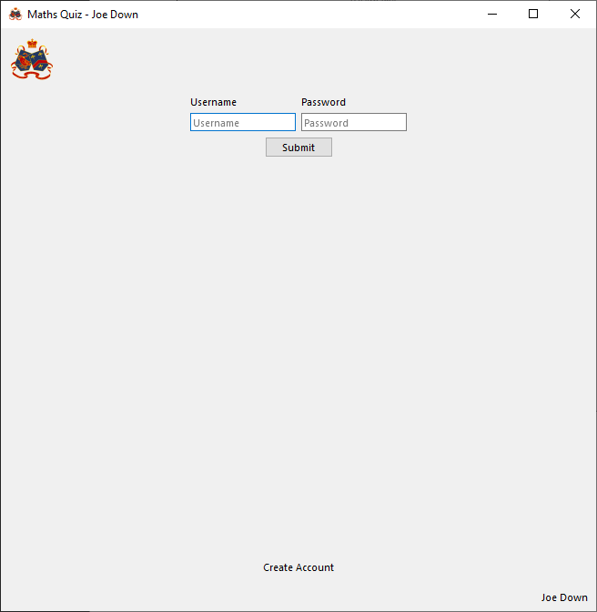

###### Response from tester (teacher)

The screen transition occurred seemingly instantly

##### Teacher login (SUCCESS)

###### Attempt

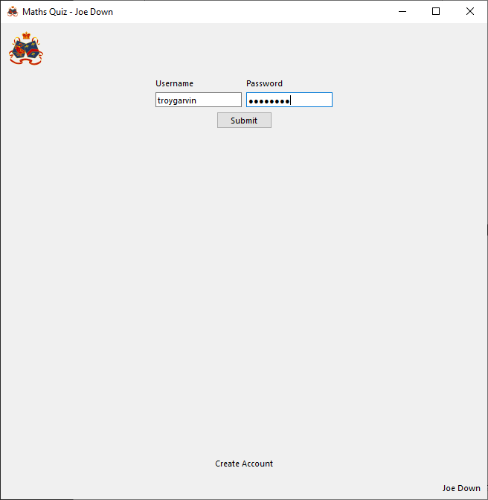

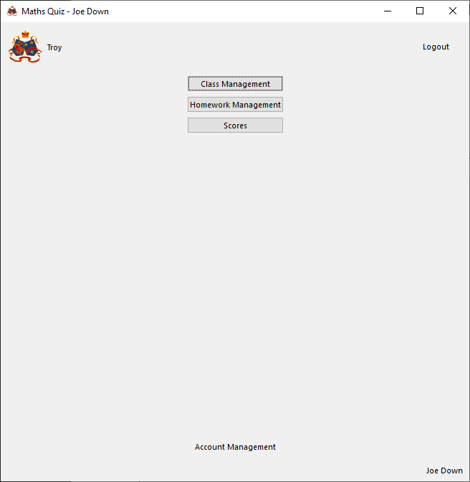

###### Response from tester (teacher)

I entered my login details and was taken to the teacher main menu page. My own name was in the top left to show I was logged in as myself

##### Student login (SUCCESS)

###### Attempt

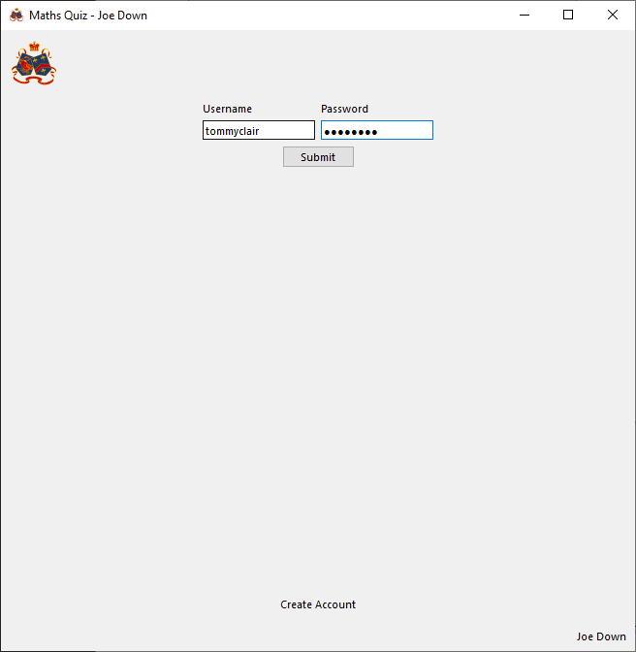

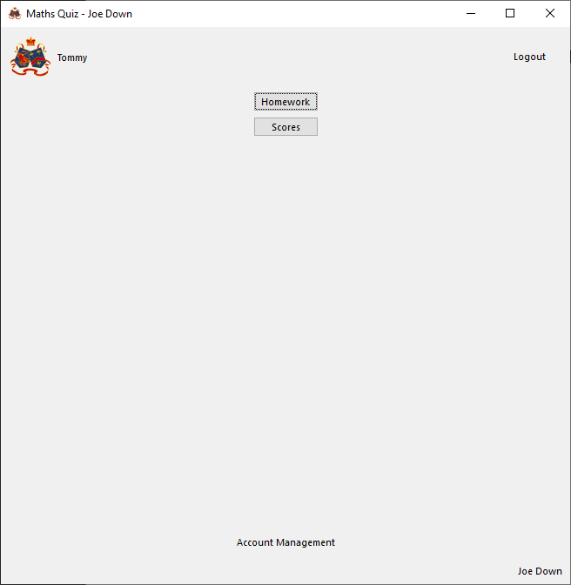

###### Response from tester (student)

Using my details logged in to the student main menu page as myself

##### Logout button (SUCCESS)

###### Attempt

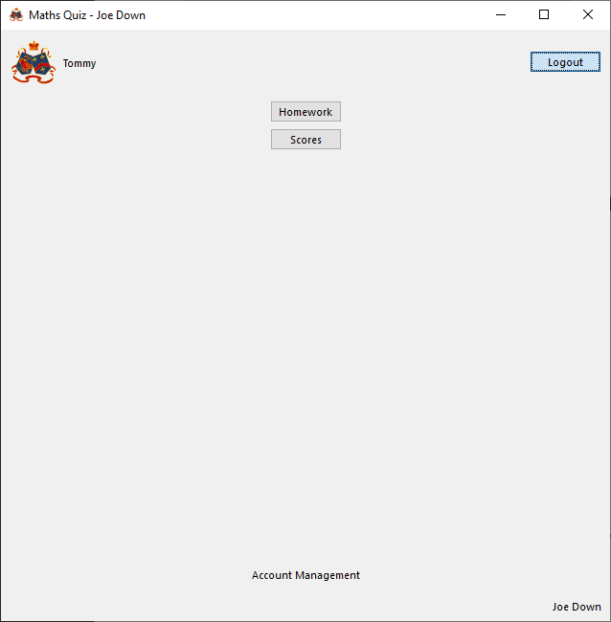

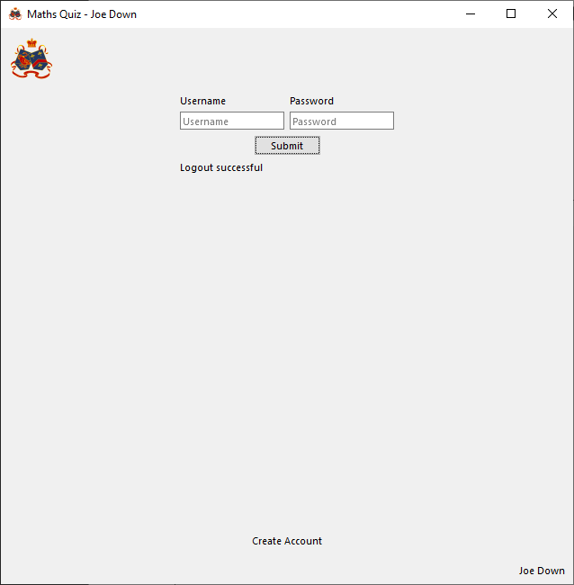

###### Response from tester (student)

Clicking the logout button returned me to the login screen and gave me a message saying I was logged out. My name disappeared from the top left corner to show I was fully logged out

##### Go to account management from main menu (SUCCESS)

###### Attempt

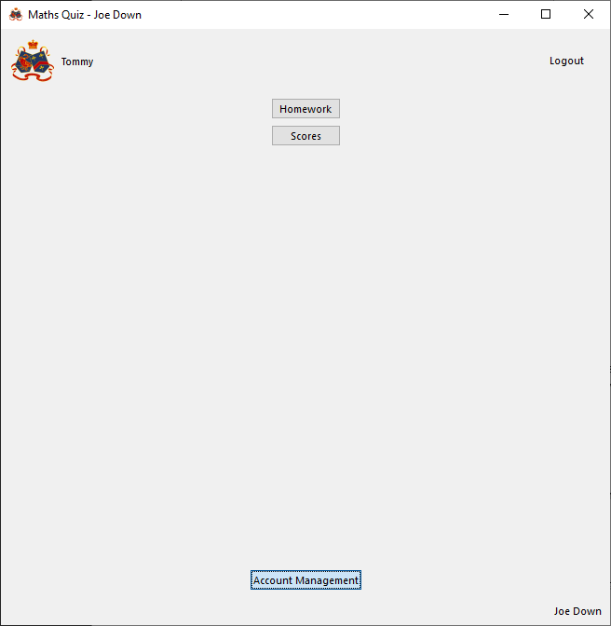

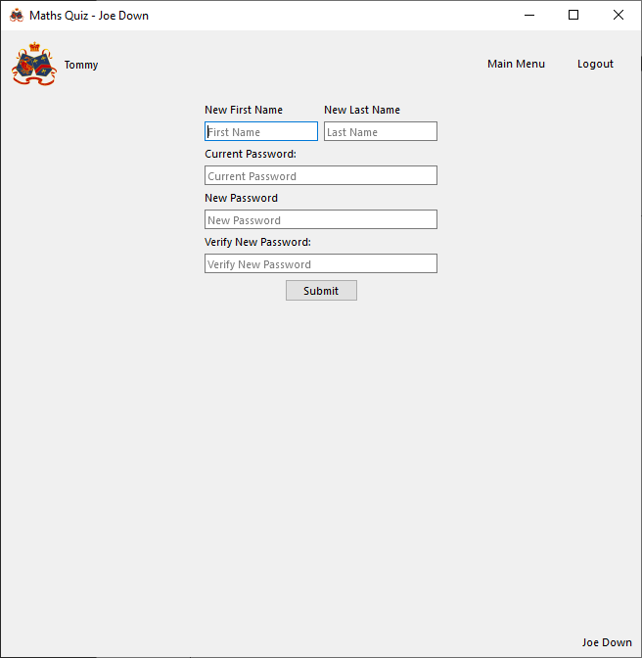

###### Response from tester (student)

Clicking the button to go to account management instantly loaded the account management page

##### Set new account details (SUCCESS)

###### Attempt

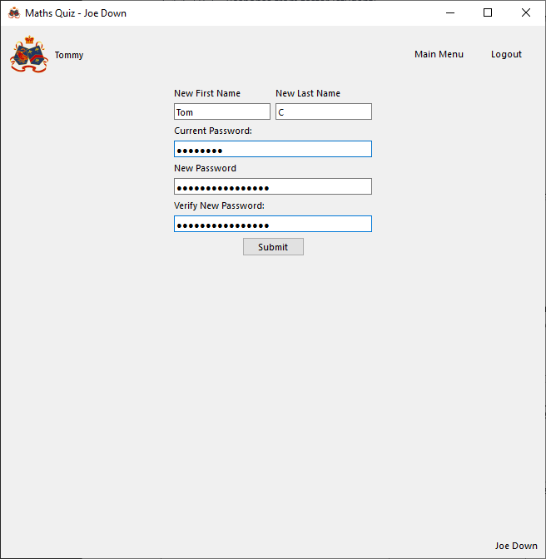 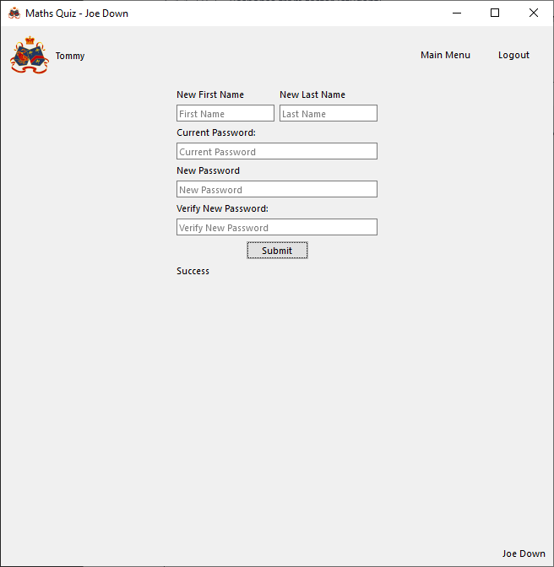

Attempting to log in with new password:

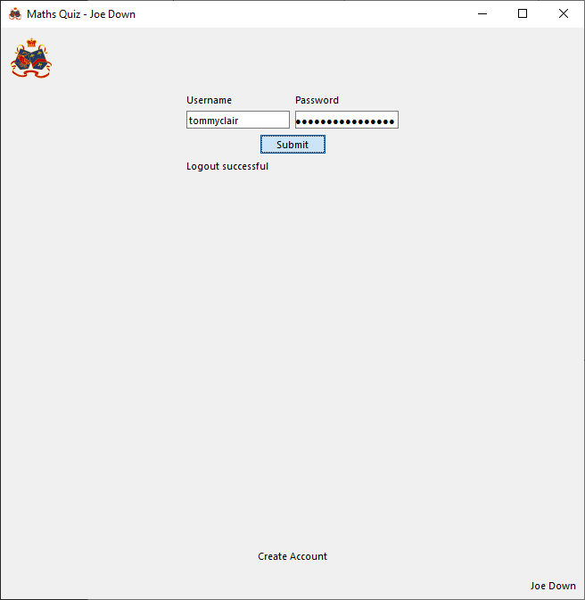

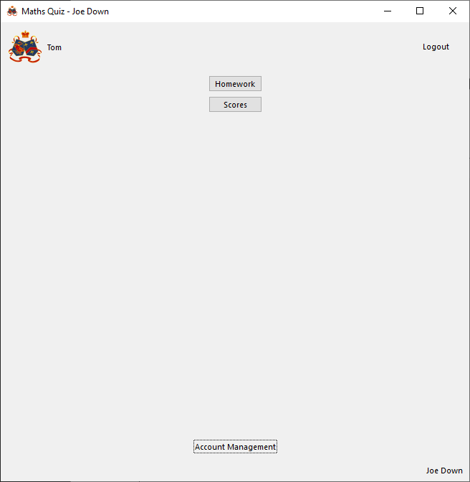

###### Response from tester (student)

When I entered and submitted a new first name, last name and password I was informed the changes were a success. When I tried to log back into the account, only the new password worked and not the old one and my name now displayed as the new first name, ‘Tom’

##### Home button (SUCCESS)

###### Attempt

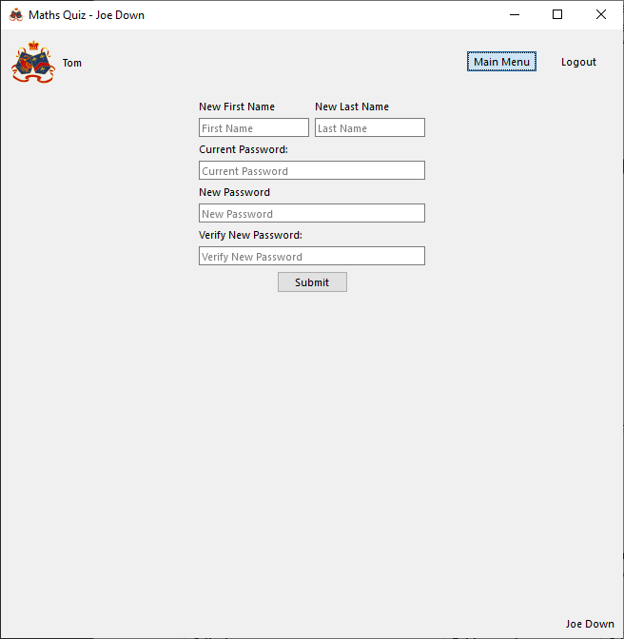

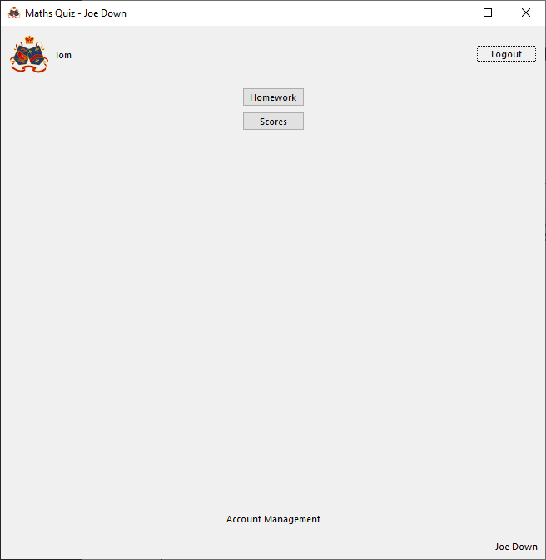

###### Response from tester (student)

Whenever I click the home button, whatever page I’m on, the program goes back to the main menu

##### Create class (SUCCESS)

###### Attempt

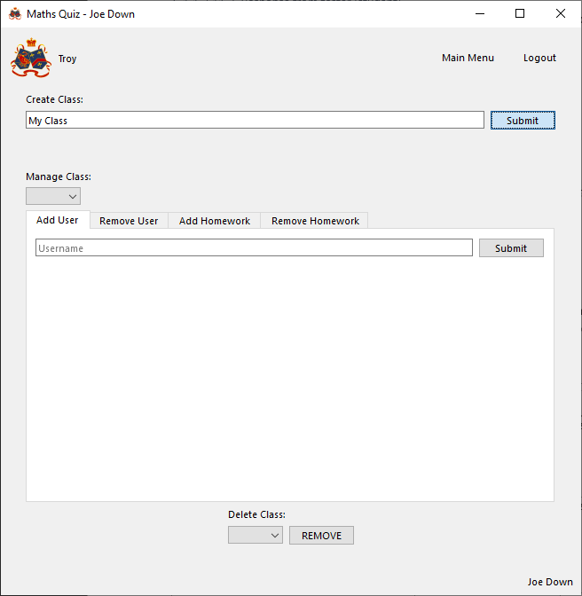

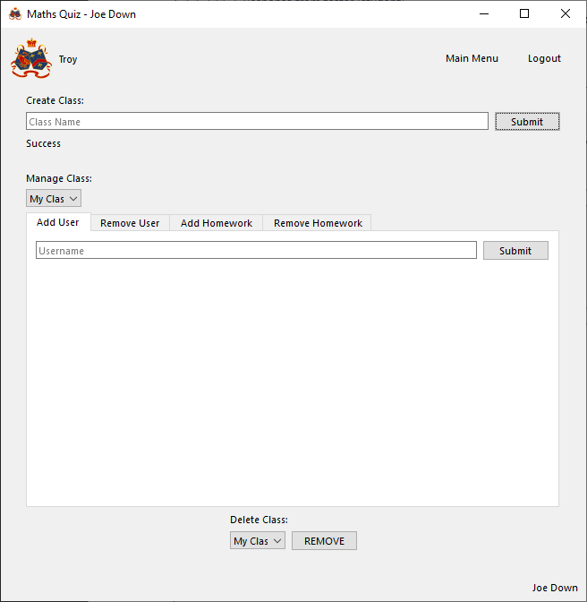

###### Response from tester (teacher)

When I entered a class name and clicked to create the class the program told me ‘success’ and the class began to show up elsewhere in the UI

##### Add user to class (SUCCESS)

###### Attempt

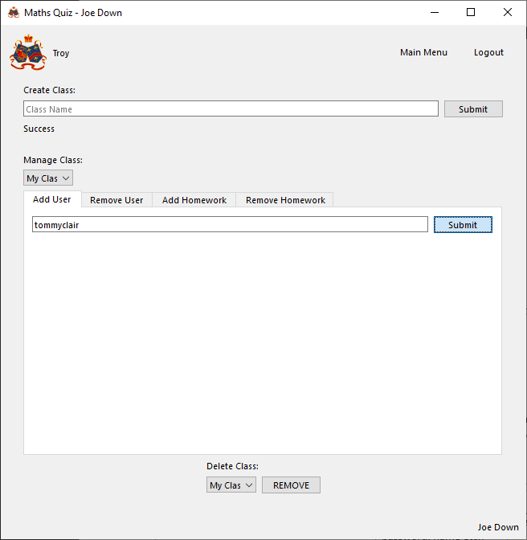

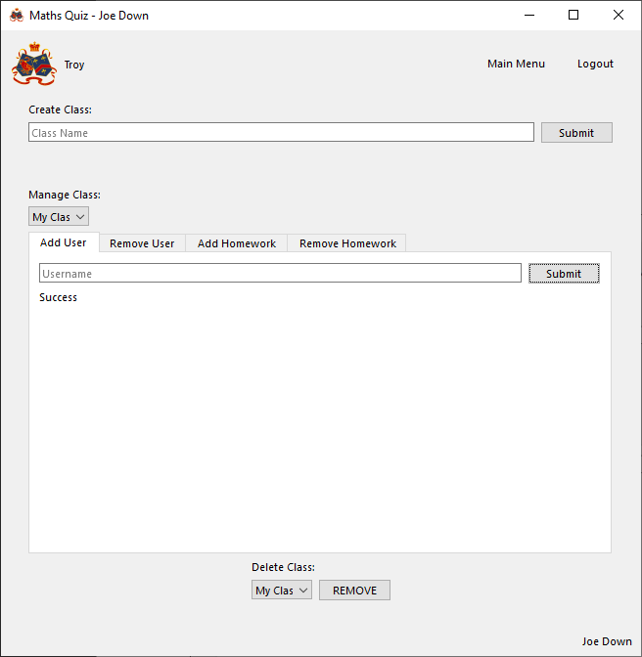

###### Response from tester (teacher)

When I typed in a student username and clicked submit the program outputted that they had successfully been added to the class and they began to show up as a class member elsewhere in the UI

##### Remove user from class (SUCCESS)

###### Attempt

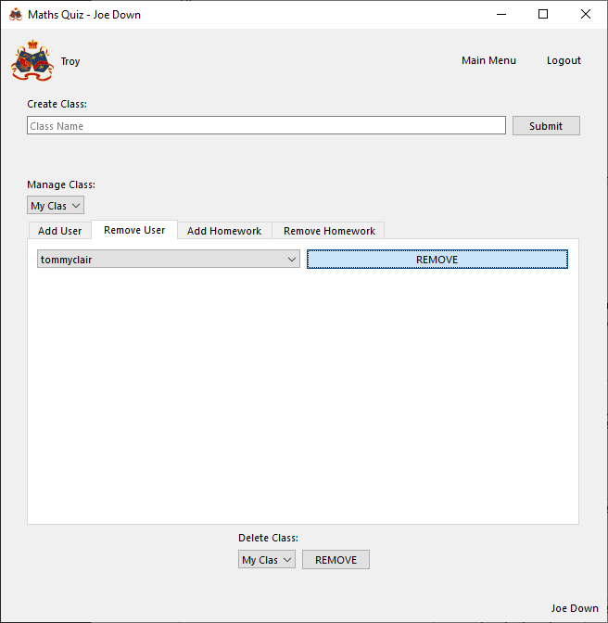

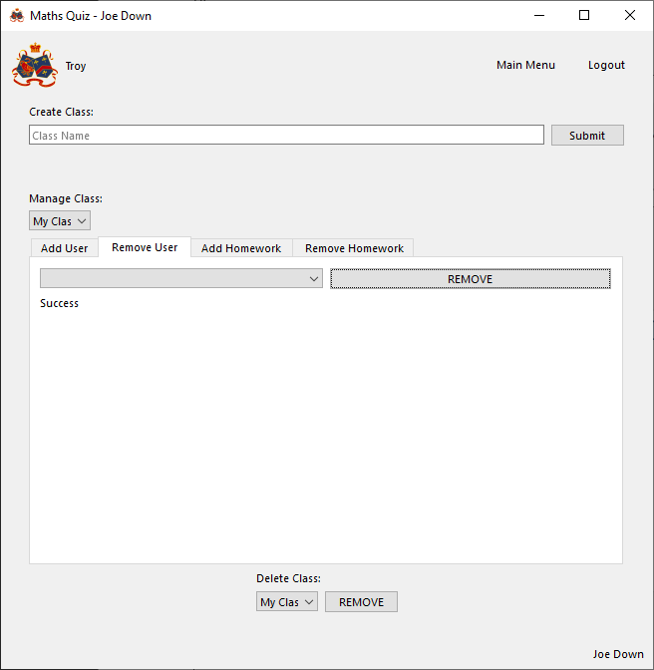

###### Response from tester (teacher)

When I selected to remove the user from the class the program told me the removal was a success and the student stopped showing up as part of the class elsewhere in the UI

##### Add homework to class (SUCCESS)

###### Attempt

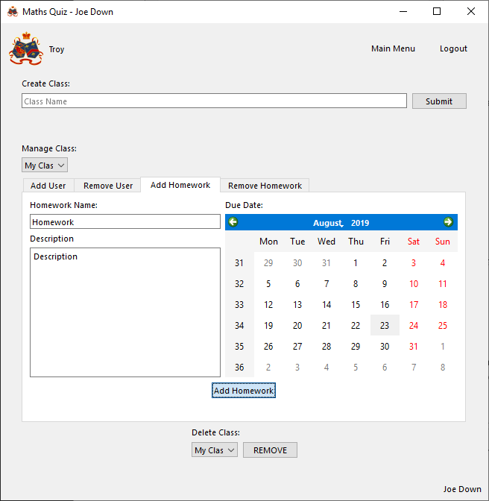

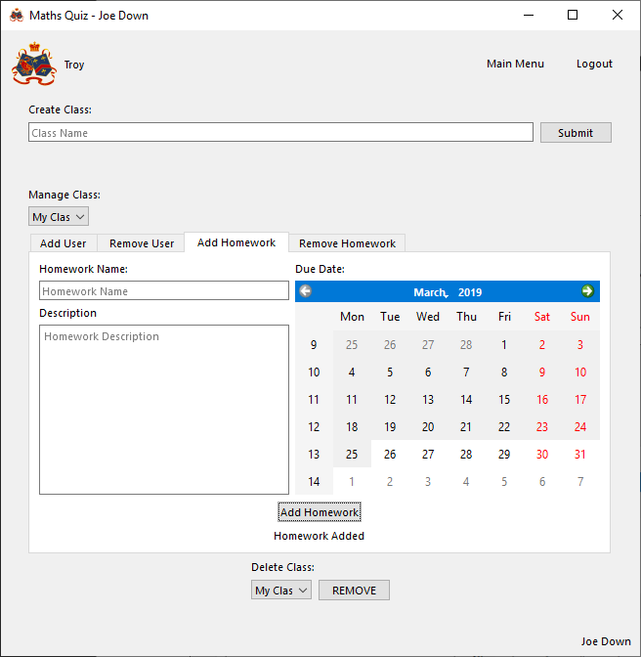

###### Response from tester (teacher)

When I entered all details the and submitted the program told me the homework was successfully added and it began to show up elsewhere in the UI

##### Remove homework from class (SUCCESS)

###### Attempt

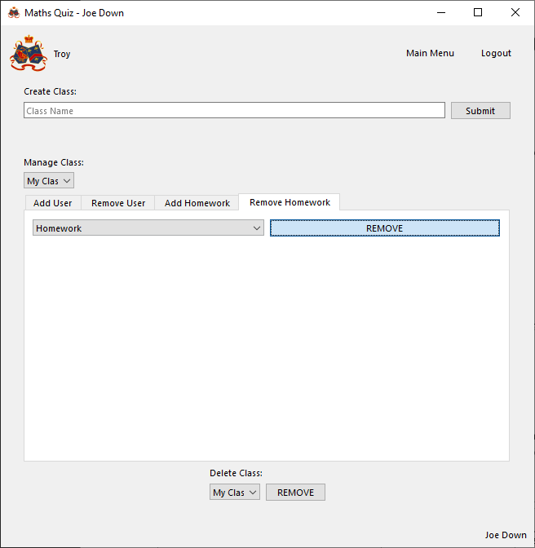

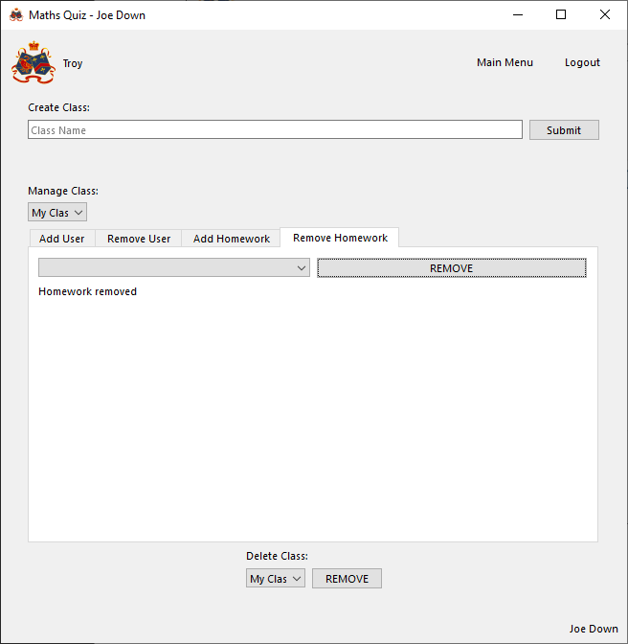

###### Response from tester (teacher)

When I selected to remove the homework from the class the program told me the removal was a success and the homework stopped showing up as part of the class elsewhere in the UI

##### Delete class (SUCCESS)

###### Attempt

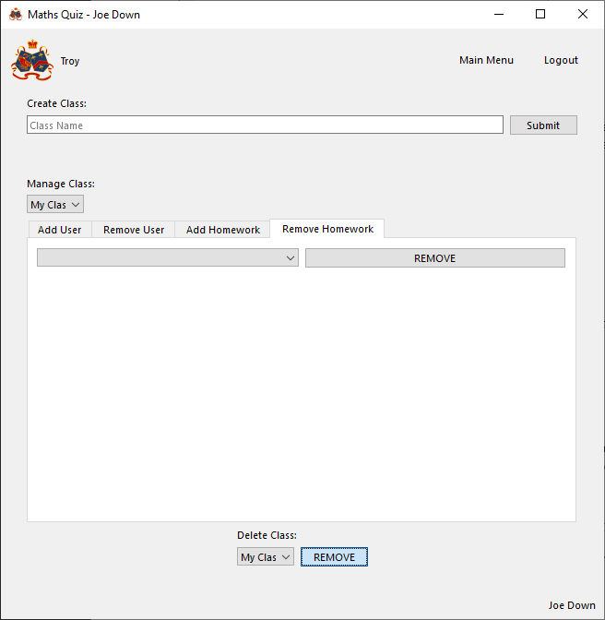

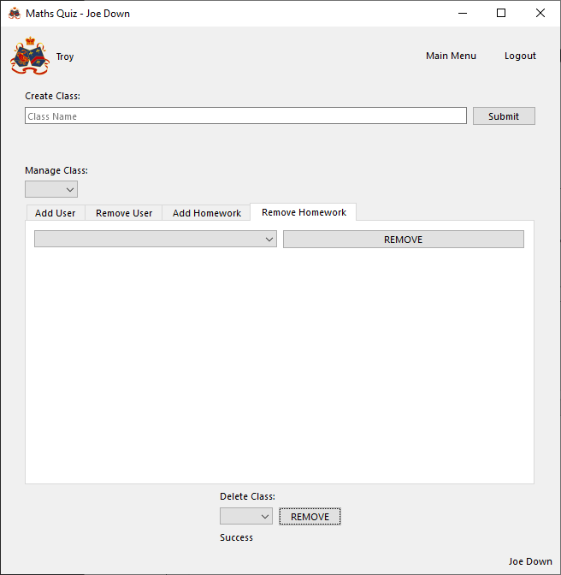

###### Response from tester (teacher)

When I selected to remove the class, the program told me the removal was a success and the class stopped showing up elsewhere in the UI

##### Add automatic question to homework (SUCCESS)

###### Attempt

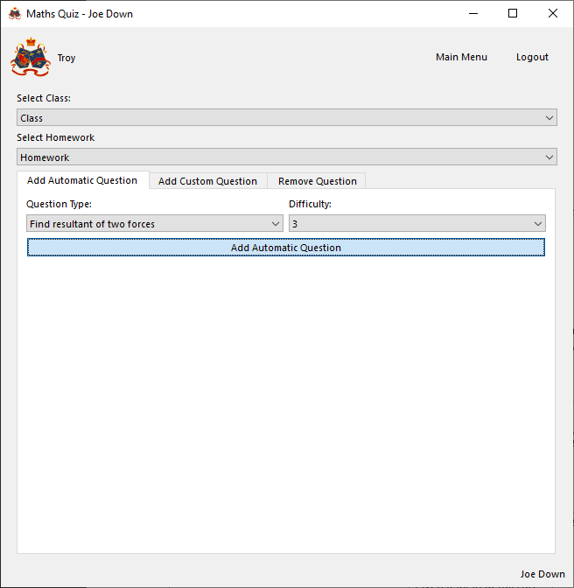

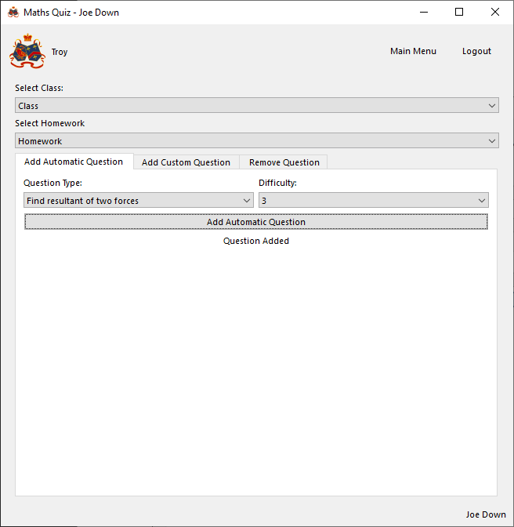

Checking new question is added to the class:

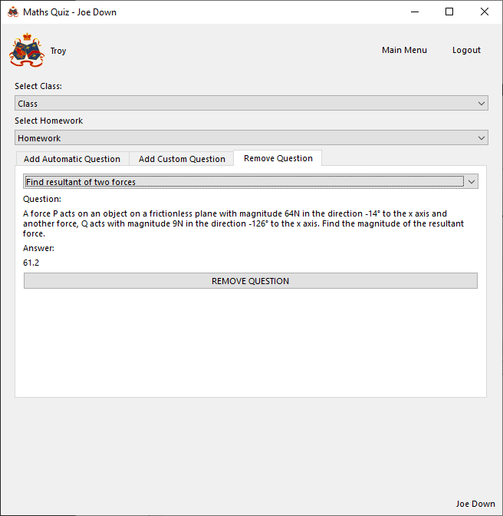

###### Response from tester (teacher)

After I selected the class and homework then selected a topic and difficulty to add an automatic question, when I clicked submit the program said adding the question was a success and a valid question was generated and added to the class

##### Add custom question to homework (SUCCESS)

###### Attempt

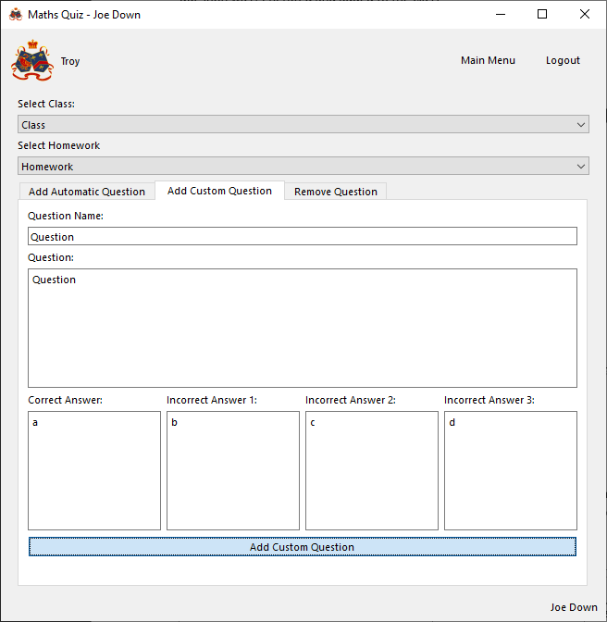

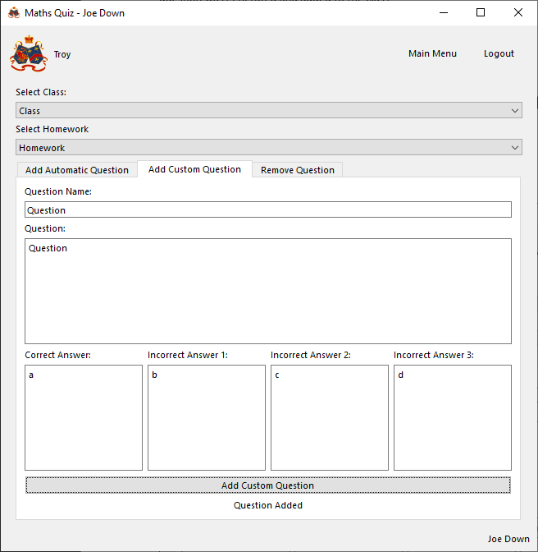

Checking new question is added to the class:

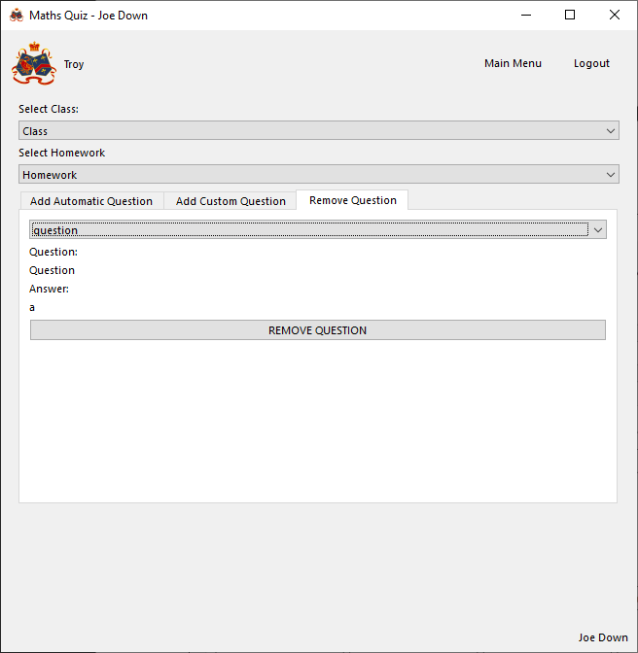

###### Response from tester (teacher)

After I selected the class and homework then entered all the custom question details, when I clicked submit the program said adding the question was a success and the question was added to the class

##### Remove question from homework (SUCCESS)

###### Attempt

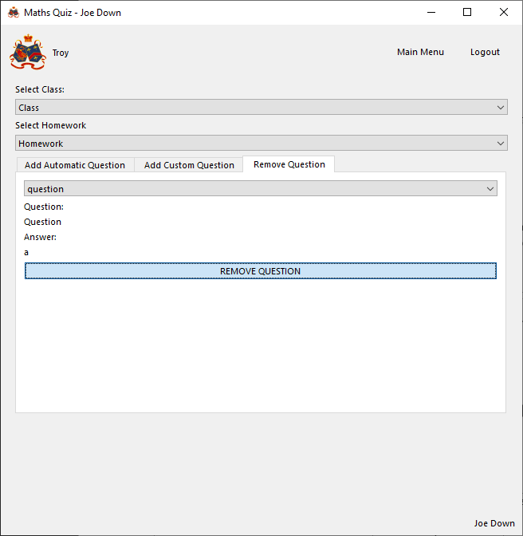

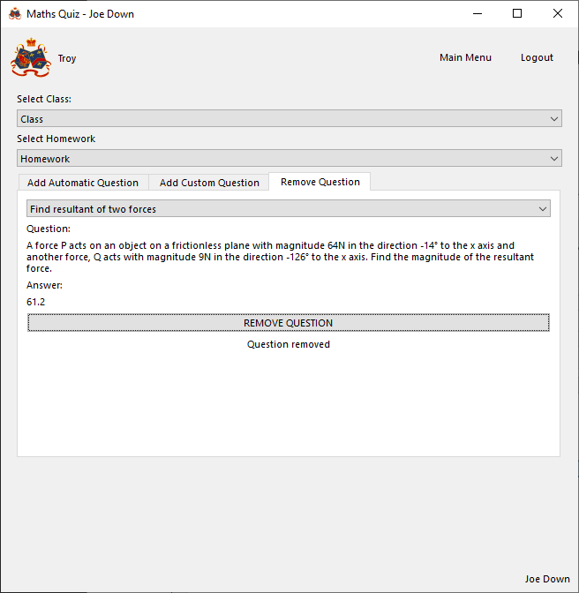

###### Response from tester (teacher)

When I clicked to remove the question, the program told me removal was a success and the removed question stop showing up in the UI

##### Select homework to do (SUCCESS)

###### Attempt

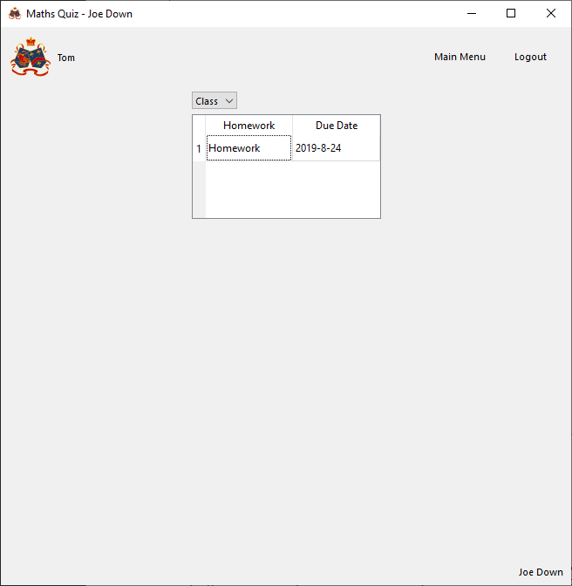

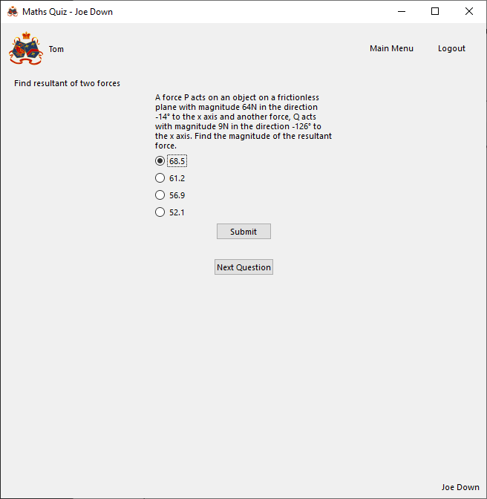

###### Response from tester (student)

I could select a class from the dropdown menu and the program showed me a list of programs and by double clicking a homework I was able to load up the test. Before selecting the homework, I was given the homework name and the date it was due on

##### Navigate quiz (SUCCESS)

###### Attempt

Next question clicked:

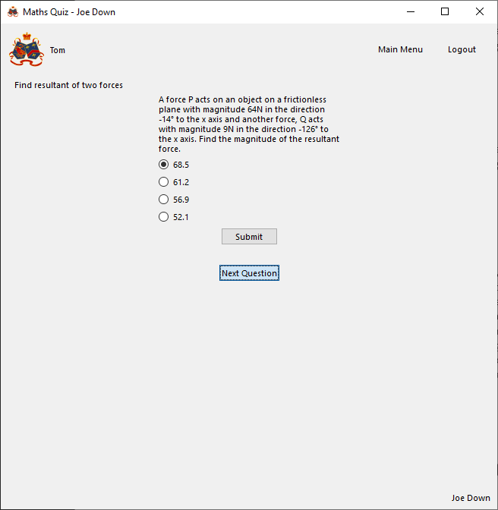

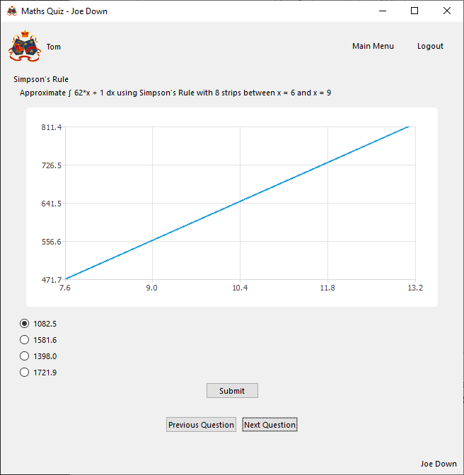

Previous question clicked:

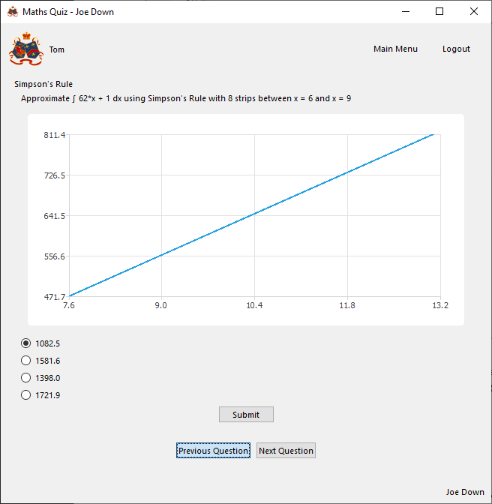

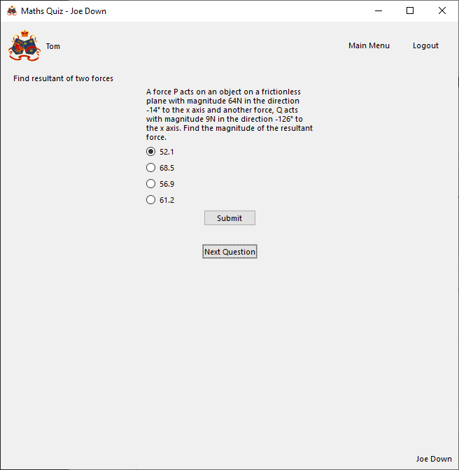

###### Response from tester (student)

From any question in the quiz, clicking next question would load the next question and clicking previous question would go back to the previous one.

##### Question output (SUCCESS)

###### Attempt

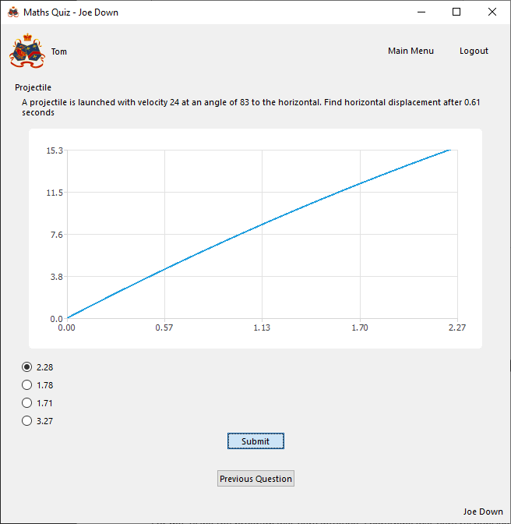

Incorrect answer selected:

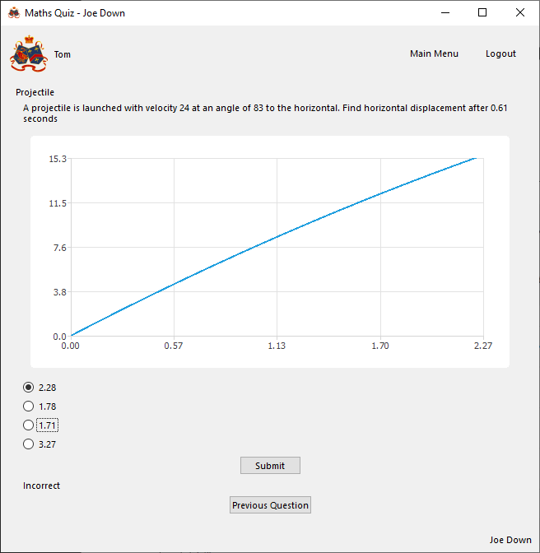

Correct answer selected:

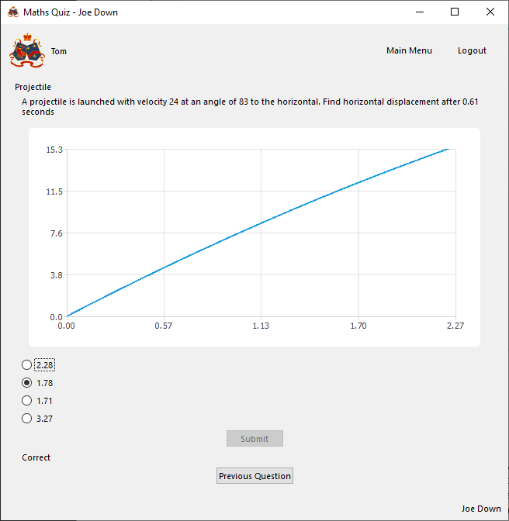

###### Response from tester (student)

The program showed me the question, four possible answers and in certain cases even a graph! When I selected to submit my response it correctly gave me feedback as to whether my answer was correct and stopped me being able to submit a new answer if I was correct

##### View previous homework results as student (SUCCESS)

###### Attempt

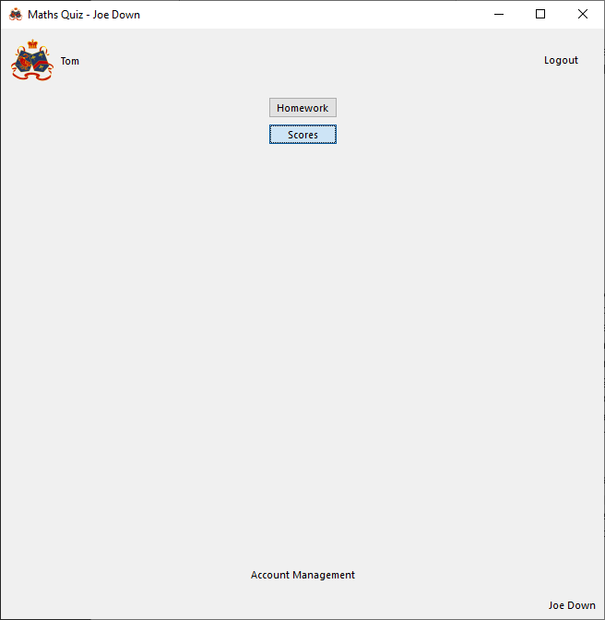

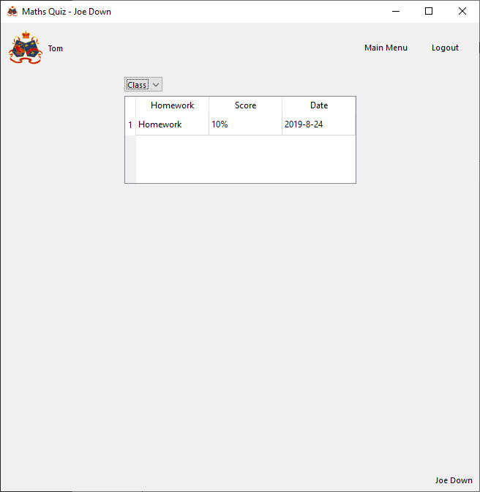

###### Response from tester (student)

I was successfully able to select to view results from the main menu and was presented with a screen which allowed me to select a class and have my homework scores displayed to me with the homework name and date

##### View class scores as teacher (SUCCESS)

###### Attempt

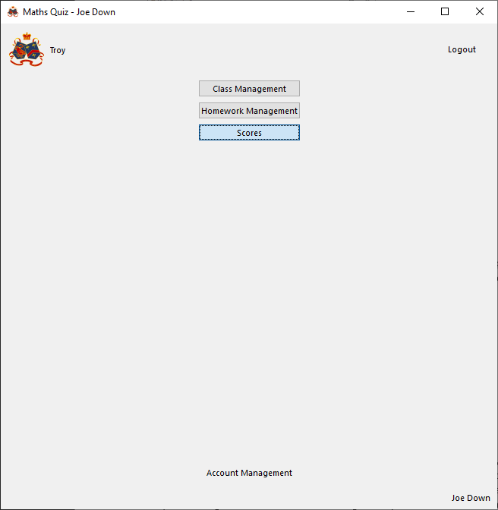

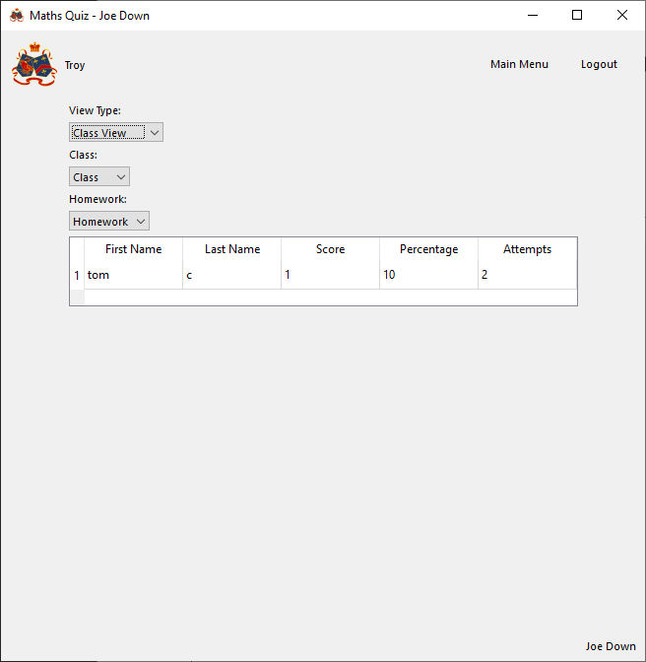

###### Response from tester (teacher)

I was successfully able to select to view results from the main menu and was presented with a screen which allowed me to select a view type (in this case I selected class view), class and homework and have all student scores for the given homework displayed to me with the student’s first name, last name, raw score, percentage and number of attempts

##### View class scores as teacher (SUCCESS)

###### Attempt

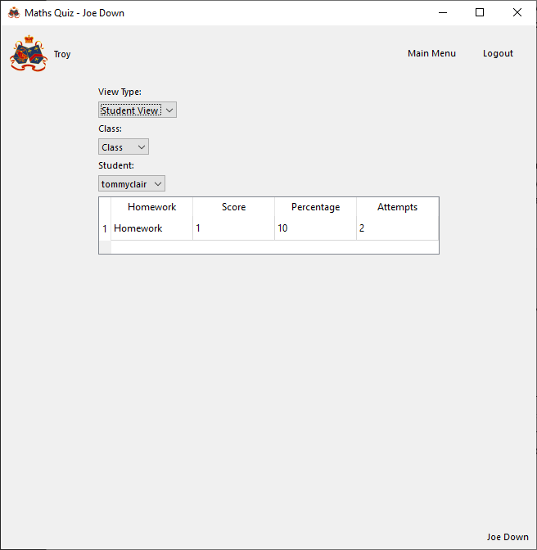

###### Response from tester (teacher)

I was presented with a screen which allowed me to select a view type (in this case I selected student view), class and student and have all homework scores for the given student displayed to me with the homework name, raw score, percentage and number of attempts

### Stakeholder response to finished program

Having used the program, the stakeholders were asked to give a final evaluation of the usability and functionality of the program and how useful they believe it is for them

#### Troy Garvin, teacher of Mathematics

For me, using the program was very intuitive. Everything was very responsive, and all the features of the program were clearly labelled with what they do. As a teacher it was relatively simple for me to create classes and homework and manage users and homework within the class. I also found the outputs relating to student scores to be enough for my needs as a teacher. The act of creating an account and logging in was also about as intuitive as it could be. A criticism I might make is that the user interface is, while not ugly, quite bland and generic and I think that it might be important for students to have a more attractive user interface to work with, even if functionality wise it is unchanged. The list of automatically generated questions was also quite limited; however, I understand that as a proof of concept which could be further developed upon given more time, the functionality to allow further topics to be integrated is clearly there.

With the addition of some more automatic topics I can very much see this as a tool I would use with my class as it is simple to use and reduces the load on me marking, as well as provides a large number of unique questions to really challenge students as not only are there an unlimited number of possible questions, there is also a scalable difficulty to allow me to tailor homework to the ability of my class in each topic.

In the design section it was stated that buttons with destructive features would be coloured red and this does not appear to be the case. Could this be addressed as I think it would further increase usability.

#### Tommy Clair, Year 12 student currently studying A Level Maths and Further Maths

I think this tool has the potential to be very useful. Yes, it doesn’t cover quite a lot of the A-Level syllabus with the limited number of question types available, but the questions that are there exceed my expectations from the initial design (I think the inclusion of graphs for many of the mathematical function in questions are useful for me visualising the problem, particularly the one showing the path of a projectile). I found it particularly helpful that for each topic the actual content of the question would change, not just the values used, meaning the question I practised were less monotonous than I thought they could be as I wasn’t always able to use the same method repeatedly.

Another thing I found useful was how easy it was to know how I’m doing. While doing quizzes I was immediately told whether I was right or not without having to check a mark scheme and see the real answer, so I was able to try again without the correct answer being spoiled and stopping me from working efficiently. After doing a homework it was also straightforward to navigate to a screen which would show me a very easily understandable breakdown of my scores in every homework I had done for each class.

While it’s not a vital feature, and the program was very intuitive to use, I think it could have done with having a bit more of an aesthetic design as I think it would better entice students to want to use the program beyond obligation to do homework and make it stand out more from other options.

#### Analysis of responses

From the stakeholder responses to the program the program clearly largely satisfies and, in some areas, even exceeds expectations. This is with regards to the ease of navigation, taking quizzes, viewing scores and receiving any feedback related to any program functions. The addition to include graphs with questions seems to be a particularly strong adaptation from the initial design from the student side of the program as it helps give a better understanding of what a question is asking for and how the situation, such as the motion of a projectile, works. It is also apparent that the program could do with being able to generate a greater range of question types and this will be discussed further in the further development section.

Stakeholder responses will be used below, along with my own testing, to decide to what extent success criteria have been met below.

With regards to the lack of red buttons from the design in the final program have now been addressed by simply changing the colour property of the relevant buttons:

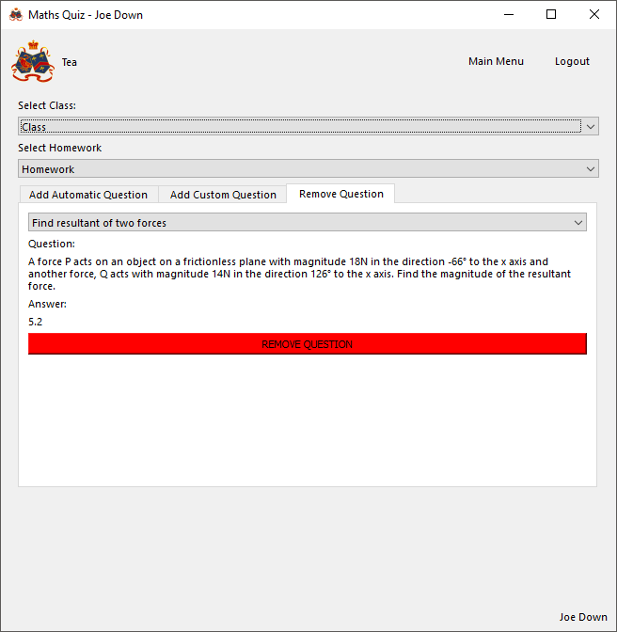

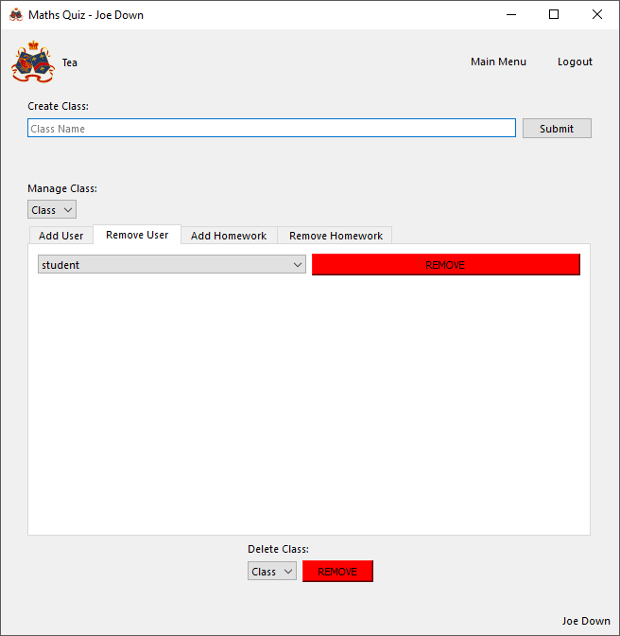

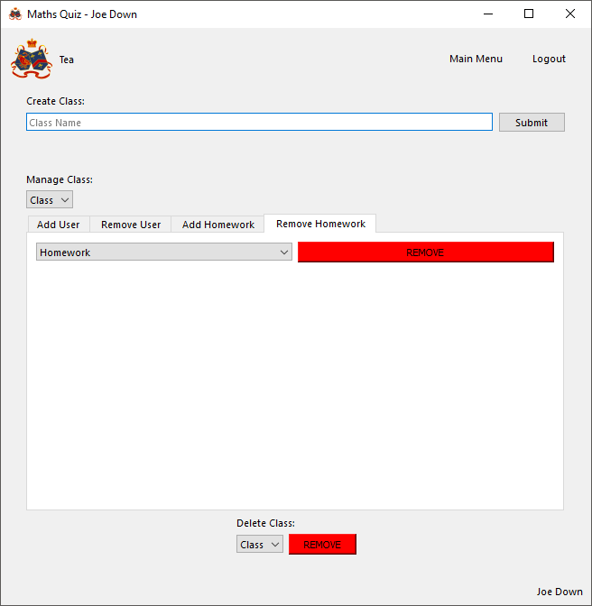

## Level of Success

### Success Criteria Summary

Success criteria will be checked against stakeholder responses to the program and final testing done above and labelled with whether they have been achieved. Where not achieved or only partially achieved, further detail will be given.

#### General

|  |  |  |
| --- | --- | --- |
| Criteria | Evidence of success | Criteria met? |
| User can create account | User details (username, password, name etc.) are correctly and permanently stored in a database | Yes |
| User can login with account details | User login details can be correctly compared to those in database and matching user access given if login details are matching | Yes |
| User can logout | Logout button can be pressed and return to login screen with access to the rest of the program revoked | Yes |
| User can update account details | Non-identifying user details (i.e. All details except for username and id) stored in database can be changed and amended values permanently stored without confliction | Yes |
| User details are store securely | Password is stored in a correctly salted and hashed form | Yes |
| Enough usability features are in place | Features are sufficiently labelled and features such as buttons or dropdown menus etc. are used as appropriate. Destructive features such as deleting information is made clear to not take lightly (e.g. buttons made red to alert user) | Yes |
| Navigation features | Ability to navigate to key pages such as the main menu | Yes |
| All features contained within a graphical user interface | All features of the program can be accessed through windows with user typing kept to a minimum and at no point requiring interaction with a terminal | Yes |
| Database integration to permanently store data | All data is retained when the program is restarted and structured in such a way that data can be accessed, and new data added as needed | Yes |
| Features should be all accessible as required from a main menu | Main menu through which all pages are reachable by navigation though a minimal number of other pages | Yes |
| Permission system | Access to data should be restricted to only those it relates to (i.e. teachers can only see their details and student details in their classes and students should be unable to access teacher or other student data).  Program features should be limited to only the type of user they apply to (only teachers can make and manage classes and only students can be set homework) | Yes |

#### Teacher

|  |  |  |
| --- | --- | --- |
| Criteria | Evidence of success | Criteria met? |
| Teacher can create class | Class details (Name, teacher, students, homework etc.) are correctly and permanently stored in a database | Yes |
| Teacher can add student to class | Class student relationship is correctly and permanently stored in database | Yes |
| Teacher can remove student from class | Class student relationship is correctly and permanently removed from database | Yes |
| Teacher can add homework to class | Class homework relationship is correctly and permanently stored in database with relevant homework details (name, questions etc.) | Yes |
| Teacher can remove homework from class | Class homework relationship is correctly and permanently removed from database | Yes |
| Teacher can delete class | Class details are correctly and permanently removed from database | Yes |
| Teacher can add custom question to homework | Question homework relationship is correctly and permanently stored in database with relevant question details (name, question text, correct answer, incorrect answers etc.) | Yes |
| Teacher can add automatically generated question to homework | Question homework relationship is correctly and permanently stored in database with relevant question details (name, question text, correct answer, incorrect answers etc.) | Yes |
| Teacher can select question difficulty and question adjusts as needed | Question difficult is correctly stored with question in database and question generation criteria are satisfied (see below) | Partially  While all question types adjust depending on the difficulty selected to produce harder questions, in some cases the scope of this is limited to the same question type simply using larger numbers or increasing the number of terms in mathematical function rather than the question itself asking for something more complex to be found compared to lower difficulties |
| Teacher can remove question from homework | Question homework relationship is correctly and permanently removed from database with relevant question details | Yes |
| Teacher can view results for each student for a given homework | For each student, question results for a given homework and student are retrieved from the database and a score calculated from the number of correct responses | Yes |
| Teacher can view results for each homework for a given student | Question results for each homework in the class and a given student are retrieved from the database and a score calculated from the number of correct responses | Yes |
| Scores correctly calculated | Score calculated as the sum of each correct response divided by the number of times that question was attempted, all divided by the number of questions and multiplied by 100 to give a percentage | Yes |
| Database usability | Database should be structured in such a way that it is fast to insert and find relevant data without the need for superfluous extra processing  Database relations should allow for the introduction of new tables or introduction of new types of relationship between tables to allow for potential future maintainability and updates without extensive restructuring | Partially  Database is well structured and easily usable within the program’s code. However, it would have been better to anticipate the inclusion of graphs with questions when first creating the database a new graphs table would not have needed to be created |
| Validation | All inputs should be validated to be of a valid form and usable for their intended purposes | Yes |

#### Student

|  |  |  |
| --- | --- | --- |
| Criteria | Evidence of success | Criteria met? |
| Student can access homework set for a given class | Program can output a list of homework from the database for the given class and launches the quiz if a homework is selected | Yes |
| Student can only do homework before due date | Program excludes student from accessing quiz past stored due date | Yes |
| Quiz gives question and allows choice and submission of multiple-choice response | Question correct status is correctly changed to True in database for given user and question only if the correct response was selected and submitted | Yes |
| Student can see results for each homework in a class by class basis | Question results for each homework in the class and the current student are retrieved from the database and a score calculated from the number of correct responses | Yes |
| Score correctly calculated | Score calculated as the sum of each correct response divided by the number of times that question was attempted, all divided by the number of questions and multiplied by 100 to give a percentage | Yes |

#### Questions

|  |  |  |
| --- | --- | --- |
| Criteria | Evidence of success | Criteria met? |
| Enough topics covered | Topics that can be generated cover multiple different topics | Partially  Topics covered are a mixture of both pure and mechanics, with some from Further Maths and others Maths. However, much of the syllabus is not accounted for in any way other than if a teacher creates a custom question and so given more development time more question generation frameworks would be written |
| Generated correct answers are correct | When manually calculating answers to generated questions, the answer found matches the one generated | Yes |
| Generated incorrect answers are unique and incorrect | When manually calculating answers to generated questions, the answer found does not match any of the ones generated and each incorrect answer is different | Yes |
| Questions are relevant to the mathematics specification | Topics covered are all within the Edexcel mathematics specification | Yes |

### Evaluation of success criteria

Overall most success criteria have been successfully accomplished, with many more features added on top. Areas of only partial completion can all be attributed to time constraints and have still been demonstrated in some capacity in the program, even if not in all instances where they could be demonstrated (while not all question types can be generated the framework to integrate new types of question is very strong). As no success criteria have been completely failed to be met it can therefore be concluded that the program development has been a success. In addition to this success in terms of functionality, usability and robustness testing carried out and the stakeholder responses indicate that all features have been implemented efficiently and intuitively, further indicating a useful and usable final product.

## Maintenance and Further Development

### Current program limitations

|  |  |
| --- | --- |
| Limitation | Consequence |
| Database is stored locally | Teachers and students must use the same installation of the software on the same system or manually transfer updated versions of the database, meaning students cannot easily take work set away from school and only one student can work at a time. |
| Not all topics on syllabus covered | Program is only useful in its current state for revision of a very narrow selection of topics spread out between Maths and Further Maths syllabuses |
| Platform availability | Executable can only run on windows and so users of Linux or MacOS machines cannot use the program in its current state |

### Summary of further development and maintenance

#### Range of questions

The main limitation of the program is clearly that there are many topics in the A-Level syllabus which there was not time to develop question generators for. However, the relatively little code required to integrate these generators into the main code of the quiz program itself indicate that a framework has been developed of sufficient quality that, given further development time, it would not be infeasible to code these functions and implement them into the quiz program as it currently stands without impacting any of the other functions of the quiz. This is because all question generation scripts are kept in a library separate from the main program, with all final generated questions conforming to the Question class before being passed to the main program, ensuring they will always be handled the same way from this point, regardless of topic.

#### User interface

Further developments could also be made regarding the UI. While functionality wise everything works as intended it is still quite visually bland and so tie could be spent implementing backgrounds and/or a colour scheme to the program, as well as manipulating the properties of each widget such as buttons to give the program a more unique visual identity.

#### Usability

Alongside visual improvements to the UI, changes could also be made to further increase usability. Firstly, simply making the UI more aesthetically pleasing as described above should make it easier for a user to use the program as a clear and consistent design language is memorable and helps indicate what various interactions better from the context of other actions in the program. Further features for usability in further development could also be the implementation of features to accommodate for disabilities, such as a high contrast mode which makes darker colours darker and lighter colours lighter or a large text mode to accommodate for users with visual impairments. Meta tags could also be included with each element on a page in order to allow a screen reader to inform a user what is on the page and what they have selected by audio.

In its current state the program is also limited only to the English language, so will be unusable in many places around the world. This could be improved by working with a speaker of both English and another language to implement translations of all text in the program. A menu could then be implemented to set which language the program should be displayed in and methods added which redefine what is placed in every text output in the program to match this. Language selection could be made clear by placing a flag next to each language to indicate what it is. No significant changes would need to be made to the workings of the program as maths is a near universal language, with only certain small regional changes being required for notation, such as substituting a . for a , when defining a decimal for mainland European users.

#### Database structure

Another aspect that could be reworked is the database structure now that it is clearer exactly how the program is structured and where further development would be headed. The most notable change would be integrated the data stored in the graphs table into the questions table to reduce the amount of data searching required. This would however potentially require a large amount of reworking and retesting any code which utilises either of these two tables.

#### Other platforms

PyQt is also supported on MacOS and Linux. This means that, given access to the platforms (which I do not currently have) a bundled program of the correct type (the generated windows exe is incompatible with either of these OSes) could be generated from my code and made to run on that platform. This would increase accessibility of the program for those using other platforms, though further testing would need to be done to check for platform specific errors.

#### Database accessibility

To address the limitation that the database is stored locally, and teachers and students must therefore use the same machine, work could be done to have the database stored on an external, internet accessible, server to which the program could be adapted to connect to as a client from any internet connected system at any location. This would however require the cost of setting up the server, as well as extensive changes to the code used to read and write to the database as direct database access will not be available to the program, only the ability to request data from the server or for the server to change data it has stored. Relevant and extensive permission systems would need to be put in place server side.

#### Commenting

Finally, the coded solution has been heavily commented and meaningful naming used in order to ensure that the way code works and what sections of code do can be more easily understood if development were to recommence in the future. This means development of new features could begin more quickly and existing functions could more easily be utilised.

#### Version control usage

Additionally, git has been used for version control of the program, allowing the easy tracking of changes made to the program and allowing changes to be reverted if errors are created in later development. This further increases maintainability as it is made easier to identify when errors were introduced. It also allows for the branching in development to prototype new features which an be later merged back into the master branch only once fully tested, without interfering with further development of the main branch itself until ready. Changes could also be pushed and pulled from GitHub by other developers if permission were granted, allowing the potential to increase the scope of further development by allowing additional developers to work on different parts of the program and easily share changes.